Flowchart images for showing features which will be implemented on final project named (Comox Fashion Inventory)

An Inventory Management System

Flowchart Images Link: <https://drive.google.com/drive/folders/1k-jjUpQ6va45RC1RjY1cfr-STemgKTX7>

1. **Admin Login**:

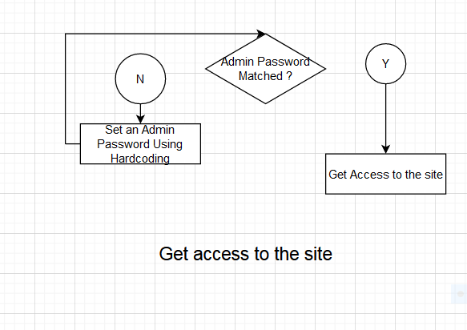

1. **Stock Status**: When users log in to the system, they will be able to watch the current stock status.

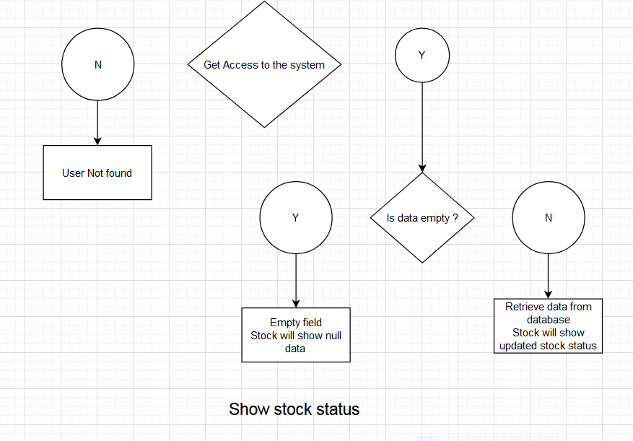

1. **Purchase items**: User can purchase new items (add new item to the database).

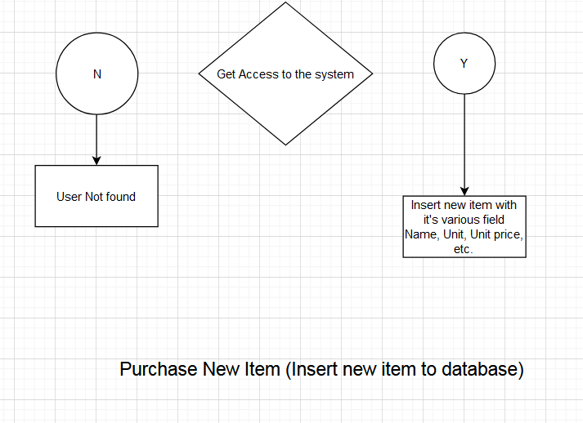

1. **Sell items**: Users can update sales quantity of each product.

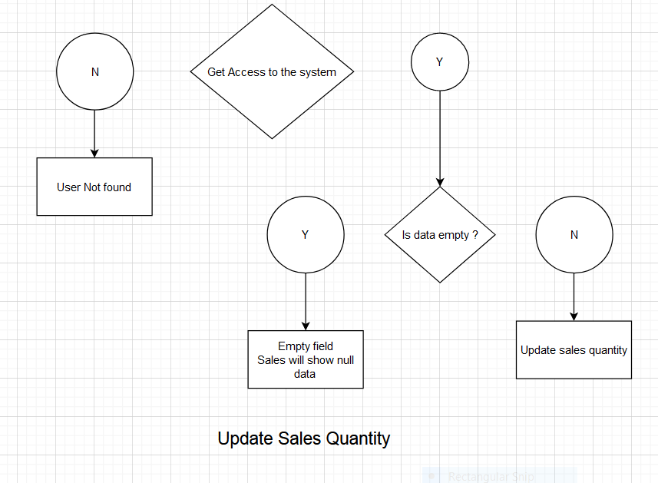

1. **Generate purchase report** : User can generate purchase report based on a timeframe. User can set start date and end date.

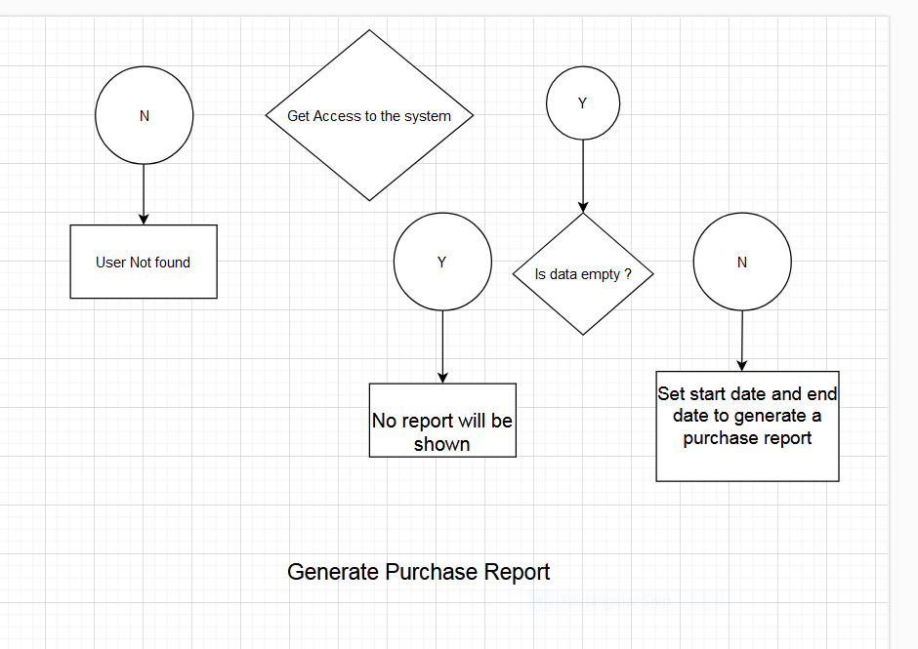

1. **Generate Sales Report**: User can generate sales report based on a timeframe. User can set start date and end date.

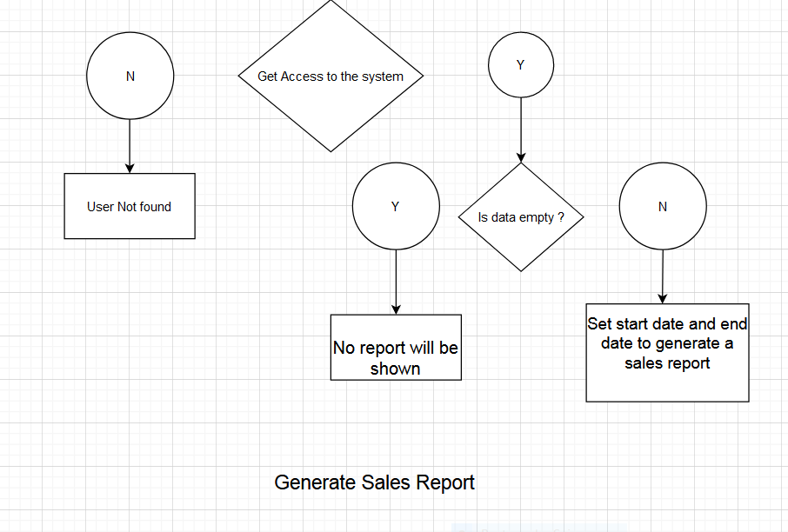

Self-Evaluation:

Grade: 3/4. Meets Expectation.