Page 1

[…]the Kanban approach to managing production operations [2]. In recent years, Kanban has become more popular in software development. Kanban approach is the most recent addition to the agile and Lean software development research area.

Despite recently increasing interest in Kanban among practitioners, existing scientific literature seems to address it quite infrequently in the context of software development. Only a few studies on Kanban usage, how it is carried out in practice and what are its effects in software development, have been published

Page 2

Section II describes the background and motivation of the study. Sections III discusses the methods used in this study. Section IV reports the findings of the review, along with the implications of the research. Section V provides a conclusion, with recommendations for further research.

Introduction et description sommaire de la méthode

Lean and Kanban approaches were introduced in the Japanese manufacturing industry in the 1950s. Kanban is a Japanese word meaning a signboard, and it is used in manufacturing as a scheduling system. It is a flow control mechanism for pull-driven Just-In-Time production, in which the upstream processing activities are triggered by the downstream process demand signals [2, S9]. It was successfully used in practice by Toyota. The basic idea behind Kanban usage is to execute the Lean thinking in practice; however, Lean is more than Kanban [5, 6, 7]. The Kanban method in software development was originated in 2004, when David J. Anderson [9] was assisting a small IT team at Microsoft that was operating poorly. The Kanban method in software development drives project teams to visualise the workflow, limit work in progress (WIP) at each workflow stage, and measure cycle time [8]. The Kanban board provides visibility to the software process, because it shows assigned work of each developer, clearly communicates priorities and highlights bottlenecks. Additionally, its goal is to minimize WIP, i.e. develop only those items which are requested. This produces constant flow of released work items to the customers, as the developers focus only on those few items at given time. Kanban method aims to quickly adapt the process by using shorter feedbacks loops. The key impetus for the usage of Kanban’s is focus on flow and the absence of obligatory iterations.

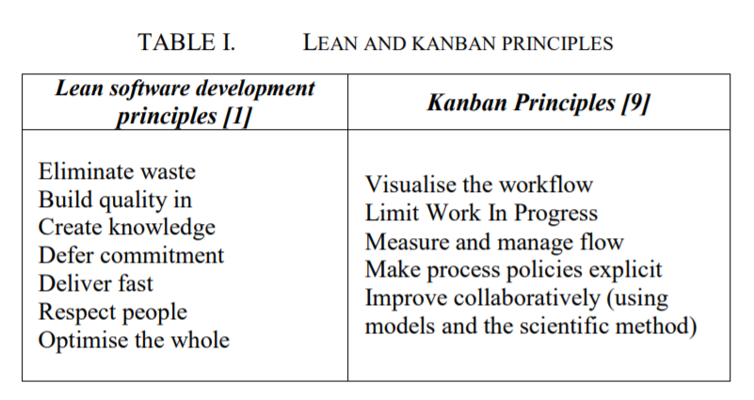

Kanban limits work in progress according to team capacity, which balances demand against the throughput of team delivered work. It helps to visualise process problems, decrease defects and maintain a steady flow. By limiting work in progress a sustainable pace of development is achieved, yielding higher quality products and greater team performance. The combination of improved flow and higher quality software helps to shorten lead time, leading to regular releases that help in building trust among the customers.

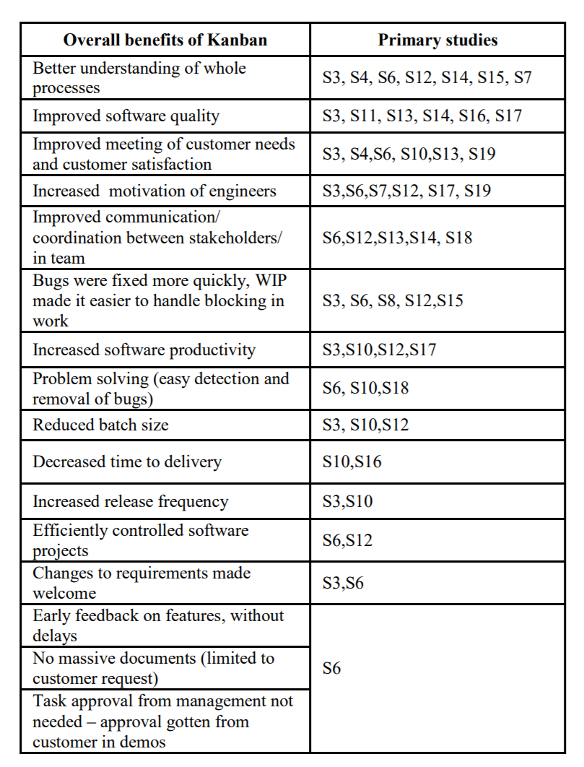

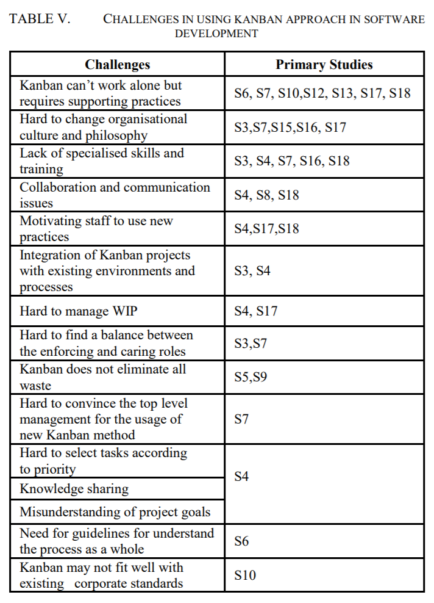

The primary studies suggest that the Kanban method needs to be implemented gradually in software development. It incrementally changes the way how work is done in an organisation. Patience throughout the process, which is very challenging for organisations, is essential.

According to [S6], visualisation alone does not guarantee success; Kanban is a basic controlling tool that needs to be supported with additional practices. In all of the primary studies, we see that there is a mixture of different agile practices used with the Kanban method. Hybrid models, integrating conventional agile practise with Kanban, are suggested for use. Mixtures of agile practices and Kanban principles were used in the primary studies, which showed incremental improvements in processes. The Kanban method should be used as a ‘plug-in’ with existing methods, rather than a replacement.

Based on existing literature the following good practices can be summarised:

• Protect teams from external tasks during the actions phase.

• Consider ways of limiting work in progress.

• Create a culture for collaboration on solving tasks and problems.

• Use a visual board to make low team orientation visible and improve the shared mental model.

• Encourage team members to provide feedback to each other.

• In order to create value, note that all non-value added work is not waste, and that some non-value added waste is necessary.

• Have senior managers constantly work on value creation for the organisation, allotting time to teach and solve technical problem with teams. In short, provide technical leadership.

• Provide a clear vision for the whole team.

Incremental transition is recommended, starting with the basic idea of Kanban. So far, there is no unified method for deploying the Kanban approach, but the current literature suggests an incremental and mixed approach, involving other agile methods and proper team mentoring. Daily meetings were found to play an important role in information flow. During daily stand-up meetings, disturbances should be avoided, while leaving in the middle of daily stand up meeting should not be permitted. Educating staff about new approaches through specialised training is essential.