Lesson 1: Introduction to Databases and SQL

Introduction:
In today's data-driven world, understanding how to store, access, and manipulate data is a key skill for anyone in IT or software development. This module introduces you to the fundamentals of SQL (Structured Query Language) and how relational databases work.

Objectives:
By the end of this module, students should be able to:

- Define SQL and understand its role in data management.
- Differentiate between DBMS and RDBMS
- Identify the key components of a database: tables, rows, columns, primary and foreign keys.
- Write and execute basic SQL queries.

Lesson:

What is SQL?
Definition: SQL (Structured Query Language) is a standard language for accessing and manipulating databases.
Purpose: It allows users to create, retrieve, update, and delete data in a database.
Common SQL Commands:

- SELECT – retrieve data
- INSERT – add new data
- UPDATE – modify existing data
- DELETE – remove data
- CREATE, DROP, ALTER – manage database structure

Tables, Rows, Columns, Keys
Table: A collection of related data in rows and columns.
Row (Record): A single entry in a table.
Column (Field): A specific attribute or field within a table.
Primary Key: A unique identifier for each record (e.g., student_id).
Foreign Key: A column that creates a link between two tables (e.g., course_id in students that refers to courses).

Access XAMPP

- For Windows - XAMPP on Windows is typically installed in C:\xampp.
- Steps:
  - Open Command Prompt:
    - Press Win + R, type cmd, and hit Enter.

  - Navigate to XAMPP directory:
    - cd C:\xampp
  - Access MySQL from terminal:
    - cd C:\xampp\mysql\bin
    - mysql -u root -p
- For MAC - XAMPP is installed in /Applications/XAMPP
- Steps:
  - Open Terminal:
    - You can search "Terminal" via Spotlight (Cmd + Space).
  - Navigate to XAMPP directory:
    - cd /Applications/XAMPP
  - Access MySQL CLI:
    - sudo /Applications/XAMPP/xamppfiles/bin/mysql -u root -p

Database
- Show all database
  - SHOW DATABASES;

You’ll see output like:
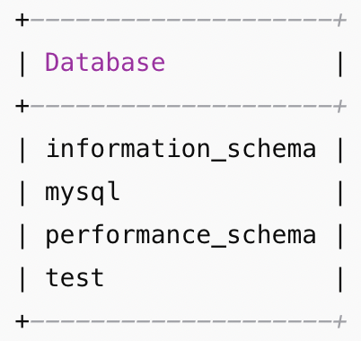

- Create database
  - CREATE DATABASE <database_name>;
- Delete database
  - DROP DATABASE <database_name>;
- Use database
  - USE <database_name>;

Table
- Show all tables
  - SHOW TABLES;
- Show table structure
  - DESCRIBE <table_name>
- Delete a table
  - DROP TABLE <table_name>;
- Rename a table
  - RENAME TABLE <table old_name> TO <table new_name>;
- Create a table
  - CREATE TABLE students (
id INT AUTO_INCREMENT PRIMARY KEY,
name VARCHAR(100),
age INT,
email VARCHAR(100)
);

Data Manipulation
- Insert data
  - INSERT INTO <table_name> (col1, col2) VALUES (val1, val2);
- View table data
  - SELECT *
FROM <table_name>;
- Update data
  - UPDATE <table_name>
SET col1 = val
WHERE condition;
- Delete data
  - DELETE FROM <table_name>
WHERE condition;

Activity – Lesson 1

- Create a database named school_db.

- Show all databases.

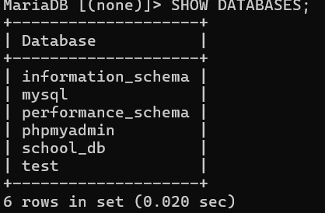

- Use the database you have created.

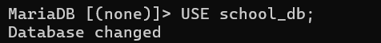

- Create a table named students with the following columns:
Column name | Data Type | Notes
id | INT | Auto increment, primary key
name | VARCHAR(100)
age | INT
email | VARCHAR(100)
course | VARCHAR(100)

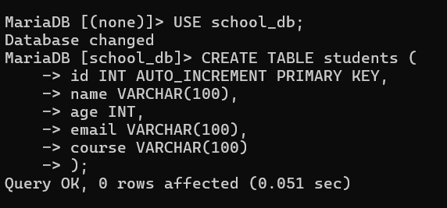

- Show table structure

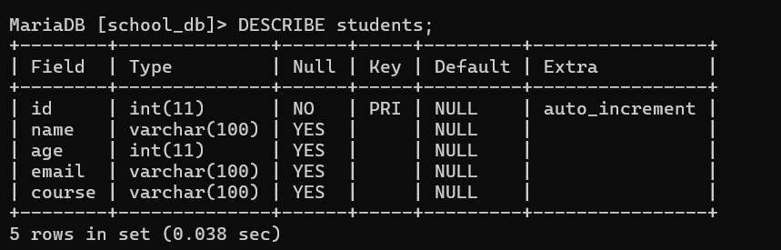

- Insert 3 students into the table.
  - Alice Johnson / 20 / alice@example.com / BSCS
  - Bob Smith / 22 / bob@example.com / BSIT
  - Clara Davis / 21 / clara@example.com / BSEMC
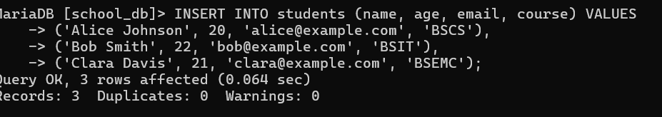

- Display all records in the students table.
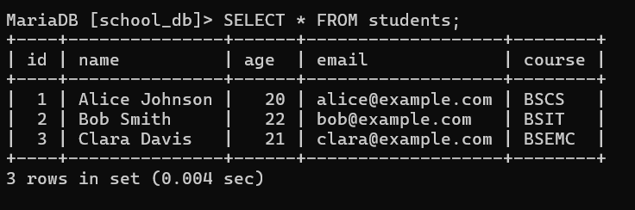
- Display only names and emails.
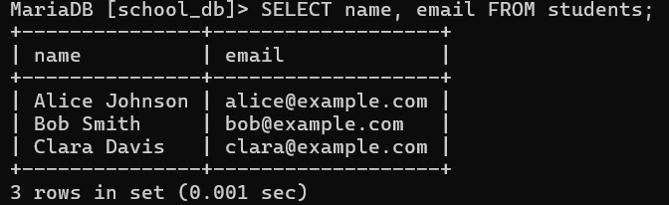
- Display students older than 20.
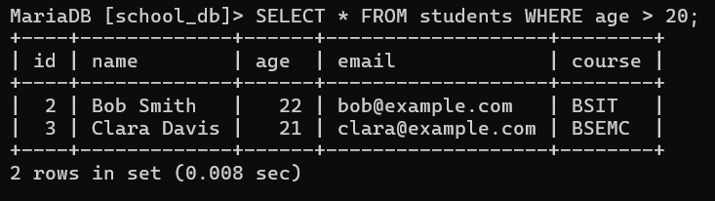
- Change Clara’s course to Data Science.
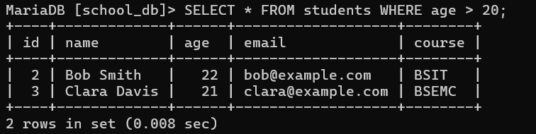

- Delete the student named Bob Smith.

