

**University of Caloocan City**

**Bachelor of Science in Information System**

**3-A**

**A.Y. 2020-2021**

**5YNTAX**

Barruela, Marie Joy B.

Brigoli, Mary Rose B.

Garcia, Nicole Mae M.

Vibiesca, Serge Ivon E.

Villanueva, Cyrus Jeurell Y.

# **SYSTEM DOCUMENTATION**

Fireon is a Payroll System that aims to automate and digitalize the previous manual payroll system of the company **Macrohard**©.

In partial fulfillment of requirements for these subjects: Enterprise Resource Planning and Business Process Management under the guidance and supervision of Mr. Ryan Rei Alban.

# **FIREON PAYROLL SYSTEM**

ABOUT THE SOFTWARE

* Fireon Payroll System ERP Software is a Payroll system that is business solution for the Human Resource Department and a tool for efficiently managing your current employees and their salaries. The Payroll System will be built for Windows application using C#.NET with MySQL database.
* This document aims to guide the user regarding the features and workarounds of Fireon Payroll System. This manual will explain the steps on how to run the software well, from Dashboard screen up to Payroll screen.

# **FIREON PAYROLL SYSTEM**

TABLE OF CONTENTS

Dashboard……………………………………………………………………… 5

Manage Employee…………………………………………………………… 7

Leave……………………………………………………………………………. 8

Overtime………………………………………………………………………… 10

Holiday…………………………………………………………………………... 12

Violations………………………………………………………………………… 14

Cash Advance…………………………………………………………………. 16

Deductions……………………………………………………………………… 18

Allowances……………………………………………………………………… 19

Payroll Computation………………………………………………………….. 20

All Data………………………………………………………………………..... 21

Department…………………………………………………………………….. 22

Single Posting…………………………………………………………………... 23

Main Function of the System………………………………………………… 24

Departments and Positions…………………………………………………... 25

Holidays…………………………………………………………………………... 28

# **HOW DOES *DASHBOARD* WORK?**

*Figure 1: Dashboard*

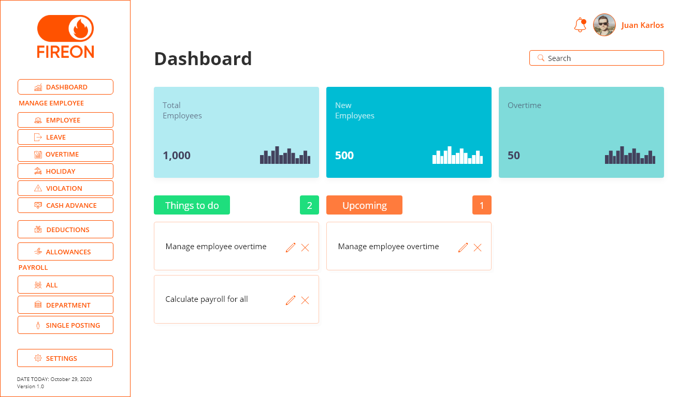

*Serves as the welcome page of the program and provides quick overview of the statistics.*

## **TOTAL EMPLOYEES**

* Gets the number of total employees.
* DATA: from the employees’ table/page.

## **NEW EMPLOYEES**

* Gets the number of new hired employees during that day.
* Restarts from 0 every day.
* DATA: from the employees’ table/page.

## **OVERTIME**

* Gets the number of employees who works overtime during that day.
* Restarts from 0 every day.
* DATA: from the overtime table/page.

## **THINGS TO DO**

* The admin can list down the things he/she needs to do during that day and delete if done.
* If the admin clicks that task, the admin will automatically go to that page.
* *EXAMPLE: The admin needs to delete an employee, when the admin clicks that task, it will automatically go to EMPLOYEE PAGE.*

## **UPCOMING**

* Similar with things to do but with date for specific tasks.
* The data from ‘upcoming’ should automatically go to ‘things to do’
* *EXAMPLE: the admin needs to delete an employee on December 5. On December 5, that task should go to ‘things to do’.*

## **NOTIFICATIONS**

* Displays important events such as Payday and Holiday.

# **HOW DOES *MANAGE EMPLOYEE* WORK?**

*Figure 2: Manage Employee***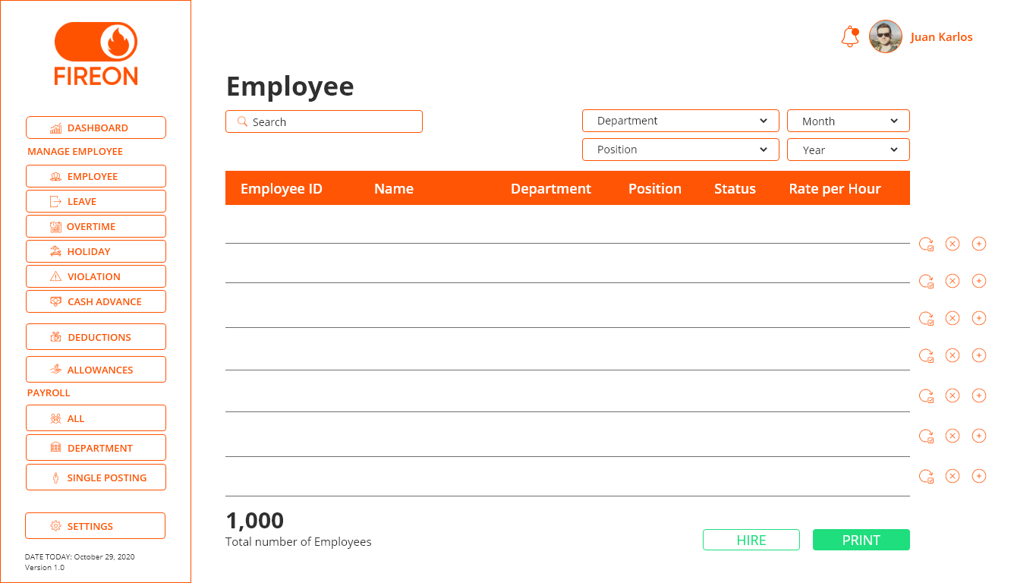**

*Manages all employees in different aspects.*

## **MANAGE EMPLOYEE VIEWING TABLE**

* For specific viewing, payroll personnel can choose by department, position, month, or year of employment.

## **HIRING AN EMPLOYEE**

* The payroll personnel can hire the employee by just clicking the hire button and type the details of the employee.
* The employee id is auto generated.
* The payroll personnel should set the rate per hour manually based on position.
* Once saved, the number of ‘Total Employees’ and ‘New Employees’ should increase in the dashboard.
* Once deleted, the number of ‘Total Employees’ or ‘New Employees’ should decrease in the dashboard.

# **HOW DOES *LEAVE* WORK?**

*Figure 3: Leave*

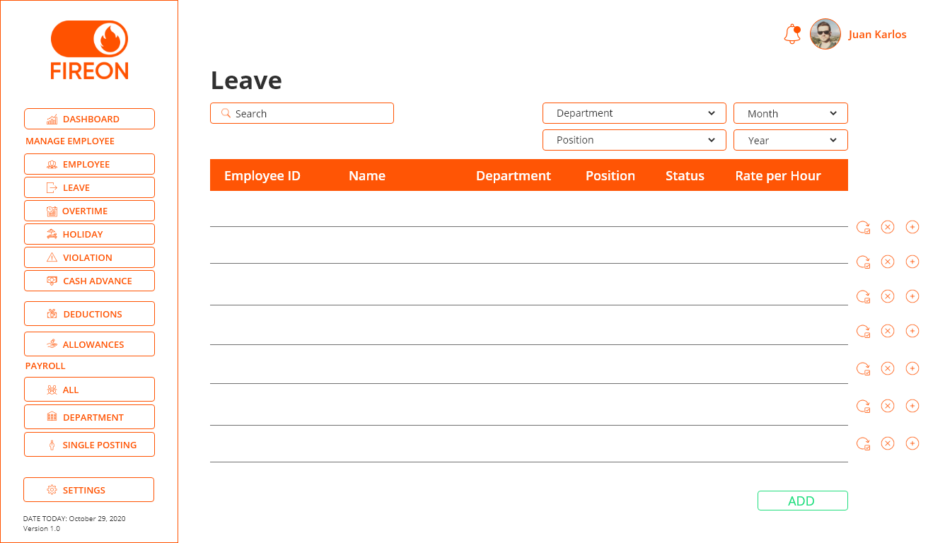

*Manages all the employee leaves in the company.*

## **LEAVE VIEWING TABLE**

* For specific viewing, payroll personnel can choose by department, position, month, or year that leave has been created.

## **ADDING EMPLOYEE LEAVE**

* The admin will only be typing the employee id, then the information like name, department, and position will automatically show.
* Every employee has specific number of leave (days) in a year.
* The employee should not exceed to the days given, if exceeded the request for a leave should not be accepted.
* The number of days in database will decrease if the request for a leave is accepted.

## **EXAMPLE**

* Employee requests for a vacation leave for 30 days.

## **FORMULA**

* Number of days * 8 = paid working hours  
  Why 8? Because 1 day = 8 working hours

## **AVAILABLE LEAVE FOR EVERY EMPLOYEE IN A YEAR**

* Sick leave – 30 days
* Vacation leave – 60 days
* Maternity leave – 180 days

## **RESULT**

* As you can see, the vacation leave decreases from 60 days to 30 days.

|  |  |  |  |  |  |  |  |  |  |
| --- | --- | --- | --- | --- | --- | --- | --- | --- | --- |
| Date | ID | Name | TYPE OF LEAVE | DATE (FROM) | DATE  (TO) | PAID WORKING HOURS | SL | VL | ML |
| 10/20/2020 | 113 | Mary Rose Brigoli | Vacation Leave | 11/01/2020 | 11/30/2020 | 240 | 30 | 30 | 180 |

# **HOW DOES *OVERTIME* WORK**

*Figure 4: Overtime*

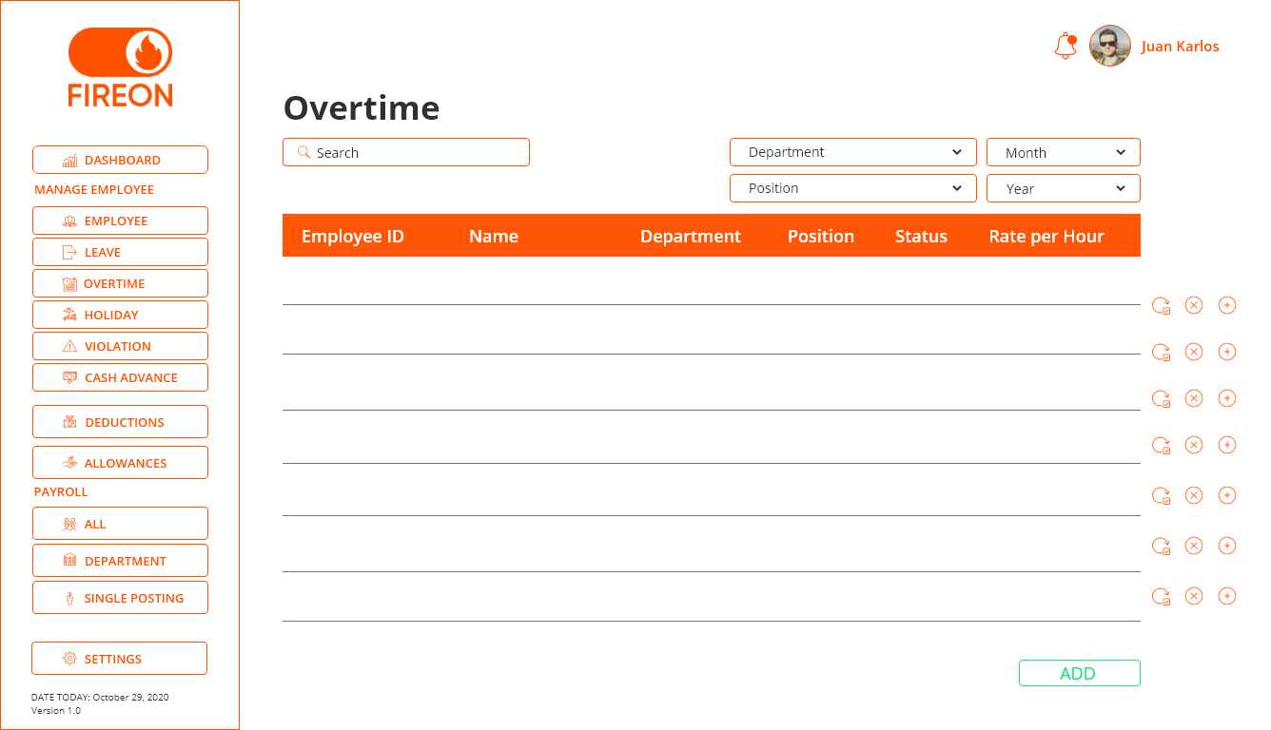

*Manages all the employee overtimes in the company.*

## **OVERTIME VIEWING TABLE**

* For specific viewing, payroll personnel can choose by department, position, month, or year.

## **ADDING EMPLOYEE OVERTIME**

* The admin will only be typing the employee id, then the information like name, department, and position will automatically show.
* The admin will specify how many additional hours the employee had work, then the total rate will be automatically calculated.
* The amount is added to the employees’ net pay.

## **EXAMPLE**

* Employee works for additional 5 hours, if the employee has a rate of 100 per hour the total rate is 500

## **FORMULA**

* additional hours * rate per hour = amount

|  |  |  |  |  |  |  |  |
| --- | --- | --- | --- | --- | --- | --- | --- |
| DATE | ID | Name | DEPARTMENT | POSITION | ADDITIONAL HOURS | RATE PER HOUR | AMOUNT |
| 11/20/2020 | 113 | Mary Rose Brigoli | IT | PROGRAMMER | 5 | 100 | 500 |

# **HOW DOES *HOLIDAY* WORK?**

*Figure 5: Holiday*

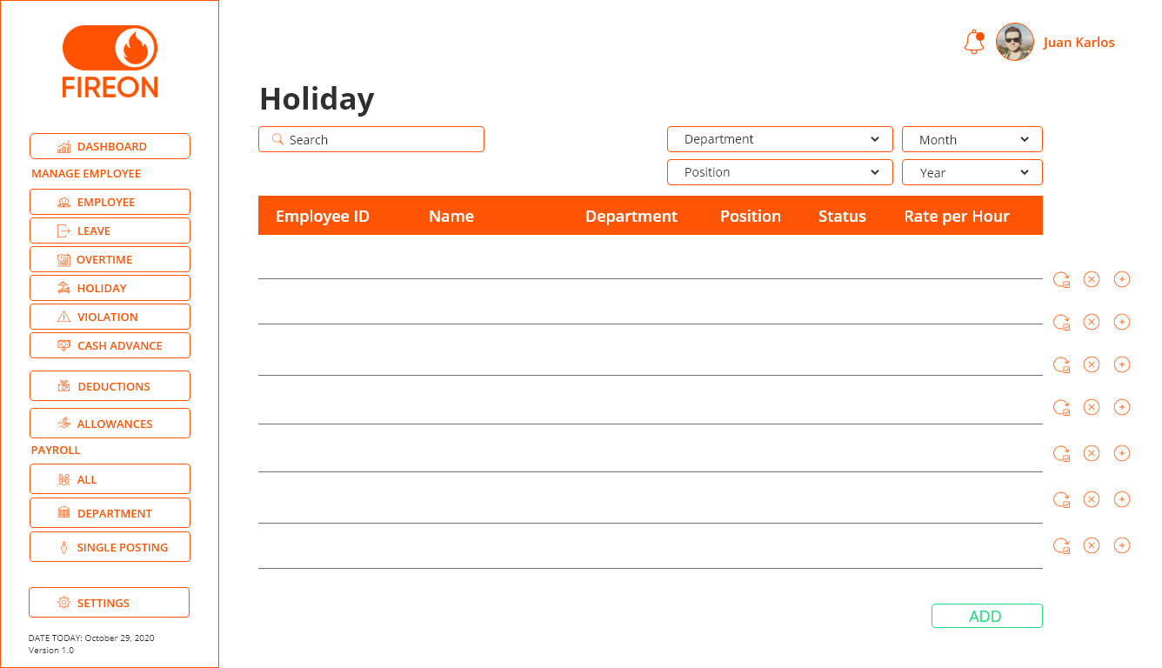

*Manages all Philippine holidays in different aspects.*

## **VIEWING TABLE**

* For specific viewing, payroll personnel can choose by department, position, month, or year.

## **ADDING EMPLOYEE HOLIDAY**

* The admin will only be typing the employee id, then the information like name, department, and position will automatically show.
* The amount is added to the employee’s net pay.
* REGULAR HOLIDAY= +100% daily rate
* SPECIAL NON-WORKING= +30% of daily rate

## **EXAMPLE**

* SPECIAL NON-WORKING HOLIDAY: If the employee has a rate of 100 per hour, he/she will receive 240

## **FORMULA**

* hourly rate * 8 = daily rate * .30 = amount

## **REGULAR HOLIDAY**

* If the employee has a rate of 100 per hour, he/she will receive 800

## **FORMULA**

* hourly rate * 8 = daily rate * 1 = amount

|  |  |  |  |  |  |  |  |
| --- | --- | --- | --- | --- | --- | --- | --- |
| DATE | ID | Name | DEPARTMENT | POSITION | HOURLY RATE | DAILY RATE | AMOUNT |
| 12/25/2020 | 113 | Mary Rose Brigoli | IT | PROGRAMMER | 100 | 800 | 800 |

# **HOW DOES *VIOLATIONS* WORK?**

*Figure 6: Violations*

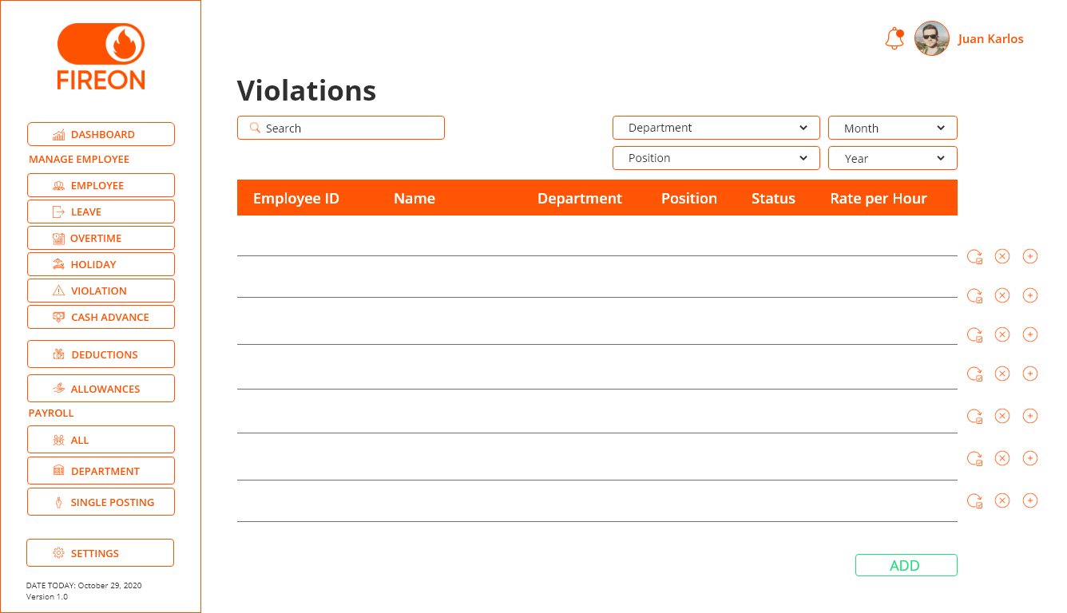

*Manages all the employee violations in the company.*

## **VIEWING TABLE**

* For specific viewing, payroll personnel can choose by department, position, month, or year.

## **ADDING EMPLOYEE VIOLATION**

* The admin will only be typing the employee id, then the information like name, department, and position will automatically show.
* The admin will be the one to specify the type of violation and the corresponding value for that violation.
* The amount is deducted to the employee’s monthly net pay.

## **EXAMPLE**

|  |  |  |  |  |  |  |
| --- | --- | --- | --- | --- | --- | --- |
| DATE | ID | Name | DEPARTMENT | POSITION | VIOLATION | AMOUNT |
| 12/25/2020 | 113 | Mary Rose Brigoli | IT | PROGRAMMER | Broke the printer | 500 |

# **HOW DOES *CASH ADVANCE* WORK?**

*Figure 7: Cash Advance*

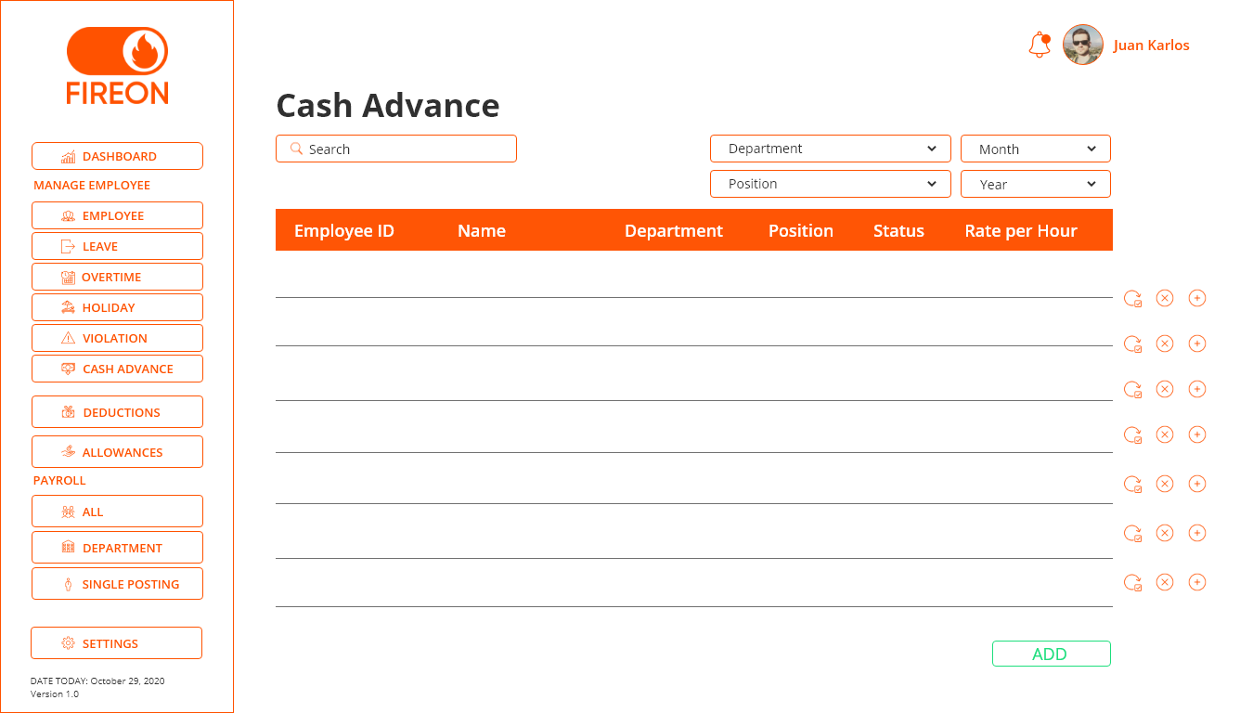

*Manages all the employee cash advances in the company.*

## **VIEWING TABLE**

* For specific viewing, payroll personnel can choose by department, position, month, or year.

## **ADDING EMPLOYEE CASH ADVANCE**

* The admin will only be typing the employee id, then the information like name, department, and position will automatically show.
* Every employee has a maximum amount for cash advance every month.

## **EXAMPLE**

* Maximum is 5000 per month.
* The employee is not allowed to advance cash worth 5001.
* The employee can request for cash advance once a month only.
* The amount is deducted to the employee’s monthly net pay.

|  |  |  |  |  |  |
| --- | --- | --- | --- | --- | --- |
| DATE | ID | Name | DEPARTMENT | POSITION | AMOUNT |
| 12/25/2020 | 113 | Mary Rose Brigoli | IT | PROGRAMMER | 5000 |

# **HOW DOES *DEDUCTIONS* WORK?**

*Figure 8: Deductions*

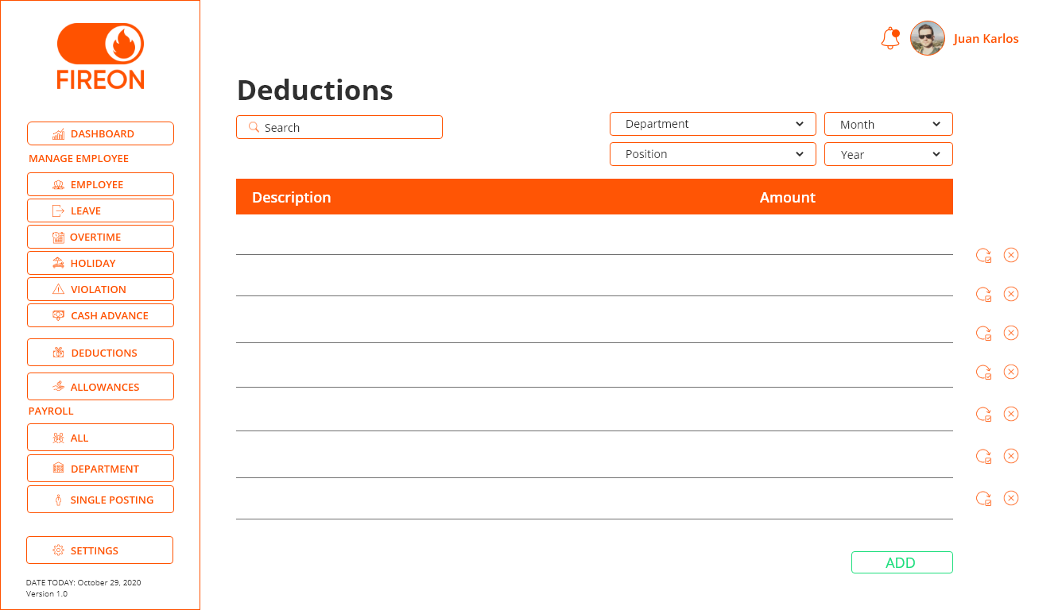

*Manages all Philippine deductions in different aspects.*

## **ADDING DEDUCTION**

* The payroll personnel should specify the type of deduction and set the value for it.
* The total will be deducted to the net pay of all the employees

## **EXAMPLE**

|  |  |
| --- | --- |
| Description | Amount |
| Pag-Ibig | 200 |
| PhilHealth | 300 |

Total Deduction = 500

# **HOW DOES *ALLOWANCES* WORK?**

*Figure 9: Allowances*

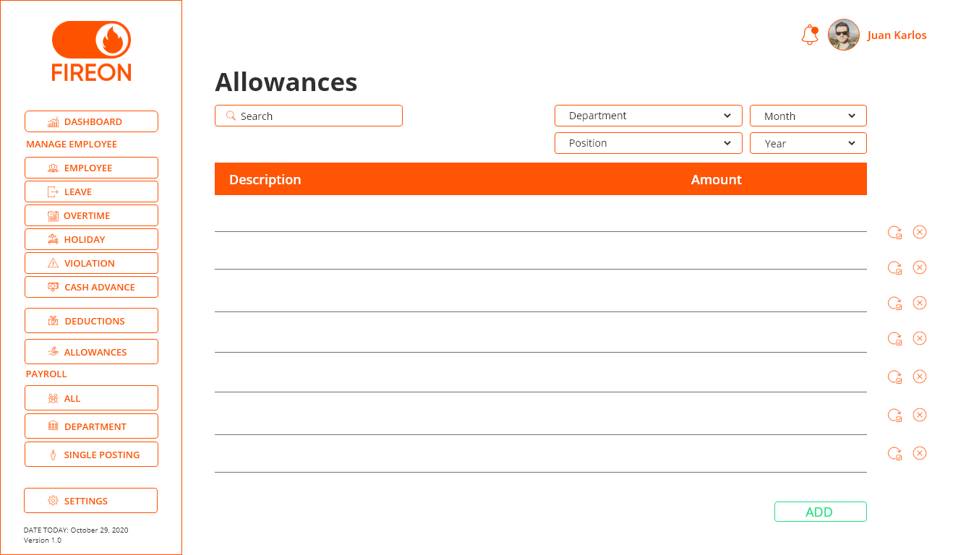

*Manages all allowances issued by the company in different aspects.*

## **ADDING ALLOWANCES**

* The payroll personnel should set the value for every type of allowances.
* The total will be added to the net pay of all the employees.

## **EXAMPLE**

|  |  |
| --- | --- |
| Description | Amount |
| Food | 200 |
| Transportation | 300 |

Total Allowance = 500

# **HOW DOES *PAYROLL* WORK?**

* *Calculates the salary of employees.*
* In this part, the payroll personnel can only VIEW the table, the data is not editable. To update the data, the payroll personnel should go to ‘manage employee’.
* DATA: from manage employee page.

**FORMULA**

*Figure 10: Payroll Computation*

* Since we don’t have attendance monitoring, the working hours is fixed for all employees.

|  |  |  |  |  |  |  |  |  |  |  |
| --- | --- | --- | --- | --- | --- | --- | --- | --- | --- | --- |
| Hours | Overtime | Total Working Hours | Hourly Rate | Basic Salary | Violation | Cash Advance | Deduction | Holiday | Allowance | Net Salary |
| 218 | 10 | 228 | 100 | 22,800 | 500 | 1000 | 500 | 800 | 500 | **22,100** |

# **EXAMPLE**

# **HOW DOES *ALL* WORK?**

*Figure 11: All Data*

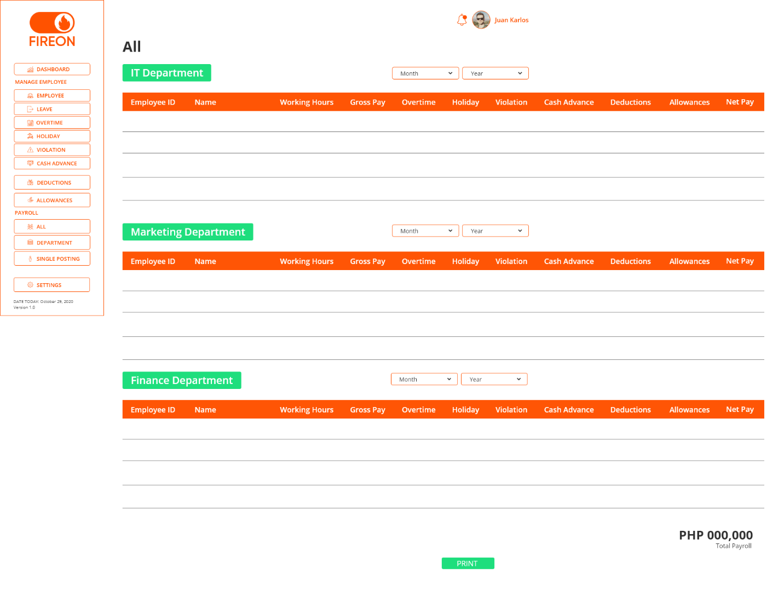

*Calculates the total net salary of all employees.*

# **HOW DOES *DEPARTMENT* WORK?**

*Figure 12: Department*

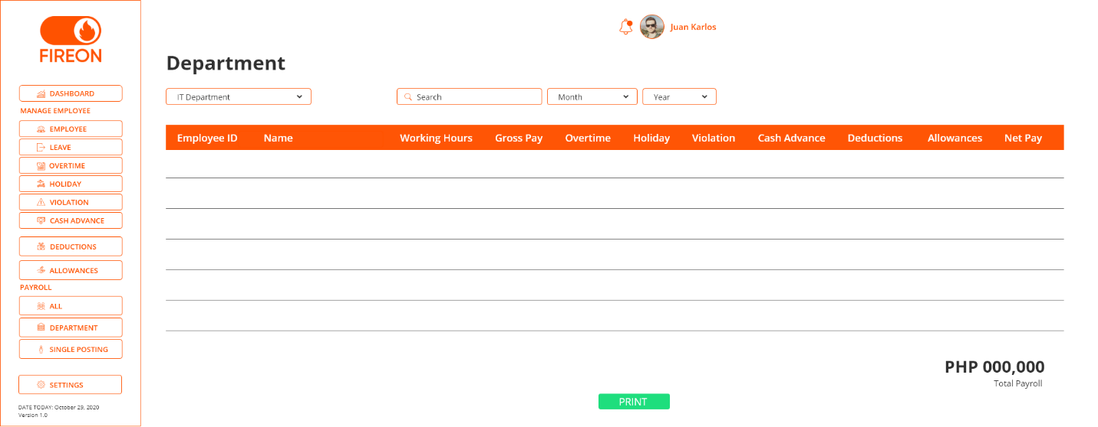

*Calculates the total net salary of every department.*

## **VIEWING TABLE**

* First, the payroll personnel should choose what department he/she wants to view.
* For specific viewing, payroll personnel can choose by month or year.

# **HOW DOES *SINGLE POSTING* WORK?**

*Figure 13: Single Posting*

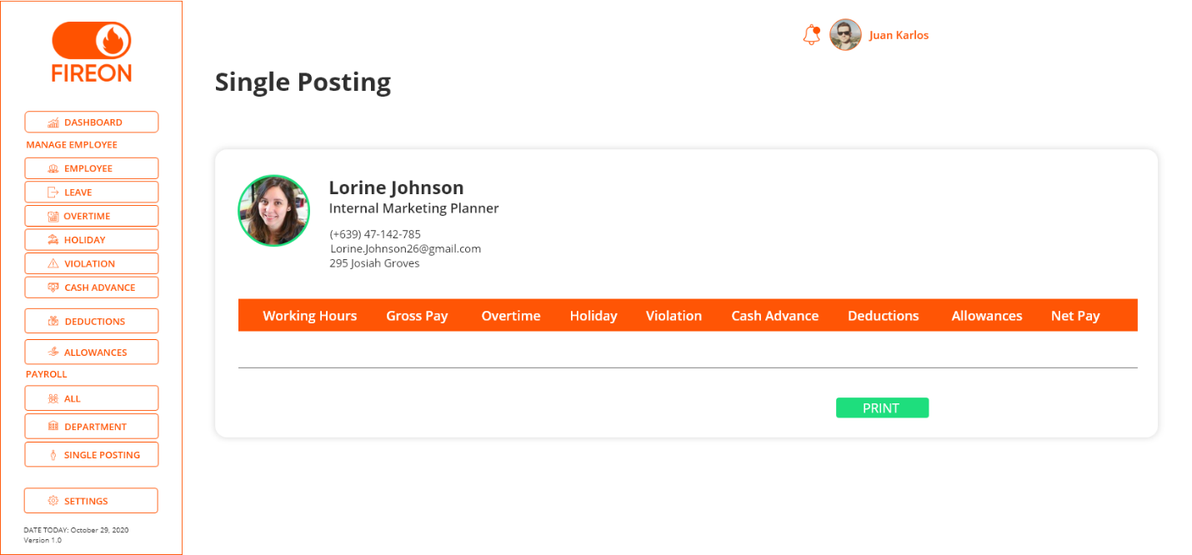

*Manages the single posting of an employee.*

* Calculation of payroll for a single employee.
* The admin will only be typing the employee id, then the information like name, department, position, and rate per hour will automatically show.
* Add retirement fee if the employee will retire.

# **MAIN FUNCTION OF THE SYSTEM**

*Figure 14: Main Function of the System*

*The general flow of the system.*

* The payroll will get the total value of overtime, holiday, violation, cash advance, allowances, and deductions in order to calculate the net pay of employees.

# **DEPARTMENTS AND POSITIONS**

## **IT DEPARTMENT**

* IT Technician
* Network Administrator
* System Analyst
* IT Director
* IT Support Specialist
* Database Administrator
* Security Specialist
* Application Developer
* Web Developer

## **MARKETING DEPARTMENT**

* Marketing Director
* Marketing Manager
* Communication Manager
* Product Manager
* Marketing Consultant

## **FINANCE DEPARTMENT**

* Payroll Clerk
* Financial Analyst
* Payroll Assistant
* Finance Clerk
* Financial Advisor Assistant
* Purchasing Clerk
* Accountant
* Assistant Accountant
* Auditor

## **OPERATIONS DEPARTMENT**

* Operations Manager
* Operations Supervisor
* Operations Assistant
* Operations Analyst
* Facilities Coordinator
* Logistics Manager

## **SALES DEPARTMENT**

* Sales Collection Agent
* Sales Account Manager
* Sales Account Executive
* Sales Manager
* Sales Representative
* Sales Consultant

## **HUMAN RESOURCE DEPARTMENT**

* Human Resource Generalist
* Human Resource Assistant
* Human Resource Associate
* Human Resource Representative
* Human Resource Administrator
* Human Resource Analyst
* Human Resource Specialist
* Human Resource Supervisor
* Human Resource Manager
* Human Resource Director

## **CUSTOMER SERVICE DEPARTMENT**

* Customer Experience Specialist
* Customer Support Associate
* Customer Service Agent
* Retail Associate
* Telephone Support Specialist
* Customer Interaction Management Specialist
* Call Center Customer Support
* Customer Care Operator

## **RESEARCH AND DEVELOPMENT DEPARTMENT**

* Research Assistant
* R&D Manager
* R&D Supervisor
* R&D Specialist

## **ADMINISTRATIVE DEPARTMENT**

* Administrator
* Administrative Coordinator
* Administrative Director
* Administrative Manager
* Administrative Specialist
* Services Manager
* Secretary
* Administrative Assistant Director

## **PURCHASING DEPARTMENT**

* Purchasing Manager
* Materials Manager
* Purchasing Director
* Purchasing Supervisor
* Purchasing Agent
* Purchasing Assistant
* Purchasing Clerk
* Production Planner

## **LEGAL DEPARTMENT**

* Arbitrator
* Attorney
* Case Manager
* Jury Consultant
* Law ﬁrm Administrator
* Legal Analyst
* Legal Services Director

## **PRODUCTION DEPARTMENT**

* Robotics Technician
* Mechatronic Engineer
* Assembler
* Machinist
* Production Manager
* Quality Control Inspector
* Product Designer

# **PHILIPPINE HOLIDAYS**

## **NATIONAL REGULAR HOLIDAYS**

* **New Year’s Day** – January 1
* **Maundy Thursday** – April 1
* **Good Friday** – April 2
* **Araw ng Kagitingan** – April 9
* **Labor Day** – May 1
* **Independence Day** – June 12
* **National Heroes’ Day** – August 30
* **Bonifacio Day** – November 30
* **Christmas Day** – December 25
* **Rizal Day** – December 30

## **SPECIAL (NON-WORKING) HOLIDAYS**

* **Chinese New Year** – February 12
* **EDSA Revolution Anniversary** – February 25
* **Black Saturday** – April 3
* **Ninoy Aquino Day** – August 21
* **All Saints’ Day** – November 1
* **Feast of the Immaculate Conception of Mary** – December 8
* **Last Day of the Year** – December 31

CLASS BASED DATABASE FUNCTION

GOAL: Use one class file that will handle all the database operations.

HOW IT WORKS

1. Every time a form requires a database operation, it will just:

a. Create an instance of the class.

b. Use that class to perform database operations.

WHY THIS METHOD?

1. This method is neat and clean as you would only create 1 class that handles all the database operations

2. In all parts of the system, you will just have to call that class to invoke that database capabilities.

TITLE: LOGIN FEATURE

LEVELS OF USERS

1. Super User (with administrative privileges)

2. Normal User (with limited privileges)

FIRST TIME INSTALLATION

1. When the program is freshly installed on the machine, couple of things should happen:

a. No accounts yet.

b. Show "Create Account" form which requests the user (probably the super user) to create the 1st existing account within the system. Credentials include:

i. First Name (optional)

A. Max of 120 characters (15 bytes)

ii. Last Name (optional)

A. Max of 120 characters (15 bytes)

iii. Username (required)

A. Max of 32 characters (4 bytes).

B. Alphanumeric characters only (A-Z, a-z, 0-9).

iv. Password (required)

A. Max of 32 characters (4 bytes).

B. Any character is allowed.

WHEN LOGIN BUTTON GETS CLICKED

a. Validations

NORMAL RUN

1. When the program is already installed and ran, the program should behave in these ways:

a. Show the "LOGIN" form.

b. Check for "Keep Me Logged In" variable.

i. If true, then grant access for the LAST person who logged in.

WHEN USER IS LOGGED IN THE SYSTEM

1. When the user clicks the "LOGOUT" button.

a. Prompt a MessageBox dialog confirming the logout action.

b. If yes then close the "FIREON" form and show the "LOGIN" form again.

c. If no then just close the MessageBox and return to program.

2. When the user clicks the "CLOSE" button (X).

a. Prompt a MessageBox dialog confirming the closing action.

b. If yes then just close the "FIREON" form and terminate the program.