**multiPrime2-GUI.exe: Designing degenerate primers for maximum coverage with minimal degeneracy.**

Welcome to multiPrime2-GUI.exe! MultiPrime2-GUI is a user-friendly and one-step tool for designing degenerate primer pairs. It integrates degenerate primer design theory with mismatch handling, resulting in improved accuracy and specificity in detecting broad spectrum sequences. It outperformed conventional programs in terms of run time, primer number, and primer coverage. In the Method, the 'multiPrime1' approach represents a local optimum solution, resembling the core primer design module of multiPrime, available at https://github.com/joybio/multiPrime. In contrast, the 'multiPrime2' Method stands as a global optimum solution, capable of achieving maximum primer coverage with minimal degeneracy.

**How to Use multiPrime2-GUI.exe**

To utilize multiPrime2-GUI.exe effectively, follow these steps:

1. **Input Data:** Prepare your input data in a msa format (multiple alignment file). If you're unsure about the meaning of a parameter, simply click the question mark symbol (?), and it will provide you with an explanation.

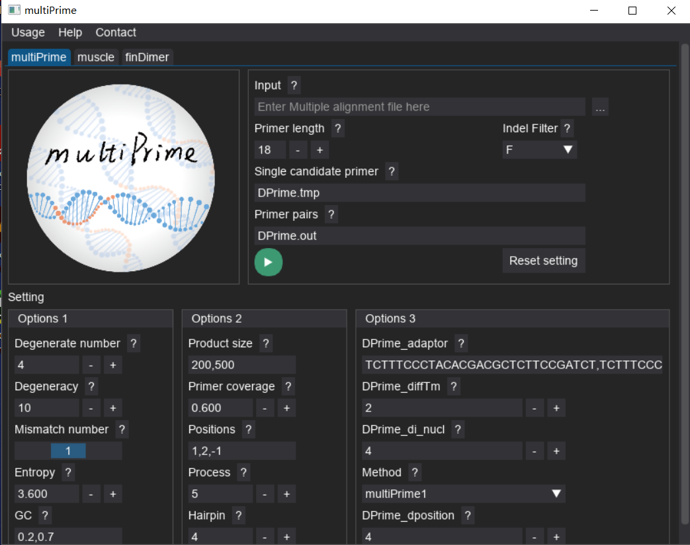

Click here to select input file

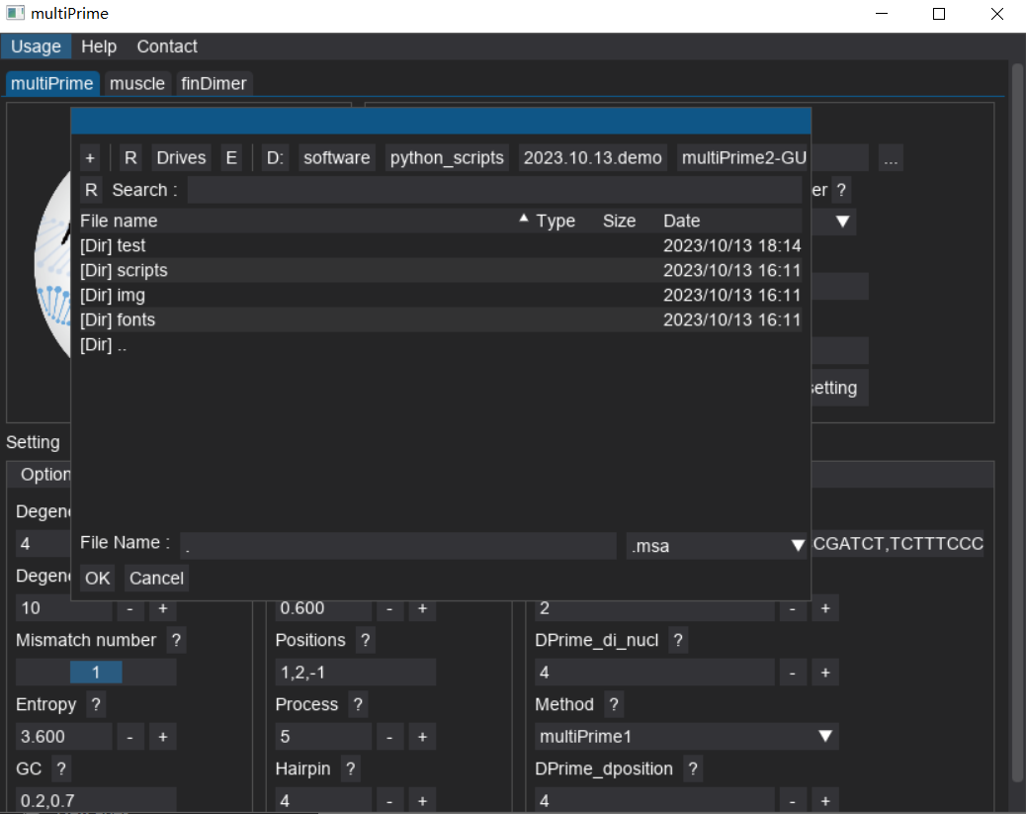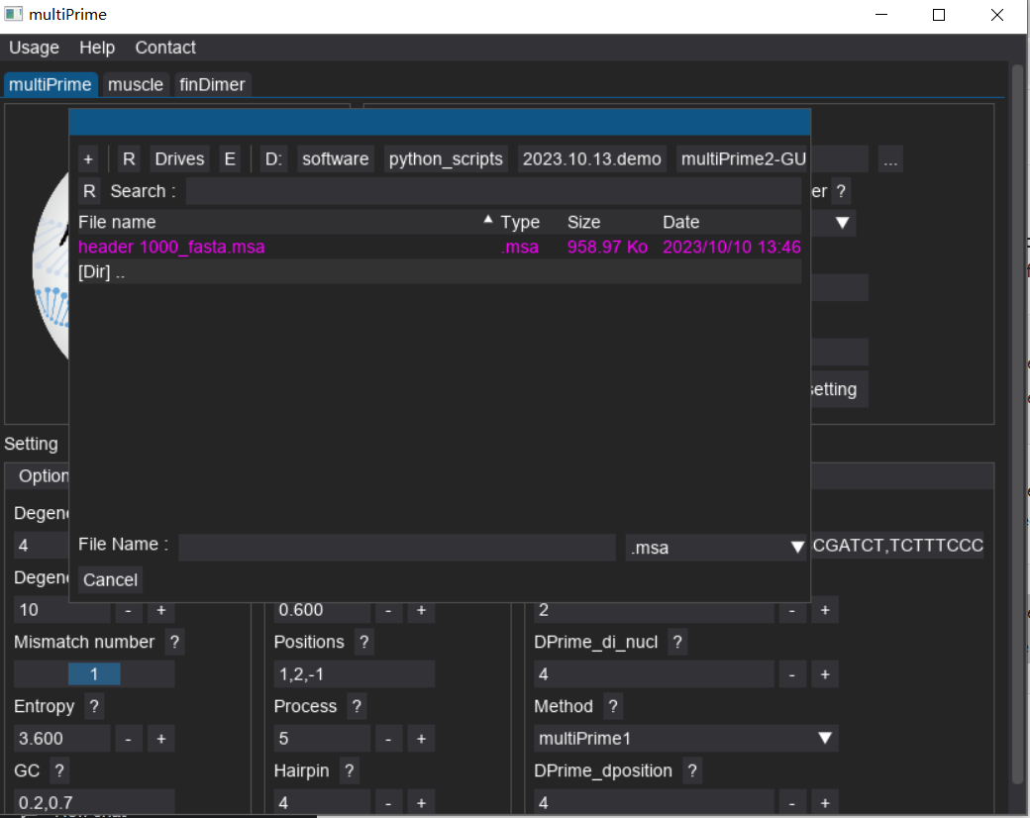Example:

Here is a test dataset.

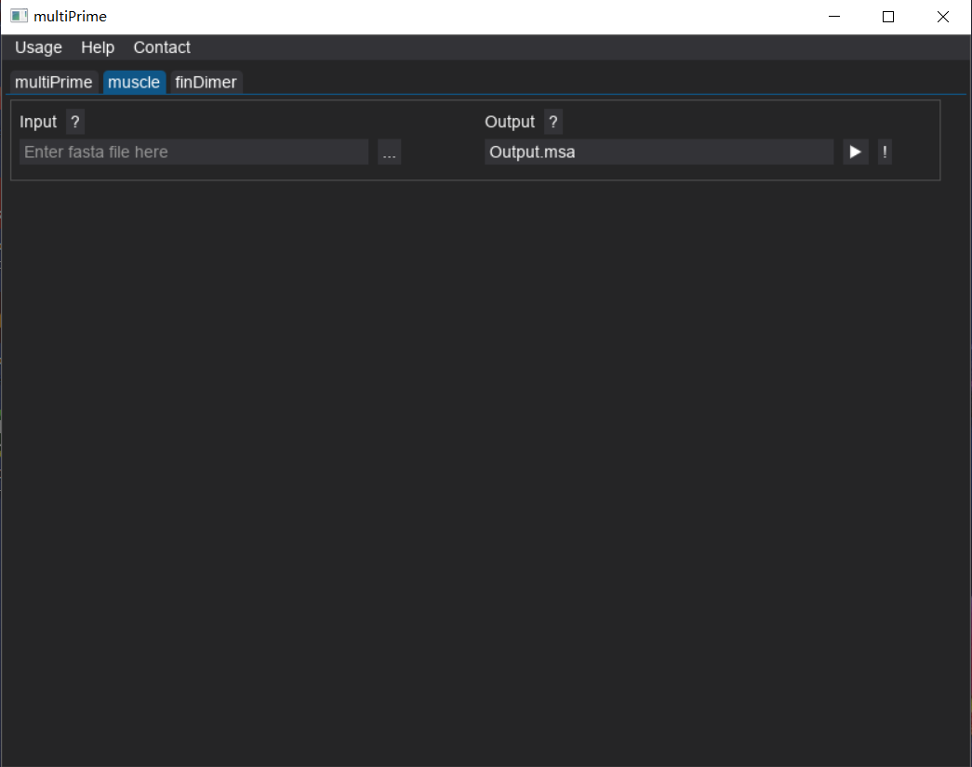If you don’t have multiple alignment file, you can run muscle in the muscle window.

1. **General Settings**: Customize Options to Suit Your Preferences

In the use multiPrime2-GUI application, we understand the importance of flexibility in tailoring the tool to your specific needs. As such, all the available options can be easily configured according to your preferences. You have the freedom to set them as you see fit. Empower yourself with complete control over the tool's behavior, allowing for seamless integration into your research and analysis workflows.

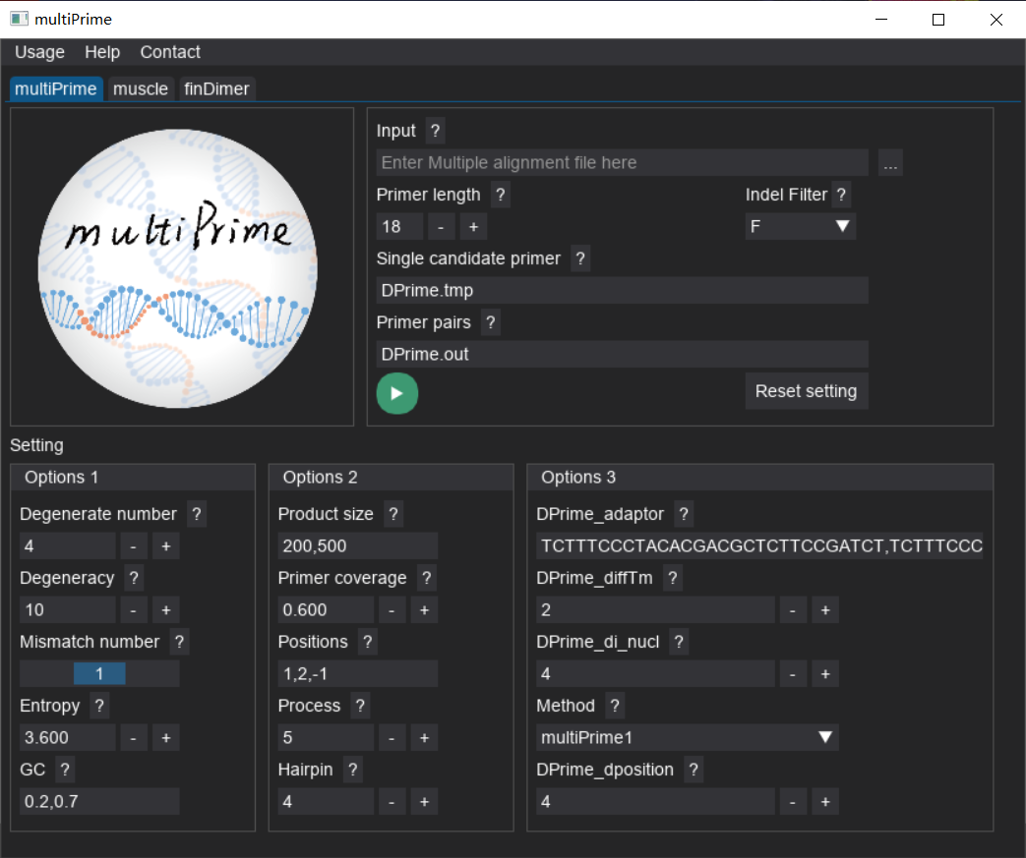

Once you have selected your input file, the output file name will be generated automatically, and these files will be located in the same directory as the input file.

1. **Primer Pair Generation:** Run multiPrime2-GUI.exe on your input data to initiate the primer pair design module. The tool will use its mismatch-tolerant approach to generate highly specific and effective degenerate primer pairs.

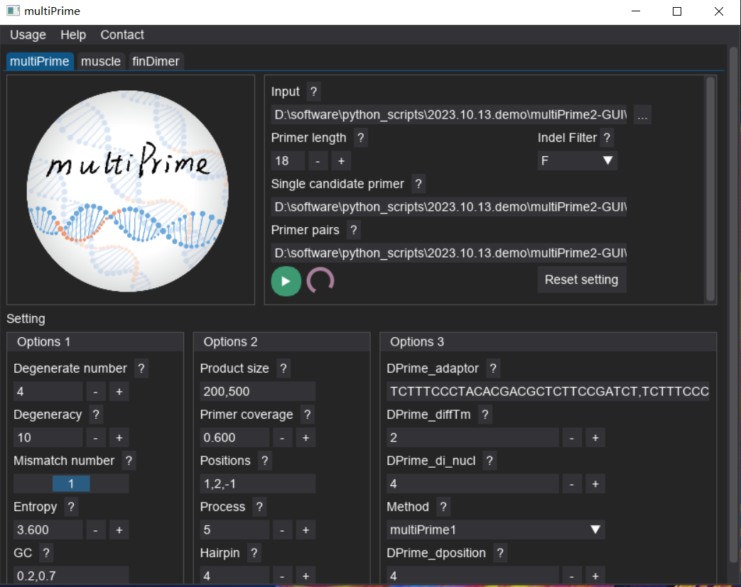

Start button

Processing indicator: The primer pairs are generated once the process has stopped.

1. **Analyze Results:** Once the primer design step is complete, carefully review the results, including the generated primer pairs, PCR product lengths, melting temperatures, and other relevant factors.
2. **Result Interpretation:** The multiPrime2-GUI.exe generates four result files, including a temporary file (*.tmp), two JSON files (*.json), and one Excel file (*.xls). The temporary file records the best candidate primers for each position, which can be viewed using Excel. The JSON files record the sequences ID that each primer at each position can capture and the sequences they cannot capture. The Excel file, on the other hand, contains information about the candidate primer pairs.

Example (.xls file):

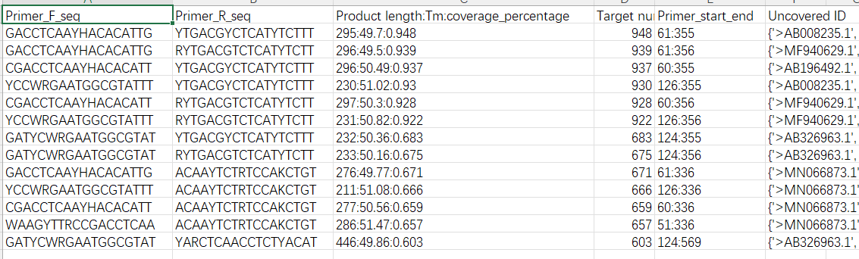

1. 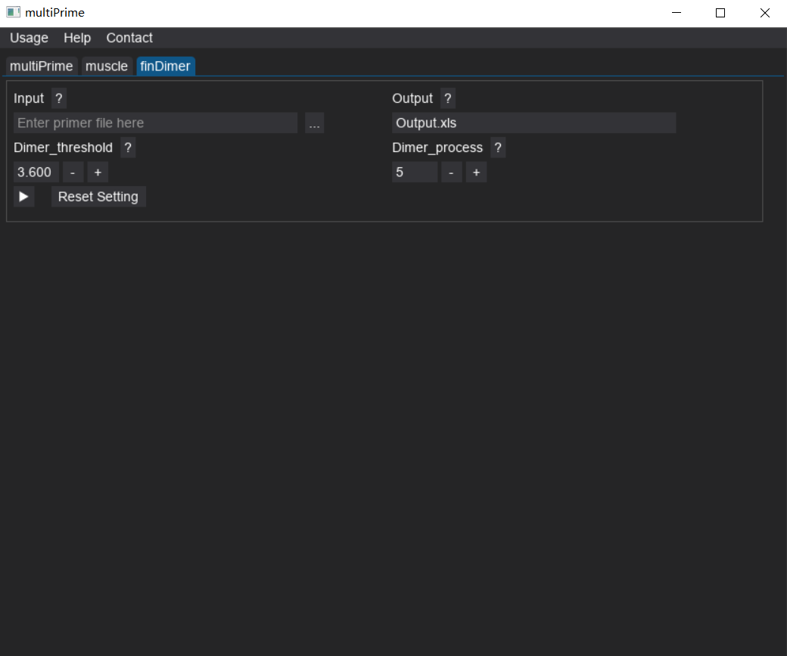**Dimer examination:** We have also integrated a dimer examination tool into the multiPrime2-GUI.exe. This tool accepts FASTA files and provides the capability to assess the potential for dimer formation within the FASTA sequences.

**System Requirements**

* Operating System: Windows
* CPU: NA
* RAM: NA
* Disk Space: NA

**Dependencies**

Please ensure you have the following dependencies installed on your system before using multiPrime2-GUI.exe:

* NA

**Installation and Execution**

* NA

**Support and Contact**

If you encounter any issues, have questions, or need further assistance, please don't hesitate to contact me at [[yang_junbo_hi@126.com](mailto:yang_junbo_hi@126.com)] or [1806389316@pku.edu.cn]. We value your feedback and are committed to enhancing the multiPrime for a better user experience.

**Acknowledgments**

We would like to express our gratitude to all contributors and developers who have made the multiPrime2-GUI pipeline possible. Your dedication and support have been invaluable in creating this powerful tool for the scientific community.

**License**

The MIT License (MIT)

Copyright (c) 2022 Junbo Yang [yang_junbo_hi@126.com; 1806389316@pku.edu.cn](mailto:yang_junbo_hi@126.com;%201806389316@pku.edu.cn) Permission is hereby granted, free of charge, to any person obtaining a copy of this software and associated documentation files (the "Software"), to deal in the Software without restriction, including without limitation the rights to use, copy, modify, merge, publish, distribute, sublicense, and/or sell copies of the Software, and to permit persons to whom the Software is furnished to do so, subject to the following conditions: The above copyright notice and this permission notice shall be included in all copies or substantial portions of the Software.

THE SOFTWARE IS PROVIDED "AS IS", WITHOUT WARRANTY OF ANY KIND, EXPRESS OR IMPLIED, INCLUDING BUT NOT LIMITED TO THE WARRANTIES OF MERCHANTABILITY, FITNESS FOR A PARTICULAR PURPOSE AND NONINFRINGEMENT. IN NO EVENT SHALL THE AUTHORS OR COPYRIGHT HOLDERS BE LIABLE FOR ANY CLAIM, DAMAGES OR OTHER LIABILITY, WHETHER IN AN ACTION OF CONTRACT, TORT OR OTHERWISE, ARISING FROM, OUT OF OR IN CONNECTION WITH THE SOFTWARE OR THE USE OR OTHER DEALINGS IN THE SOFTWARE.

Thank you for choosing multiPrime2-GUI! We hope this tool proves to be an invaluable asset in your target sequence detection endeavors using tNGS. Happy sequencing!