A Neurophenomenological Knowledge Graph for Contemplative States: Matching Brain Signals to What Practitioners Actually Experience
Joy Bose
Independent Researcher, Bangalore, India
joy.bose@ieee.org
Abstract. Meditation research has a labeling problem. Studies often place very different mental practices under one broad word, such as mindfulness or meditation. This hides real differences in how each tradition trains attention and how each tradition understands the mind. As a result, EEG and brain scan studies often produce results that do not agree with each other. This paper builds a knowledge graph ontology, not just a descriptive table, that connects specific brain measurements to the actual experiences described by practitioners through a layered pipeline: practice, training objective, phenomenological operation, computational mechanism, predicted neural signature, observed EEG, observed fMRI, and evidence strength. We look at six traditions: Samatha Jhana, Vipassana, Dzogchen Rigpa, devotional and deity practices, Korean Seon (hwadu investigation), and Jōdo Shinshū (nembutsu recitation). We also add a third axis to the usual two part model of consciousness, one that tracks how much a state has moved toward open, nondual awareness. This ontology is implemented as an actual knowledge graph, openly available in a public repository alongside this paper, so that its claims can be queried and checked rather than only read once. One finding deserves special attention. A study that directly compared six traditions in a single experiment found no meaningful difference in EEG power between the styles. This limits how confidently we can say these traditions produce distinct brain signatures. We conclude that meditation is not one single brain state, but the evidence for this claim is much stronger at the level of subjective experience and religious doctrine than at the level of raw brain signals. We point out exactly where more research is needed, especially for Korean Seon and Jōdo Shinshū.
Keywords. contemplative neuroscience, meditation taxonomy, knowledge graph ontology, EEG, fMRI, default mode network, Samatha, Vipassana, Dzogchen, Jhāna, Korean Seon, Jōdo Shinshū, nondual awareness
I. INTRODUCTION
Meditation research has a labeling problem. Many studies place very different mental training methods under one broad word, meditation or mindfulness [1]. This ignores real differences in attention, intention, and body sense that traditions have described for centuries [2]. Because of this, brain imaging and EEG studies often produce results that clash with each other [3]. Researchers sometimes group deep sensory withdrawal with open monitoring, or group nondual rest with detailed visualization, as if they were the same thing [3].
What is needed is a knowledge graph ontology that solves this problem directly, one that links brain scan and EEG findings to the specific experiences reported by trained practitioners through explicit, separately checkable stages, rather than a table that jumps straight from a tradition's name to its EEG findings. This paper builds such an ontology. We start with four main styles: Samatha Jhana, Vipassana, Dzogchen Rigpa, and devotional or deity practices. We then add two more traditions, Korean Seon and Jōdo Shinshū, where the evidence is much thinner, and we say so clearly wherever that is the case. Combining traditional contemplative theory with current brain research lets us explain some contradictions in past studies, while staying honest about where the evidence is weak, mixed, or simply missing.
II. A KNOWLEDGE GRAPH ONTOLOGY FOR CLASSIFYING CONTEMPLATIVE STATES
A. Four Requirements for a Good Classification
Before building a useful model, we need a clear way to sort meditative states into categories. Many research designs fail because they rely on loose, informal groupings instead of a systematic foundation [8]. A good classification should meet four standards. It should rest on real theory. It should sort states into separate, non overlapping groups. It should use clear language rather than vague terms. And it should be useful for designing new experiments [8].
Requirement | What It Means | How It Applies Here | Common Mistake in Past Research
Real theoretical basis | Categories need an explicit basis in theory, not just intuition. | Ground brain measurements in actual Buddhist, Sufi, or Tantric models of mind. | Treating mindfulness as one single, uniform state.
Separate categories | Categories should not overlap, and together should cover the whole space. | Keep practices that reduce sensory content (Jhana) separate from practices that restructure awareness itself (Dzogchen). | Mixing up sensory shutdown with nondual openness.
Clear language | Use terms that can actually be measured. | Replace a vague term like pure consciousness with something specific, like non representational awareness. | Studying reports that were never scored on a validated scale.
Practical use | The framework should lead to testable predictions. | Predict whether a classifier can tell meditation apart from ordinary mind wandering. | Recruiting subjects whose training does not match the task.
B. From a Flat Table to a Layered Pipeline
A simple table that lists a practice next to its EEG findings looks organized, but it hides an important step. It skips over the reasoning that connects a practice to a brain signal. Two practices can share a phenomenological label, such as attentional narrowing, while coming from entirely different traditions and doctrines, and two traditions can share a low level brain signature, such as elevated alpha power, for entirely different reasons. To make this reasoning explicit rather than implicit, we treat each tradition in this paper as an instance of an eight stage pipeline, shown in Figure 1.
Each stage answers a separate question. What is the practice. What does the tradition say it trains toward. What cognitive operation does the practitioner actually perform, described in terms that could in principle apply across traditions, such as narrowing attention, broadening attention, holding an unresolved doubt, or replacing the default sense of self. What computational mechanism might explain that operation, such as suppressing predictive error, monitoring conflict, or substituting an identity model. What would that mechanism predict about brain activity, stated before looking at any data. What does the EEG literature actually show. What does the fMRI literature actually show. And finally, how strong is the evidence connecting all of these stages together, rated openly as high, moderate, low, or theoretical only.
Separating prediction from observation this way is what turns a review into an ontology. A reviewer can see exactly where a claim in this paper rests on a measured brain signal, and where it rests only on a theoretical prediction that has not yet been tested. Section VII, on Korean Seon, is a direct example. Its predicted neural signature stage is filled in, but its observed EEG and observed fMRI stages for the hwadu stage specifically are empty, and Table II marks this gap rather than quietly filling it with the nearest available finding.
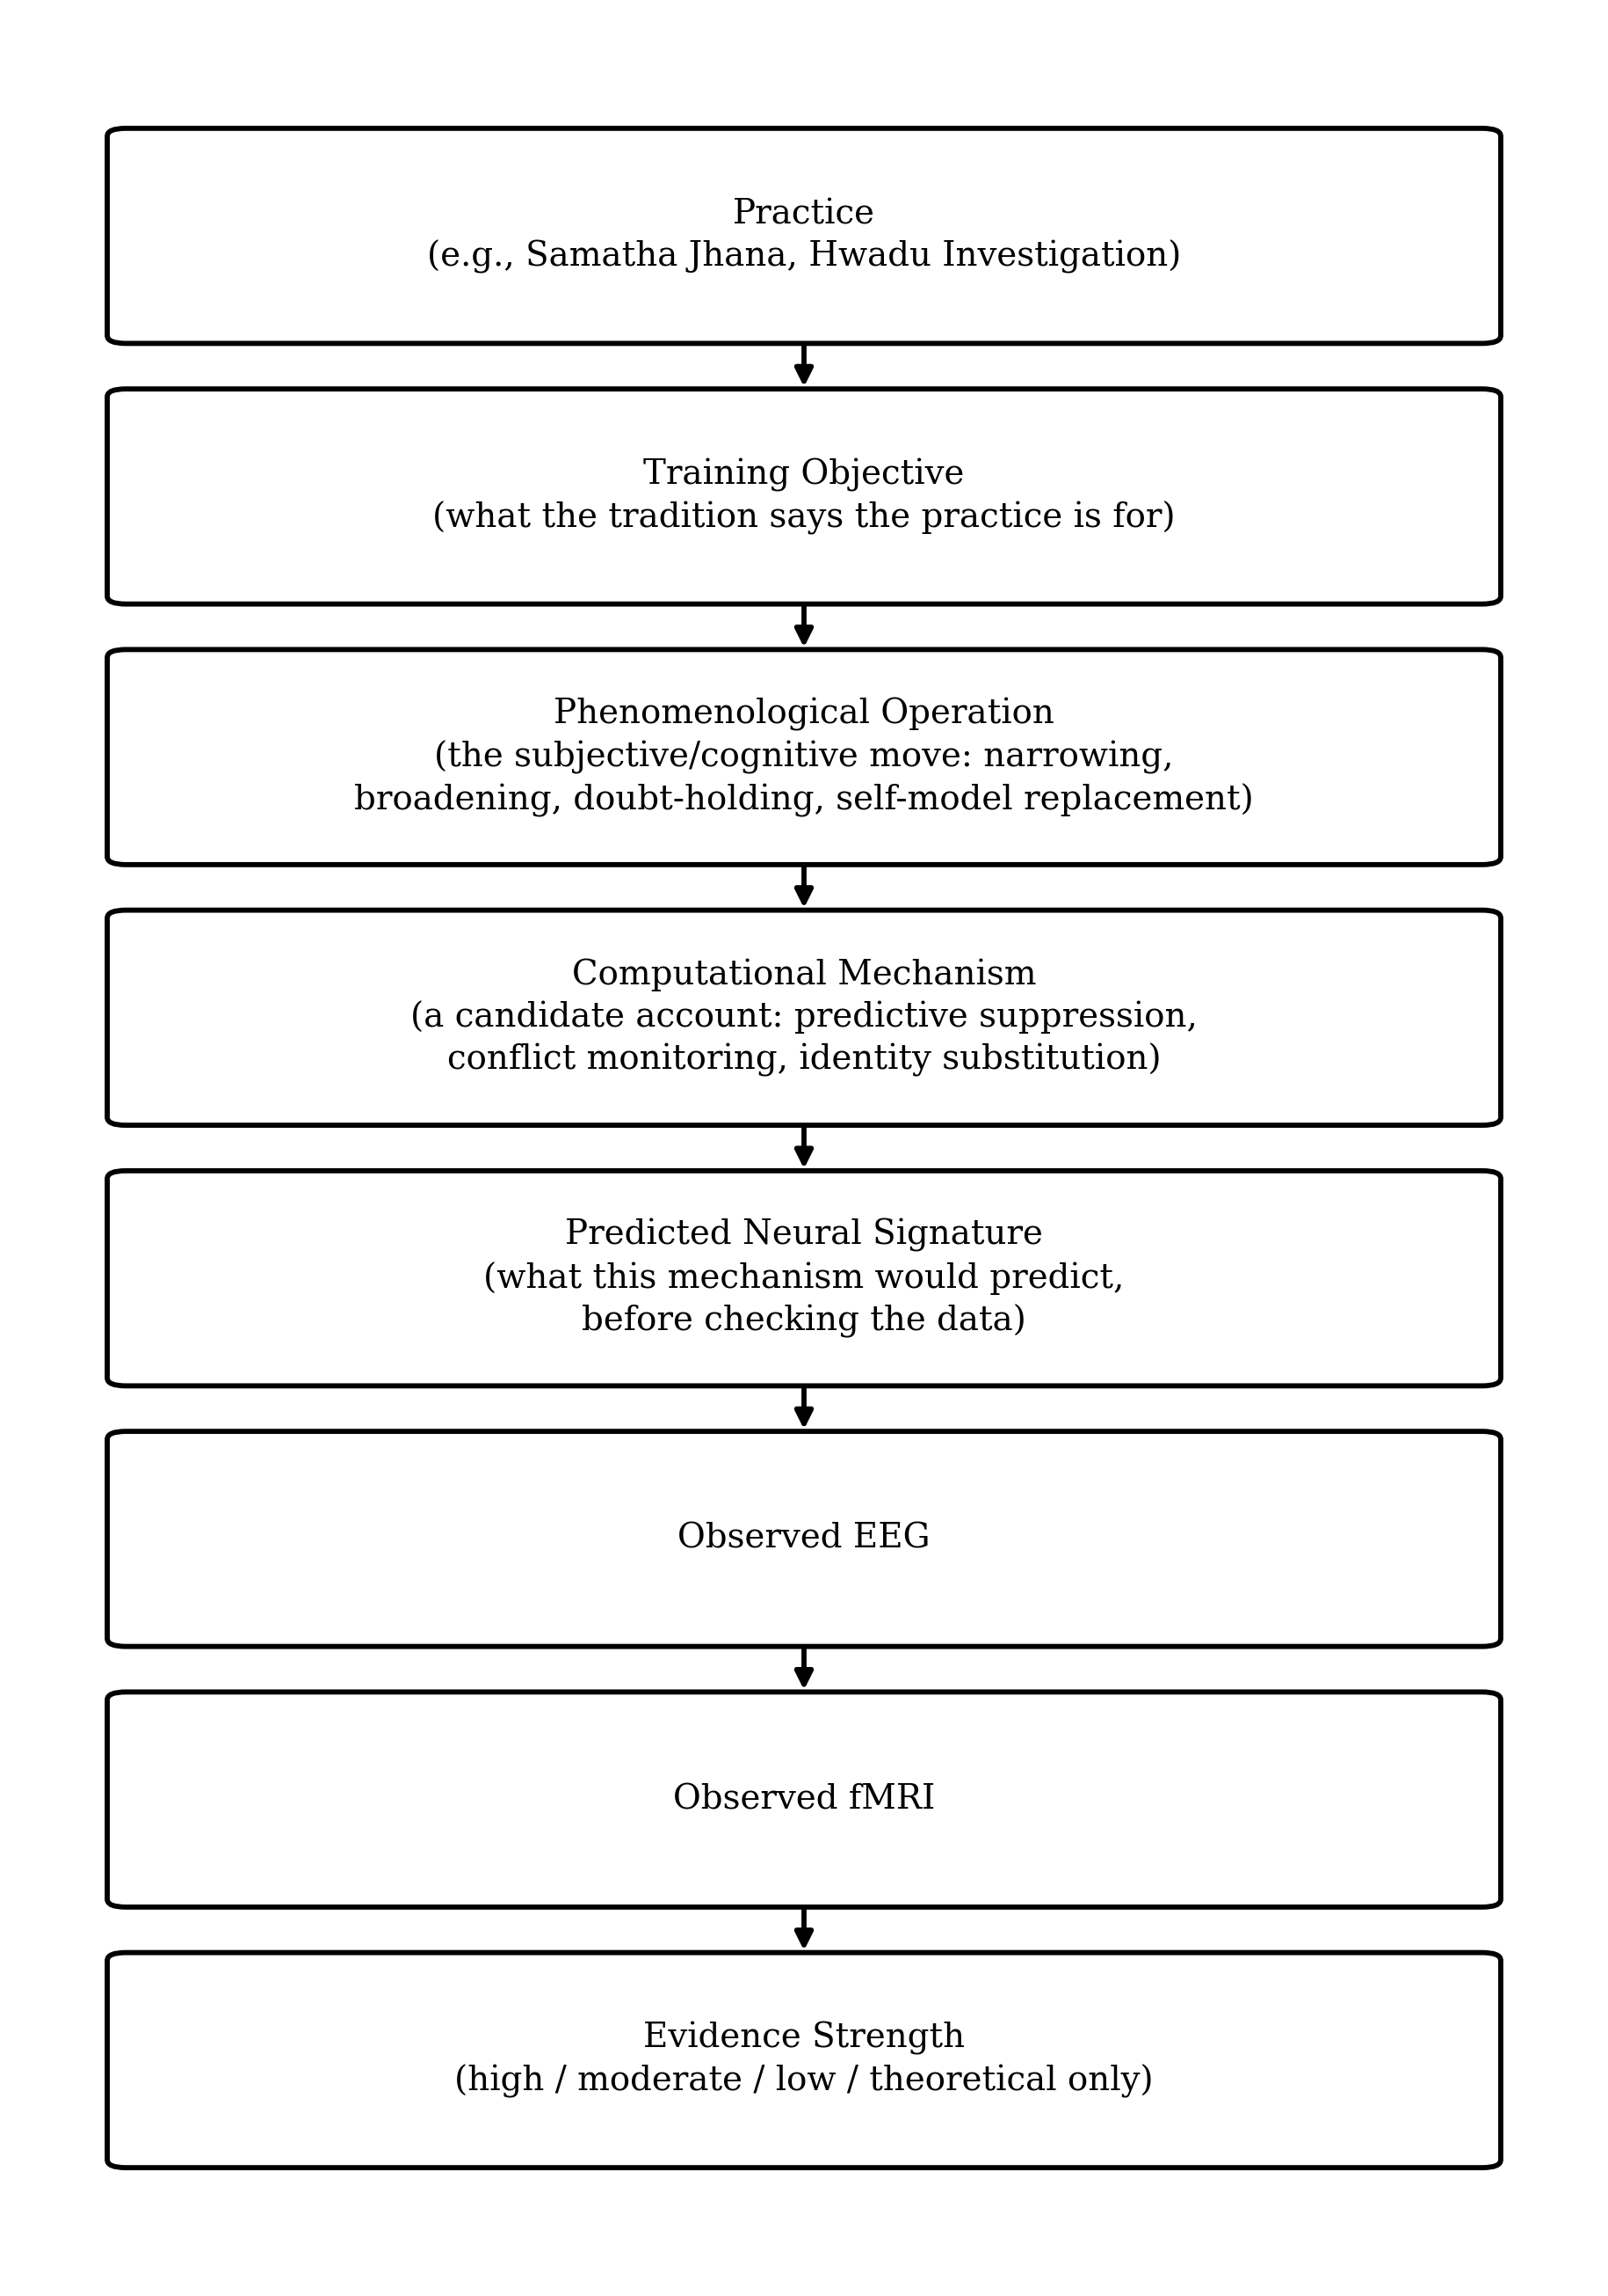
Fig. 1. The eight stage pipeline used to classify each contemplative tradition in this paper. Each stage is filled in independently, so a gap (for example, no observed EEG specific to hwadu investigation) stays visible instead of being silently patched over with a neighboring tradition's data.
C. Implementation as a Machine Readable Graph
This ontology is not only a diagram. It is implemented as an actual knowledge graph, openly available alongside this paper, with a defined schema of node types (Tradition, Practice, PhenomenologicalState, NeuralSignature, NetworkNode, CognitiveMechanism, CognitiveOperation, Citation, Finding) and edge types (including PRODUCES, CORRELATES_WITH, MEDIATED_BY, EMPLOYS, and CAVEATED_BY). Every CORRELATES_WITH, MEDIATED_BY, and EXPLAINED_BY edge carries an evidence strength rating as a queryable property, so a reader or a future researcher can filter the graph down to only its high confidence claims, or can specifically pull up every low confidence, theoretical only edge that most needs a dedicated study.
The graph also stores empirical findings as first class nodes rather than only as footnotes. The null result discussed in Section IX-C, that six traditions compared directly showed no significant EEG power difference between styles, is stored as a Finding node and connected by CAVEATED_BY edges directly to the ORTHOGONAL_TO claims it complicates. This means the caution in Section IX-C is not just a sentence a reader might skim past. It is a structural part of the ontology itself, attached to the exact claims it constrains, and any future user of the graph inherits that caution automatically rather than having to rediscover it.
D. A Third Axis for Nondual Awareness
Standard models of consciousness usually plot mental states along two axes, how alert someone is, and how much sensory content is present. This misses an important feature of unusual states [9]. We add a third axis: how far awareness has moved from an ordinary implicit sense of self toward a fully open, nondual awareness [13]. This third axis works somewhat independently of whether a person is conscious or unconscious [13]. It lets us separate dualistic experience, where there is a clear split between an observer and an object, from nondual experience, where that split fades away [6].
E. Availability, a Graph Excerpt, and Worked Queries
The graph is not only described here. It is published in full, alongside the ingestion code used to load it into FalkorDB, at github.com/joyboseroy/contemplative-neuroscience-graph. Figure 2 shows a real excerpt: the actual neighborhood of the Samatha Jhana practice node in the current graph, with every edge type and label taken directly from the underlying data rather than simplified for illustration.
As of this writing, the published graph holds 59 nodes and 42 edges. By node type, this breaks down as 8 Practice nodes, 6 Tradition nodes, 7 PhenomenologicalState nodes, 8 NeuralSignature nodes, 8 NetworkNode nodes, 4 CognitiveMechanism nodes, 8 CognitiveOperation nodes, 9 Citation nodes, and 1 Finding node. By edge type, PRACTICED_WITHIN and PRODUCES each appear 8 and 7 times, one for every practice, EMPLOYS appears 9 times across the CognitiveOperation axis, and CORRELATES_WITH appears 8 times. Of the 10 edges that carry an explicit evidence strength rating, 2 are rated high, 2 moderate, 4 low, and 2 theoretical only, a distribution that is itself a useful summary of how much of this ontology rests on solid ground versus how much is still a hypothesis waiting for a study.
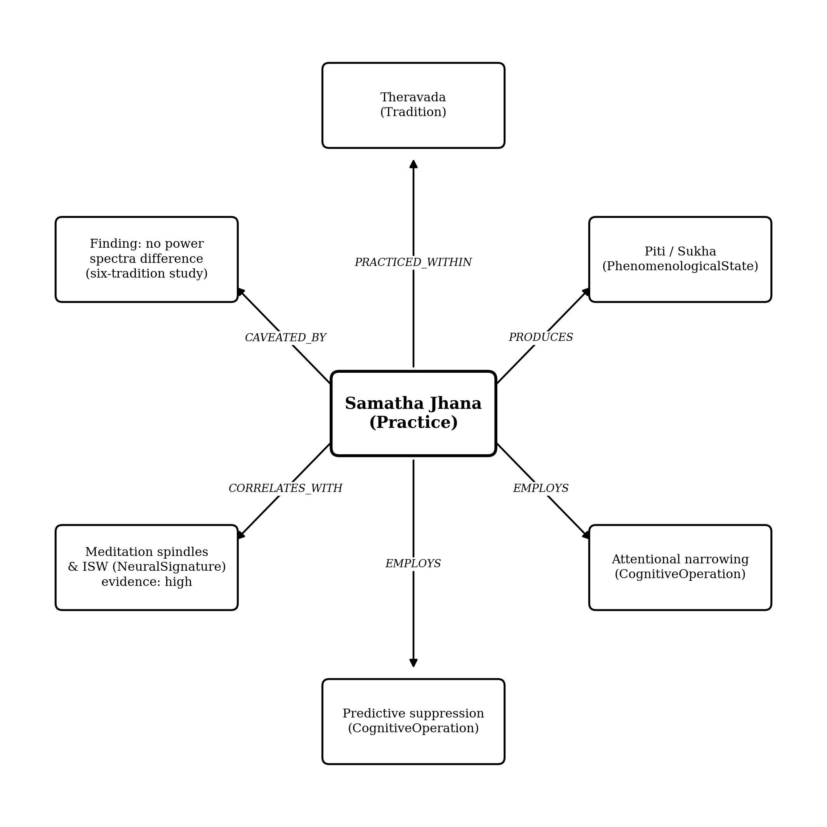
Fig. 2. An excerpt of the graph centered on Samatha Jhana, showing its real edges to a Tradition, a PhenomenologicalState, two CognitiveOperation nodes, a NeuralSignature carrying a high evidence rating, and the Finding node that caveats it. Every label shown is taken directly from the published graph, not simplified for the figure.
Three queries run against the published graph, with their actual returned results, follow.
Query 1, which practices employ predictive model suppression. Returned result: Samatha Jhana. Only one practice in the current graph is linked to this operation, which is itself informative, since it means no other tradition here is currently modeled as suppressing predictive error in this specific way, whether or not that turns out to be true empirically.
Query 2, every correlational edge rated low or theoretical only, returned in full. The graph returns four results: the link between Uisim and its still undetermined hwadu signature, rated theoretical only, and three low rated links, nembutsu to medial frontal gyrus activation, Sufi Dhikr to delta-theta entrainment, and Deity Yoga to gamma and occipital bursts. A researcher deciding where a new study would matter most could run exactly this query and get this list directly, rather than having to re-read the whole paper to reconstruct it.
Query 3, the practice most closely analogous to hwadu investigation, and at what confidence. Returned result: Vipassana, at low confidence, with the stored description noting that this is a provisional placement pending a dedicated hwadu phase EEG study, since hwadu shares Vipassana's external tracking engagement but adds an unmodeled conflict and doubt component. This is the same result obtainable by running the query directly against the live graph, shown here as text rather than a screenshot only because the underlying data is small enough to state exactly.
III. SAMATHA JHANA: DEEP CONCENTRATION AND A LOOSENING OF THE BRAIN'S USUAL HIERARCHY
A. How the Experience Unfolds
In the Theravada tradition, Samatha Jhana is a set of eight stages of deep concentration [3]. A practitioner first reaches access concentration, where attention rests steadily on something simple, often the breath, until the five main obstacles to concentration settle down [1]. Moving into the first four jhanas, the outside world starts to fade, inner speech quiets, and the felt sense of the body's boundaries can shift. Physical pleasure, called pīti, and mental happiness, called sukha, arise on their own [1]. One useful explanation is the signal to noise idea. By cutting down sensory input and mental chatter, the brain lowers its background noise. This lets an internally generated feeling of joy stand out clearly, without needing any outside reward [3].
B. What the EEG Shows
One study recorded EEG from 29 experienced Samatha meditators across 35 sessions and found three recurring patterns. Meditation spindles looked similar to sleep spindles, but appeared while people were fully alert, seen in 25 of 29 subjects. Slow, large waves near the top of the head appeared alongside feelings of pīti and sukha, seen in 21 of 29 subjects. A smaller group showed brief bursts resembling seizure activity, but fully under voluntary control, seen in 8 of 29 subjects [1]. Overall EEG power dropped across most frequency bands during jhana, while a measure of brain complexity called Lempel-Ziv complexity went up. Higher complexity was linked to a wider, more open kind of attention [18].
C. What Brain Scans Show
Brain scans show activity in the nucleus accumbens during jhana, a region tied to dopamine and opioid reward pathways [10]. Researchers ruled out simpler explanations such as muscle tension, changes in breathing, or facial movement [10], and a separate high field MRI study reproduced this pattern across several practitioners [17]. At the network level, advanced jhana states show less separation between brain regions, more overall connectivity, and a mixing together of the default mode network and the visual network [18].
IV. VIPASSANA: TRACKING THE BODY'S CHANGING SENSATIONS
A. The Experience of Tracking Impermanence
Vipassana works differently from Samatha. Instead of narrowing attention onto one object, it uses open, moment to moment tracking of bodily and mental events. The goal is direct insight into three things: impermanence, called anicca, unsatisfactoriness, called dukkha, and the absence of a fixed self, called anattā [1].
B. Brain Networks During Vipassana
Brain scans show a strong, stable opposite pattern between two systems, the dorsal attention network, which handles focused attention, and the default mode network, which is active during mind wandering and self reflection [7]. During Vipassana, attention network regions become more active while default mode regions quiet down [7], which matches what practitioners describe: a sense of effortless, undistracted awareness [7]. Long term practice also raises the resting connection between the default mode network and the salience network [19]. On EEG, Vipassana practitioners show higher fractal dimension and higher permutation entropy than they do at rest [20].
V. DZOGCHEN RIGPA: AWARENESS WITHOUT A FIXED OBJECT
A. The Experience of Rigpa
Dzogchen centers on directly recognizing rigpa, a form of nondual awareness. Practitioners describe it as open, empty, and naturally clear, something already present rather than something built through effort [2]. In this state, the usual split between an inner observer and outer objects begins to dissolve [6].
B. Two Networks Working Together Instead of Against Each Other
Normally the default mode network and the task positive network work against each other. During Dzogchen and similar nondual states, this opposition weakens, and the two systems become active together instead [4]. This seems to depend on a network centered on the precuneus, near the back of the brain, connected to a region toward the front. Together they may support a kind of self aware awareness that does not rely on mental representations [4]. Machine learning models can tell Dzogchen apart from ordinary mind wandering with over 70 percent accuracy [11].
VI. DEVOTIONAL AND DEITY PRACTICES: RHYTHM AND IDENTITY
A. Sufi Dhikr
Sufi dhikr involves repeating a name or phrase tied to the divine. Rather than cutting down sensory input, it works by shifting what feels emotionally important to the practitioner [2]. Sufi teaching describes three stages. The first is nafs, the ordinary ego, tied to self focused brain activity. The second is qalb, the heart, where a more balanced sense of what matters begins to form. The third is rūḥ, the spirit, where self focused, salience, and control networks work together more smoothly [2]. This can lead to fanā', a temporary loss of the ego structure, and baqā', a stable return with a less self centered outlook [2]. Researchers believe the steady rhythm of dhikr recitation may train slow brainwave patterns in the delta and theta range [2].
B. Vajrayana Deity Yoga
Deity yoga asks the practitioner to build a detailed mental image of a deity, then take on that identity. This resembles the well known rubber hand illusion, where the brain can be tricked into feeling ownership over something outside the body [5]. Brain scans show that this kind of visualization activates motor and visual areas in ways that overlap with actually performing the imagined movements [21]. Advanced practices such as tummo, or inner heat meditation, show brief seizure like bursts and strong high frequency gamma activity [1]. Machine learning models sort visualization practices best using a method called random forest, rather than the nearest neighbor method that works well for Samatha and Dzogchen [12].
VII. KOREAN SEON: A TRADITION WE BARELY UNDERSTAND YET
A. The Experience of Hwadu Investigation
Korean Seon, practiced in the Chogye order, is best known for hwadu investigation, part of a wider approach called kanhwa Seon. The practitioner holds a question that cannot be solved through ordinary logic, such as What is this [22]. This builds uisim, a strong and sustained sense of doubt. The doubt is meant to grow until it breaks open into a sudden insight known as gyeonseong. This is a very different mental process from either the narrow focus of Samatha or the open tracking of Vipassana, yet it is the least studied tradition covered in this paper.
B. What We Actually Know
In 1966, Kasamatsu and Hirai recorded EEG from 48 Zen priests during zazen. They found rising alpha waves, along with something unusual: a repeated sound kept triggering an alpha response instead of that response fading over time, as it normally would [22]. A more recent study of Juingong meditation, using a simple four channel EEG device, found more alpha activity than theta activity during meditation compared to mind wandering [23]. Neither study looked specifically at the hwadu stage. Both studied general seated Zen practice instead. No EEG or brain scan study has yet isolated the hwadu stage on its own, so we mark this entry as provisional in Table II.
VIII. JŌDO SHINSHŪ: A PRACTICE THAT CLAIMS TO NEED NO EFFORT
A. A Different Kind of Doctrine
Jōdo Shinshū teaches that rebirth in the Pure Land comes through tariki, or other power, meaning Amida Buddha's vow, rather than through jiriki, or self power. Reciting the nembutsu, the phrase Namu Amida Butsu, is not treated as a technique for reaching a state through effort. It is described instead as a natural expression of gratitude, called shinjin. This is quite different from every other tradition covered in this paper, all of which involve some form of trained effort.
B. The Puzzle in the Evidence
One fMRI study scanned eight well trained Japanese monks. Reciting the nembutsu activated the medial frontal gyrus, a region tied to concentration and spatial attention. Chanting sutras activated a different set of regions instead, including parts of the left frontal lobe and the right parietal lobe [24]. This activation pattern looks like an effortful, concentrated state. Yet the tradition describes nembutsu as effortless. We call this the tariki paradox and leave it unresolved, since no study has yet tracked whether this pattern changes as practitioners gain years of experience.
IX. WHERE THE EVIDENCE IS WEAK
A. Small Samples and Selective Recruitment
Many of the most detailed jhana findings come from single case studies. Even the largest EEG study cited here had only 29 participants [18]. Nearly every study recruited already advanced practitioners from specific centers, which makes it hard to say how well these findings apply to meditators in general.
B. Mismatched Equipment
Some studies used research grade EEG with many channels, or 7 tesla MRI scanners. Others used simple four channel consumer devices [23], or equipment from the 1960s [22]. Some of the differences reported between traditions could come from equipment quality rather than real differences in mental state.
C. A Direct Comparison Found No Real Difference
One study compared six traditions directly: shamatha, vipassana, zazen, dzogchen, tonglen, and visualization, all against the same mind wandering control. Brain signal complexity differed between meditation and mind wandering in general, but EEG power did not differ significantly between the six meditation styles themselves. The authors describe any style differences they found as exploratory only, not confirmed [25]. This puts a real limit on how confidently we can say these traditions are neurally distinct. The differences described in this paper may be genuine at the level of experience and doctrine, without yet being proven at the level of raw EEG signals.
D. How Much to Trust the Two New Additions
Korean Seon and Jōdo Shinshū appear in this paper as placeholders, built from the best evidence available right now. They do not yet carry the same weight of support as the four main traditions. Readers should treat the hwadu and nembutsu sections as open questions for future research, not settled conclusions.
X. PUTTING IT ALL TOGETHER
Table II brings together the brain imaging, EEG, and cognitive findings across all six traditions. The computational operation column uses the same cross tradition vocabulary as the CognitiveOperation nodes in the companion graph, so that two traditions sharing an operation (for instance, both nembutsu and dhikr using affective entrainment) are visible as such, even where their doctrines differ sharply. An honest evidence strength rating closes out each row.
Tradition | What the Experience Feels Like | Computational Operation | Brain Signature | Likely Mechanism | Evidence
Samatha Jhana | Sensory withdrawal, self generated bliss | Attentional narrowing, predictive suppression | Looser brain hierarchy, DMN and visual network mixing, spindles and slow waves, reward region activation | Weaker top down prediction, internal reward stimulation | High
Vipassana | Tracking of impermanence | Attentional broadening, metacognitive monitoring | Attention network and self focused network working against each other, higher signal complexity | Conflict monitoring, updating of body sense | High
Dzogchen Rigpa | Open awareness without a fixed object | Subject object collapse | Attention network and self focused network working together, precuneus linked network, alpha synchrony | Loss of a fixed viewpoint, self aware awareness without mental content | Moderate
Devotional / Deity | Loosening of ego, or taking on a new identity | Affective entrainment, self model replacement | Shift from ego focused to spirit stage networks, slow wave entrainment, gamma bursts in deity yoga | Rhythmic stabilization, felt ownership over a new identity | Moderate
Korean Seon (Hwadu) | Sustained doubt held toward a question | Generative doubt holding | No dedicated signature yet, general Seon practice shows more alpha activity | Predicted but untested conflict monitoring | Low
Jōdo Shinshū (Nembutsu) | Effortless entrusting, called shinjin | Affective entrainment (predicted) | Medial frontal gyrus activation, different from sutra chanting | Tariki paradox, unresolved | Low
XI. CONCLUSION
The literature reviewed here, and the representation this ontology gives it, together argue against meditation being one single brain process, rather than proving this outright through new experimental data. Samatha Jhana works by shutting out sensory input and triggering an internal reward response. Vipassana strengthens the split between attention networks and self focused networks, while keeping brain activity complex and varied. Dzogchen dissolves that same split, bringing the two networks into agreement instead. Devotional and deity practices use rhythm and mental simulation to shift what feels emotionally important, or to change the felt sense of identity. Korean Seon and Jōdo Shinshū extend this ontology into two traditions where our predictions are reasonable but not yet tested directly.
The contribution of this paper is not only the six traditions it covers, but the layered pipeline and the machine readable graph that implements it. Because each stage from practice to evidence strength is a separate, queryable part of the graph, a future researcher can extend this work by adding a new tradition without disturbing the existing ones, or can filter the whole graph down to only its high confidence claims before designing a new study. This is meant as a starting structure for a much larger effort, not a finished map.
One caution deserves the last word. The only study that compared six traditions directly found no significant difference in EEG power between styles [25], even though the traditions clearly differ in experience and doctrine. In the graph, this finding is attached directly to the claims it complicates, rather than left as a separate warning a reader might miss. Future work should study hwadu investigation on its own, and should follow nembutsu practitioners over time as their practice deepens. Researchers should also keep what the brain data actually shows clearly separate from what traditional concepts say it might mean.

REFERENCES
[1] “The Human Default Consciousness and Its Disruption: Insights From an EEG Study of Buddhist Jhāna Meditation,” Frontiers in Human Neuroscience, 2019.
[2] “Extending the Scientific Study of Advanced Meditation Across Contemplative Traditions to Sufism within Islam,” Harvard Meditation Research Program, OSF preprint.
[3] “Samatha Buddhist Meditation, EEG Study,” samatha.org.
[4] “The Neuroscience of Enlightenment,” The Psychedelic Society.
[5] “Raising the Buddha's Hand: Illusory Ownership in the Experience of Identification with a Supernatural Agent in Deity Yoga,” ResearchGate.
[6] “Neural Correlates of Nondual Awareness in Meditation,” ResearchGate.
[7] “Attention and Default Mode Network Assessments of Meditation Experience during Active Cognition and Rest,” PMC, 2021.
[8] “An Updated Classification of Meditation Methods Using Principles of Taxonomy and Systematics,” PMC, 2023.
[9] “Nondual Awareness: Consciousness-as-Such as Non-Representational Reflexivity,” ResearchGate.
[10] “Brainwave Patterns in the Jhanas,” SuttaCentral Discourse.
[11] “Classifying EEG Signals of Mind-Wandering Across Different Styles of Meditation,” TU Delft Research Portal.
[12] “EEG Analysis of Meditation Styles, Mind Wandering,” Scribd.
[13] “Implicit-Explicit Gradient of Nondual Awareness or Consciousness as Such,” Neuroscience of Consciousness, Oxford Academic, 2021.
[14] “Case Study of Ecstatic Meditation: fMRI and EEG Evidence of Self-Stimulating a Reward System,” PMC.
[15] “Low and Then High Frequency Oscillations of Distinct Right Cortical Networks are Progressively Enhanced by Medium and Long Term Satyananda Yoga Meditation Practice,” Frontiers in Human Neuroscience, 2014.
[16] “Case Study of Ecstatic Meditation,” The Open Buddhist University.
[17] “The Science of Jhana: What Research Shows,” Jhourney, 2024.
[18] A. Chowdhury, M. Bianciardi, E. Chapdelaine, O. S. Riaz, C. Timmermann, R. van Lutterveld, T. Sparby, and M. D. Sacchet, “Multimodal Neurophenomenology of Advanced Concentration Absorption Meditation: An Intensively Sampled Case Study of Jhana,” NeuroImage, vol. 305, p. 120973, 2024.
[19] J. H. Jang, W. H. Jung, D. H. Kang, M. S. Byun, S. J. Kwon, C. H. Choi, and J. S. Kwon, “Increased Default Mode Network Connectivity Associated with Meditation,” Neuroscience Letters, vol. 487, no. 3, pp. 358-362, 2011.
[20] “Meditation Induces Shifts in Neural Oscillations, Brain Complexity, and Critical Dynamics,” Neuroscience of Consciousness, Oxford Academic, 2025.
[21] “3 Totally Different Types of Visualization Meditation,” Pzizz.
[22] A. Kasamatsu and T. Hirai, “An Electroencephalographic Study on the Zen Meditation (Zazen),” Psychiatry and Clinical Neurosciences, 1966.
[23] “The Effect of Juingong Meditation on the Theta to Alpha Ratio in the Temporoparietal and Anterior Frontal EEG Recordings,” PMC, 2021.
[24] “Functional Brain Mapping During Recitation of Buddhist Scriptures and Repetition of the Namu Amida Butsu: A Study in Experienced Japanese Monks,” PubMed, 2008.
[25] J. H. Young, M. E. Arterberry, and J. P. Martin, “Contrasting Electroencephalography-Derived Entropy and Neural Oscillations With Highly Skilled Meditators,” Frontiers in Human Neuroscience, vol. 15, p. 628417, 2021.

