AegisCloud
Technical project overview
Adaptive security for simulated cloud sessions
Prepared by Praveen Sudireddy

About this document
This technical overview describes the delivered educational prototype, its architecture, synthetic experiment, test coverage and limitations. It can be adapted to an institution’s required report template. The sequence-model notebook is prepared but not trained.
Risk recommendations do not enforce access to any cloud provider, and the metrics below are not real-world attack-detection results.

Abstract
AegisCloud is a demonstration prototype combining password and second-factor authentication, authenticated encryption and machine-learning-assisted session scoring. An AES-256-GCM vault encrypts files with individual data keys protected by a local master key. An independent Shamir secret-sharing demonstration operates over GF(2⁸). A synthetic dataset of 9,000 sessions is split chronologically into 70% training, 15% validation and 15% test. User baselines and the feature vocabulary are fitted using only training rows. Four scikit-learn classifiers are compared on validation data; the selected MLPClassifier model achieves test accuracy 0.8304, success-class F1 0.8829 and ROC-AUC 0.8701 on 1,350 synthetic test sessions. The model output and deterministic rules produce an interpretable 0–100 score and suggested allow, step-up, review or block outcomes. A dashboard displays simulated traffic, a PSI distribution comparison, a model registry and an audit hash chain. These are prototype recommendations, not enforced decisions for an actual cloud provider. The current evidence does not establish real-world attack-detection performance or a deep-learning advantage.
Keywords: multi-factor authentication, AES-GCM, secret sharing, risk scoring, synthetic data, model evaluation, distribution drift.

1. Objectives and scope
- Demonstrate password hashing, revocable sessions, TOTP and recovery-code primitives.
- Protect demonstration files with AES-256-GCM envelope encryption and show tag-based tamper detection.
- Compare several classifiers using a chronological evaluation of synthetic session data.
- Explain a risk recommendation using explicit model and rule-point contributions.
- Present drift indicators, manually triggered retraining, a model registry and an audit trail.
Scope boundary: the console does not intercept actual AWS, Azure or GCP access requests; step-up, review and block are recommendations for simulated events. A separately generated Shamir share set is not connected to the vault master-key recovery process.

2. Capabilities and boundaries
Area | Prototype capability | Boundary
Identity | Password hashing, TOTP API, recovery codes and revocable sessions. | Demo OTP is shown on screen; secure delivery is not integrated.
Risk | Model output and rule points combine into an explainable recommendation. | No provider-side access enforcement or validated attack-detection claim.
Cryptography | AES-GCM envelope encryption and tamper detection. | Local master key and rotation are for demonstration only.
Secret sharing | GF(2⁸) k-of-n splitting of a supplied secret. | The demo is independent of the vault recovery workflow.
Monitoring | Synthetic replay, PSI, model registry and hash-linked audit. | Replay is not live telemetry; retraining is manual.

3. Architecture and components
Component | Implementation | Scope
Identity | scrypt, TOTP, signed revocable sessions, lockout | Demo email OTP appears in the UI; no email provider is integrated.
Vault | Per-file AES-256-GCM DEK; master-key wrapping | Local single-node key and file store.
Risk model | MLPClassifier; 37 model features | Predicts a synthetic success label.
Policy | Additive rule points + model contribution; four recommendations | No live cloud-enforcement integration.
Drift | PSI on reference and replay CSV files | Monitoring aid; retraining is manual.
Audit | Hash-linked SQLite events with an integrity checker | Tamper evidence, not cryptographic non-repudiation.

4. Design details

4.1 Authentication and sessions
Passwords are stored with per-user salts using scrypt. The seeded analyst uses RFC 6238 TOTP; other seeded demo accounts use a generated code shown on screen. Signed session tokens are backed by server-side records so that they can be revoked. TOTP enrollment and recovery-code endpoints are present, but enrollment has no dedicated console page. The demo lacks an SMTP delivery provider, phishing-resistant authentication, HTTPS termination and production-grade session controls.

4.2 Authenticated file encryption
Each uploaded file is encrypted using a random 256-bit data-encryption key and a fresh 96-bit GCM nonce. Its owner ID and file name are authenticated as associated data. The data key is wrapped with another AES-GCM operation under a local master key. Decryption checks the authentication tag and a stored SHA-256 digest. The tamper-test action modifies and restores a ciphertext byte to demonstrate detection. Key rotation and local key storage are intended only for a single-node demonstration, not production key management.

4.3 Threshold secret-sharing demonstration
Each secret byte is used as the constant of a random polynomial over GF(2⁸). Any k proper shares allow interpolation; fewer do not reveal the secret. The interface splits a user-supplied demo secret rather than the actual vault key. The share format does not carry authenticated threshold metadata: providing too few shares can produce incorrect bytes rather than a reliable explicit error.

4.4 Risk scoring and limitations
The model contributes 0.42 × 100 × (1 − P(success)). Additional rules contribute points for the chosen authentication method, failed attempts, new device, geographic anomaly, off-hours access, request rate, resource sensitivity and anomaly flags. A baseline contribution and any score-bound adjustment are included, so displayed contributions sum to the score in the range 0–100. Base demo thresholds are 38, 64 and 82; they may shift using the scored subject’s prior recorded risk. These are prototype heuristics, not validated safety guarantees or actual enforcement policies.
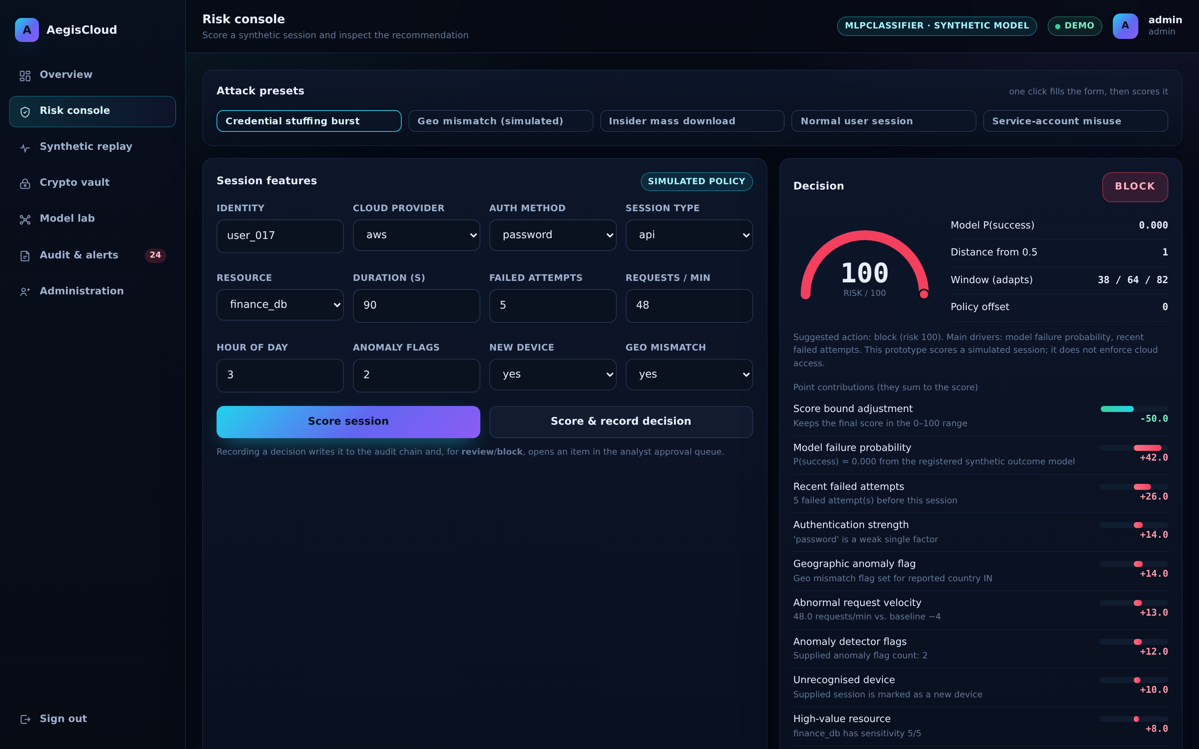
Figure 1. Example simulated session and additive score explanation.

5. Data and experimental method
The supplied generator creates 9,000 synthetic multi-cloud sessions and an additional 2,500-row replay corpus with a different distribution. Features and synthetic outcomes are generated together; therefore these results evaluate that generator, not real cloud telemetry or attacker behavior. The outcome is success = 1 and failure = 0.
The training pipeline orders rows by timestamp and partitions them into 6,300 training, 1,350 validation and 1,350 test sessions. User-duration statistics and category columns are learned on the training split; unseen users use training-wide statistics. Four candidates are compared at threshold 0.50 on validation. The highest validation success-class F1 is selected, then its probability threshold is tuned on validation to maximize that F1 subject to success-class recall at least 0.80. Finally the selected model is assessed on the chronologically later test block.

5.1 Validation candidate comparison
Candidate | Accuracy | Precision¹ | Recall¹ | F1¹ | ROC-AUC
MLPClassifier * | 0.8007 | 0.8359 | 0.8687 | 0.8520 | 0.8661
RandomForest | 0.7933 | 0.8385 | 0.8507 | 0.8446 | 0.8524
HistGradientBoosting | 0.7874 | 0.8199 | 0.8687 | 0.8436 | 0.8496
LogisticRegression | 0.7867 | 0.8831 | 0.7800 | 0.8284 | 0.8738

Table 1. Validation results at threshold 0.50; * selected before threshold tuning. ¹ Success class.

5.2 Selected model: final synthetic test block
Measure | Value
Model / version | MLPClassifier / v20261105-001233-6a9a
Test rows / selected threshold | 1,350 / 0.44
Accuracy | 0.8304
Success precision / recall / F1 | 0.8387 / 0.9320 / 0.8829
Failure recall (specificity) | 0.6085
ROC-AUC / Brier score | 0.8701 / 0.1292
Confusion matrix [TN, FP; FN, TP] | [258, 166; 63, 863]

Failure recall is TN/(TN+FP) because failure is encoded as class 0. Success recall is TP/(TP+FN). Neither quantity is a validated real-world attack-detection rate. Brier score measures mean squared probability error; by itself it does not prove calibration. A reliability plot and independent real-world data are needed for stronger claims.
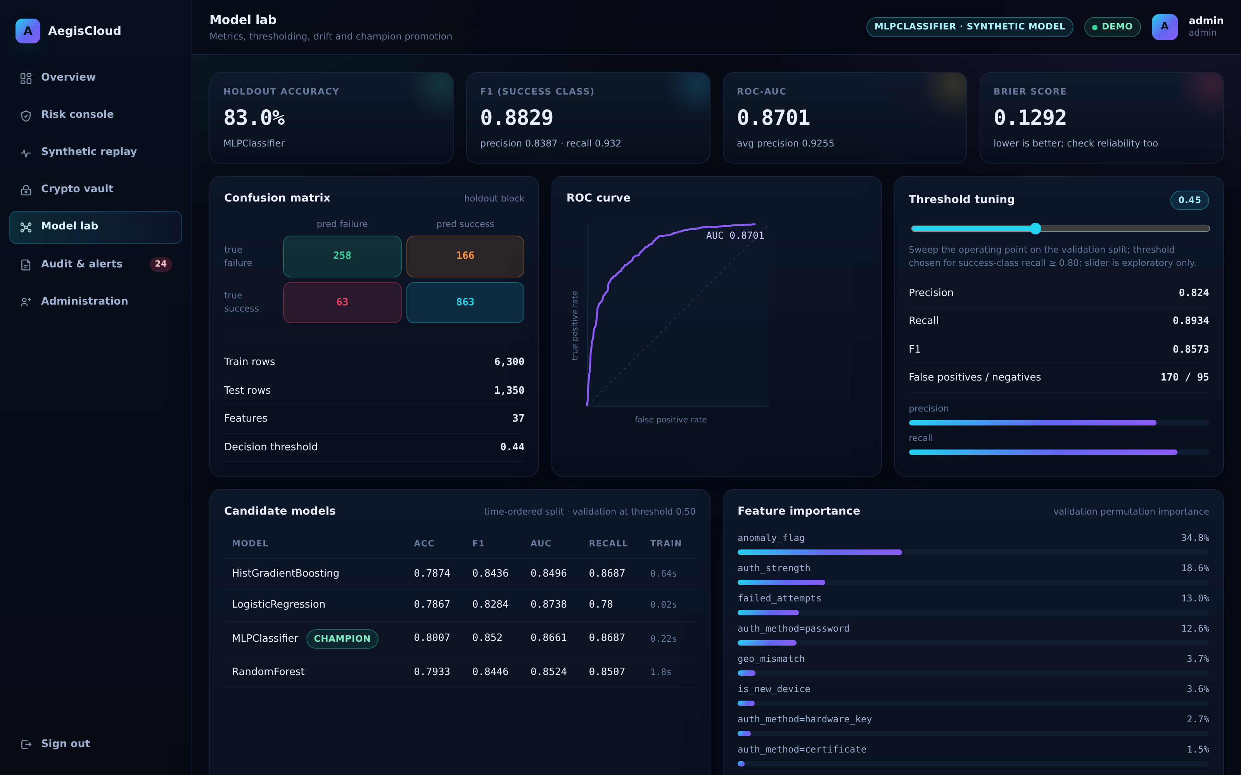
Figure 2. Model lab: test metrics and validation-based model comparison.

6. Drift and retraining
The PSI screen compares the synthetic training CSV with the supplied synthetic replay CSV, not live provider telemetry. PSI values from 0.10 to below 0.25 are labelled watch, and values at or above 0.25 are labelled drift. In this snapshot request rate and failed attempts are in the watch band. An operator can manually retrain and promote a model. The current retraining job reuses the reference CSV; recorded analyst feedback is not yet incorporated into model training.

7. Testing and demonstration
At the time of this report, the isolated pytest suite reports 26 passing tests. The tests cover GF arithmetic, threshold reconstruction, vault integrity, share-link limits and concurrency, password hashing, TOTP vectors, session authorization and revocation, audit-chain consistency under concurrent writes, drift bins, training-only baseline handling and risk-score contributions. The test suite uses a temporary DB and vault rather than the running demo’s storage.
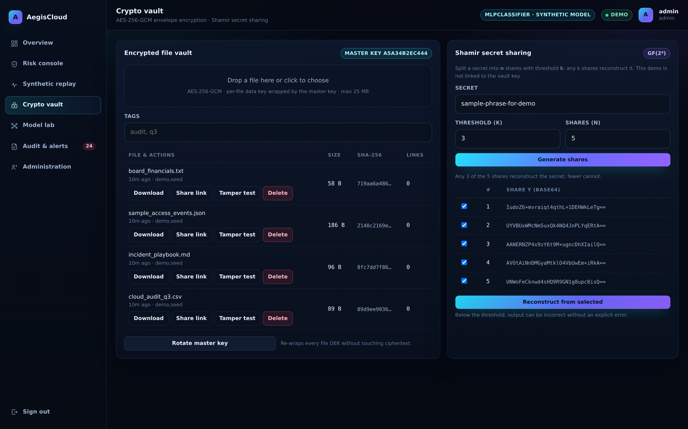
Figure 3. Local demo vault and a separate secret-sharing demonstration.

Suggested demonstration sequence
- Sign in with the seeded demo account and enter the on-screen demo OTP.
- Compare the normal and credential-stuffing presets; point out that outcomes are recommendations.
- Replay synthetic traffic and show the PSI comparison and validation/test metrics.
- Upload and download a test file, then run the vault tamper test.
- Split a demo string 3-of-5: three shares reconstruct; two may produce invalid text rather than an explicit error.
- Verify the audit chain and show the manual model-retraining control.

8. Conclusion and future work
AegisCloud demonstrates how authentication, authenticated encryption, synthetic session scoring and an auditable interface can be combined in one educational prototype. The experiment supports the reported synthetic-data metrics but does not show a real-world security benefit or production readiness. The companion Colab notebook provides a sequence-model experiment to run, not precomputed LSTM or CNN findings.
- Evaluate on independently sourced, properly consented real telemetry with threat-labelled data.
- Integrate provider-side policy enforcement and design an actual approval separation-of-duties control.
- Implement secure OTP delivery, phishing-resistant MFA, HTTPS, rate limiting and managed secrets.
- Connect protected key recovery to a KMS/HSM with an authenticated, tested recovery protocol.
- Validate calibration and define false-positive/false-negative costs before selecting operating thresholds.
- Implement a reviewed, versioned feedback-ingestion pipeline and reevaluate drift on live windows.

Selected references
- NIST SP 800-207, Zero Trust Architecture, 2020. https://csrc.nist.gov/pubs/sp/800/207/final
- NIST SP 800-38D, Galois/Counter Mode (GCM), 2007. https://csrc.nist.gov/pubs/sp/800/38/d/final
- D. M’Raihi et al., RFC 6238: TOTP, 2011. https://www.rfc-editor.org/rfc/rfc6238
- A. Shamir, “How to Share a Secret,” Communications of the ACM, 1979. https://doi.org/10.1145/359168.359176

