Object | Data Engineer Code Assessment
Participant | Joyce Chan
Status | Imcompleted

Overview
The goal of this exercise is to build a complete end-to-end ETL pipeline using Python. I’m given data from the SpaceX API, and provided API https://pipeworx.io/blog/spacex-api-revived/. The main technical stack are Apache Airflow, DBT, docker and duckdb.
Pre-requisite
- Ubuntu: https://ubuntu.com/tutorials/install-ubuntu-desktop
- Docker desktop: https://docs.docker.com/desktop/setup/install/windows-install/
Step of install Airflow
Step1:
- Open Ubuntu to install apache airflow composer
curl -LfO 'https://airflow.apache.org/docs/apache-airflow/3.3.0/docker-compose.yaml
Step2:
Enable WSL integration & Ubuntu in docker desktop
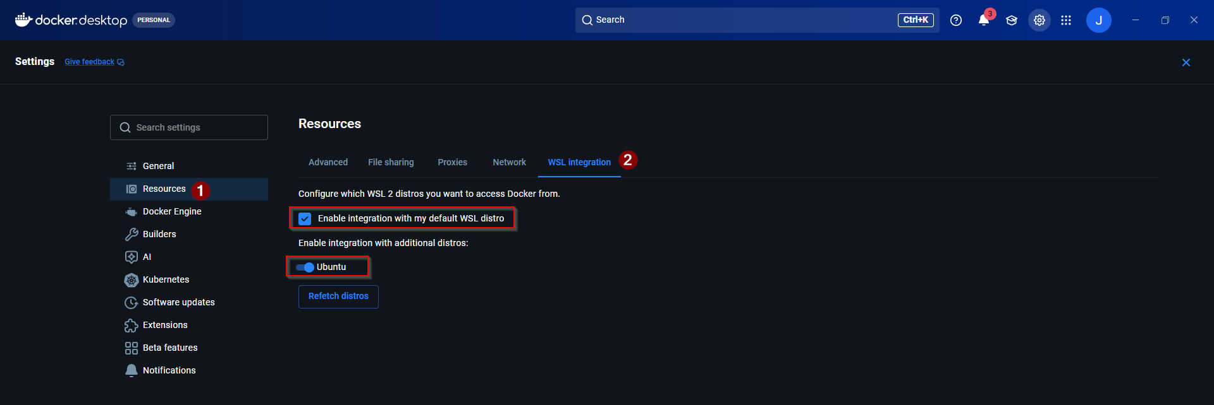
Step3:
- Create .env file at your airflow project location
AIRFLOW_UID=50000
FERNET_KEY=...
_AIRFLOW_WWW_USER_USERNAME=admin
_AIRFLOW_WWW_USER_PASSWORD=admin
** generate fernet_key by running this command in powershell
python -c "from cryptography.fernet import Fernet; print(Fernet.generate_key().decode())"
Step4:
- Init airflow storage database and update docker compose yml
- docker compose up airflow-init
- sudo apt install curl -y
- mkdir -p ./dags ./logs ./plugins ./config

Docker compose yml from
volumes:
- ${AIRFLOW_PROJ_DIR:-.}/dags:/opt/airflow/dags
- ${AIRFLOW_PROJ_DIR:-.}/logs:/opt/airflow/logs
- ${AIRFLOW_PROJ_DIR:-.}/config:/opt/airflow/config
- ${AIRFLOW_PROJ_DIR:-.}/plugins:/opt/airflow/plugins
To
Mount folder to share though among docker container simultaneously (e.g., Airflow webserver, scheduler, and worker containers can all read and write to the dags folder at the same time)
volumes:
- ${AIRFLOW_PROJ_DIR:-.}/dags:/opt/airflow/dags:z
- ${AIRFLOW_PROJ_DIR:-.}/logs:/opt/airflow/logs:z
- ${AIRFLOW_PROJ_DIR:-.}/config:/opt/airflow/config:z
- ${AIRFLOW_PROJ_DIR:-.}/plugins:/opt/airflow/plugins:z

Step5:
- start airflow
docker compose up
Step 6: add airflow variable
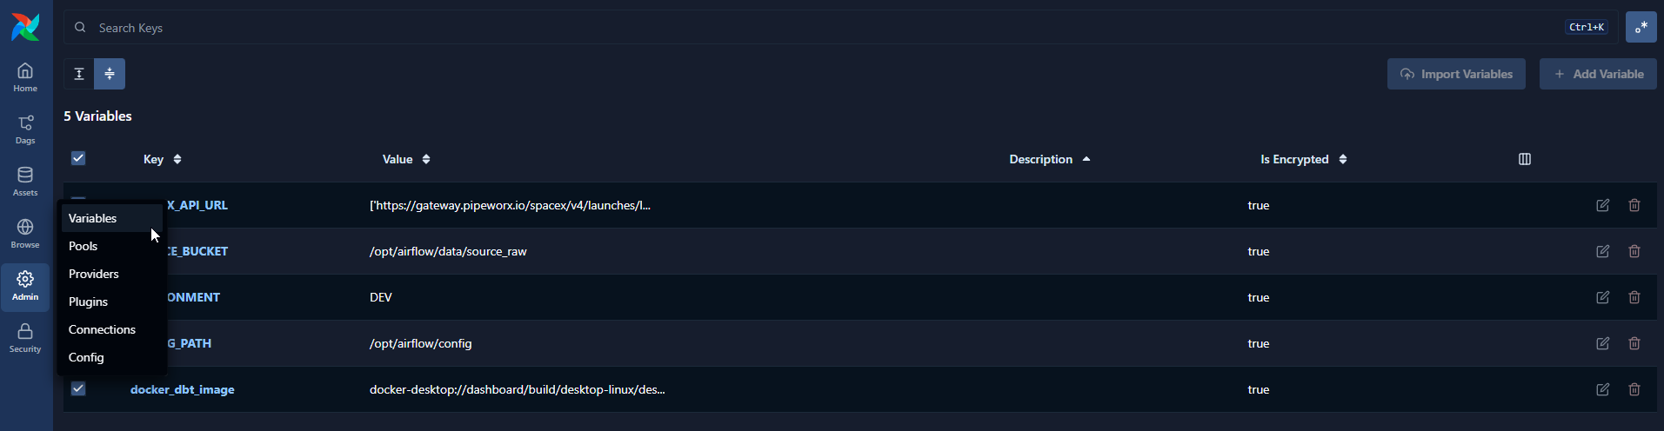
key | value
SOURCE_BUCKET | /opt/airflow/data/source_raw
ENVIRONMENT | DEV
CONFIG_PATH | /opt/airflow/config
docker_dbt_image | docker-desktop://dashboard/build/desktop-linux/desktop-linux/hzj3tiuqc3vc7jwcc7dpws2cv
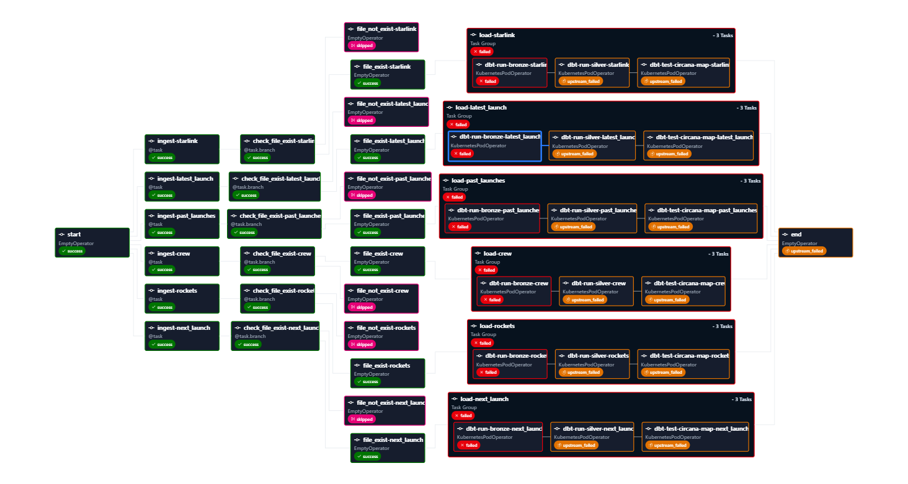
Workflow Design

I would like to apologize for the task failure dbt task because I’m not familiar to setup Kubernetes pod to host dbt docket image to run the dbt command, this is newer area of development work for me. In my previous company, most of the devops development will be done by software engineer. I’m always seeking for the opportunity to learn end to end pipeline development. I’m sorry that I’m not able to resolve the Kubernetes pod operator. But I will roughly share the load and transformation parts. Thanks.

Folder structure:
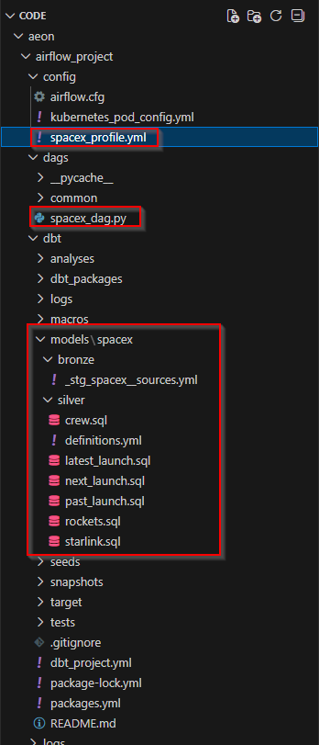

Description | Path
Dag py file | ..\aeon\airflow_project\dags\spacex_dag.py
Config variable setting | ..\aeon\airflow_project\config\spacex_profile.yml
Setup bronze layer table | ..\aeon\airflow_project\dbt\models\spacex\bronze\_stg_spacex__sources.yml
Silver layer, table and models | …\aeon\airflow_project\dbt\models\spacex\silver

`intakeDate` string matching Airflow's execution date (`kwargs["ds"]`) is passed from the orchestrator into the dbt compilation scope.

Downstream Silver staging models are built using an `incremental` materialization with an `insert+delete` strategy. This sets up a **Delete-and-Insert** data structure: if an execution block for a specific date is re-triggered, previous historical entries for that partition are atomically dropped before the fresh records are merged, preventing duplicate values.
Improvement & suggestion:
- Add dbt test before the staging table refresh
- add release id for all the entity, easy to trace record and data governance purposing.

