Joyce Chen CS31 Project 2 Report (Dis 2A)

In this project, one difficulty I had was figuring out how to structure the if statements in order to meet all the requirements for the income tax calculation. There were plenty of ways I could have written out the code, like adding an if statement for every single requirement – however, that would create too many nested if-else statements which would not be optimal. Some ways I thought of structuring the code included having a conditional block for each income bracket as shown in the picture below (< $55,000, < $125,000, and > $125,000): 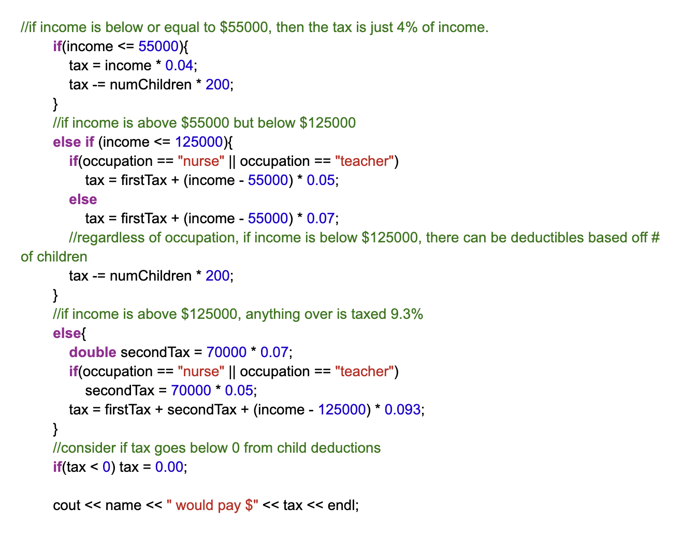

I ended up using a structure that divided the tax into 3 subsets – the 4% tax on the first $55000, then the 5% or 7% tax on the next $70000, and finally the 9.3% tax on the rest of the income. Based on the taxpayer’s income bracket, I calculated what their tax for each of the subsets would be and finally added all 3 subsets together to obtain the total tax they’d have to pay. In addition, I found it slightly challenging to take care of the corner cases, such as what would happen when the tax exemption amount (from # of children) exceeded the income. I eventually added some conditional statements to the end of my code to handle these cases.

Test cases:

* Income of $50,000 (under $55,000)
  + Lowest income bracket test; see if total tax would be just 4% of the income
* Income of $100,000.09, occupation teacher, 2 kids
  + Middle income bracket test; see if taxpayer will be taxed 5% for the 2nd subset and $400 exempt, and if tax will be truncated to 2 decimal places
* Income of $150,789.90 (over $125,000), occupation is teacher
  + Highest income bracket test; see if taxpayer will be taxed 4% for 1st subset, 5% for 2nd subset, and 9.3% for the rest of their income
* Income of $55,000, 1 kid
  + Corner case test (exactly $55k); ensure that no additional tax will be applied besides the 4%
* Income of $125,000
  + Corner case test (exactly $125k); ensure that 9.3% tax is not applied
* Income of $25,000 (under $50,000), occupation is nurse, 3 kids
  + Test for child tax deduction in lowest income bracket & no benefits due to occupation
* Income of $123,456 (under $125,000), occupation is nurse
  + See if 5%, not 7% tax is applied to all the income above $55k
* Income of $123,456 (under $125,000), occupation is nurse, 5 kids
  + Test to ensure that tax reduction is applied for the kids
* Income of $198,456 (over $125,000), occupation is nurse, 5 kids
  + Ensure that tax reduction is not applied for the kids, and that secondary tax is 5% (not 7%) due to occupation
* Income under $125,000 and amount of deductible from children is greater than income
  + Corner case test to ensure that tax doesn’t go below $0.00, because negative tax wouldn’t make sense. If deductible is greater than income, the tax should just be $0.00.
* Income of $0 and occupation is nurse
  + See if $0 income results in $0 tax (no income = no tax)
* Didn’t enter a name or occupation, put a negative number of kids
  + Test for invalid inputs – should return the phrase “You must enter a name” or for whichever came invalid input first after the 3 hyphens
* Entered negative number for income
  + Test for invalid income input – should return an error message if that was the first problem that occurred in the input