# Factorial

Factorial of N

* N * (N-1) * (N-2) * …… 1
* **5**
  + 5 * 4 * 3 * 2 * 1
* 7
  + 7 * 6 * 5 * 4 * 3 * 2 * 1
* With every iteration
  + Multiplication
  + Number moves in decreasing order

| **Iteration** | **Current Value** | **Previous Value (Result)** | **IterationResult** |  |
| --- | --- | --- | --- | --- |
|  |  |  | CurrentValue *  PreviousValue |  |
| 1 | **5** | DefaultValue  **1** | 5 * 1 = **5** |  |
| 2 | **4** | **5** | 4 * 5 = **20** |  |
| 3 | **3** | **20** | 3 * 20 = **60** |  |
| 4 | **2** | **60** | 2 * 60 = **120** |  |
| 5 | **1** | **120** | 1 * 120 = **120** |  |

# 

# 

# 

# 

# Multiplication Table

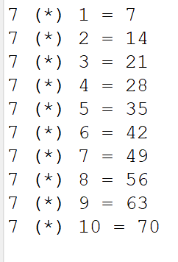

Fixed Value

* Given number N -> 7

Varying values

* No of Times -> 1 to 10 or 1 to 12
* Result or Product

Formatted printing

Scanner

* Use scanner for reading user input -> N

# 

# 

# 

# 

# Fibonacci Series

Every number -> sum of prev 2 numbers

0, 1, 1, 2, 3, 5, 8, 13, 21, 34 and so on….

| IterationNo | FirstNo | SecondNo | SummedNo |
| --- | --- | --- | --- |
| 3 | 0 | **1** | **1** |
| 4 | **1** | **1** | **2** |
| 5 | **1** | **2** | 3 |
| 6 | 2 | 3 | 5 |
| 7 | 3 | 5 | 8 |
|  |  |  |  |
|  |  |  |  |

# 

# 

# 