Data Analytics, May 15 2026, Spring 2026
2026-05-15
# This is the homework assignment on FPKMdatasets.
# Data Analytics, May 15 2026, Spring 2026
# J. H. Williams ver .1
# Filename: 2026may15workingwithfkpm.R
# 1. Load the data (assuming they are tab or space separated)
# Note: adjust the path if your files are in a specific folder
rep1 <- read.table("~/Documents/2026May15/Assignment2/rep1.fpkm", header=TRUE)
rep2 <- read.table("~/Documents/2026May15/Assignment2/rep2.fpkm", header=TRUE)
# 2. Extract column 10 and apply log10 transformation
log_fpkm_rep1 <- log10(rep1[, 10] + 0.01)
log_fpkm_rep2 <- log10(rep2[, 10] + 0.01)
# 3. Calculate the Pearson correlation coefficient
cor_coef <- cor(log_fpkm_rep1, log_fpkm_rep2, method = "pearson")
# 4. Make the scatterplot
plot(log_fpkm_rep1, log_fpkm_rep2,
main = paste("Log10 FPKM Comparison\nCorrelation (r) =", round(cor_coef, 3)),
xlab = "Log10 FPKM (Replicate 1)",
ylab = "Log10 FPKM (Replicate 2)",
pch = 16, # Solid circle points
col = "purple") # Point color
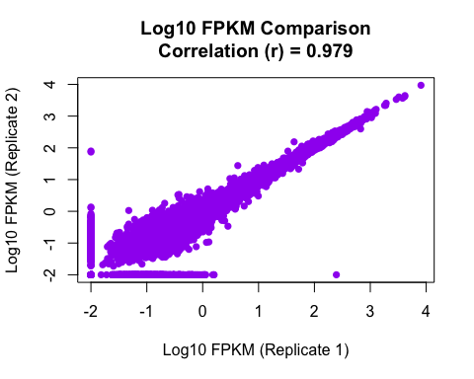
# 5. Generate the boxplots
boxplot(log_fpkm_rep1, log_fpkm_rep2,
names = c("Replicate 1", "Replicate 2"),
main = "Distribution of Log10 FPKM Values",
ylab = "Log10 FPKM",
col = c("lightblue", "lightgreen"))
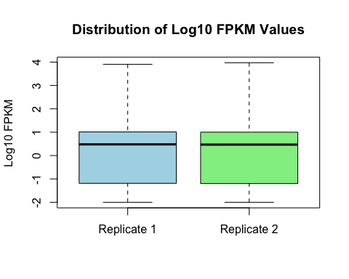
dev.off()
## null device
## 1

