Raft Framework User Guide(V1.0)

James Deng/Cheng Chi

Raft framework project folder structure overview 2
Project folder/files description 2
Test case Management,Execution (TestNG) 3
How to run a test class(all of its method) 3
How to test only one method 3
How to run multiple rounds of one test method 4
How to set running timeout of a test method 4
How to run multiple xml file suites 4
How to config cross module config.xml 4
Control Your WebDriver 5
How to get a WebDriver(No logging functionality) 5
How to get a WebDriverPlus(which accompanied by logging, report function) 6
How to get real IE/Firefox/Chrome/... browser webdriver instance 6
How to judge browser type 6
Load parameters 6
Assertion utilities 7
How to control global rounds of test suites running 7
How can I get browser page screenshot 8
Appendix 8
How to run multiple test methods concurrently? 8
Will framewok quit the running webdriver when webdriver occure exception or failed? 9
What is browserKillerTimeout? 9
What is autoBrowserKiller? 9
If I do not want to take screen shot, what should I do ? 9
What kind of Logging info do we have currently? 9
How to Add your own Apis? 10

Raft framework project folder structure overview

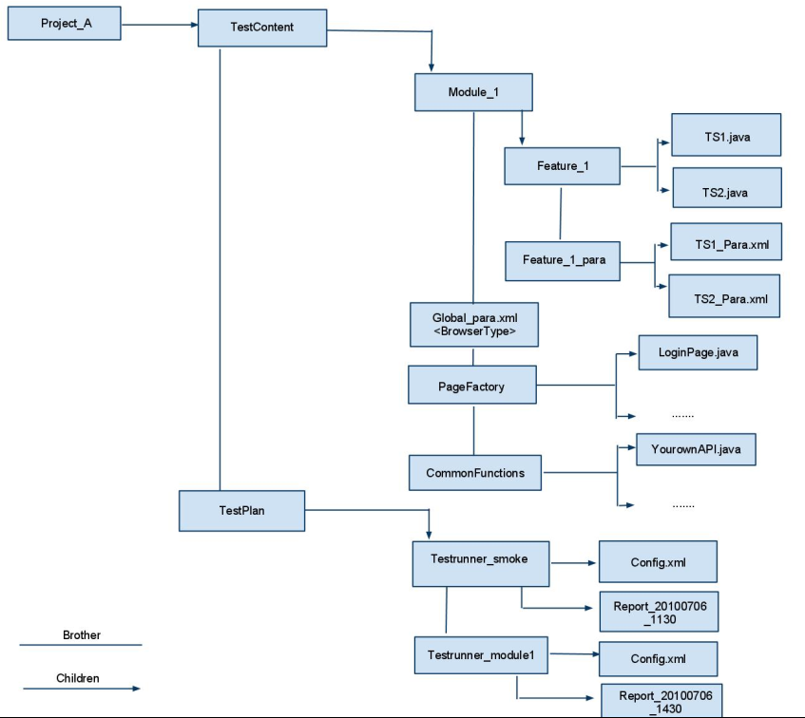

Project folder/files description

TestContent folder store your test suite/test cases/local test parameter and other java files: commonapi, page factory, global parameters)
TestPlan folder store your test plan
Classes folder store all the testing class files, globalPara.xml, …
Lib folder store all webdriver necessary jar(s) and testng jar(s), raft-xx.xx.jar, …
TestRunner_Module/ TestRunner_Cross_Module folder store test plan runner, config, report files
Runner.bat launch raft framework and start your test
Config.xml testng configuration file
Log.txt output of Runner.bat
Report_XXX report for each Test module
Logs: Log output for each test case(method)
Screenshots: Taking screen shot on Exception/failed case
Html reports: Summary report and detail test case report
…

Test case Management,Execution (TestNG)

How to run a test class(all of its method)

config your config.xml file like this:
<!DOCTYPE suite SYSTEM "http://testng.org/testng-1.0.dtd" >
<suite name="Suite Demo" verbose="1" >
<test name="Test Demo">
<classes>
<class name="demo.Demo" />
</classes>
</test>
</suite>

How to pick up a few methods to run

config your config.xml file like this:
<!DOCTYPE suite SYSTEM "http://testng.org/testng-1.0.dtd" >
<suite name="Suite Demo" verbose="1" >
<test name="Test Demo">
<classes>
<class name="demo.Demo">
<methods>
<include name="test1" />
<include name="test2" />
</methods>
< /class>
<class name="demo.Demo2">
<methods>
<include name="try1" /> <include name="try2" />
</methods>
< /class>
</classes>
</test>
</suite>

How to run multiple rounds of one test method

add an attribute on @Test annotation
@Test(invocationCount = 2)
public void test1() {
…}

How to set running timeout of a test method

add an attribute on @Test annotation
@Test(timeOut = 10000)
public void test1() {
…}

notice: timeout means the maximum time in milliseconds this test will take.

How to run multiple xml file suites
Solution1:
modify your Runner.bat →
java -cp ..\Classes;..\lib\*; raft.engine.TestEngine ..\Classes ..\Classes\globalParam.xml smoke.xml,uat.xml > log.txt

Solution2:
refer to “6.How to config cross module config.xml”

How to config cross module config.xml

config your config.xml file like this:

<!DOCTYPE suite SYSTEM "http://testng.org/testng-1.0.dtd" > <suite name="Suite1" verbose="1" > <test name="test1">
<classes>
<class name="module1.feature1.TS1" />
</classes>
</test>

<test name="test2">
<classes>
<class name="module2.feature2.TS3" />
</classes>
</test>

</suite>

or:

<!DOCTYPE suite SYSTEM "http://testng.org/testng-1.0.dtd" >
<suite name="Suite1" verbose="1" >
<test name="test1">
<classes>
<class name="module1.feature1.TS1" />
</classes>
</test>

<test name="test2">
<parameter name="testngFile" value="TestRunner_Module2\Config.xml" />
</test>
</suite>

notice: name=”testngFile” will tell framework to treat the following value specified xml file as a testng configuration file. value=”XXX” XXX is the path of a testng configuration file

Control Your WebDriver

How to get a WebDriver(No logging functionality)

you can use:
WebDriver driver = new FirefoxDriver();
or:
FirefoxDriver dirver = new FirefoxDriver();
or:
WebDriver driver = WebDriverBasic.newWebDriverInstance(“Firefox”);
or:
WebDriver driver = WebDriverBasic.newWebDriverInstance(LoadPara.getGlobalParam("browser"));

notice: LoadPara refer “5. Load parameters”

How to get a WebDriverPlus(which accompanied by logging, report function)

WebDriverPlus driver = WebDriverPlus.newWebDriverPlusInstance(LoadPara.getGlobalParam("browser"));
or
WebDriver driver = WebDriverPlus.newWebDriverPlusInstance(LoadPara.getGlobalParam("browser"));

How to get real IE/Firefox/Chrome/... browser webdriver instance

WebDriverPlus driver = WebDriverPlus.newWebDriverPlusInstance(LoadPara.getGlobalParam("browser"));

// driverType now is actual IE/FF/Chorme/… browser webdriver instance.
WebDriver driverType = driver.getBrowserType();

How to judge browser type

WebDriverPlus driver = WebDriverPlus.newWebDriverPlusInstance(LoadPara.getGlobalParam("browser"));
if( driver.isIE() ) {
//do sometiong
} else if (drver.isFirefox()) {
//do sometiong else
} …

Load parameters
Global parameters: all .java files of your test cases can share these parameters
Local parameters: one .java file has one corresponding .xml data file(they must have the same file name), only this .java can access the parameters of the mapping .xml data file.
a)global parameters
parameters stored at “globalPara.xml”
format is like:
<data>
<var name="browser">Firefox</var>
<var name="globalList">gv1,gv2</var>
</data>

b)local parameters
must ensure you put the xml file with right name and right place.
suppose we have TS1.java, class is module1.feature1.TS1, then the mapping local parameter file should be TS1.xml and it should be under module1\feature1_para folder.
the format is also like:
<data>
<var name="browser">Firefox</var>
<var name="globalList">gv1,gv2</var>
</data>

now we support:
String getGlobal/LocalParam(String name)
int getGlobal/LocalParamInt(String name)
String[] getGlobal/LocalParamArray(String name)

notice: when reading a list/array, default separator is “,”, also enable user to define the separator string like this:
<var name="arraySeparator">|</var>

global parameters when reading to a list/arry, will first search the arraySeparator’s setting under “globalPara.xml”, if not found, use default value “,”
local parameters when reading to a list/arry, will first search the arraySeparator’s setting under its own xml data file, if not found, search arraySeparator’s setting under “globalPara.xml”, if not found, use default value “,”

Assertion utilities

provide some utilities:
1)public static boolean hasText(WebDriver driver, String text) //whether the page contain the text.
2) public static boolean matchText(WebDriver driver, String regex) // whether the page contain the text with a regular expression.
3) public static boolean hasElement(WebDriver driver, By by) //whether the page contains the WebElement

Samples:
assertTrue(Assertion.hasText(driver, "XX Page"),"A Page expected, but failed.");
assertTrue(Assertion.matchText(driver, "^Title$"),"A Page expected, but failed.");
assertTrue(Assertion.hasElement(driver,By.partialLinkText(facilityname)),"A Page expected, but failed.");

How to control global rounds of test suites running

modify globalRunCount in globalPara.xml file like this:
add an item:
<var name="globalRunCount">2</var> //notice: defaut is 1, can be 0, 1, 2, …

How can I get browser page screenshot

So, if webdriver exception occurs, such as “driver.findElement(By.linkText("download test4")); “ and “download test4” actually not exist, we will take a browser page screenshot.

if testing method failed (such as assertion fail or java exception thrown), if driver not closed/quit, we will take a browser page screenshot.

The browser page screenshot file can be found under Report_XXX\screenshots folder, and the full path of the file can be found in the log_XXX.txt file.

Appendix

How to run multiple test methods concurrently?

It contains two steps
a)ensure your test case is like:
@Test
public void t1() {
WebDriverPlus driver = WebDriverPlus.newWebDriverPlusInstance(LoadPara.getGlobalParam("browser"));
…
quit.quit();
}

@Test
public void t2() {
WebDriverPlus driver = WebDriverPlus.newWebDriverPlusInstance(LoadPara.getGlobalParam("browser"));
…
quit.quit();
}

b) modify your Config.xml under your test plan folder
like this:
<suite name="My suite" verbose="1" parallel="methods" thread-count="2">

Will framewok quit the running webdriver when webdriver occure exception or failed?

Yes. And user no need to worry about using driver.quit() multiple times. The driver will only quit once. So, user can try catch the webdriver exception or test failed exception and then finally call driver.quit().

User should know this:
1) framework will quit webdriver after this test method finished (pass or fail or skip);
2) While onExcepiton occours, (webdriver) framework not to quit the webdriver. It will lead to cuase test method failed, then (webdriver) framework will quit Webdriver.
3) If user used driver.quit() many times, no worry, it won’t throw out webdriver internal errors. Framework will handle this and only quit once.

What is browserKillerTimeout?

Framework use the value to set the timeout of each test method. It is similar to @Test’s timeOut attribute. But this function will kill the browser process tree if a test method’s execution time is longer than browserKillerTimeout’s value. So, if you are using concurrency running test methods, be careful to use this setting.

It is useful to handle this situation: browser frozen(unkown error) during running.

Its default value is 10 minutes.

What is autoBrowserKiller?

If this switch is turned on, framework will check whether there is browser process after a test method finish(pass or fail or skip), if the process exist, framework will kill the browser process tree. The original intention of this function is to quit the browser if user forgot to write driver.quit(). But if you are using concurrency running test methods, be careful to use this setting.

If I do not want to take screen shot, what should I do ?
You can set “onExceptionScreenshot”/”onAssertionFailScreenshot” to false in globalPara.xml, it will disable screenshot functionality.

What kind of Logging info do we have currently?
- beforeNavigateTo( )
- afterNavigateTo( )
- beforeClickOn( )
- afterClickOn( )
- beforeChangeValueOf( )
- afterChangeValueOf( )
- beforeFindBy( )
- afterFindBy( )
- beforeScript( )
- afterScript( )
- onException( )

How to Add your own Apis?
You can put your own class/method in CommonAPI package, and in your test scripts to import them on demand.

