How to Create a Raft project to start Automation test
1> Create proper folder structure or download the Sample_Raft_Project folders to your local Disk

2> Create a new project:

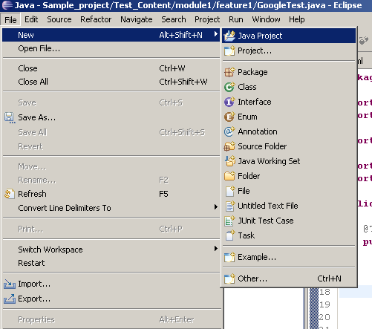

3> Name your projects and set the project location:
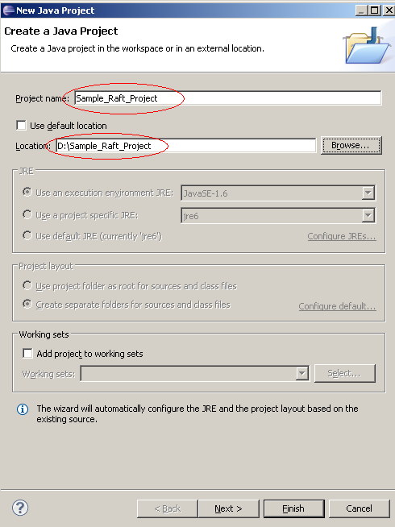

4> Java Settings. Default value should be fine; BTW, output folder should be in Test_Plan/Classes
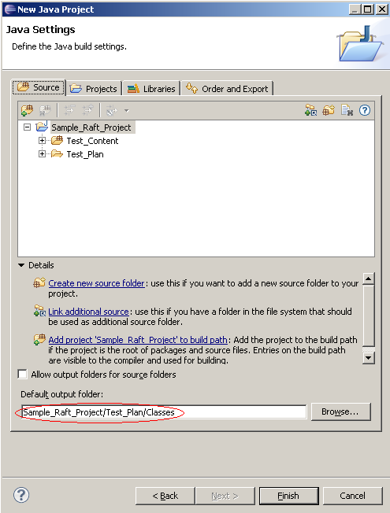

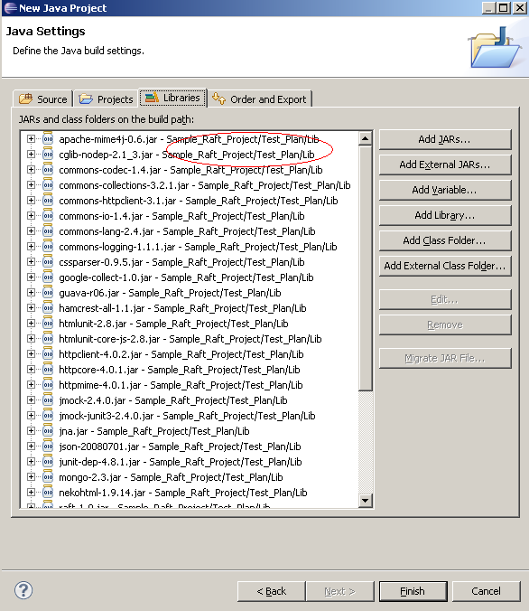

Then, Click Finish button, start writing your test code

How to Run your WebDriver Test:

Go to Sample_Raft_Project directory on your computer:
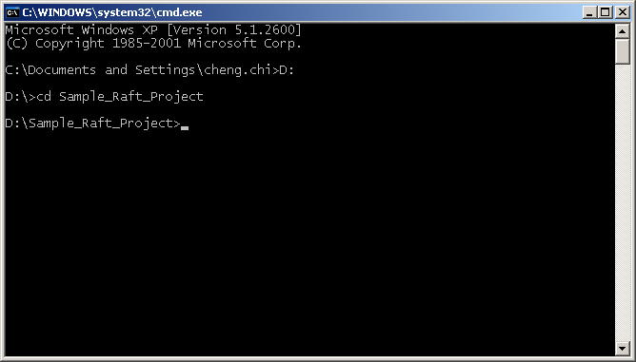

Find Your TestRunner folder which contain your TestNG config.xml:
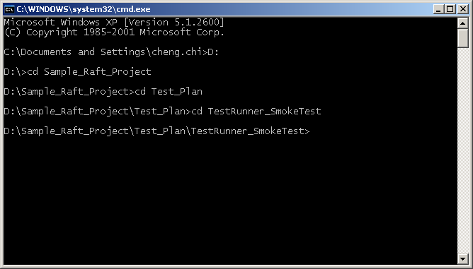

List all the files within TestRunner folder, Run “Runner.bat” to start your tests
