MCA Programme – Semester 3
Project Synopsis Submission
Title of the Project: DentaAI -AI-Powered Dental Disease Detection and Doctor Consultation System
Student Name: Joycil Britto
USN: 4JK25MC046
Guide Name: Mr. Sunith Kumar T
1.TITLE & INTRODUCTION:
Project Title: AI-Powered Dental Disease Detection and Doctor Consultation System
INTRODUCTION
Dental diseases such as dental caries, cavities, gum-related problems, and other oral conditions are common health concerns that may affect individuals of different age groups. Early identification of visible dental abnormalities will help individuals become aware of potential oral health problems and encourage them to seek professional dental care at an appropriate time. However, many people may delay consulting a dentist because of limited awareness, difficulty in recognizing visible symptoms, or lack of access to preliminary screening facilities.
The DentaAI - AI-Powered Dental Disease Detection and Doctor Consultation System will be developed as an AI-powered web-based application to assist users in the preliminary analysis of dental images and facilitate communication with dental professionals. The system will allow users to upload dental images, which will be processed using a trained deep learning model to identify possible dental conditions represented in the supported dataset.
The results generated by the system will be presented as an AI-assisted preliminary assessment and will not be considered a final medical diagnosis. Based on the analysis, users will be able to view the detected results, access relevant information, request consultations, and track their consultation status through the web application.
The proposed system will include separate functionalities for users, doctors, and administrators. Users will be able to upload dental images and request consultations. Doctors will be able to review consultation requests and provide professional guidance to users. Administrators will be responsible for managing users, doctors, records, and overall system activities.
By integrating artificial intelligence, image-based dental analysis, and a web-based doctor consultation workflow, the proposed system will aim to provide a structured and accessible platform for preliminary dental disease detection and professional consultation. The project will focus on supporting early awareness and improving access to dental consultation through the effective use of modern web and AI technologies.

2.PROBLEM STATEMENT
Early detection of dental diseases is important for improving oral health and encouraging timely professional consultation. However, preliminary identification of dental problems often depends on an individual's ability to recognize visible symptoms, which may not always be reliable.
Existing dental care workflows generally require users to visit a dental professional before receiving an assessment. There is a need for a supportive digital system that can perform preliminary analysis of dental images and provide a structured pathway for users to seek professional consultation.
The proposed project addresses this problem by developing an AI-powered dental disease detection and doctor consultation system. A deep learning model analyzes uploaded dental images and generates a preliminary prediction based on the classes supported by the training dataset. The result is then integrated with a consultation workflow that allows users and doctors to interact through the web application.
The system is intended to assist preliminary screening and consultation management and does not replace professional dental examination, diagnosis, or treatment.

3.LITERATURE REVIEW
Hafeez et al. [1] (2022) proposed a custom Convolutional Neural Network (CNN) called Dental-Net for automatically detecting dental cavities from oral photographic images. The researchers used a dataset of 609 diverse images containing teeth with and without cavities, collected from multiple sources. The images were resized, converted to grayscale, normalized, and augmented before training. The performance of Dental-Net was also compared with pre-trained models such as VGG16, MobileNetV2, InceptionV3, and ResNet18. The proposed Dental-Net achieved the highest performance, with 94.25% training accuracy and 91.09% validation accuracy. The study demonstrates that CNN-based image analysis can effectively support automated dental cavity detection and can contribute to the development of low-cost AI-assisted dental screening systems.
Rathod et al. [2] (2025) proposed a novel Artificial Intelligence (AI) model for detecting common oral and dental diseases from intraoral photographs. The researchers trained a Convolutional Neural Network (CNN)-based model using a dataset of over 5,000 images to identify conditions such as plaque, calculus, gingivitis, and caries. The model was tested using 90 unseen images and its performance was compared with that of 51 dentists. The results showed that dentists correctly diagnosed 82.09% of the pathologies, while the AI model achieved 81.11% accuracy, indicating that the AI system performed at a level comparable to dental practitioners. The study highlights the potential of AI-based image analysis as an effective tool for the early detection of oral and dental diseases and as a valuable decision-support system in dental healthcare.

Kühnisch et al. [3] (2021) proposed a deep learning-based approach for detecting and categorizing dental caries from intraoral photographs using Artificial Intelligence. The study used 2,417 intraoral images representing healthy tooth surfaces, noncavitated caries lesions, and caries-related cavitations. The researchers applied image preprocessing, augmentation, normalization, and transfer learning, using MobileNetV2 as the base architecture for the CNN model. The results showed that the trained CNN achieved more than 90% agreement under ideal conditions for caries detection from intraoral photographs. The study demonstrated the potential of AI-based image analysis for supporting automated caries detection and provides a strong foundation for developing AI-assisted dental disease detection systems.
Felsch et al. [4] (2023) proposed a Vision Transformer-based approach for the detection and localization of dental caries and molar-incisor hypo mineralization (MIH) from dental photographs. The study used 18,179 anonymized dental photographs, which were carefully annotated pixel by pixel by trained experts. The researchers used image augmentation and implemented a SegFormer-B5 Vision Transformer model, which was trained and fine-tuned over 250 epochs. The model achieved excellent performance, with an IoU of 0.959, average precision of 0.977, and accuracy of 0.978. The study demonstrated that Vision Transformer models can effectively identify and precisely localize pathological regions in dental images, supporting the development of advanced AI-assisted dental disease detection systems.
Adnan et al. [5] (2024) proposed an AI-based smartphone application for detecting dental decay from intraoral photographs. The study used a dataset of 7,465 intraoral images, which were annotated and verified by experienced dentists. The researchers trained a YOLOv5s model and integrated it into the application, while explainable AI techniques were used to understand the model's decision-making process. The system achieved a precision of 90.7%, sensitivity of 85.6%, and F1-score of 88.0%, outperforming junior dentists in sensitivity and F1-score during the comparison. The study demonstrated that AI-based applications can effectively support dental decay detection from intraoral photographs and have potential for practical community-level dental healthcare applications.

4.OBJECTIVES & SCOPE
OBJECTIVES:
- To design and develop an AI-powered system capable of detecting possible dental diseases from dental or oral images.
- To implement image preprocessing techniques for preparing uploaded dental images for analysis.
- To develop and implement a suitable Deep Learning model for dental disease detection.
- To classify uploaded images based on the dental disease categories supported by the trained model.

- To provide users with a simple interface for uploading images and viewing AI-based prediction results.
- To provide relevant disease-related information and intelligent assistance based on the prediction.
- To develop a doctor consultation or appointment request module for connecting users with dental professionals.
- To maintain user, prediction, and consultation records for future reference, depending on the final implementation.
SCOPE BOUNDARIES:
  - The system focuses on the dental disease categories supported by the available dataset and trained model.
  - The prediction result is intended for preliminary AI-based assistance and does not replace professional diagnosis.
  - The accuracy of predictions depends on the quality, size, and diversity of the dataset.
  - The quality and clarity of uploaded images may affect system performance.
  - Doctor consultation features facilitate communication or appointment requests and do not automate professional medical treatment.
  - Advanced clinical diagnosis, prescriptions, and treatment procedures are outside the core scope of the proposed system.

5.PROPOSED METHODOLOGY
- User Registration and Login – Users and doctors can access the system through appropriate authentication and account management features.
- Image Input – The user uploads a dental or oral image through the web application for AI-based analysis.
- Image Preprocessing – The uploaded image is resized, normalized, enhanced, and prepared for processing by the Deep Learning model.
- AI Model Processing – A trained CNN or suitable Deep Learning model analyzes the processed image and identifies patterns associated with the supported dental disease categories.
- Disease Prediction – The system generates a prediction result indicating the possible dental disease category along with a confidence value, where supported.
- Result Display and Assistance – The prediction result and relevant disease information are displayed through the user interface to help users understand the preliminary analysis.

- Doctor Consultation – Users can view doctor information and request or schedule a consultation for professional follow-up.
- Database and History – User details, prediction records, doctor information, and consultation requests may be stored in a database for future access and management.

PROPOSED SYSTEM ARCHITECTURE
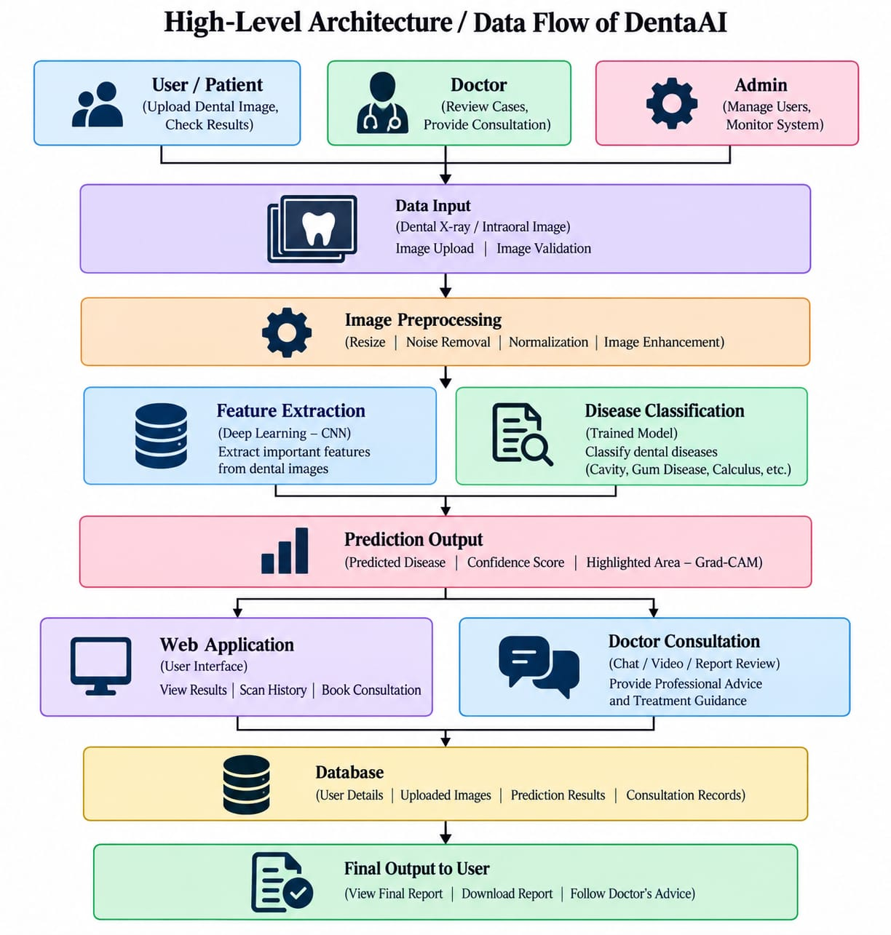
Fig 2 . Workflow of the proposed on DentaAI
6.DATASET:
The dataset used in DentaAI consists of dental images collected from suitable publicly available or approved sources for the supported dental disease classification task. The images are organized according to their class labels and processed before model training.

Dataset Component | Purpose | Description
Dental Image Dataset | Model Training | Images representing the dental conditions supported by the classification model.
Training Dataset | Learning | Used to train the deep learning model to learn visual patterns.
Validation Dataset | Model Validation | Used during development to evaluate and tune model performance.
Testing Dataset | Final Evaluation | Used to assess the performance of the trained model on unseen images.
Application Database | System Records | Stores user, doctor, consultation, and application-related records.
The exact disease classes, number of images, and dataset split will be finalized according to the selected dataset used for implementation. All images are preprocessed to ensure a consistent input format for the AI model.

7. Hardware & Software Requirements
Hardware Requirements
- Processor: Intel Core i3 or above
- RAM: Minimum 8 GB
- Storage: Minimum 10–20 GB free space
- Internet: Required for web-based features and dataset access
Software Requirements
Category | Technology / Tool
Operating System | Windows or Linux
Programming Language | Python
Machine Learning | TensorFlow / Keras, Scikit-learn
Image Processing | OpenCV, Pillow
Data Processing | Pandas, NumPy
Backend | Flask
Database | SQLite
Frontend | HTML, CSS, JavaScript
Development Environment | Visual Studio Code
Version Control | Git / GitHub (optional)

8.Expected Outcomes & Future Scope
Expected Outcomes
The project is expected to produce the following outcomes:
- A trained AI model for preliminary classification of supported dental conditions from uploaded images.
- A web-based dental disease detection system with image upload and result viewing.
- A preliminary prediction interface displaying AI-assisted analysis results.
- A doctor consultation workflow connecting users with registered doctors.
- Separate dashboards for users, doctors, and administrators.
- Centralized management of users, consultations, and application records.
- A scalable foundation for future AI-assisted dental healthcare application.

Future Scope
The system can be further extended by:
- Supporting additional dental diseases and a larger variety of image types.
- Integrating dental X-ray and radiographic image analysis.
- Improving model performance using larger and more diverse datasets.
- Adding explainable AI techniques to visualize the image regions influencing predictions.
- Supporting online appointment scheduling and secure communication features.
- Integrating patient history and dental treatment records where appropriate.
- Developing a mobile application for improved accessibility.
- Conducting advanced clinical validation with qualified dental professionals.

9. Timeline & References
Timeline
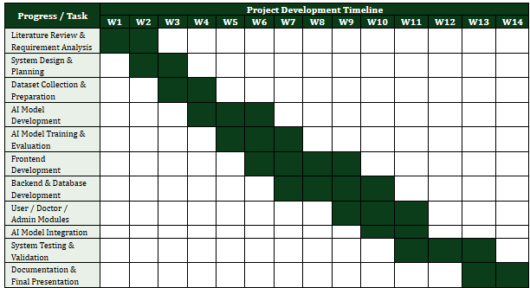
References
[1] Khan, M. A. Hafeez, Giri Prasad, S., & Jothi, J. A. A. (2022). Detection of Cavities from Oral Images using Convolutional Neural Networks. Proceedings of the 2022 International Conference on Electrical, Computer and Energy Technologies (ICECET), pp. 1–6. IEEE. https://doi.org/10.1109/ICECET55527.2022.9872786.
[2] Kühnisch, J., Meyer, O., Hesenius, M., Hickel, R., & Gruhn, V. (2022). Caries Detection on Intraoral Images Using Artificial Intelligence. Journal of Dental Research, 101(2), 158–165. https://doi.org/10.1177/00220345211032524.
[3] Felsch, M., Meyer, O., Schlickenrieder, A., et al. (2023). Detection and Localization of Caries and Hypomineralization on Dental Photographs with a Vision Transformer Model. npj Digital Medicine, 6, 198. https://doi.org/10.1038/s41746-023-00944-2.
[4] Adnan, N., Faizan Ahmed, S. M., Das, J. K., et al. (2024). Developing an AI-Based Application for Caries Index Detection on Intraoral Photographs. Scientific Reports, 14, 26752. https://doi.org/10.1038/s41598-024-78184-x.
[5] Rathod, R., Dean, S., & Sproat, C. (2025). The Effectiveness of a Novel Artificial Intelligence (AI) Model in Detecting Oral and Dental Diseases. BDJ Open, 11, 62. https://doi.org/10.1038/s41405-025-00336-6.

