Active Learning Strategy
The Muddiest and the Mightiest
- The muddiest and the mightiest is both an active learning strategy and a formative assessment method.
- It is a quick way to find what learners have understood and with what learners are having challenges.
- It also gives the instructor information that will help modify future deliveries of the lesson and for potential follow-up to fill in learner knowledge or skill gaps.
- It is easily adapted to different instructional strategies like informative videos, skills demonstrations, individual lessons, units etc.

Please record the most confusing, unclear, or muddiest part of your learning so far in this module.
Please record the clearest, concise, or mightiest part of your learning so far in this module.

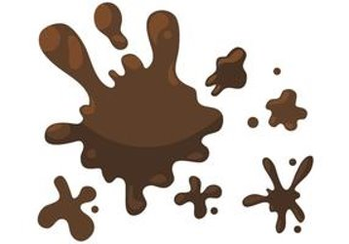  Muddiest Idea  I need clarity on how to incorporate technical concepts and hands on activities into a supportive and inclusive community for learners with diverse skill levels. |   Mightiest Idea  I learned that every learning environment is different and depends on the learners, content, and teaching methods. Small changes in how I plan or teach can make a big difference in helping learners feel supported and connected.

