PROJECT REVIEW 1 REPORT
QKraft: AI-Driven Database Schema & Query Optimization Platform
Project Title | QKraft – Automated Schema & Query Optimizer
Student / Developer | Romel
Domain & Area | Database Engineering, Artificial Intelligence & Cloud Developer Tools
Review Milestone | Project Review 1 (Phase 1 Progress & Architecture Defense)

1. Executive Summary
In modern web applications, the performance and scalability of backend services are critically dependent on relational database design. However, application developers frequently deploy schemas containing structural design flaws—such as unindexed foreign keys, absent primary keys, and sub-optimal data types. These errors lead to high disk I/O, sequential table scans, slow query executions, and unnecessary cloud database bills.
QKraft is an intelligent developer workbench created to solve these challenges proactively. It ingests standard SQL Data Definition Language (DDL) scripts, analyzes them using rule-based heuristics and generative AI, renders interactive Entity-Relationship (ER) diagrams, and spins up an isolated sandbox database populated with synthetic data. QKraft then executes candidate queries against both the unoptimized and optimized schemas side-by-side, measuring exact latency in milliseconds and proving performance gains with measurable data.
2. Problem Statement & Motivation
Relational database optimization has traditionally suffered from three fundamental bottlenecks:
- • Reactive Rather Than Proactive: Query performance is usually examined only after an application goes live and users report slow response times or query logs show timeouts.
- • High Barrier to DBA Expertise: Identifying missing compound indexes, table joins, and execution plan anomalies requires specialized database administration skills that many full-stack developers lack.
- • Friction in Testing Alternatives: Developers hesitate to modify table schemas or add B-Tree indexes in live or staging environments because creating safe sandboxes with realistic test rows is tedious and time-consuming.
3. Project Objectives
- 1. Automated DDL Parsing & Visualization: Ingest raw SQL DDL and render a clean, interactive entity-relationship diagram with foreign key associations.
- 2. Dual-Layer Schema Optimization: Combine deterministic pattern-matching rules (for primary/foreign keys and index placement) with Google Gemini AI for contextual schema refactoring.
- 3. Isolated SQLite Sandbox Engine: Automatically translate standard/Postgres DDL into a functioning SQLite sandbox environment with automated realistic mock data generation.
- 4. Query Advisor & Natural Language Prompting: Provide an intelligent SQL assistant that converts user intent into optimized SQL statements.
- 5. Side-by-Side Performance Benchmarking: Execute queries against both unoptimized and optimized schemas, measuring runtime in milliseconds, row counts, and percentage time saved.
4. Existing System vs. Proposed System
Evaluation Metric | Traditional Existing Approach | Proposed System (QKraft)
Analysis Stage | Post-production (slow query logs, APM tools) | Pre-production (during schema design & development)
Schema Recommendations | Manual DBA code review & trial-and-error | Instant automated rule engine + Gemini AI advisor
ER Diagramming | Separate static tools (draw.io, dbdiagram.io) | Built-in dynamic SVG/Canvas entity relationship graph
Safe Sandbox Validation | Requires manual Docker setup & custom SQL seed scripts | One-click automated SQLite sandbox with synthetic mock records
Performance Proof | Theoretical EXPLAIN plan interpretations | Empirical side-by-side timing in milliseconds & % speedup
5. Data Flow Diagrams (DFD)
Data Flow Diagrams (DFDs) visually map how information enters, traverses, transforms, and is persisted across the QKraft platform. The following hierarchical diagrams describe the system from high-level context down to the inner mechanics of the sandbox execution engine.
5.1 DFD Level 0: Context Diagram
The Context Diagram (Level 0) treats the entire QKraft platform as a single process (Process 0.0), showing interactions with three key external entities: the Developer/User, the external Google Gemini AI engine, and the underlying Sandbox Database storage.
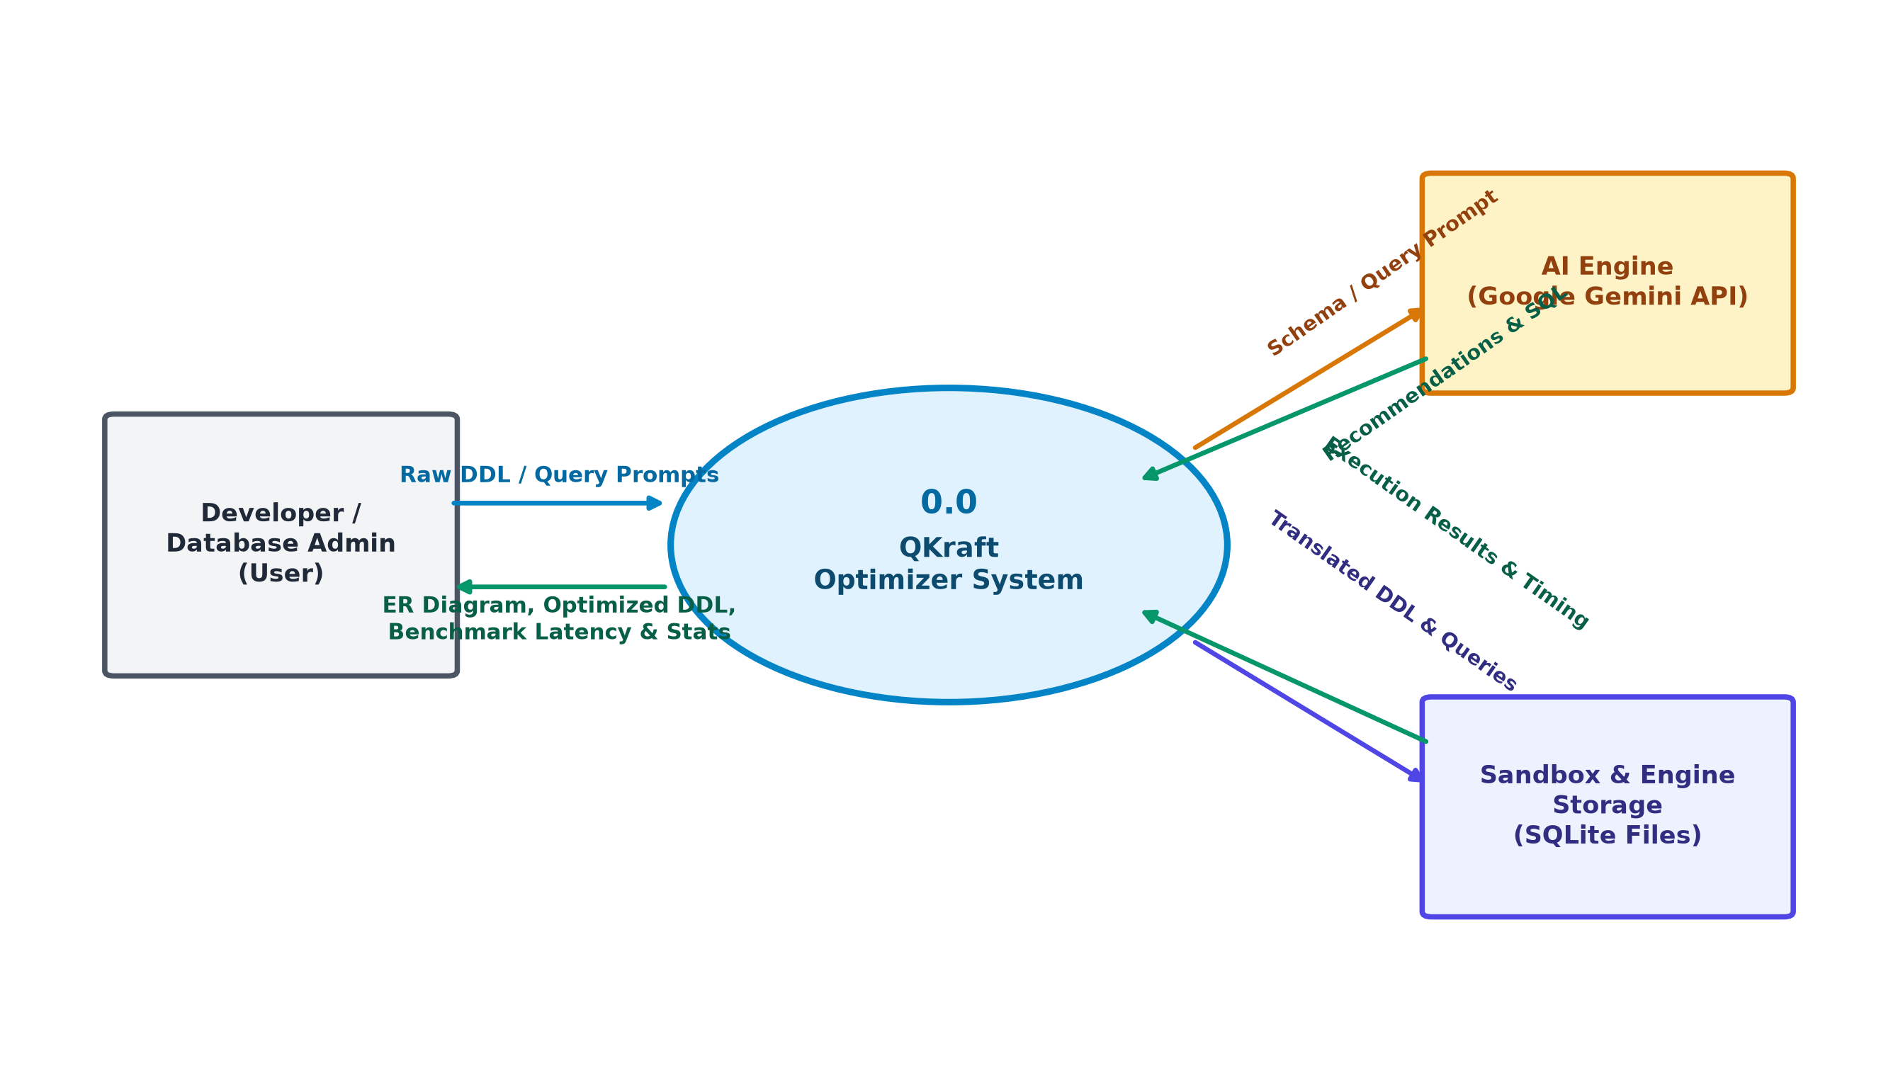
Figure 1: DFD Level 0 – Context Diagram for QKraft Platform
5.2 DFD Level 1: Functional Decomposition
The Level 1 DFD decomposes the system into five core functional processes and three dedicated data stores:
• Process 1.0 (DDL Parsing & Diagramming): Ingests DDL, extracts relational entities, and normalizes table structures.
• Process 2.0 (Schema Optimization Engine): Employs heuristic rules and Gemini AI to suggest missing primary keys, foreign keys, and indexes.
• Process 3.0 (Sandbox DB & Mock Seeding): Translates SQL dialect into SQLite, initializes sandbox files, and generates realistic records.
• Process 4.0 (Query Advisory & Generation): Converts natural language prompts into optimized SQL statements.
• Process 5.0 (Performance Benchmarker): Executes queries concurrently on original and optimized sandboxes to compute latency and speedup.
• Data Stores: D1 (Schemas Store), D2 (Isolated Sandbox Databases), and D3 (Query History & Metrics).
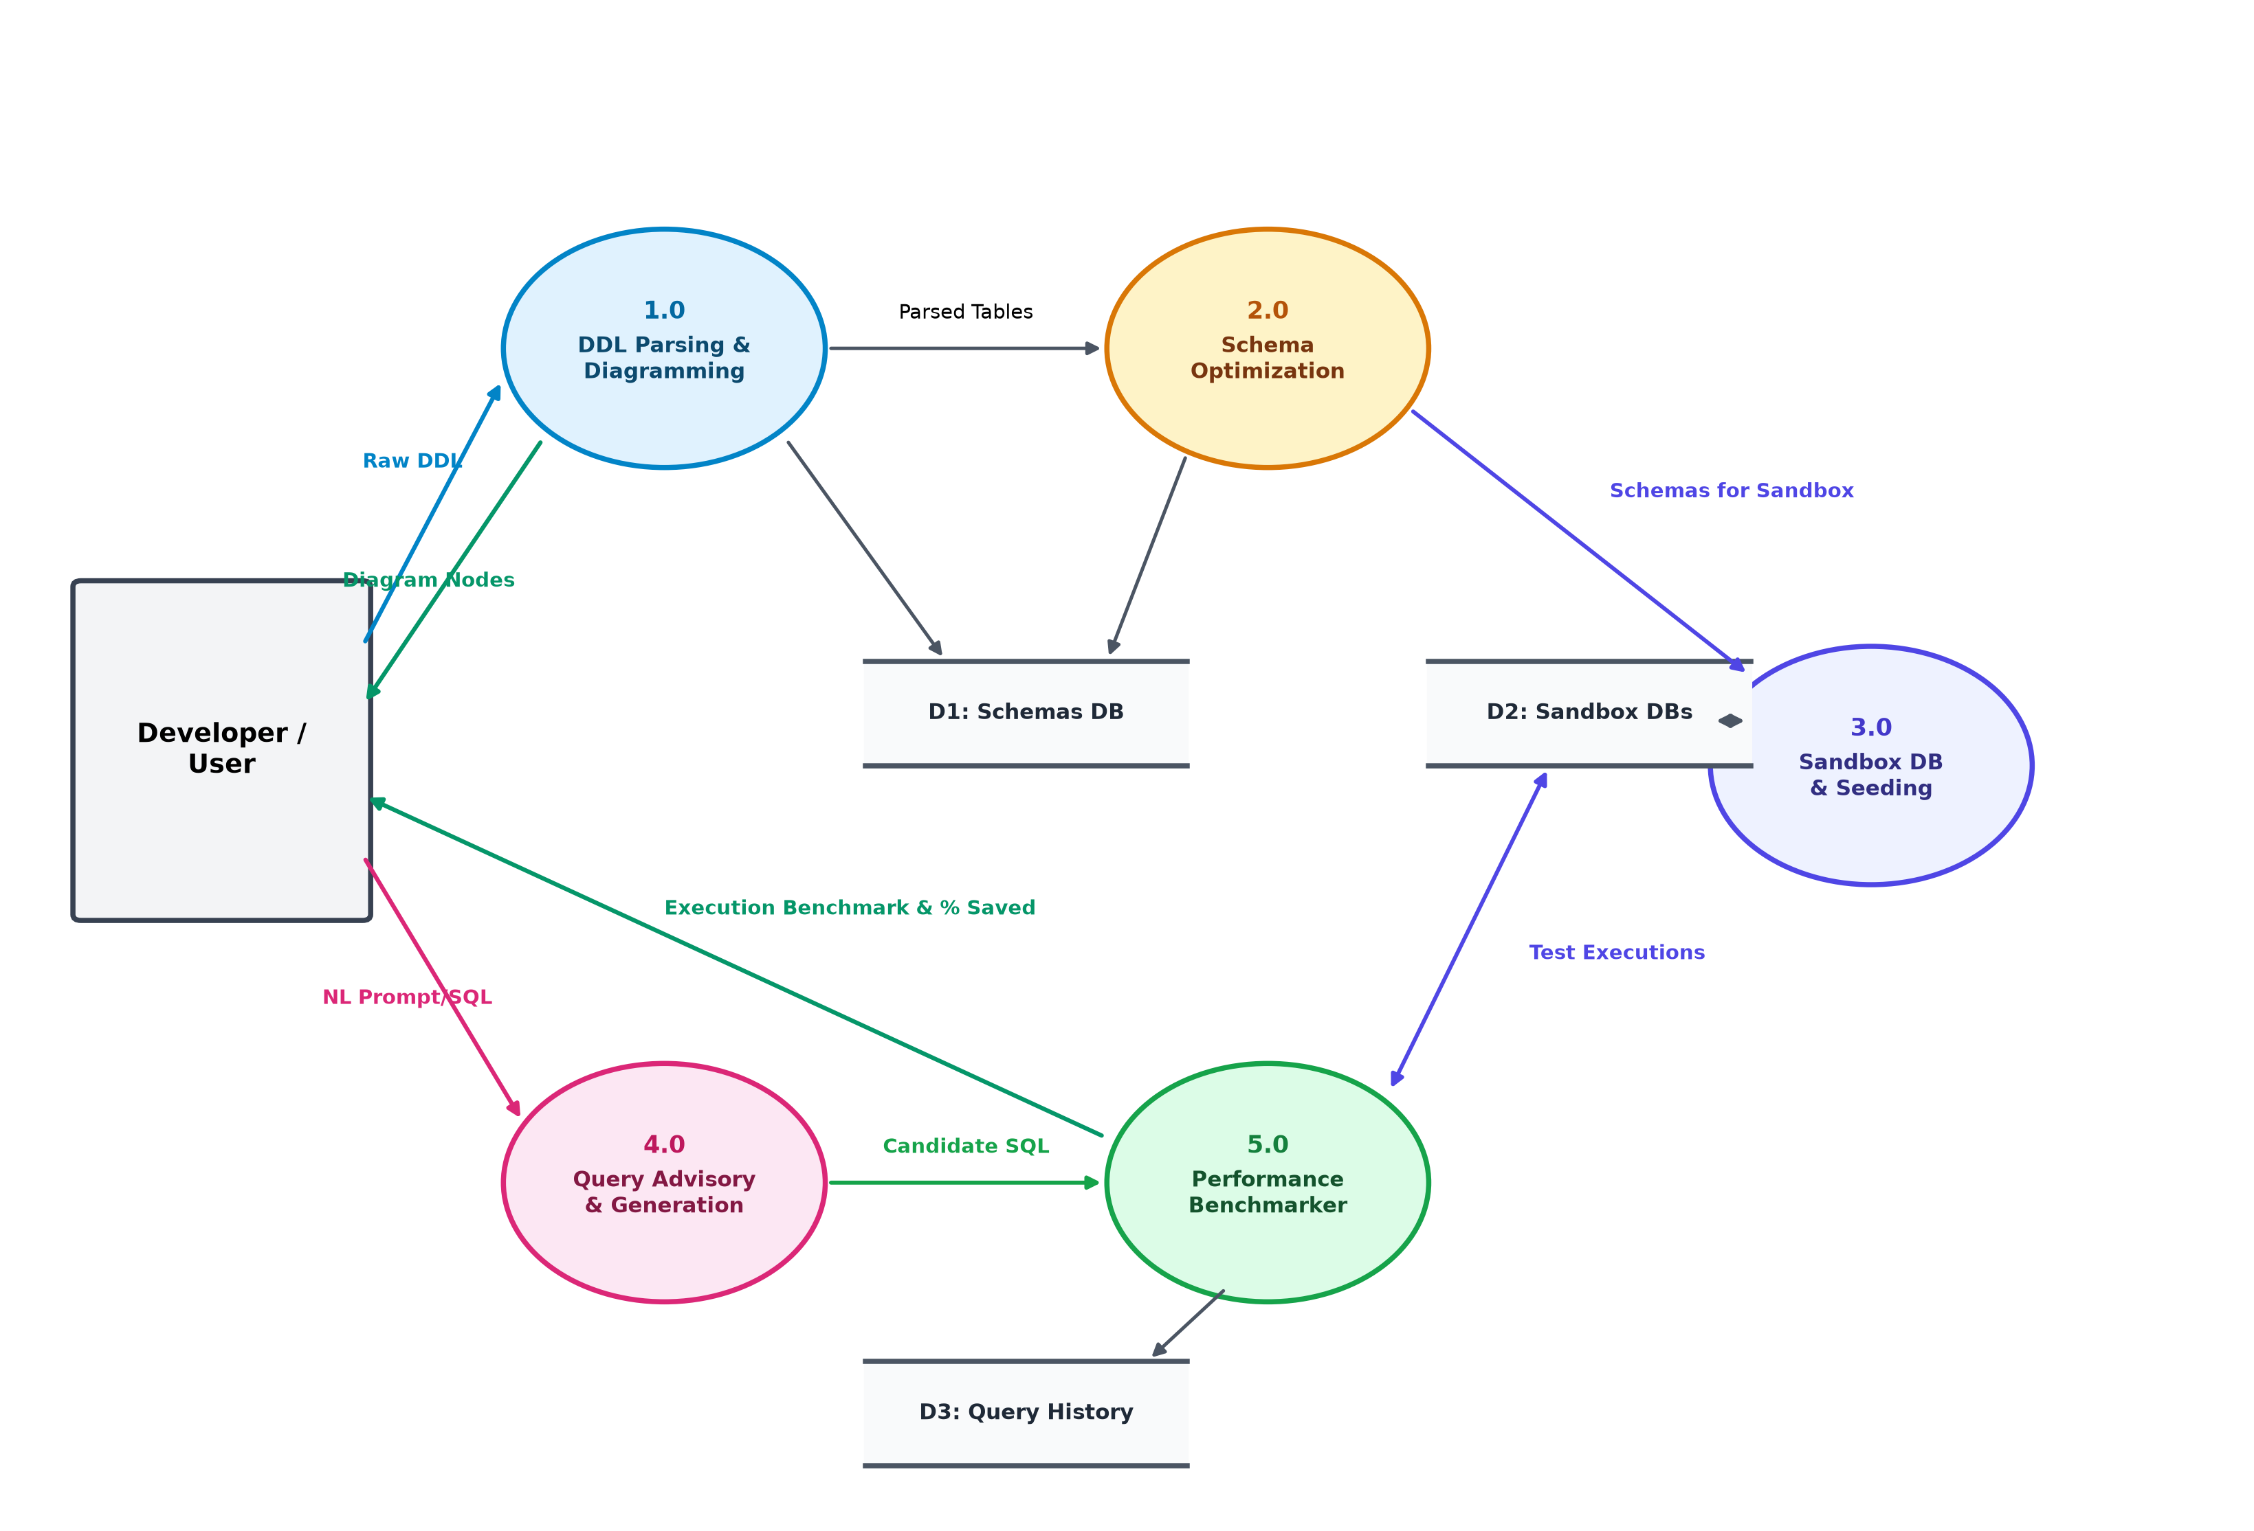
Figure 2: DFD Level 1 – Decomposed Functional Process Flow
5.3 DFD Level 2: Sandbox Creation & Performance Benchmarking
The Level 2 DFD provides an in-depth view of the Sandbox Creation (Process 3.0) and Benchmarking (Process 5.0) pipeline. It details the dialect translation from PostgreSQL constructs (e.g. SERIAL, TIMESTAMPTZ) to SQLite, dynamic schema generation, table introspection via PRAGMA, realistic mock data synthesis, and side-by-side millisecond timing calculations.
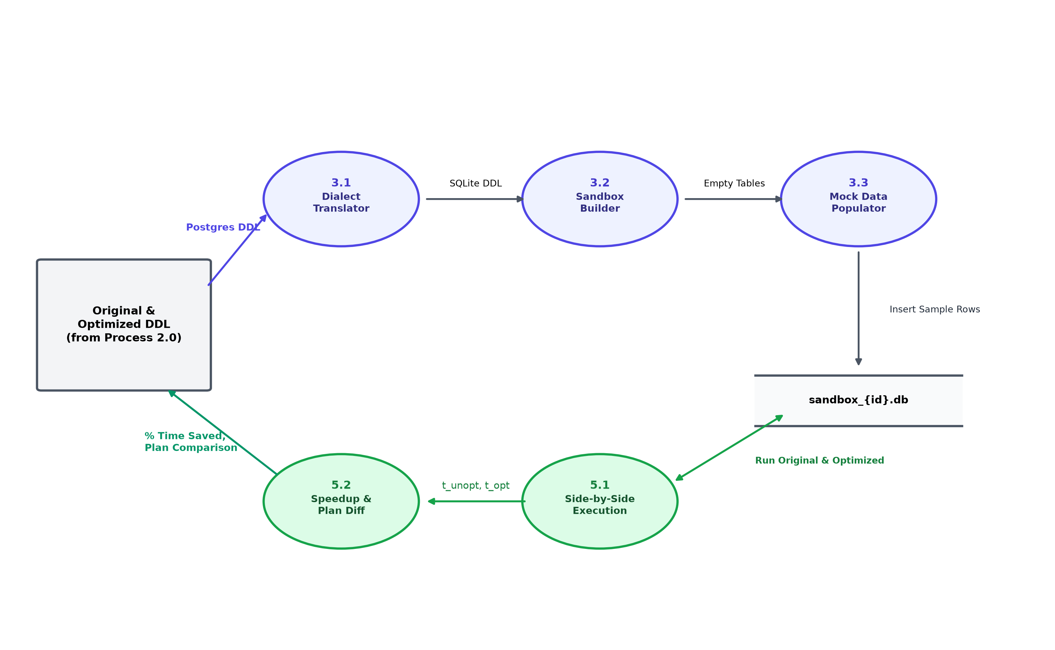
Figure 3: DFD Level 2 – Detailed Sub-Process Flow of Sandbox & Benchmark Engine
6. System Architecture & Technologies
Layer | Technology / Framework | Specific Role in QKraft
Frontend Dashboard | Next.js 16 (React 19), TypeScript | Dynamic client application, schema visualizer, and benchmarking modals
Frontend Styling | Vanilla CSS Modules | Zero-runtime bespoke design system with dark mode and smooth animations
Backend Web API | FastAPI (Python 3.13) | Asynchronous high-performance REST endpoints for parsing, optimization, and testing
ORM & Storage | SQLAlchemy + SQLite | Metadata database tracking saved schemas, query histories, and metrics
AI Intelligence | Google Gemini API (Generative AI) | Context-aware schema auditing, query generation, and refactoring tips
7. Current Progress & Completed Deliverables
For Phase 1 (Project Review 1), all core foundational modules have been fully implemented and verified:
- [COMPLETED] Full-Stack Scaffold: FastAPI backend paired with Next.js 16 React frontend with hot-reloading and robust CORS configuration.
- [COMPLETED] SQL DDL Parser: Extracts table names, columns, data types, primary keys, and foreign keys even with syntax variations.
- [COMPLETED] Interactive Schema Visualizer: Canvas/SVG representation of relational tables with foreign key link highlights.
- [COMPLETED] Deterministic & AI Optimization: Detects missing B-Tree indexes on join and filter columns (e.g. status, created_at) and recommends corrected DDL.
- [COMPLETED] Isolated Sandbox Generation: Automated creation of standalone sandbox_{id}.db instances with Postgres-to-SQLite type conversion.
- [COMPLETED] Side-by-Side Benchmarking Modal: Executes queries concurrently on original and optimized sandboxes, displaying time in milliseconds, row counts, and speedup %.
- [COMPLETED] Metrics & History Engine: Aggregates total time saved (ms), average percentage improvement, and session query histories.
8. Challenges Encountered & Engineering Solutions
- • SQL Dialect Differences: PostgreSQL features types like SERIAL, UUID, TIMESTAMPTZ, and JSONB that are unsupported in embedded SQLite sandboxes. Solution: Built an automated regex dialect translator in db_sandbox.py to seamlessly normalize and convert these constructs.
- • Millisecond Timing Precision on Empty Tables: Running queries on empty tables yields near-zero execution times (0.01ms), hiding index benefits. Solution: Built an intelligent synthetic mock data generator that seeds realistic rows for users, orders, products, and generic tables automatically.
9. Plan for Phase 2 (Review 2 & Final Review)
- 1. Visual Query Execution Plan (EXPLAIN): Render a graphical tree showing exact table scans vs. index lookups.
- 2. Multi-Engine Docker Runners: Add optional Docker containers for PostgreSQL and MySQL sandbox execution.
- 3. Migration Script Export: One-click export of Flyway/Liquibase-compatible SQL migration files containing only the delta changes.
- 4. Benchmarking on Standard Datasets: Test and document performance gains across standard enterprise schemas (TPC-H, Northwind).

