MINI PROJECT REPORT
Design and PCB Development of a Custom STM32CUBEMX-Based Flight Controller for UAV Applications
Mini Project Report Submitted in Partial fulfilment of the requirements for the degree of Bachelor of Technology
From
Maulana Abul Kalam Azad University of Technology, West Bengal
(formerly West Bengal University of Technology)
Submitted By
Under the Guidance of
Project Supervisor/(s):

Technical Facilitator:

Department of Electronics and Communication Engineering
Cooch Behar Government Engineering College
Cooch Behar, West Bengal
2026

ACKNOWLEDGEMENT
I would like to express my sincere gratitude to my project supervisor for providing continuous guidance, valuable suggestions, and encouragement throughout the completion of this mini project. Their technical knowledge and constructive feedback greatly contributed to the successful completion of this work.
I also express my heartfelt thanks to the Technical Facilitator for providing constant support during the design process and helping me understand various aspects of embedded hardware development.
I sincerely thank the Head of the Department and all the faculty members of the Department of Electronics and Communication Engineering, Cooch Behar Government Engineering College, for providing the necessary facilities and academic environment to complete this project successfully.
PROJECT MEMBERS
Roll No. Name Signature
Dibyendu Koley | 34900323017
----------------------------------  Irfan Halder | --------------------------------------------  34900323018 | --------------------------------------------
-----------------------------  Joy dey | --------------------------------------------  34900323019 | --------------------------------------------
-----------------------------  Nabajyoti Nag | --------------------------------------------  34900323028 | --------------------------------------------
-----------------------------  Nabanita Barai | --------------------------------------------  34900323029 | --------------------------------------------
-----------------------------  Nafiz Akhtar | --------------------------------------------  34900323030 | --------------------------------------------
-----------------------------  Neha Sarkar | --------------------------------------------  34900323031 | --------------------------------------------
----------------------------- | -------------------------------------------- | --------------------------------------------

ABSTRACT
A flight controller is the central electronic unit of an Unmanned Aerial Vehicle (UAV), responsible for acquiring sensor data, processing flight information, and controlling the motors to maintain stable flight. The performance and reliability of a UAV largely depend on the design of its flight controller hardware. Therefore, a well-designed schematic and Printed Circuit Board (PCB) are essential for ensuring efficient operation, stable power distribution, and reliable communication among different onboard peripherals.
The objective of this project is to design a custom flight controller hardware based on the STM32CUBEMX microcontroller using Proteus Design Suite. The project focuses exclusively on hardware development, including circuit schematic design, PCB layout generation, and microcontroller pin configuration using STM32CUBEMX. No firmware development or hardware implementation has been carried out as part of this project.
The proposed flight controller integrates essential hardware required for modern UAV systems. These include the ICM-40609-D Inertial Measurement Unit (IMU) for measuring acceleration and angular velocity, the MMC5983MA Magnetometer for heading estimation, and the BMP390 Barometric Pressure Sensor for altitude measurement. The controller also incorporates USB Type-C connectivity, SWD debugging interface, SD card interface, ESC outputs, telemetry connectors, GPS interface, RC receiver interface, RGB status LED, buzzer circuit, and a dedicated power management section consisting of a buck converter, power multiplexer, and low-dropout voltage regulator.
The complete schematic was designed in Proteus by dividing the hardware into multiple functional blocks, including the main controller circuit, sensor interface, power supply, and communication interfaces. After schematic completion, footprints were assigned to all components and the PCB layout was developed following standard PCB design guidelines such as proper component placement, optimized routing, decoupling capacitor placement, and continuous ground plane implementation. The STM32CUBEMX peripheral configuration was also prepared using STM32CUBEMX to allocate communication interfaces including SPI, I²C, UART, USB, SDMMC, PWM, ADC, and GPIO according to the hardware design.
The completed schematic and PCB provide a robust hardware platform that can be used for future firmware development and integration into a custom quadcopter. The modular design allows additional features and software functionality to be implemented in later stages without requiring significant hardware modifications.

CONTENTS
Acknowledgement 2
Abstract 3
Project Members 4
List of Principal Symbols and Acronyms 7
List of Figures 8
List of Tables 9
- CHAPTER 1
- INTRODUCTION 10
1.1 Introduction 10
1.2 Literature Review 10
1.3 Objectives 11
1.4 Scope of Present Work 11
- CHAPTER 2
- SYSTEM DESIGN AND HARDWARE DESCRIPTION 13
2.1 System Overview 13
2.2 Hardware Architecture 14
2.3 STM32CUBEMX Microcontroller 14
2.4 Sensor Interfaces 15
2.5 Power Management 15
2.6 Communication Interfaces 15
2.7 Working Principle 16
- CHAPTER 3
- SCHEMATIC DESIGN, STM32CUBEMX PIN CONFIGURATION AND PCB DESIGN 17
3.1 Introduction 17
3.2 Design Methodology 18
3.3 Main Controller Circuit 19
3.4 Sensor Interface Circuit 19
3.5 Power Management Circuit 20
3.6 USB and External Interface Circuit 20
3.7 STM32CUBEMX Pin Configuration 20
3.8 PCB Design 21
3.9 PCB Layout 22
3.10 PCB Design Considerations 22
- CHAPTER 4
- PCB DESIGN VERIFICATION AND ANALYSIS 23
4.1 Introduction 23
4.2 Schematic Verification 23
4.3 STM32CUBEMX Pin Configuration Verification 23
4.4 PCB Layout Analysis 24
4.5 PCB Routing Analysis 24
4.6 Design Rule Verification 25
4.7 Electrical Rule Verification 25
4.8 Advantages of the Proposed Hardware Design 25
4.9 Limitations of the Current Work 26
4.10 Discussion 26
- CHAPTER 5
- CONCLUSION AND FUTURE SCOPE 28
5.1 Conclusion 28
5.2 Future Scope 29
5.3 Overall Achievement of the Project 30
REFERENCES 31

LIST OF PRINCIPAL SYMBOLS AND ACRONYMS
Acronym | Full Form
UAV | Unmanned Aerial Vehicle
MCU | Microcontroller Unit
PCB | Printed Circuit Board
IMU | Inertial Measurement Unit
ESC | Electronic Speed Controller
SPI | Serial Peripheral Interface
I²C | Inter-Integrated Circuit
UART | Universal Asynchronous Receiver Transmitter
USB | Universal Serial Bus
SDMMC | Secure Digital Multi Media Card
SWD | Serial Wire Debug
PWM | Pulse Width Modulation
ADC | Analog to Digital Converter
GPIO | General Purpose Input Output
RGB | Red Green Blue
LDO | Low Dropout Regulator
GPS | Global Positioning System
RC | Radio Control
SD | Secure Digital
DRC | Design Rule Check
ERC | Electrical Rule Check

LIST OF FIGURES
Figure No. | Title
Figure 1.1 | Flowchart of the Scope of the Project
Figure 2.1 | Overall Flight Controller Block Diagram
Figure 3.1 | Hardware Design Flow
Figure 3.2 | Main Controller Schematic (Page 1 of schematic)
Figure 3.3 | Sensor Interface Schematic (Page 2 of schematic)
Figure 3.4 | Power Supply Schematic (Page 3 of schematic)
Figure 3.5 | USB and Interface Connector Schematic (Page 4 of schematic)
Figure 3.6 | STM32CUBEMX Pin Configuration
Figure 3.7 | PCB Top Layer
Figure 3.8 | PCB Bottom Layer
Figure 3.9 | 3D PCB View
Figure 4.0 | PCB Layout
Figure 4.1 | Design Rule Check (DRC)
Figure 4.2 | Electrical Rule Check (ERC)

LIST OF TABLES
Table No. | Title
Table 2.1 | Major Hardware Architecture Blocks
Table 2.2 | STM32CUBEMX Specifications
Table 2.3 | Sensor Specifications
Table 3.1 | Hardware Components Used in Schematic Design
Table 3.2 | STM32 Peripheral Configuration
Table 4.1 | Advantages of the Proposed Design
Table 5.1 | Project Achievement Summary

CHAPTER 1
INTRODUCTION

1.1 Introduction
Unmanned Aerial Vehicles (UAVs), commonly known as drones, have become an important part of modern technology, with applications ranging from aerial photography and surveying to agriculture, logistics, and search-and-rescue operations. At the heart of every UAV lies the flight controller, an embedded electronic system responsible for acquiring data from onboard sensors, processing this information in real time, and generating the control signals required to stabilise and manoeuvre the vehicle. The reliability, responsiveness, and overall performance of a UAV depend heavily on the quality of its flight controller hardware.
Commercially available flight controllers, while functional, often restrict designers to fixed hardware configurations and limited customisation options. Designing a custom flight controller allows a deeper understanding of embedded hardware design, sensor integration, power management, and PCB layout practices, while also providing a platform that can be tailored to specific project requirements. This mini project focuses on the hardware design of a custom flight controller built around the STM32CUBEMX microcontroller, a high-performance ARM Cortex-M7 based device suitable for real-time flight control applications.
The project covers the complete hardware development cycle, from component selection and schematic capture in Proteus Design Suite to PCB layout design and microcontroller peripheral configuration in STM32CUBEMX. The resulting hardware platform is intended to serve as the foundation for future firmware development and integration into a fully functional quadcopter.

1.2 Literature Review
A number of open-source and commercial flight controller platforms are widely used in the UAV community, including Pixhawk-based boards and controllers running the ArduPilot and Betaflight firmware stacks. These platforms typically integrate an IMU, barometer, and magnetometer along with a high-performance microcontroller to perform real-time attitude estimation and control. Studies of these designs highlight several recurring hardware design principles: careful placement of decoupling capacitors near microcontroller power pins, isolation of sensitive sensors from noisy power circuitry, use of continuous ground planes to reduce electromagnetic interference, and modular schematic organisation to simplify debugging and future revisions.
The STM32 family of microcontrollers, particularly the STM32F4 and STM32H7 series, is commonly adopted in flight controller designs due to its high clock speed, rich peripheral set, and floating-point processing capability, all of which are beneficial for sensor fusion algorithms such as the Kalman filter and complementary filter. The STM32CUBEMX in particular offers a substantial improvement in processing headroom over older STM32F4-based designs, making it a suitable candidate for a modern custom flight controller.
Reviewing existing open-source hardware designs also confirms the importance of standard interfaces such as SWD for programming and debugging, USB for configuration and firmware upload, and SDMMC for onboard data logging. These observations directly informed the hardware architecture adopted in this project.

1.3 Objectives
The objectives of this mini project are as follows:
- To select suitable electronic components for the flight controller design.
- To design the complete schematic using Proteus Design Suite.
- To integrate the STM32CUBEMX microcontroller with essential onboard sensors.
- To design power management and communication interface circuits.
- To configure the STM32CUBEMX peripherals using STM32CUBEMX.
- To develop a compact and reliable PCB layout following standard PCB design guidelines.
- To create a hardware platform that can support future firmware development and UAV implementation.

1.4 Scope of Present Work
The scope of this project is limited to the hardware design and development of a custom flight controller for UAV applications. The work completed in this project includes:
- Selection of the STM32CUBEMX microcontroller.
- Design of the complete flight controller schematic using Proteus.
- Integration of the ICM40609DIMU, MMC5983MA magnetometer, and BMP390 barometer.
- Design of the USB Type-C interface, SWD debugging interface, SD card interface, GPS connector, telemetry connectors, ESC outputs, RGB LED, buzzer, and power management circuits.
- STM32CUBEMX pin configuration for all required peripherals.
- PCB layout design, component placement, routing, and preparation for future fabrication.
The following activities are not included in this mini project:
- Firmware development.
- PCB fabrication.
- Component soldering.
- Hardware testing.
- Sensor calibration.
- Flight testing.
- Autonomous navigation.
These activities are proposed as future work after successful hardware fabrication.

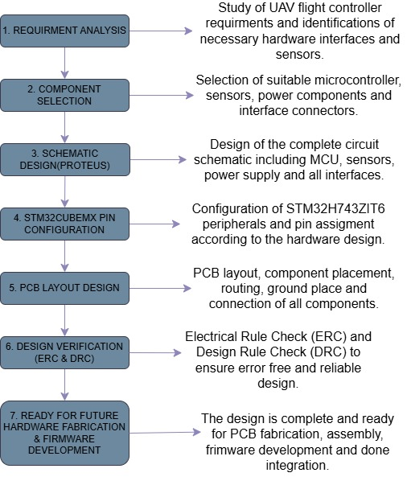
Figure 1.1 -- Flowchart of the Scope of the Project

CHAPTER 2
SYSTEM DESIGN AND HARDWARE DESCRIPTION

2.1 System Overview
The proposed system is a custom-designed flight controller hardware developed for unmanned aerial vehicle (UAV) applications. The design is centred around the STM32CUBEMX microcontroller, which serves as the primary processing unit for all future flight control operations. The objective of this hardware design is to provide a reliable and expandable platform that can later be programmed with flight control firmware and integrated into a quadcopter.
The flight controller schematic has been divided into four functional sections to improve readability, simplify debugging, and support future modifications. These sections are:
- Main Controller Circuit
- Sensor Interface Circuit
- Power Management Circuit
- USB and External Interface Circuit
Each section performs a specific function while working together to form the complete flight controller hardware. The system integrates three essential sensors required for stable UAV operation:
- ICM40609D Inertial Measurement Unit (IMU)
- MMC5983MA Three-axis Magnetometer
- BMP390 Digital Barometric Pressure Sensor
The design also includes communication interfaces such as USB Type-C, GPS, telemetry, RC receiver, SD card interface, ESC outputs, RGB status LED, buzzer, and SWD debugging interface, making the hardware suitable for future firmware implementation.
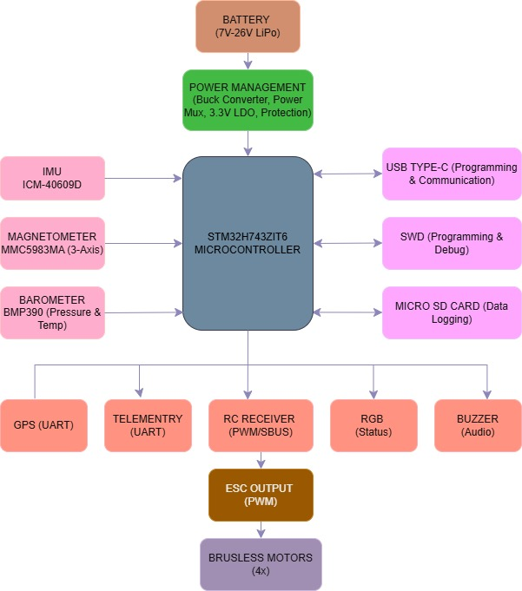
Figure 2.1 -- Overall Flight Controller Block Diagram
Hardware Block | Role in the System
Power Management | Converts and regulates battery input into stable voltage rails for the MCU and sensors
STM32CUBEMX MCU | Central processing unit; acquires sensor data and will host future flight-control firmware
Sensor Suite | Provides acceleration, angular rate, heading, and altitude measurements
Communication & I/O | Connects the controller to USB, GPS, telemetry, RC receiver, SD card, and ESC outputs
Table 2.1 -- Major Hardware Architecture Blocks

2.2 Hardware Architecture
The proposed flight controller follows a centralised architecture in which all sensors and peripheral devices are directly connected to the STM32CUBEMX microcontroller. The microcontroller communicates with the different peripherals through multiple communication protocols, namely SPI, I²C, UART, USB, and SDMMC. This centralised approach keeps signal routing predictable and simplifies both the schematic layout and the STM32CUBEMX peripheral configuration.
Sensors that require high-speed, low-latency data transfer, such as the IMU and magnetometer, are interfaced through SPI, while the barometer, which requires comparatively lower update rates, is interfaced through I²C. UART channels are reserved for the GPS module and the telemetry radio, USB OTG handles configuration and data transfer through the USB Type-C connector, and SDMMC provides an interface for an onboard microSD card used for future data logging.

2.3 STM32CUBEMX Microcontroller
The STM32CUBEMX is a high-performance microcontroller from the STM32H7 series, built around the ARM Cortex-M7 core. It was selected as the central processing unit of the flight controller because of its high clock speed, large memory capacity, hardware floating-point unit, and extensive set of communication peripherals, all of which are beneficial for real-time sensor fusion and flight control computations in future firmware development.
Parameter | Specification
Core | ARM Cortex-M7 with double-precision FPU
Maximum Clock Speed | 480 MHz
Flash Memory | 2 MB
SRAM | 1 MB
Package | LQFP144
Operating Voltage | 1.71 V to 3.6 V
Key Peripherals | SPI, I²C, UART, USB OTG, SDMMC, ADC, PWM Timers, GPIO
Table 2.2 -- STM32CUBEMX Specifications

2.4 Sensor Interfaces
Three sensors form the core sensing suite of the flight controller, each connected to the STM32CUBEMX through a dedicated communication interface as summarised below.
Sensor | Interface | Measurement
ICM-40609D | SPI | 3-axis acceleration and 3-axis angular velocity
MMC5983MA | SPI | 3-axis magnetic field for heading estimation
BMP390 | I²C | Barometric pressure and temperature for altitude estimation
Table 2.3 -- Sensor Specifications
The IMU and magnetometer are positioned away from the power management section on the PCB to reduce electromagnetic interference, while the barometer is shielded from direct airflow to improve the accuracy of altitude readings.

2.5 Power Management
The power management circuit accepts the input battery voltage and converts it into stable, regulated voltage rails for the microcontroller and sensors. The section consists of a buck converter for stepping down the input voltage, a power multiplexer for selecting between multiple possible power sources (such as battery and USB), and a 3.3 V low-dropout (LDO) regulator for generating a clean, low-noise supply for the sensitive sensor and microcontroller circuitry. Power filtering capacitors and protection circuitry are included to improve voltage stability and safeguard the board against transient conditions.

2.6 Communication Interfaces
The flight controller provides a comprehensive set of communication interfaces to support both configuration and future flight operations:
- USB Type-C - firmware upload, configuration, and data transfer.
- SWD - programming and debugging of the STM32CUBEMX.
- SD Card (SDMMC) - onboard data logging.
- GPS Connector (UART) - position and navigation data.
- Telemetry Connector (UART) - ground-station communication.
- RC Receiver Connector - manual pilot control input.
- ESC Outputs (PWM) - motor speed control signals.
- RGB LED and Buzzer (GPIO) - visual and audible status indication.

2.7 Working Principle
During operation, the STM32CUBEMX will continuously read acceleration, angular velocity, magnetic heading, and barometric pressure data from the onboard sensor suite. This raw sensor data can then be processed by future firmware using sensor-fusion algorithms to estimate the orientation and altitude of the UAV. Based on this estimated state and the pilot commands received through the RC receiver or telemetry link, the microcontroller will generate the PWM signals required to drive the Electronic Speed Controllers (ESCs) and, in turn, the brushless motors, thereby maintaining stable flight. The USB, SWD, and SD card interfaces support development, debugging, and data logging throughout this process, while the RGB LED and buzzer provide real-time status feedback.

CHAPTER 3
SCHEMATIC DESIGN, STM32CUBEMX PIN CONFIGURATION AND PCB DESIGN

3.1 Introduction
The hardware design of a flight controller is one of the most critical stages in UAV development. A properly designed schematic and PCB ensure reliable power distribution, stable communication between components, reduced electrical noise, and ease of future firmware development. In this project, the complete flight controller hardware was designed using Proteus Design Suite, while the peripheral configuration of the STM32CUBEMX microcontroller was prepared using STM32CUBEMX.
The development process followed a systematic approach beginning with component selection, followed by schematic capture, pin assignment, PCB layout generation, and design verification. The schematic was divided into functional sections to simplify design and improve readability. After successful completion of the schematic, footprints were assigned to all components, and a PCB layout was generated with careful attention to routing, grounding, and component placement.
The overall hardware design process is illustrated in Figure 3.1.
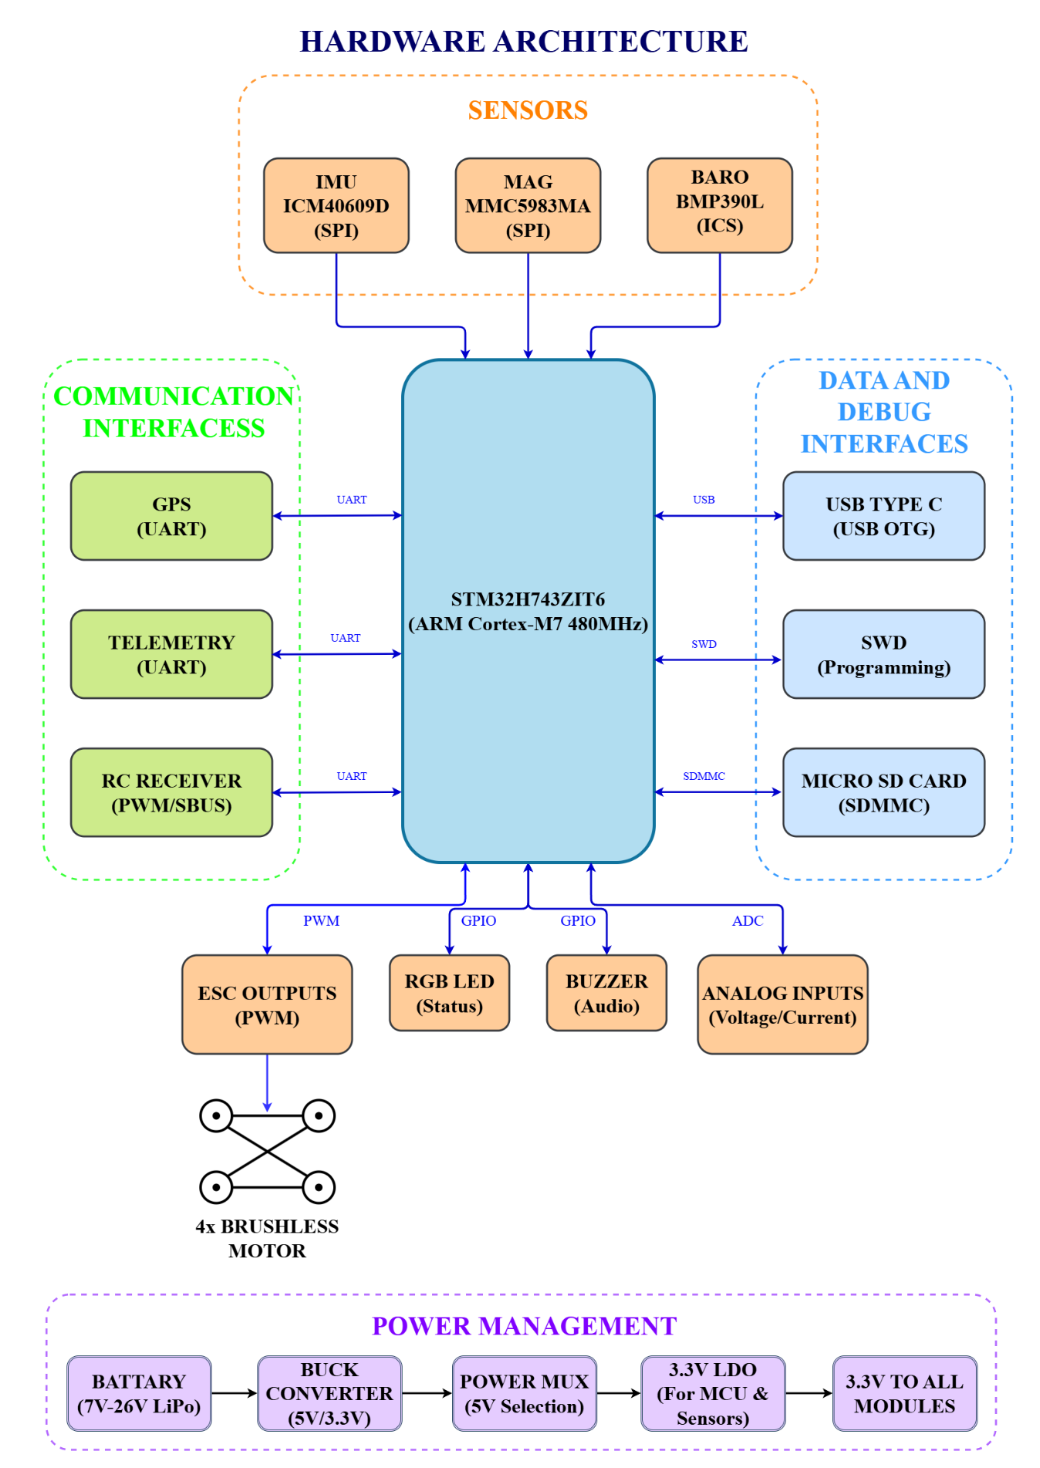
Figure 3.1 -- Hardware Design Flow

3.2 Design Methodology
The flight controller hardware was developed in five major stages.

Stage 1 -- Component Selection
The first stage involved selecting suitable components based on performance, availability, compatibility, and future expandability. The main hardware components used are listed in Table 3.1.
Component | Function
STM32CUBEMX | Main Microcontroller
ICM-40609D | Inertial Measurement Unit
MMC5983MA | Magnetometer
BMP390 | Barometric Pressure Sensor
USB Type-C Connector | Programming & Communication
Buck Converter | Voltage Conversion
Power Multiplexer | Power Source Selection
3.3V LDO | Voltage Regulation
Micro SD Card Slot | Data Logging
SWD Header | Programming & Debugging
RGB LED | Status Indication
Buzzer | Audible Notification
ESC Connectors | Motor Outputs
GPS Connector | GPS Interface
Telemetry Connector | Telemetry Interface
RC Receiver Connector | Receiver Interface
Table 3.1 -- Hardware Components Used in Schematic Design

Stage 2 -- Schematic Design
The complete schematic was designed using Proteus Professional. To improve readability, the design was divided into four functional sheets:
- Main Controller Sheet
- Sensor Sheet
- Power Supply Sheet
- USB and Interface Sheet
This modular approach simplifies future maintenance and debugging.

3.3 Main Controller Circuit
The first schematic sheet contains the STM32CUBEMX microcontroller and its supporting circuitry. The circuit includes:
- STM32CUBEMX microcontroller
- Clock oscillator
- Reset circuit
- Boot configuration
- Decoupling capacitors
- Power pins
- SWD programming interface
- Communication pin breakout
Proper decoupling capacitors were placed close to each power pin to reduce voltage fluctuations and improve stability. The oscillator was positioned near the microcontroller to minimise clock signal distortion.
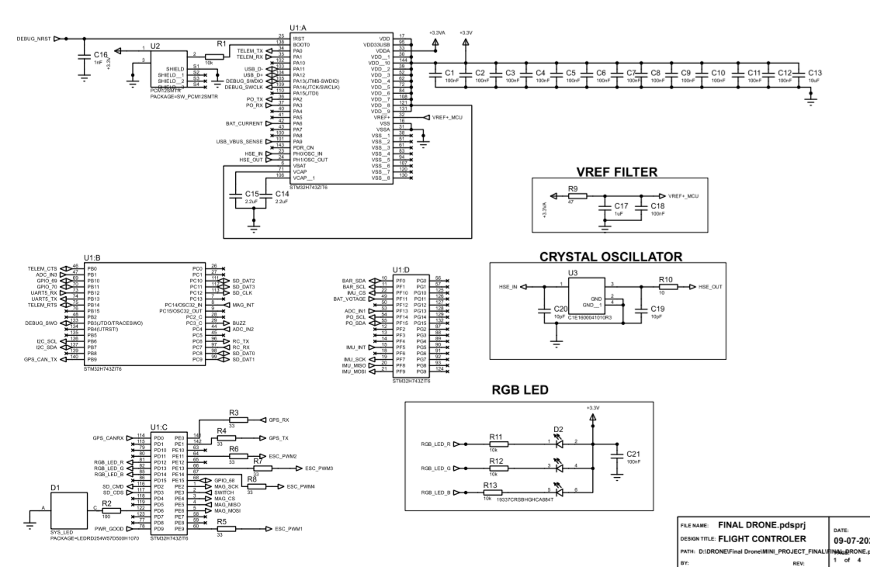Figure 3.2 -- Main Controller Schematic

3.4 Sensor Interface Circuit
The second schematic sheet contains all onboard sensors. The sensors are connected to the STM32CUBEMX through dedicated communication interfaces.

ICM40609D IMU
The IMU provides three-axis acceleration and three-axis angular velocity measurements. Communication Protocol: SPI. Purpose: Motion sensing, orientation measurement.

MMC5983MA Magnetometer
The magnetometer measures the Earth's magnetic field to determine heading. Communication Protocol: SPI. Purpose: Compass functionality, direction estimation.

BMP390 Barometer
The BMP390 measures atmospheric pressure and temperature. Communication Protocol: I²C. Purpose: Altitude estimation, vertical positioning.
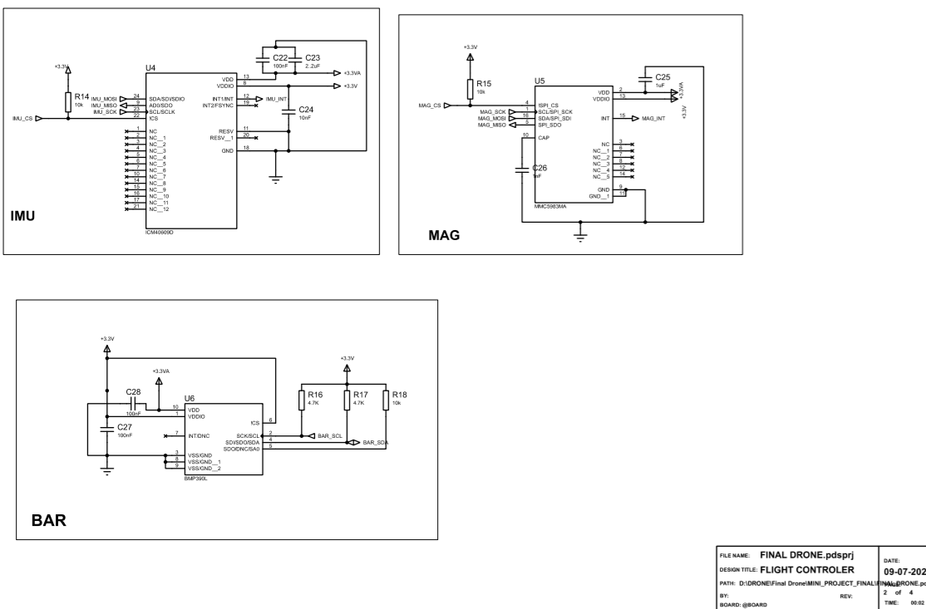Figure 3.3 -- Sensor Interface Schematic

3.5 Power Management Circuit
The third schematic sheet implements the power management section of the flight controller. The power circuit includes:
- Input power connector
- Buck converter
- Power multiplexer
- 3.3V Low Dropout Regulator
- Power filtering capacitors
- Protection circuitry
The buck converter reduces the input voltage to a suitable intermediate level, while the LDO generates a stable 3.3V supply for the microcontroller and sensors. Special attention was given to voltage stability, ripple reduction, noise filtering, and proper decoupling.
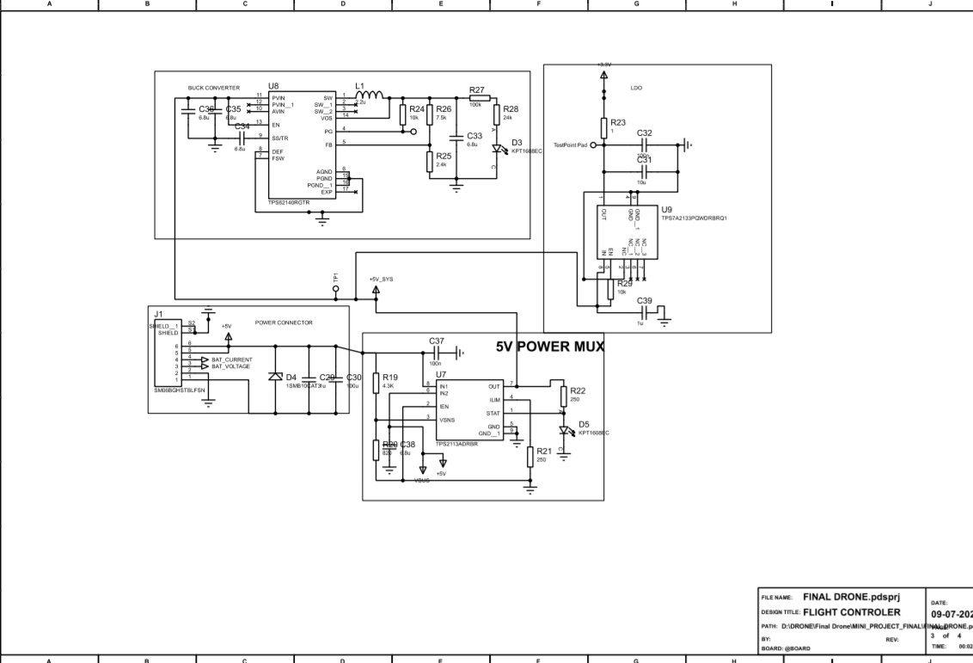Figure 3.4 -- Power Management Schematic

3.6 USB and External Interface Circuit
The fourth schematic sheet contains the external communication interfaces. These include:
- USB Type-C
- GPS Connector
- Telemetry Connector
- RC Receiver Connector
- SD Card Interface
- ESC Output Connectors
- RGB LED
- Buzzer
These interfaces provide flexibility for future expansion and integration with other UAV subsystems.
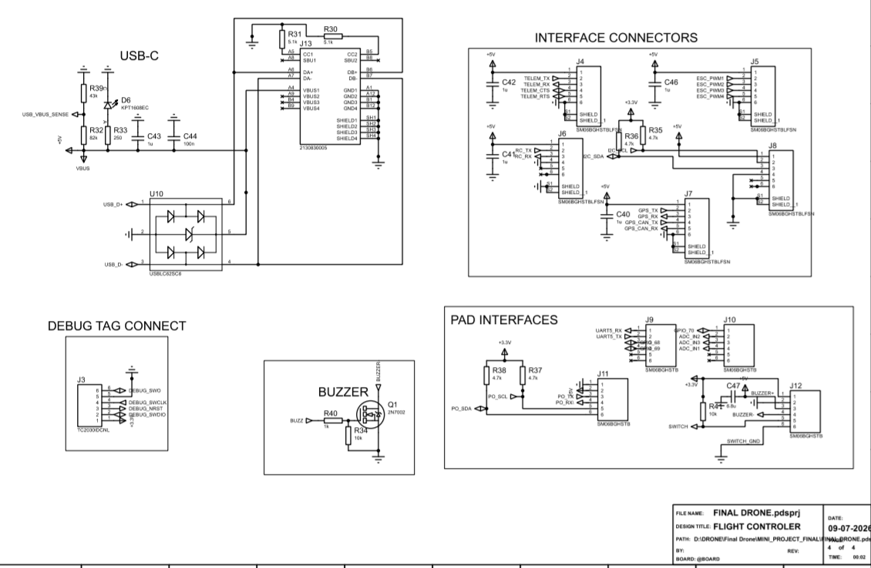Figure 3.5 -- USB and Interface Schematic

3.7 STM32CUBEMX Pin Configuration
After completing the schematic, the STM32CUBEMX was configured using STM32CUBEMX. The pin configuration was prepared according to the requirements of the hardware design. The following peripherals were enabled:
- GPIO
- SPI
- I²C
- UART
- USB OTG
- SDMMC
- ADC
- PWM Timers
- SWD Debug
Each peripheral was assigned appropriate pins based on the schematic connections to ensure compatibility between the software configuration and hardware design.
Peripheral | Purpose
GPIO | General Input/Output
SPI | IMU and Magnetometer Communication
I²C | BMP390 Communication
UART | GPS and Telemetry
USB OTG | USB Type-C Interface
SDMMC | SD Card Interface
ADC | Analog Inputs
PWM Timers | ESC Outputs
SWD | Programming and Debugging
Table 3.2 -- STM32 Peripheral Configuration
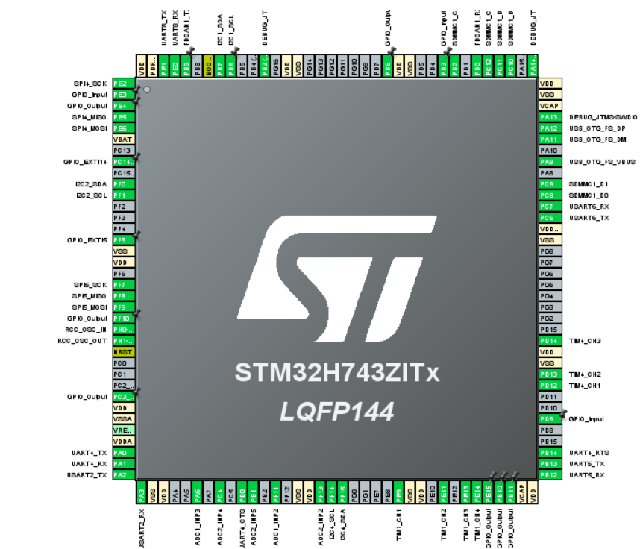
Figure 3.6 -- STM32CUBEMX Pin Configuration

3.8 PCB Design
Following successful schematic completion, the design was transferred to the PCB layout environment in Proteus. The PCB was designed with emphasis on compact board size, efficient component placement, short signal paths, stable power routing, ground plane implementation, and ease of future assembly.
The STM32CUBEMX was placed near the centre of the PCB to reduce the average routing distance to peripheral components. The IMU and magnetometer were positioned away from the power supply section to minimise electromagnetic interference. The USB connector and interface headers were placed near the board edges for convenient access.

3.9 PCB Layout
Component placement was completed before routing to achieve an organised and compact design. The PCB layout was developed using the following considerations:
- Logical grouping of components
- Short communication traces
- Wide power traces
- Continuous ground reference
- Adequate spacing between components
- Accessible connectors
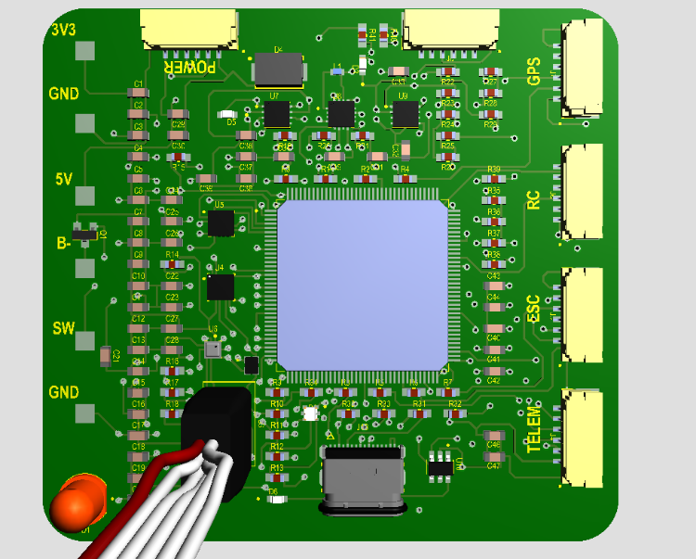
Figure 3.7 -- PCB 3D Top Layer

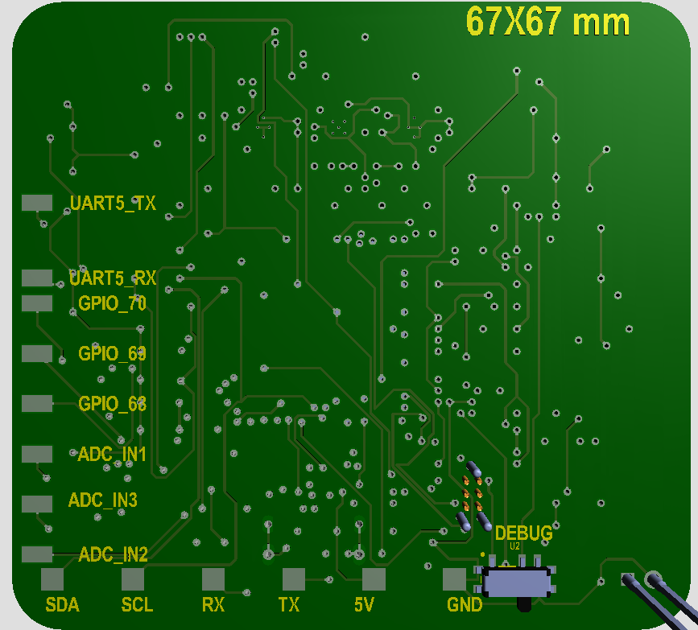
Figure 3.8 – PCB 3D Bottom Layer

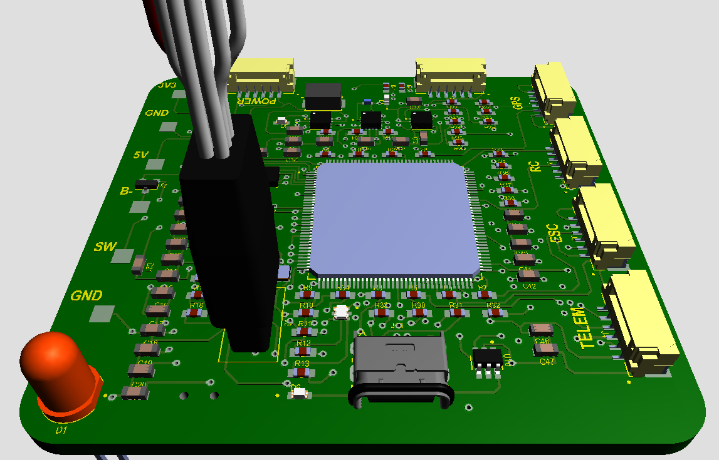
Figure 3.9 -- 3D PCB View

3.10 PCB Design Considerations
The following design practices were followed during PCB development:
- Decoupling capacitors were placed close to the power pins of the STM32CUBEMX
- High-speed communication traces were kept as short as possible
- Power traces were made wider than signal traces to reduce voltage drop
- The crystal oscillator was positioned close to the microcontroller
- A continuous ground plane was used to reduce electromagnetic interference
- Connectors were placed at the PCB edges to simplify external wiring
- Design Rule Check (DRC) was performed after routing to identify and eliminate design violations

CHAPTER 4
PCB DESIGN VERIFICATION AND ANALYSIS

4.1 Introduction
After completing the schematic design and PCB layout, it is essential to verify the design to ensure that all electrical connections are correct and that the PCB complies with standard design rules. Verification helps identify potential errors before fabrication, reducing the possibility of hardware failure and minimising redesign efforts.
In this project, the verification process consisted of checking the schematic connections, reviewing the PCB layout, confirming the STM32CUBEMX pin assignments, and ensuring that the board was ready for future fabrication and firmware development. The design was analysed with respect to power distribution, component placement, signal routing, and communication interfaces.

4.2 STM32CUBEMX Pin Configuration Verification
The STM32CUBEMX was configured using STM32CUBEMX to match the hardware connections defined in the schematic. The following peripheral configurations were reviewed:
- SPI interfaces for sensor communication
- I²C interface for the BMP390
- UART interfaces for GPS and telemetry
- USB OTG interface for USB Type-C
- SDMMC interface for the microSD card
- PWM timer outputs for ESC connectors
- GPIO pins for RGB LED, buzzer, and other control signals
- SWD interface for programming and debugging
The software pin configuration was checked against the schematic to ensure consistency between the hardware design and future firmware development.

4.3 PCB Layout Analysis
The PCB layout was designed to achieve a compact, organised, and reliable hardware platform. During layout development, emphasis was placed on minimising routing complexity while maintaining proper spacing between components.
The microcontroller was positioned near the centre of the PCB to reduce the average routing distance to peripheral components. Sensors were grouped together to simplify communication routing, and the power management section was separated from the sensor area to reduce electrical noise.
External connectors such as USB Type-C, GPS, telemetry, RC receiver, and ESC outputs were placed near the board edges to facilitate easy access during assembly and future integration.
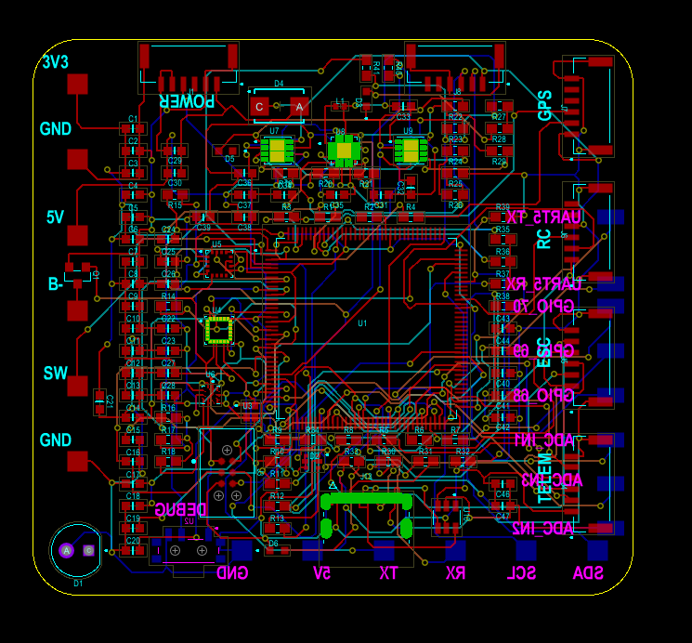Figure 4.0 -- PCB Layout

4.4 PCB Routing Analysis
The routing process was carried out by considering standard PCB design practices. The following design considerations were adopted:
- Power traces were made wider than signal traces to improve current-carrying capability
- High-speed communication traces were kept as short as possible
- The crystal oscillator was placed close to the STM32CUBEMX
- Signal routing was arranged to avoid unnecessary crossings
- Sensitive sensor connections were kept away from the power section wherever possible
- Connectors were positioned to simplify external wiring
These routing practices contribute to better signal integrity and improve the overall reliability of the PCB.

4.5 Design Rule Verification
Before considering the PCB design complete, the layout should be checked using the Design Rule Check (DRC) feature available in Proteus. The DRC verifies parameters such as:
- Minimum track width
- Clearance between tracks
- Pad spacing
- Via spacing
- Unconnected nets
- Short circuits
- Copper overlaps
Performing these checks ensures that the PCB meets the selected manufacturing rules and reduces the likelihood of fabrication errors.
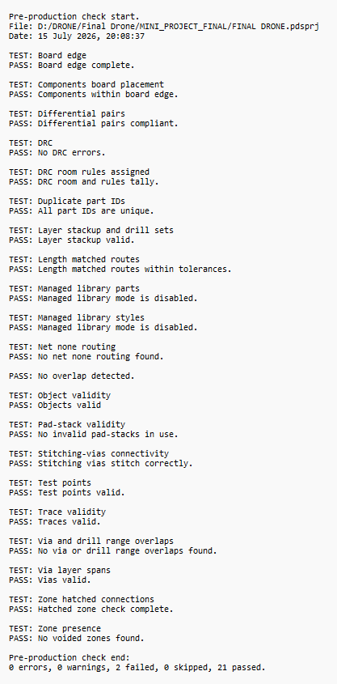
Figure 4.1 -- Design Rule Check (DRC)

4.6 Electrical Rule Verification
The Electrical Rule Check (ERC) is used to verify the logical correctness of the schematic. The ERC helps identify issues such as:
- Missing power connections
- Floating input pins
- Incorrect net assignments
- Conflicting signal directions
- Unconnected components
After resolving any reported issues, the schematic is considered ready for PCB generation.
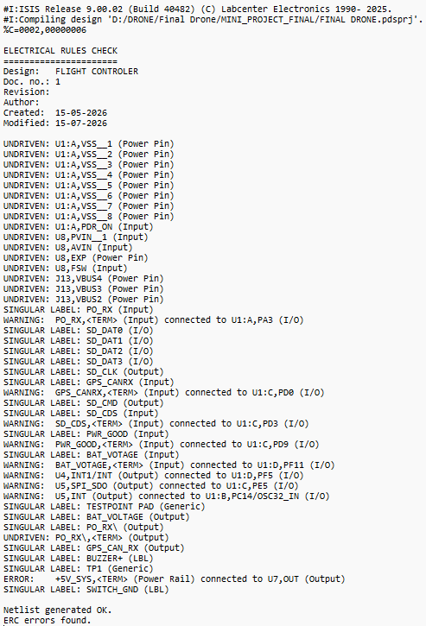
Figure 4.2 -- Electrical Rule Check (ERC)

4.7 Advantages of the Proposed Hardware Design
The custom flight controller developed in this project offers several advantages.
Advantage | Description
High-Performance MCU | Uses STM32CUBEMX ARM Cortex-M7 microcontroller.
Modular Design | Schematic divided into functional sections for easier understanding and maintenance.
Expandable Hardware | Includes interfaces for GPS, telemetry, SD card, RC receiver, and ESCs.
Professional PCB Layout | Designed using standard PCB layout practices.
Modern Connectivity | USB Type-C interface and SWD debugging support.
Essential Sensors | Integrates IMU, magnetometer, and barometer.
Ready for Future Development | Hardware prepared for firmware implementation and drone integration.
Table 4.1 -- Advantages of the Proposed Design

4.8 Limitations of the Current Work
The current project focuses only on the hardware design stage. The following activities have not been completed and are outside the scope of this mini project:
- PCB fabrication
- Component assembly and soldering
- Firmware development
- Sensor calibration
- Hardware testing
- Motor control testing
- Flight testing
- Autonomous navigation implementation
These limitations are expected because the objective of the project was to design the hardware platform rather than develop a complete flight-ready system.

4.9 Discussion
The completed schematic, PCB layout, and STM32CUBEMX pin configuration provide a solid foundation for future development of a custom UAV flight controller. By using the STM32CUBEMX microcontroller and integrating essential sensors and interfaces, the design supports future implementation of flight control firmware and expansion with additional modules.
The modular organisation of the schematic simplifies future modifications, while the PCB layout follows good engineering practices that will assist during fabrication and assembly. Overall, the project demonstrates the application of embedded hardware design principles in developing a professional flight controller suitable for educational and research purposes.

CHAPTER 5
CONCLUSION AND FUTURE SCOPE

5.1 Conclusion
The objective of this mini project was to design a custom flight controller hardware for UAV applications using the STM32CUBEMX microcontroller. The project focused exclusively on the hardware development stage, including schematic design, PCB layout, and STM32CUBEMX pin configuration. These are essential steps in developing a reliable flight controller and provide the foundation for future firmware implementation and drone development.
A complete schematic of the flight controller was successfully designed using Proteus Design Suite. The schematic integrates the STM32CUBEMX microcontroller with the essential hardware required for a modern flight controller, including the ICM40609DInertial Measurement Unit (IMU), MMC5983MA magnetometer, BMP390 barometric pressure sensor, USB Type-C interface, SWD debugging interface, SD card interface, GPS connector, telemetry connector, RC receiver connector, ESC outputs, RGB status LED, buzzer, and power management circuitry. The modular organisation of the schematic into separate functional sections improves readability, simplifies future modifications, and facilitates debugging.
Following schematic completion, a PCB layout was developed in Proteus. During the PCB design process, attention was given to component placement, routing strategy, power distribution, and signal integrity. Components were arranged to reduce routing complexity and improve accessibility, while high-speed signals and power traces were routed following standard embedded hardware design practices. The PCB layout is suitable for future fabrication and assembly.
The STM32CUBEMX was configured using STM32CUBEMX, where the required peripherals were assigned according to the hardware design. Interfaces such as SPI, I²C, UART, USB OTG, SDMMC, PWM, ADC, GPIO, and SWD were configured to support communication with the onboard sensors and external peripherals. This ensures consistency between the hardware design and future software development.
Although firmware development, PCB fabrication, hardware testing, and flight experiments were not included in the scope of this project, the completed design represents a strong foundation for future implementation. The hardware is modular, expandable, and suitable for integration into a custom UAV platform.
This project has provided practical experience in embedded hardware design, schematic capture, PCB layout development, component selection, and microcontroller configuration. It has also enhanced understanding of the hardware architecture of modern flight controllers and the design practices required for developing reliable embedded systems.
Overall, the objectives of the mini project have been successfully achieved, and the resulting design is ready for the next stages of development.

5.2 Future Scope
The current work is limited to the hardware design of the flight controller. Several stages remain to transform the design into a fully functional UAV flight control system. The proposed future work includes the following.

5.2.1 PCB Fabrication
The designed PCB can be manufactured using professional PCB fabrication services. After fabrication, all electronic components can be assembled according to the schematic.

5.2.2 Hardware Assembly and Testing
After PCB fabrication, the hardware can be assembled and tested. Basic verification such as power supply validation, clock generation, communication interface testing, and sensor connectivity can be performed to ensure correct operation.

5.2.3 Firmware Development
The next stage will involve developing firmware using STM32CUBEMX. The firmware will initialise all peripherals, configure communication interfaces, read sensor data, and control the outputs required for flight operation.

5.2.4 Sensor Calibration
The onboard sensors, including the IMU, magnetometer, and barometer, can be calibrated to improve measurement accuracy. Proper calibration is essential for reliable attitude estimation and stable flight.

5.2.5 Development of a Complete Quadcopter
The custom flight controller developed in this project can be integrated into a complete quadcopter platform. After firmware development and testing, the controller can be connected with Electronic Speed Controllers (ESCs), brushless motors, a power distribution system, and other required hardware to create a fully functional UAV.

5.2.6 Raspberry Pi Integration for Autonomous Flight
A Raspberry Pi can be integrated as a companion computer to provide advanced processing capabilities that complement the STM32CUBEMX flight controller. In the proposed architecture, the STM32CUBEMX will perform real-time flight control, sensor acquisition, and motor control, while the Raspberry Pi will execute computationally intensive tasks such as image processing, computer vision, path planning, and decision-making. This combination enables the development of an autonomous UAV capable of performing advanced missions while maintaining reliable real-time flight control.

5.2.7 Autonomous Navigation
After integrating the Raspberry Pi, autonomous capabilities can be implemented, including:
- Waypoint navigation
- Obstacle detection and avoidance
- Vision-based navigation
- Object detection and tracking
- Autonomous mission execution
These features will allow the drone to perform complex tasks with minimal human intervention.

5.3 Overall Achievement of the Project
The major achievements of this mini project are summarised in Table 5.1.
Objective | Status
Literature Review | Completed
Hardware Component Selection | Completed
Flight Controller Architecture Design | Completed
Proteus Schematic Design | Completed
STM32CUBEMX Circuit Design | Completed
Sensor Interface Design | Completed
Power Management Circuit Design | Completed
STM32CUBEMX Pin Configuration | Completed
PCB Layout Design | Completed
PCB Fabrication | Future Work
Hardware Testing | Future Work
Firmware Development | Future Work
Complete Drone Development | Future Work
Raspberry Pi Integration | Future Work
Autonomous Flight | Future Work
Table 5.1 -- Project Achievement Summary

REFERENCES
- STMicroelectronics, "STM32H743xI/G Datasheet," Rev. 9, STMicroelectronics, Geneva, Switzerland.
- STMicroelectronics, "RM0433 Reference Manual: STM32H743/753 Advanced ARM-Based 32-Bit MCUs," STMicroelectronics.
- TDK InvenSense, "ICM40609DDatasheet," TDK Corporation.
- MEMSIC, "MMC5983MA Three-Axis Magnetic Sensor Datasheet," MEMSIC Inc.
- Bosch Sensortec, "BMP390 Digital Pressure Sensor Datasheet," Bosch Sensortec GmbH.
- STMicroelectronics, "AN4488: Getting Started with STM32 Hardware Development," STMicroelectronics.
- Labcenter Electronics, "Proteus Design Suite User Guide," Labcenter Electronics Ltd.
- ARM Ltd., "ARM Cortex-M7 Technical Reference Manual," ARM Limited.
- STMicroelectronics, "STM32CUBEMX User Manual," STMicroelectronics.
- Altium Limited, "PCB Design Guidelines for High-Speed Embedded Systems," Altium Documentation.
- C. A. Balanis, Antenna Theory: Analysis and Design, 4th ed., Wiley, 2016.
- M. H. Rashid, Power Electronics: Circuits, Devices, and Applications, Pearson Education.
- H. W. Ott, Electromagnetic Compatibility Engineering, Wiley, 2009.
- Pixhawk Project, "Pixhawk Hardware Design Documentation."
- ArduPilot Development Team, "ArduPilot Documentation."

