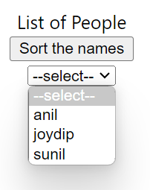

Diff algorithm

Option [list[0]: anil] => 0

Option [list[1]: joydip] => 1

Option [list[2]: sunil] =>2

Anil [0]

Joydip [1]

Sunil [2]

Option [list[0]: anil] => 0

Option [list[1]: sunil] => 1

Option [list[2]: joydip] => 2

Anil [0]

Sunil [1]

Joydip [2]