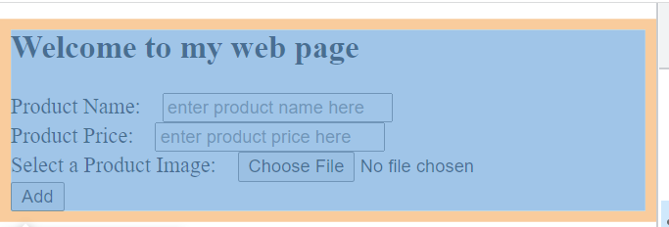



 

JS engine

HTML

JS

parser

17.16.29.203/f-w-a/index.html

C:\inetpub\wwwroot\

DNS

HTTP – port: 80