Provider for SQL SERVER

Common Provider

Provider for SQL SERVER

1. Adding package via Package Manager Console:

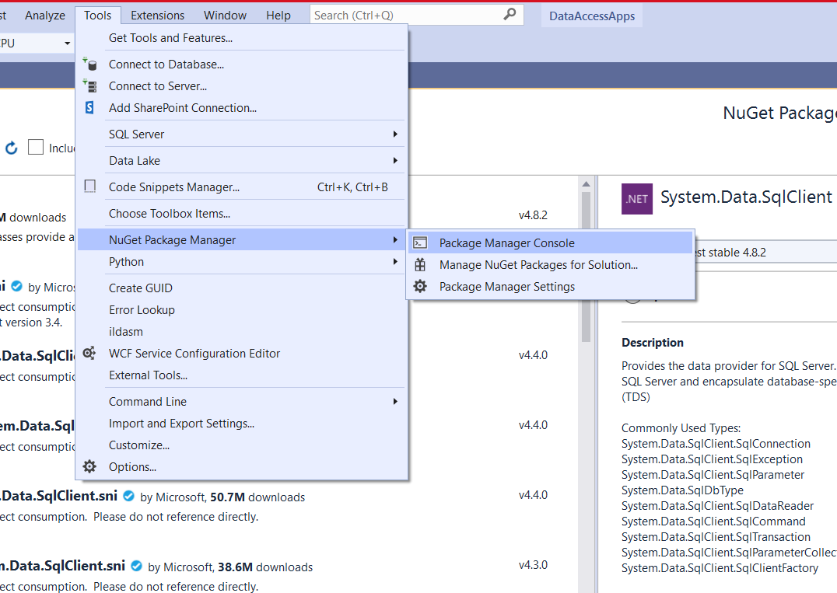

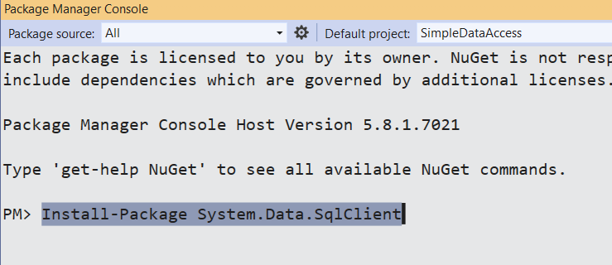

1. .NET CLI:



1. Adding the package in an application via NuGet Package Manager Dialog Box:

