1. Create a table like the following:

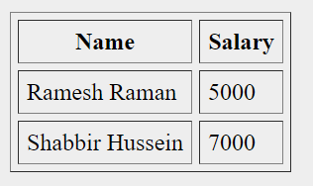

1. The table has spaces between cells and also between the cell and the content of the cell
2. Table should have border
3. Create a table like the following:

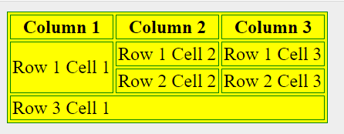

1. the first row first column has height of two rows
2. the last row column has span of 3 columns
3. border color of the table should be green and background color of the table should be yellow (do not use CSS, use attributes of table tag)
4. create an unordered list like the following where the bulltes are square (do not use CSS):

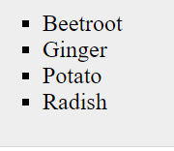

1. Create a list like the following:

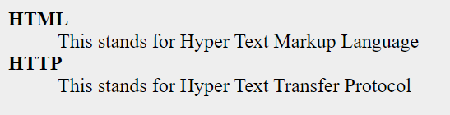

1. Create a web application with an HTML page design like the following:

