## **Payroll Application**

### Objective:

This assignment will help to understand and implement different OOP ideas, such as how to create class, object, and constructor, how to call base class overloaded constructors using ‘super keyword explicitly, inheritance etc.

### Problem Statement:

The application will be used to calculate and display salary of different types of employees, such as Developer, Manager, Human Resource people etc.

Use the following diagram to create an application with the base class, ‘Employee’ and two child (derived) classes ‘Hr’ and ‘Developer’

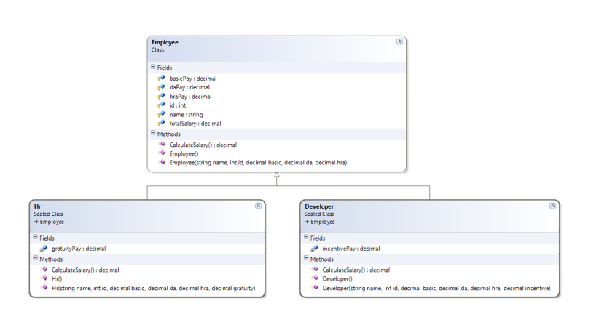

Create a Java project (payrollapplication) with following files:

1. App.java: App class with main method
2. Employee.java: Employee base class code
3. Developer.java: Developer child class code
4. Hr.java: Hr child class code

In “main” method:

1. Create an array to store at least two Developer and two Hr class object references.
2. Ask for all the necessary inputs regarding Developer or Hr and then create the objects

Iterate through the array and display salary of the employees

Note:

1. Refer the above images for the creation of classes and expected output.
2. Every class should have both default and parameterized constructor
3. Assigning values to the fields of the classes should be done through overloaded constructors
4. The same method to calculate salary should be present in the base, Employee class, as well as derived classes, i.e., “Developer” and “Hr” classes.
5. Create getter and setter for every data member of every class

Child class constructor should call overloaded constructor of the base class explicitly to by-pass all the values to the base class, and get all the common fields assigned there in the base class itself