1. Create a web application using React JS which will display certain product records (refer the screenshot)

**Objective**: Use React JS concepts: Lifecycle, map function and displaying list of items in React JS, applying styling using CSS/SCSS/SASS etc.

**Capability Code**: WEBR0017 [Understand and implement React Concepts]

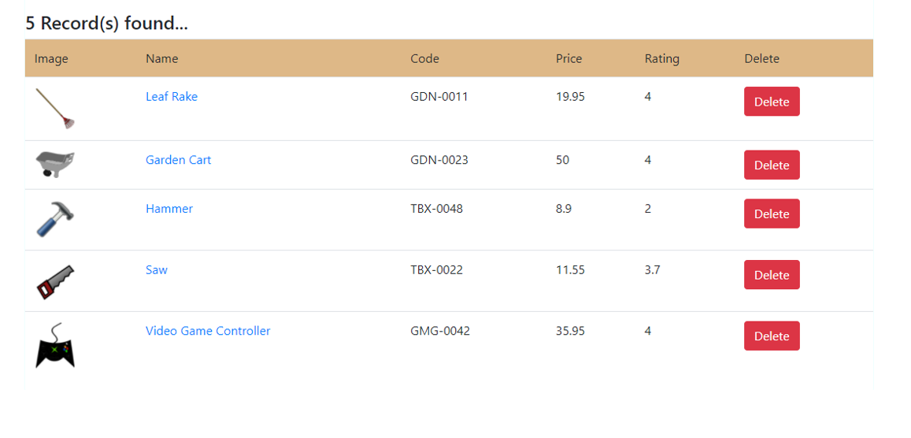

Description:

1. The application must be having following features/architecture:
   1. Model class representing product information must be created and stored in “models” folder
   2. An array which will be used to store product objects must be declared in a file and that must be stored in a folder, “data”
   3. The functions to add a new record (if that does not exist already) in the repository array and also the display all the product records should be written in a file and that should be saved in a folder, “services”, along with the method to delete the selected product record from the original array, too.
   4. the methods should be called from the component file
   5. You should use class component’s lifecycle methods
   6. You should appropriate component lifecycle method in order to stop unnecessary rendering of the class component
   7. Also, if there is any functional component, unnecessary rendering of the same should be stopped
2. The entire application must be written using TypeScript/JavaScript
3. The style should be provided using SCSS/SASS