1. Create a web application which will display certain product records (refer the screenshot)

Objective: Bundle all the modules of an application together using webpack

Capability Code: WEBR004

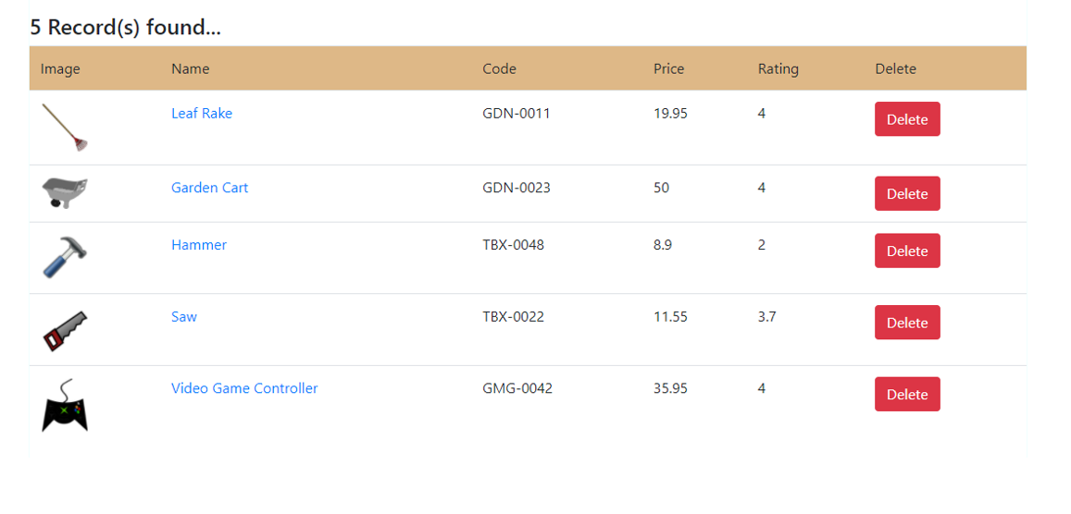

Description:

1. Create the web application having an HTML page display the above design to display records
2. The application must be having JS code written using following architecture:
   1. Model class representing product information must be created and stored in “models” folder
   2. An array which will be used to store product objects must be declared in a file and that must be stored in a folder, “data”
   3. The functions to add a new record (if that does not exist already) in the repository array and also the display all the product records should be written in a file and that should be saved in a folder, “manager”
   4. The method to display all the product records should be responsible to display the records by manipulating DOM
   5. the methods should be called from a main file
3. The entire application must be written using TypeScript
4. The entire application must be transpiled as well as bundled using transpiler and webpack bundler
5. The bundle must be hosted using webpack-dev-server