1. Create a web application which will display certain product records (refer the screenshot) and use SCSS to apply style on this webpage

Objective: Implement Visual Design Analysis - Style-guide/Pixel Perfect Design/SASS

Capability Code: WEBR006

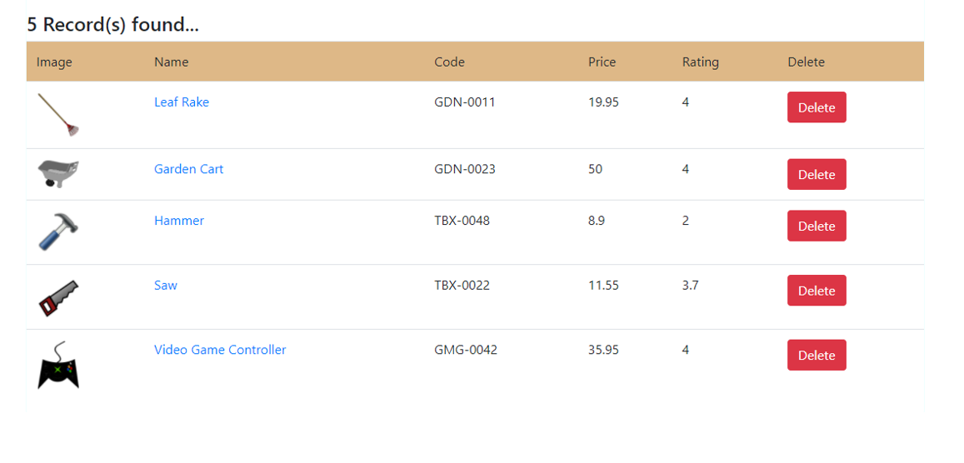

Description:

1. Use the same web application created to solve the assignment given in “Assignment_WebTech_MERNStack_WEB004_Webpack.docx”, having an HTML page to display the above design to display records
2. Use SCSS to apply the style in that web page
3. Check whether you need to import “styles.scss” file or “styles.css” file in main.ts file and change the code accordingly