1. Create web application which displays the product records: (just an HTML file and one JS file with all elements, array etc.)

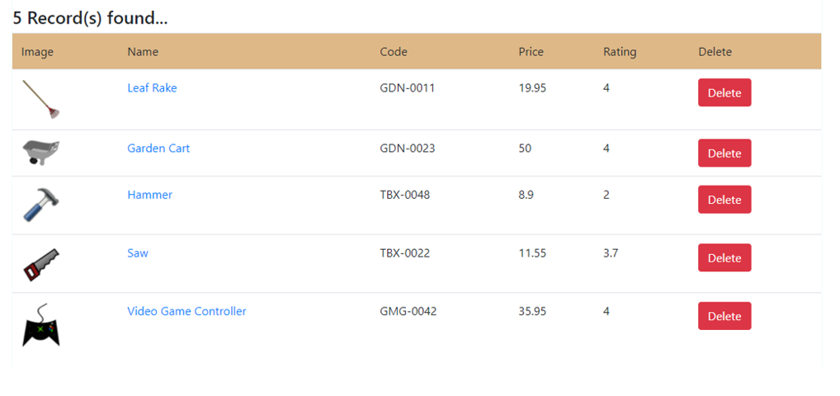

Description:

* 1. Store product data in an array (As objects)
  2. Create a component (ProductRowElement) for every row
  3. All the row-components will be part of the parent component (say, ProductsElement)
  4. Click the delete button to remove the corresponding productrowelement from DOM as well as the product record from array