1. Create web application which displays the product records: 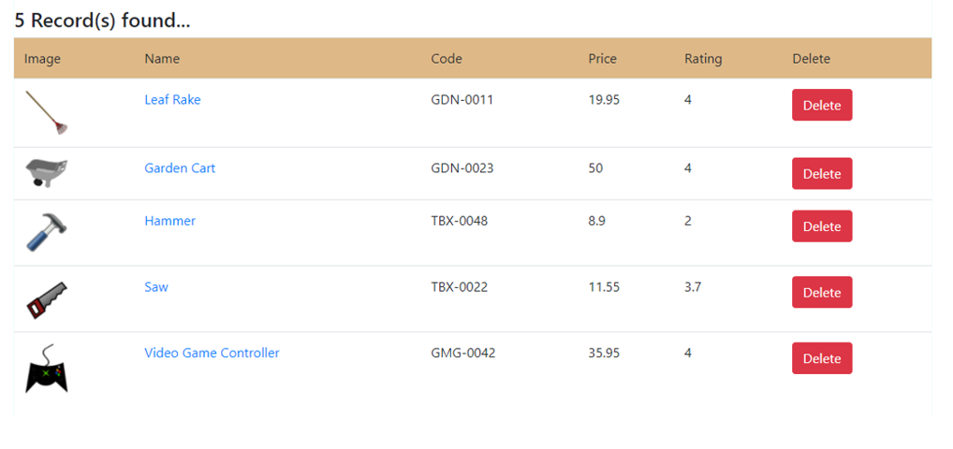

Description:

* 1. Store product data in an array (As objects)
  2. Create a component (ProductRowElement) for every row
  3. All the row-components will be part of the parent component (say, ProductsElement)
  4. Click the delete button to remove the corresponding productrowelement from DOM as well as the product record from array
  5. array, elements etc. should be placed in separate files and will be written using TS/JS, will be hosted by webpack-dev-server and bundled using webpack [use your previous application done with SASS/SCSS]

1. Do the same application using Polymer.js (don’t use previous application)
2. Do the same application using Stencil.js (don’t use previous application)