1. Create a web application using React JS routing and Form

**Objective**: learn routing in React JS, how to use forms in React JS, how to validate an input form and its controls

**Capability Code**: WEBR0023 [Develop complex applications using “Formik” or redux-forms]

1. When you load/run the application, Home and Default View (landing page) should be displayed.

URL: <http://localhost:3000/> or <http://localhost:3000/home>

Image-1:

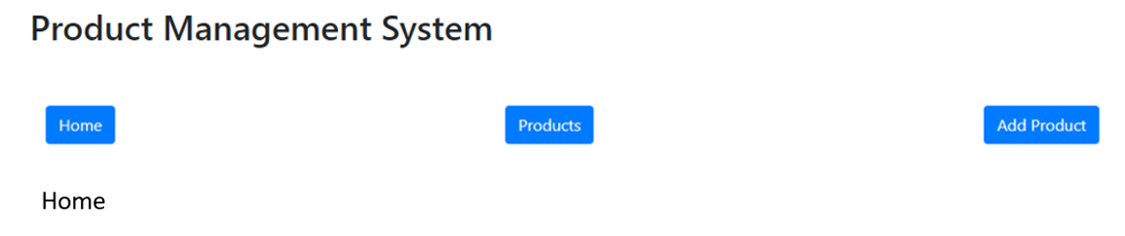

1. When ‘Products’ button on the dashboard is clicked, then you should be directed to the given URL where list of products will be displayed through another component, with the facility of filtration and sorting.

URL: <http://localhost:3000/products>

Image-2:

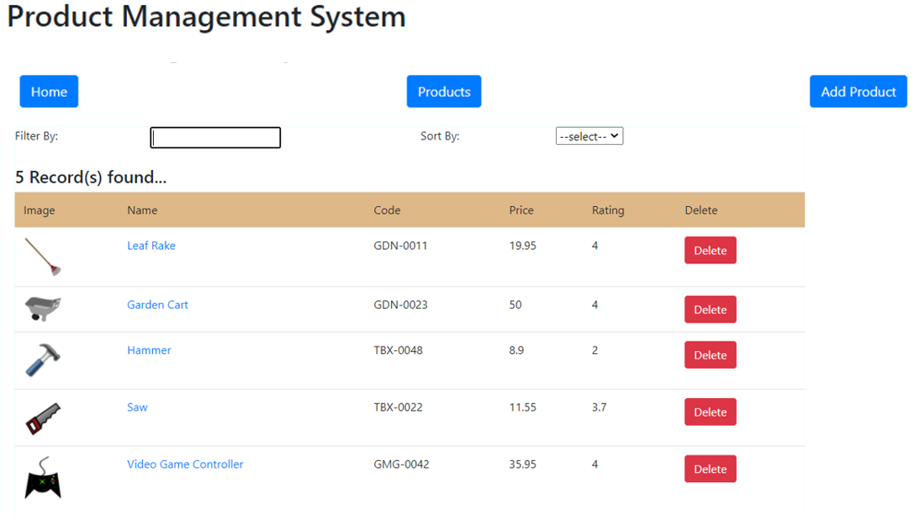

1. If you click on any image from any row, you should be able to view the complete details of a selected product through another component.

URL: [http://localhost:30000/products/view/{id}](http://localhost:30000/products/view/%7bid%7d)

Image-3:

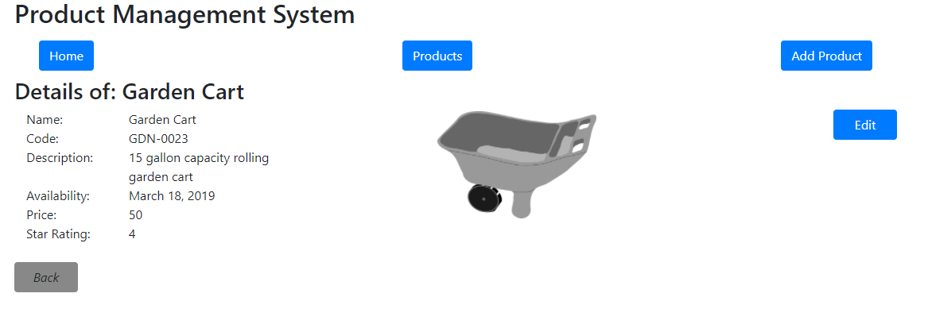

1. If you click on the Edit button in view component or if you click on any name from any row in the table of products (previous image-2), you should be able to edit the selected product through another component. On click of ‘Update’ button, the product record must be updated in the data source as well as you should be redirected to the table of products view where the updated product detail will be visible, after the displaying success message (in case of error, failure message) through alert box

URL: [http://localhost:3000/products/edit/{id}](http://localhost:3000/products/edit/%7bid%7d)

Image-4:

[the image for Add feature has been used. In reality, the input controls of the form will be displaying the selected product’s property values and the text of the button at the bottom will be ‘Update’, NOT ‘Add’]

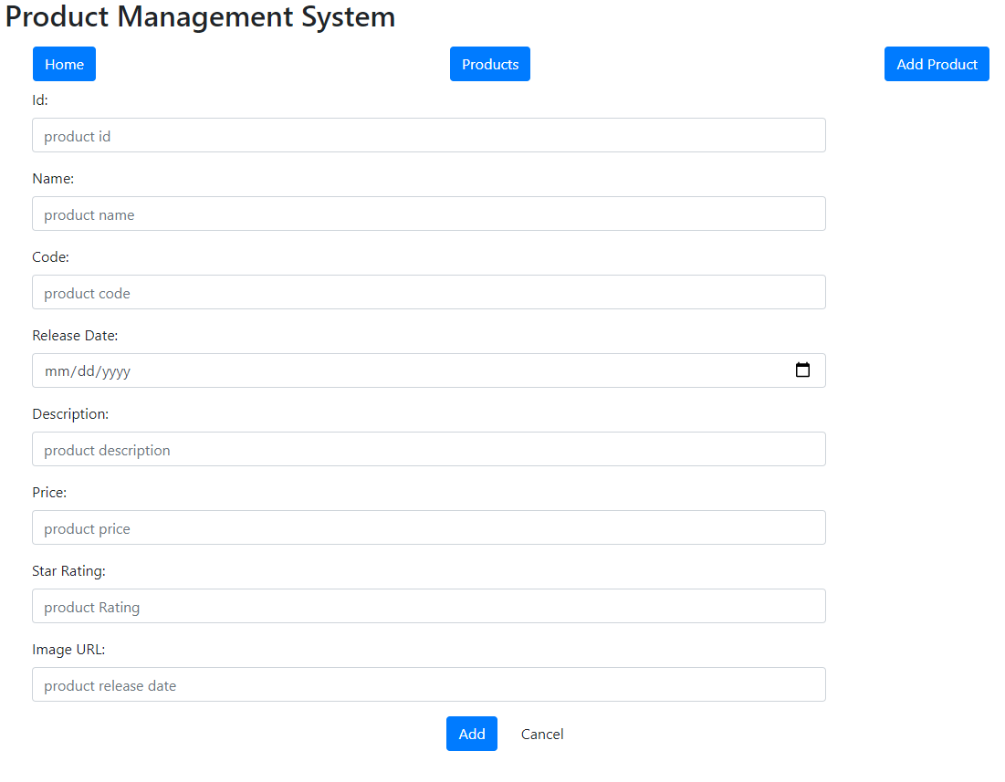

1. If you click on the ‘Add Product’ button on the dashboard, then you should be able to add a new record through another component. Upon clicking the ‘Add’ button here, the product must be added successfully in the data source and you should be redirected to the list/table of products view after displaying the success message through alert box. If the product addition is unsuccessful, then the error message should be displayed through alert box first and then you should be redirected to product list/table component.

Image-5:



NOTE:

1. This application must have two versions: one without any React Hook and another completely done with the help of React Hooks
2. Kindly use the two version of the application as created for the assignments given for the previous capability and document in *‘Assignment_WebTech_MERNStack_WEB0022_ReactJS.docx*’
3. The **1st version of the application** [the one without hook] must use **Controlled component** (component controlling and maintaining state of the input controls of a form) and the **2nd version** [the one with Hook] must use **Formik** for the update and add module/component
4. The input controls must be validated and if any validation error happens, the error message should be displayed beside the controls and should disappear as soon as the error rectified
5. The entire application must use routing feature, necessary components (such as, Route, BrowserRouter, Switch, Link, NavLink etc.)