1. Create web application which displays the product records:

Use the application solution for the 1st assignment in “Assignment_WebTech_MERNStack_WEB009_WEBCOMPONENTS.docx”

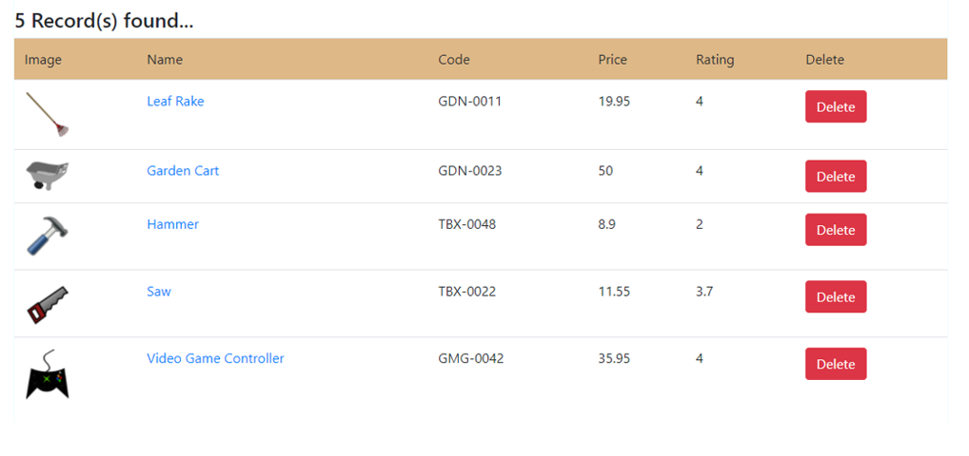

Description:

* 1. Store product data in a JSON file
  2. Host the file using JSON-SERVER
  3. Create a component (ProductRowElement) for every row
  4. All the row-components will be part of the parent component (say, ProductsElement)
  5. Product records should be fetched using
     1. Pure AJAX
     2. Fetch() API
  6. Click the delete button to remove the corresponding productrowelement from DOM as well as the product record from JSON file
  7. array, elements etc. should be placed in separate files and will be written using TS/JS, will be hosted by webpack-dev-server and bundled using webpack [use you previous application done with SASS/SCSS]