1. Create a React JS application which helps you to add two numbers: (refer the screenshot)

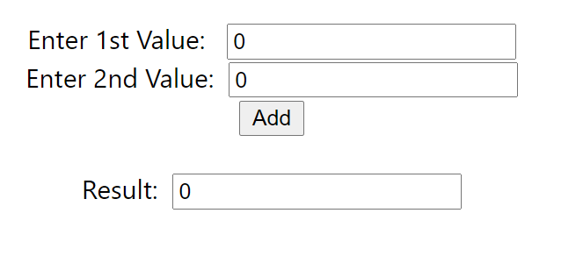

1. TypeScript should be used
2. Apart from App component, you need to create another component (say, Calculator) to complete the task
3. Naming convention must be followed (file name, class name in Pascal casing and method, property names in camel casing, application name with dash separated value, names should be self-describing)

Ex:

Calculator.tsx 🡪 Calculator

Class Sample{

someData:string;

addNumbers(){

}

}

xx-yy-zz

calculator-react-app