1. Create the web page to add a product record like the following:

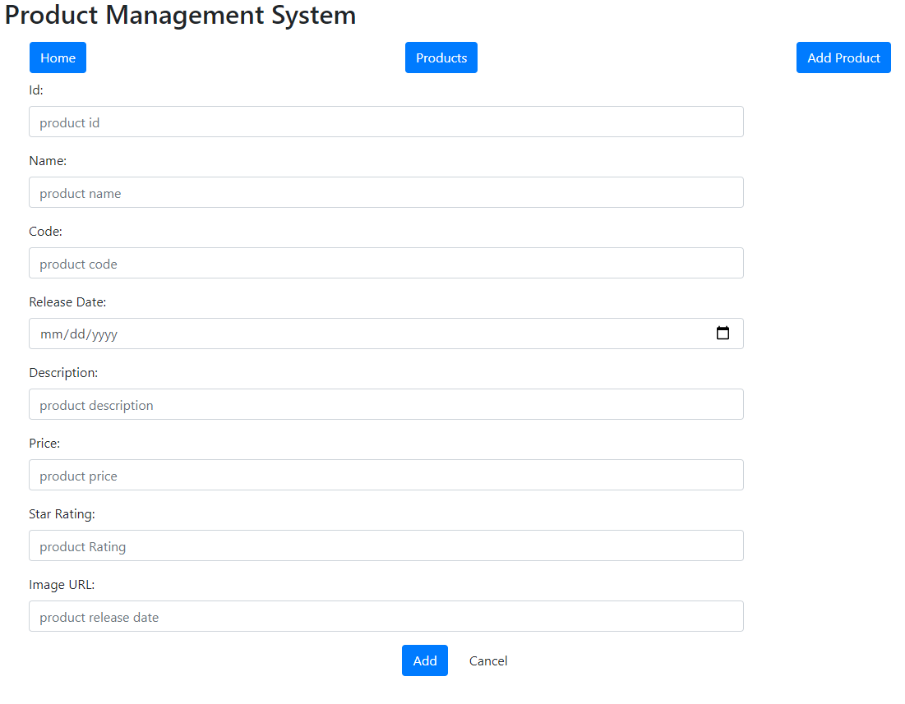

1. Create the following design2 to view the details of a product when the image of any record is clicked in design 1.

