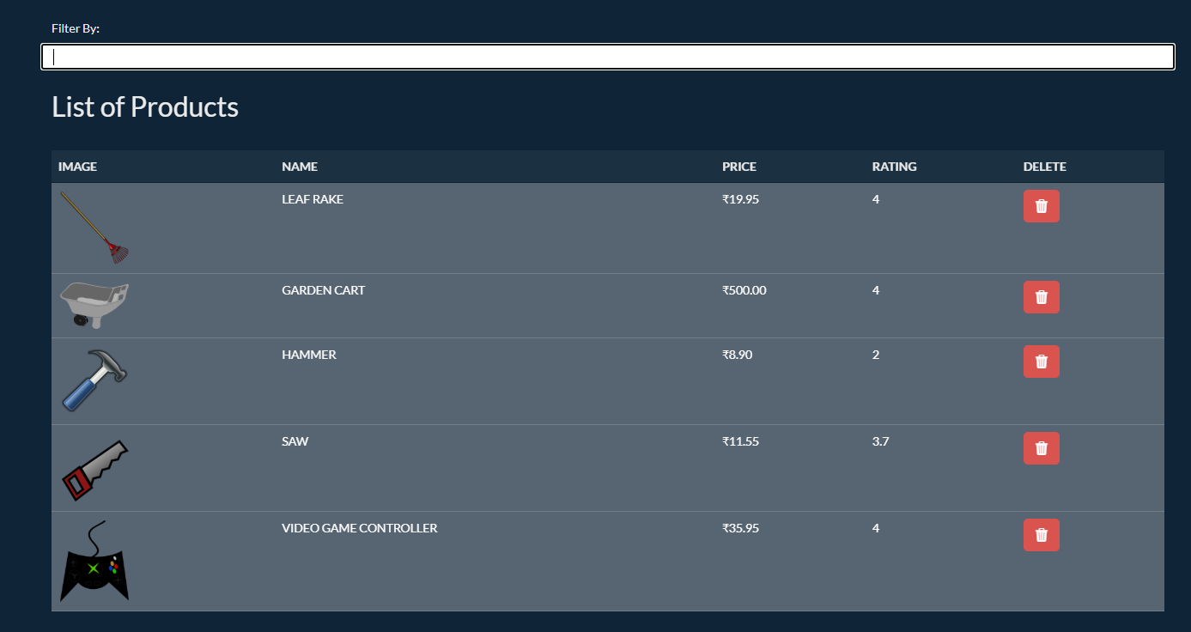
Filter Product
Product List
Product Container

