- By default, the app starts with /home URL and you navigate to Home component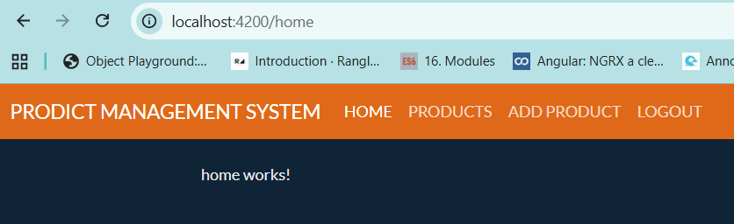
- When the URL is http://localhost:4200/products to view all the products you navigate to ProductContainer (ProductList + FilterProduct components) component
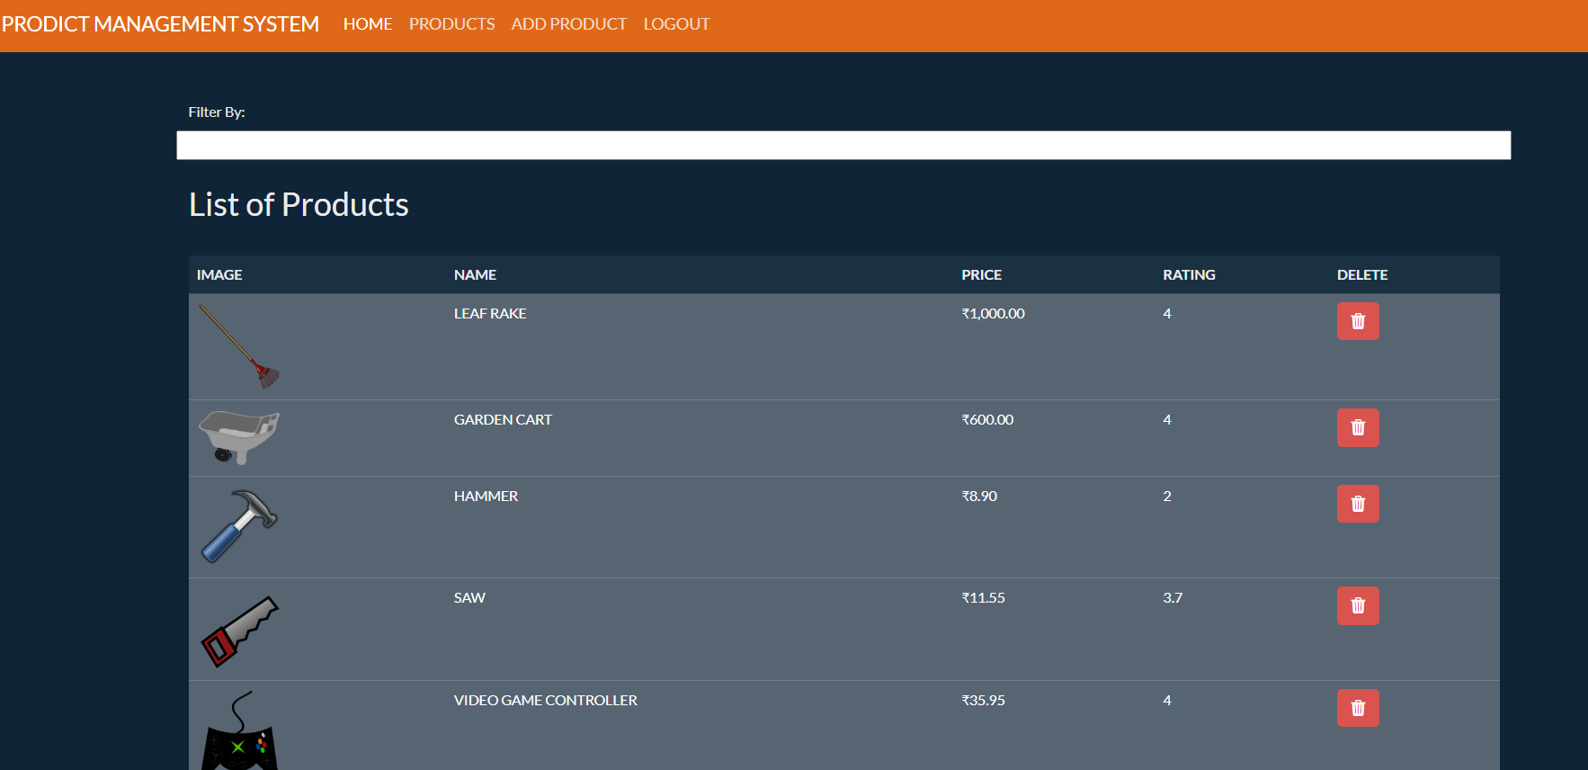
- When you click on any image you navigate to ViewProduct component (http://localhost:4200/products/view/<id>)
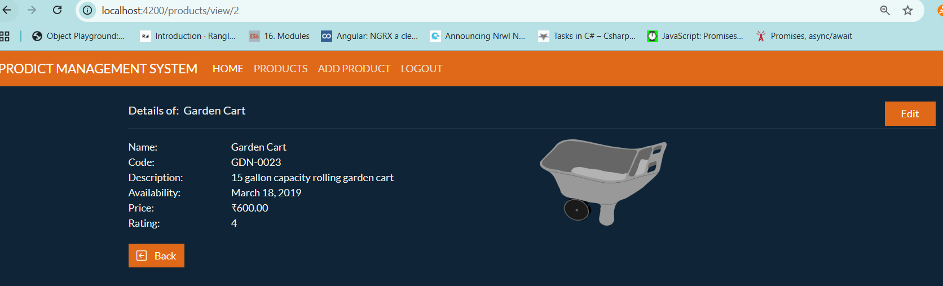
- When you click on edit button you navigate to EditProduct component
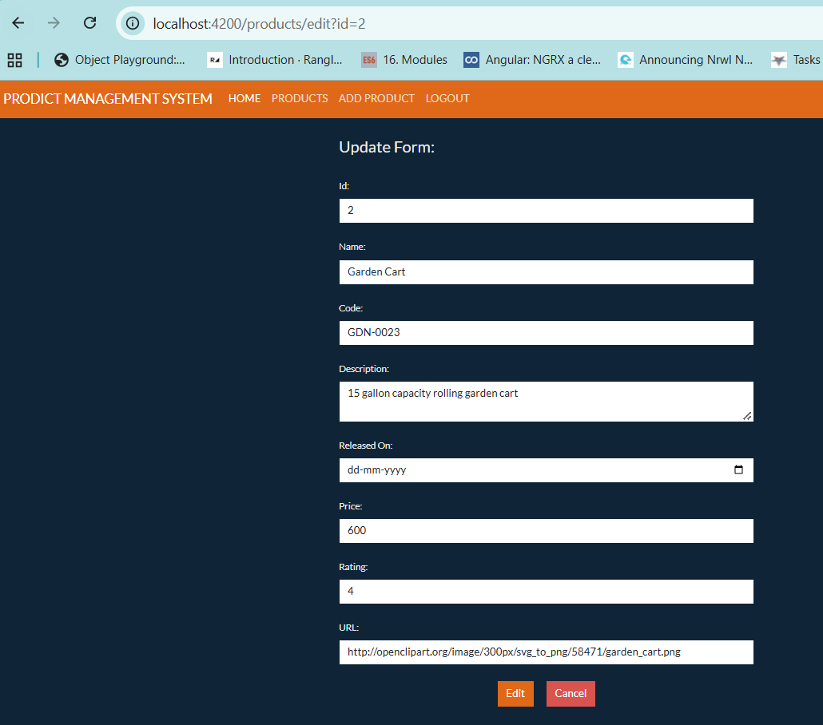
Clicking on “Edit” button will help you to send the edited the product object to the backend to update the same. After successful edit, the user should be directed to ProductContainer component by navigating the “/products” URL
- Clicking on “Add Product” link on the navbar, will take you to AddProduct component
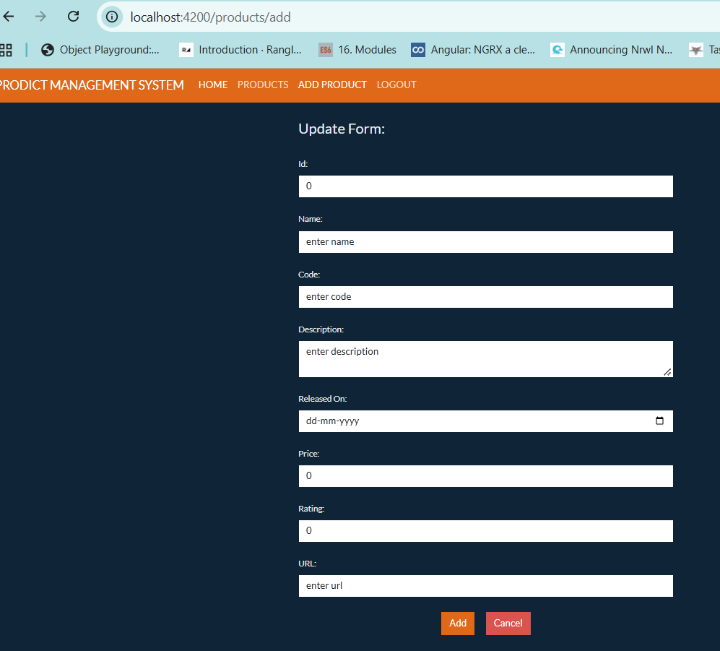
Clicking on “Add” button will send the product data to the backend to be saved and then user should be directed to “/products” URL after successful add operation.

