- Default navigation: [base redirection to base/home]
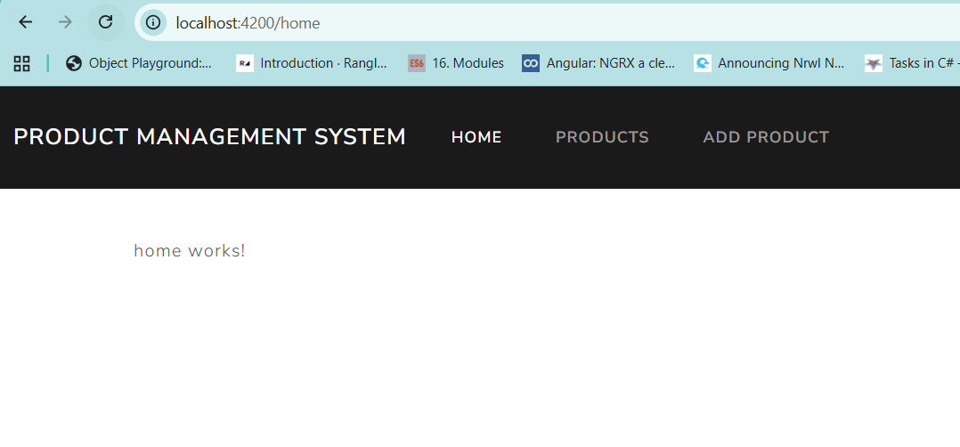
- When “products” link is clicked on the dashboard navigate to ProductContainer
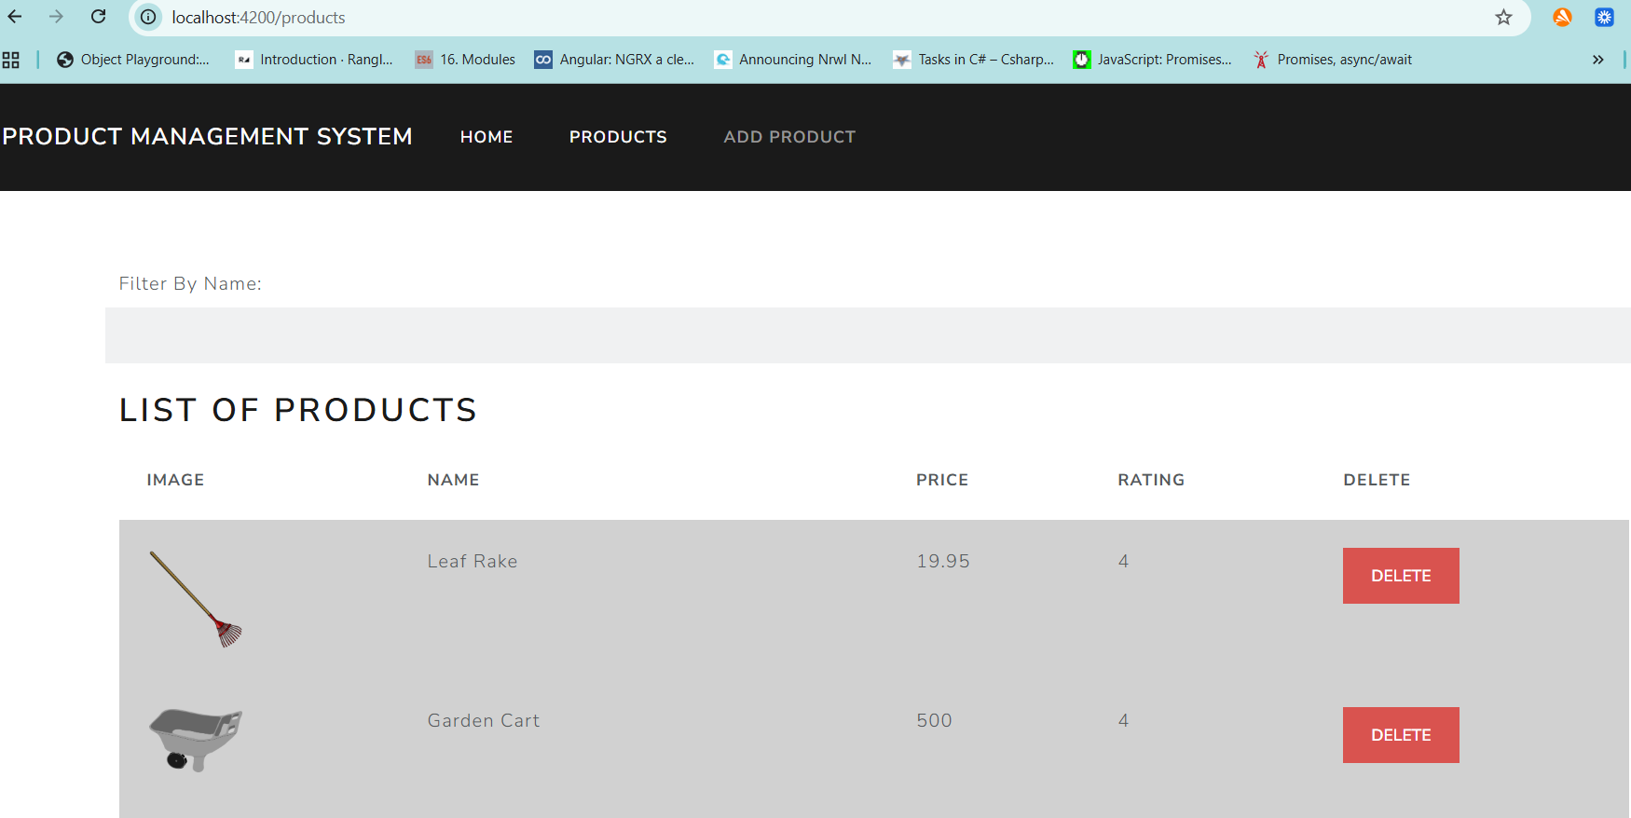
- When the image on any row is clicked navigate to ProductDetail component and pass the “id” of the product through URL as route paremeter. Fetch the same in the component from ActivatedRoute object. Then fetch the data from backend and display the product detail in the component.
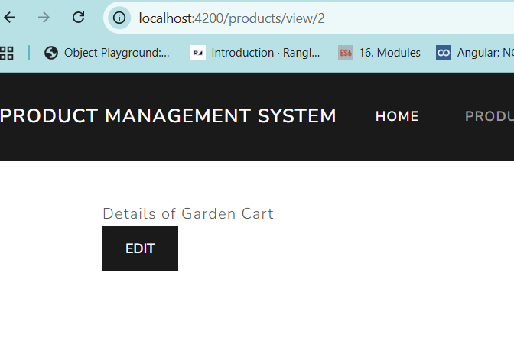
- When the “Edit” on ProductDetail is clicked, you should navigate to EditProduct component where the “id” of the product is passed through query string parameter. Fetch the details of the same product and display in the text boxes. These details can be edited (except “id”). Then click the “Update” button the update the data in the backend. You should be redirected to “/products” automatically to view the updated product details.
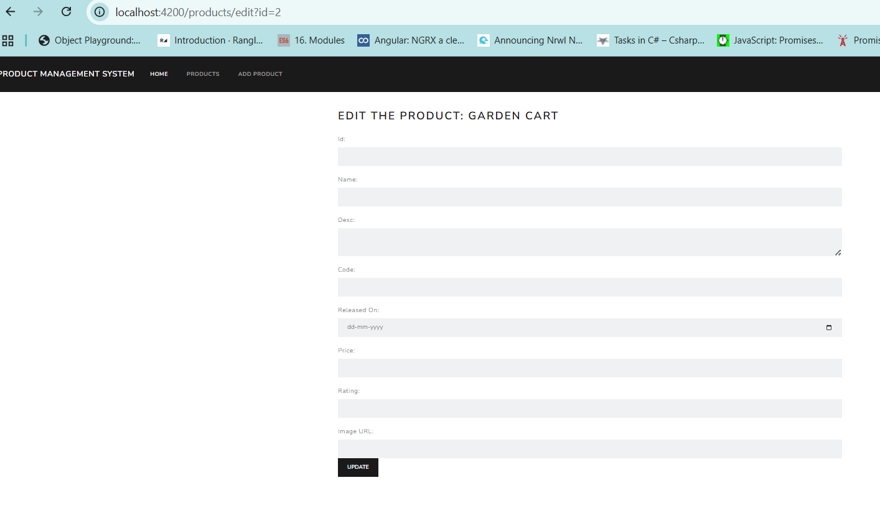
- Clicking on “Add Product” button helps you to navigate to the AddProduct component. Here you can add new product details. Clicking on “Add” button should add a new product to the backend and you should automatically be redirected to “/products” to view the newly added product
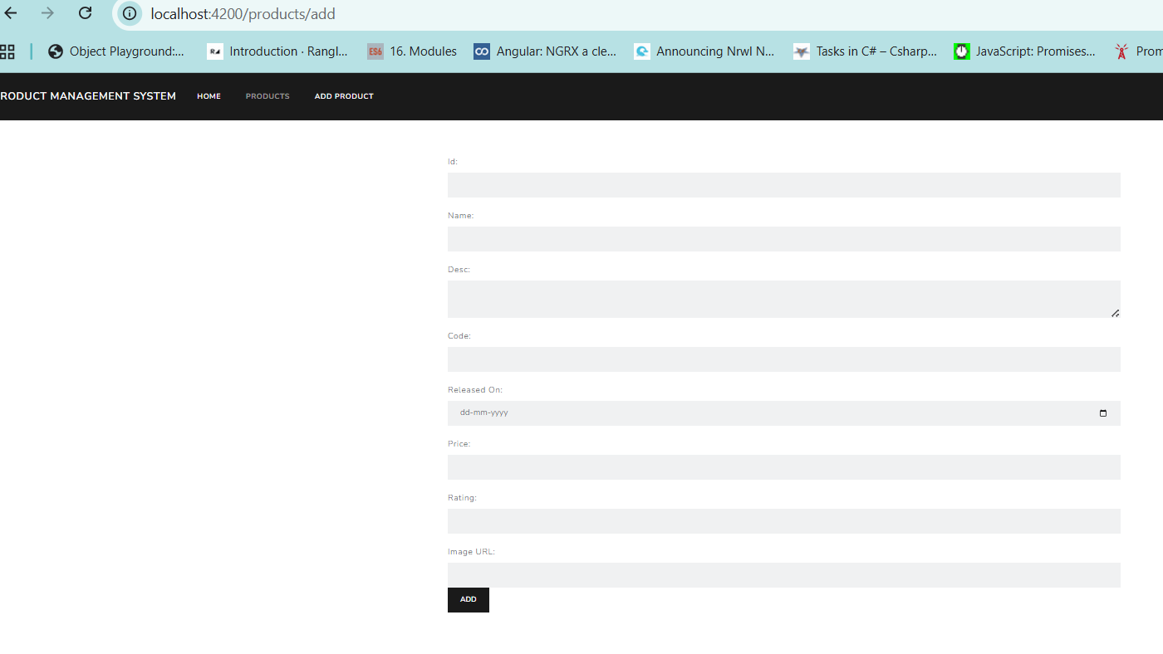
- If any URL apart from the registered ones is accessed then one will be navigated to PageNotFound component

