NAME: LIBRARY MANAGEMENT SYSTEM

# Features:

A library consists of different category of books like fiction, art, cooking, comic, etc. Each category can contain some extra attributes which can be added later at some point of time. Each book consists of attributes like unique book id, title, author name and price.

Application has to keep track of book issue date, return date, which user has borrowed the book.

Users of this application can perform the following:

* Login
* Logout
* Borrow a book
  + Select a book
    - User can search a book based on category, and select the book by providing “book Id” from the displayed list.
    - User can directly select a book if “book Id” is known.
  + Once user selects a book, he/she can borrow a book.
* Return borrowed book.

***Note: User can return only books which he/she has borrowed.***

# Diagram:

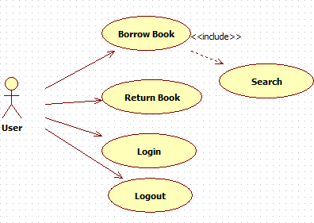

**Functionalities**:

1. Initially user is given choices
   1. Login
   2. Logout
   3. Exit
2. User should login first
3. After successful login, user should be given choice to either
   1. borrow a book or
   2. return a book
4. If user chooses to borrow a book, then
   1. user should be able to view all categories
   2. User selects a category id
   3. Books belonging to that category should be displayed
   4. User selects a book id, which the user wants to borrow
   5. System should check whether selected book does exist or not. If the book is existing then it should be checked whether the book is available for loan or not. If so, then user can successfully borrow a book and this borrowing information should be recorded. Otherwise this book will not be possible to be borrowed by the user
5. If user chooses to return a book, then
   1. System should check whether it is the same user who borrowed the exact same book or not
   2. If so, then the book should be returned and the borrowing information saved in step 4 should be removed regarding the user and the book should be made free/available for further borrowing
   3. If the book that user claims to have borrowed was not borrowed by the user at all, then the book can’t be returned
6. If user chooses to logout then user should be able to logout
7. If user chooses to exit, then the application should terminate

# Implementation:

Create an application **LibraryManagementSystem** in Visual Studio.

The solution should contain following folders and files:

* **BusinessEntity** folder: Contains user entity classes – Book, User and Category Note: If application demands any extra entity to be created, then add the same in this folder
* **Data** folder: Add a class file **LibraryManager.cs** and it should contain a class –

LibraryManager

* **Program.cs** file: File containing Program class, where client code has to be written in Main method. Code has to be completed in that method in order to implement all the features

Complete the following functionalities by adding methods in the class in

# LibraryManager.cs file

* + Method to return all books belonging to a particular category id
  + Method to get a book detail based on a particular book id
  + Method to borrow a particular book
    - The method should return “true” if book was successfully borrowed else it should return “false”
    - Method should store data about which user is borrowing a book, which book is being is borrowed as well as borrow date while user is borrowing a book
  + Method to return a book
    - Check if the book which is being returned was borrowed by the same user or not first
    - Method should record return date.
    - The method should return “true” if book was successfully returned else it should return “false”
  1. Information about user: username and password
  2. Information about few users should be stored in a collection
  3. Information about book: book id, book name, publisher and price
  4. Information about few books should be stored in a collection
  5. Information about the book being borrowed, user who is borrowing the book as well as borrowed date should be recorded in some collection
  6. Information about the borrowed book should be removed from that collection once the book has been returned