1. Find out the list of dotnet core (.NET) SDK versions installed in your machine:

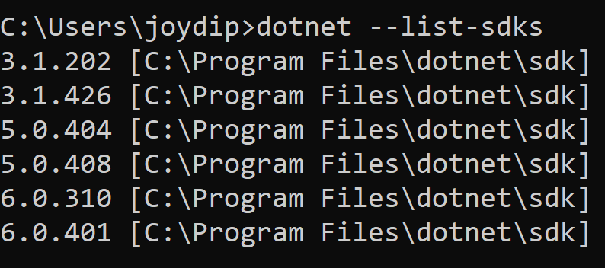

1. Which are the additional commands to use with “dotnet new”

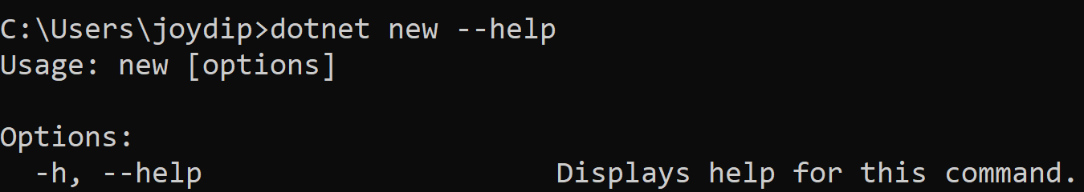

1. How to find out different type of applications that can be created in .NET

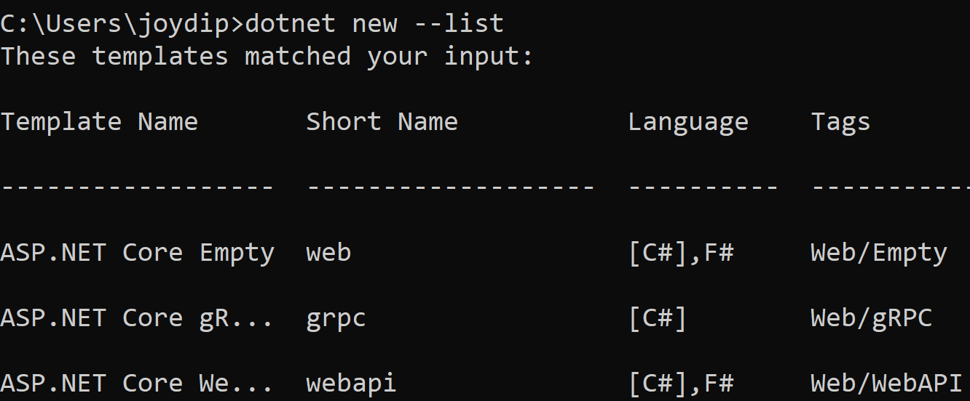

1. Additional commands required during creating a new type of project

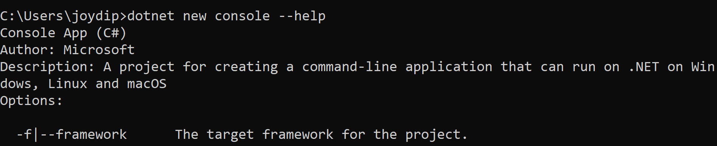

1. How to mention framework version when creating a new application:

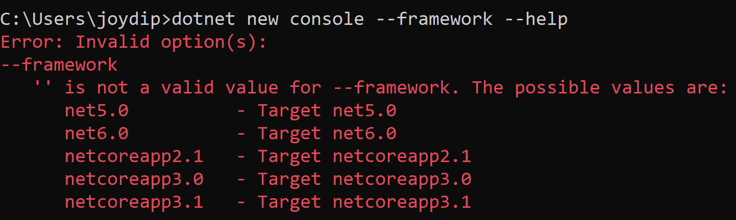

1. How to create a console application with C# as language in .NET using dotnet tool

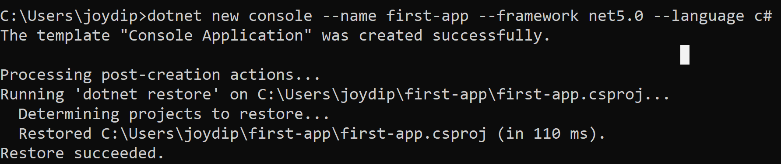

1. How to compile your application using dotnet tool:
2. Move inside the application directory (if you are outside)
3. Type the following command: **dotnet build**

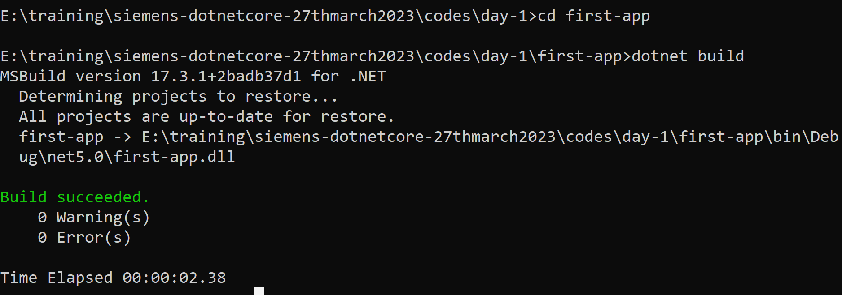

1. If outside the application directory, then type the following command:

**dotnet build path/*.csproj**

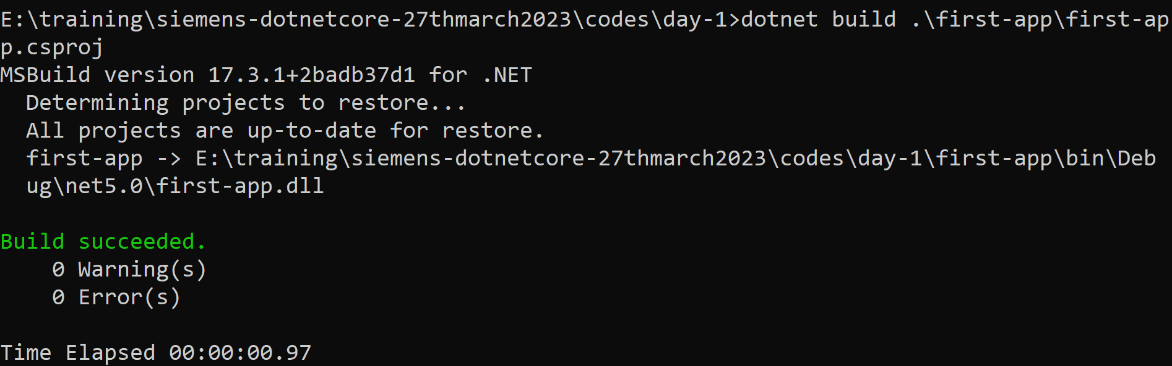

1. How to run the application (executable)
   1. If you ae inside he application directory: **dotnet run**



* 1. If you are outside the application directory: **dotnet run --project <application-path>**

