Total Marks: 20*1 = 20 Duration: 30 minutes

1. You want to call a generic method which accepts an argument of type T and returns Boolean. Which of the built-in generic delegate will you use? [choose whichever options you find correct]
   1. Action<T>
   2. Func<T,bool>
   3. Predicate<T>
   4. None of them
2. What is the output of the following code?

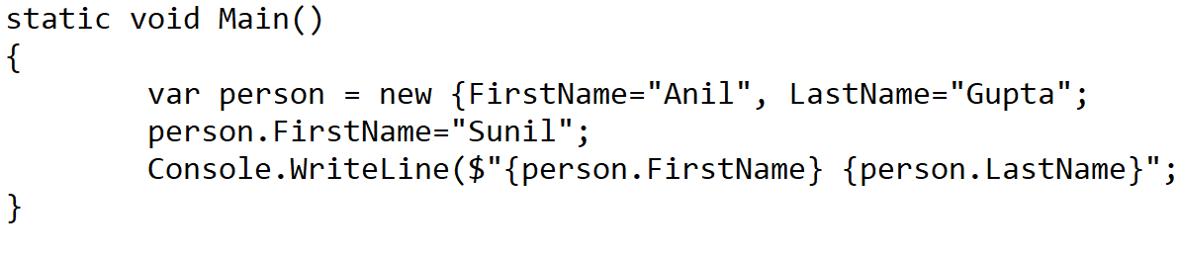

* 1. Anil Gupta
  2. Sunil Gupta
  3. Compilation Error
  4. None of them

1. Which of the following code will throw error?
   1. var arr = new [ ] {1, 2, 3, 4};
   2. var arr=new [ ] {“bangalore”,”chennai”};
   3. var arr = new [ ] {1, “Bangalore”, ’a’};
   4. None of them
2. Go through the following code

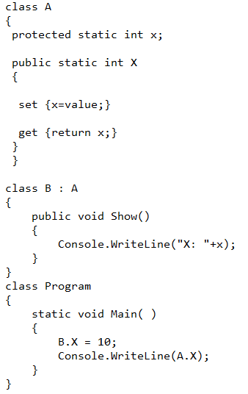

State which of this statement is correct?

1. The output of the program will be 10
2. The program will generate an compiler error
3. The output of the program will be 0
4. Though B.X=10 is possible but no value can retrieved by A.X and program will throw a runtime error
5. Match the following:

Extension Description

1. .cs A. Organizes projects, project items, and solution items in the solution

2. .sln B. Represents forms, user controls, classes and module files that belong to a project.

3. .csproj C. Represent the class file.

Which of the following combination is correct?

1. 1-C, 2-A, 3-B
2. 1-A, 2-B, 3-C
3. 1-B, 2-C, 3-A
4. 1-B, 2-A, 3-C
5. Go through the following code

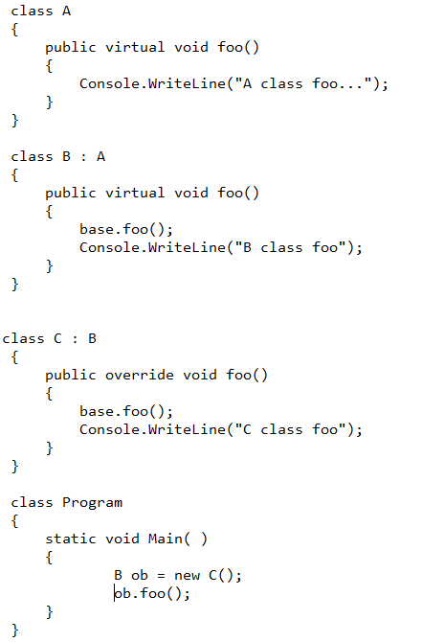

State which of the following output will be correct

1. output will be:

A class foo

B class foo

C class foo

1. output will be:

B class foo

1. output will be :

C class foo

1. Go through the following code

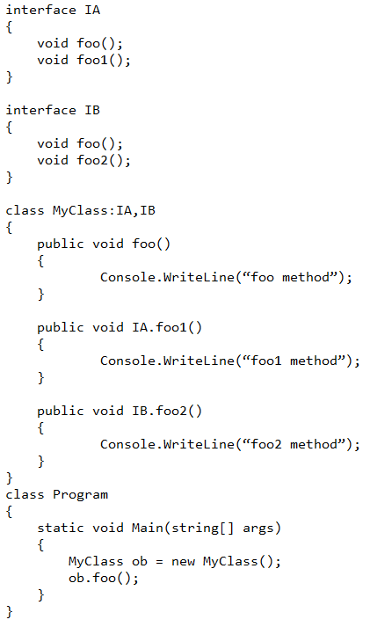

Which of the following statements is correct?

1. The program runs without any error
2. Program generates an error because you can’t use ‘public’ keyword in the line ‘public void IA.foo1()’ and ‘public void IB.foo2()’
3. Program generates an error because you can’t implement two interfaces in a class
4. Program generates an error because you can’t craete an object of ‘MyClass’, because it has two explicitly defined functions of two different interfaces
5. Find out the correct array declarations
6. int [ , ] myarray=new int [ , ] {(1,2), (3,4)};
7. int [ , ] myarray={(1,2), (3,4)};
8. myarray={(1,2), (3,4)};
9. 1,2,3
10. 1,2
11. 2,3
12. Find out that whether the following inheritance is possible or not.

` 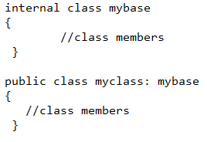

* 1. Possible
  2. Not Possible

1. State which of these following statements is correct.
2. All the interface members are by default private
3. All the interface members are by default public
4. All the interface members, when implemented in class, have to be declared with override keyword
5. Go through the following code

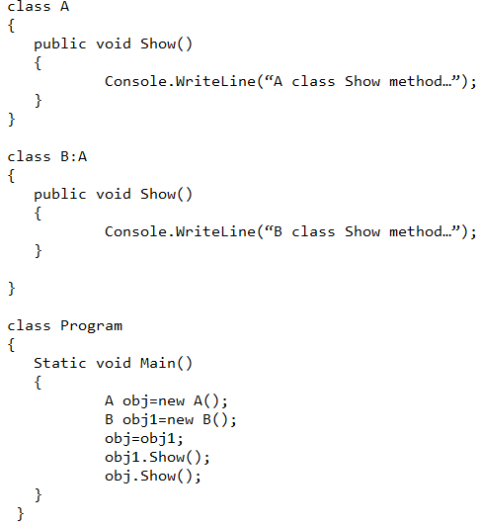

Which one of the following is correct answer?

1. The program shows an error
2. The output is “A class Show method“ and “B class Show method”
3. The output is “B class Show method” and “A class Show method”
4. The output is “A class Show method” and “A class Show method”
5. Which of the following statements is correct?
6. Structure is reference type
7. Structures are by default supplied with default constructor
8. I can write default constructor in the structure
9. Structure can have overloaded constructor as long as the constructor assigns values to all the variables declared in the structure
10. Go through the following code…

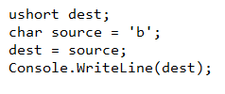

* 1. This is implicit data type conversion
  2. This is explicit data type conversion

1. Go through following code



* 1. Value of x is 10
  2. Value of x is 11
  3. Value of x ix 9

1. Reference type variables are stored in _________________________.
   1. Stack
   2. Heap
   3. Code Region
2. How many mistakes are there in the following code?

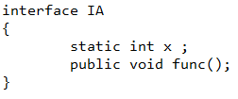

* 1. 1
  2. 2
  3. 3

1. if you want to access the keys and values stored inside the Dictionary<Tkey,Tvalue> generic class, then which of the following classes should be used to represent the key-value pair present inside the Dictionary<Tkey,Tvalue>?
   1. DictionaryEntry
   2. Object
   3. IList<Tkey,Tavlue>
   4. KeyValuePair<Tkey,Tvalue>
2. Which of the following code segment is correct?
   1. 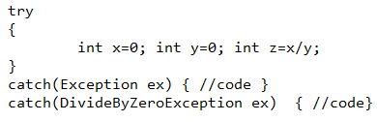
   2. 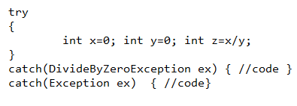

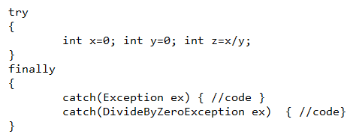

1. Go through the following code and select a correct option.

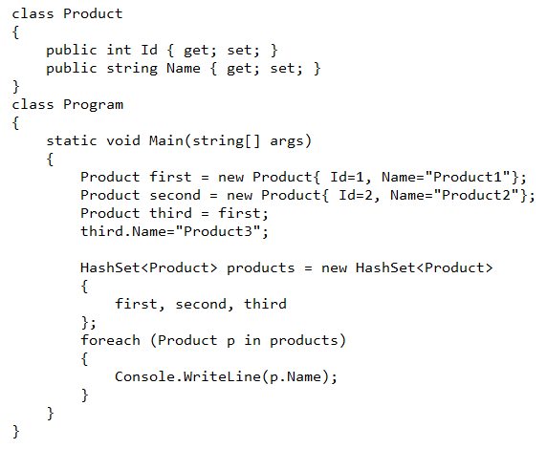

* 1. Output will be

Product1

Product2

Product3

* 1. Output will be

Product1

Product2

* 1. Output will be

Product2

Product3

* 1. Output will be

Product3

Product2

1. Go through the following code and select the best answer from the options mentioned below.

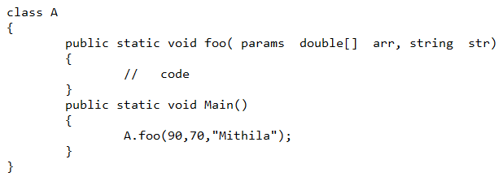

* 1. The code runs without any error.
  2. The code might throw exception during run time but will not throw any compile time error.
  3. The code throws a compile time error since param array declaration should be the last one in the function argument list of foo() function.