## Outstanding Persons

We judge a person if he is outstanding or not by the achievement in his/her profession. A professor and a student have different criteria for being called outstanding.

### Objective:

Understand overriding and polymorphism.

### Problem Statement:

Refer the class diagram snippet shown below and create the corresponding classes in Java. Refer the business rules mentioned below and come up with a solution.

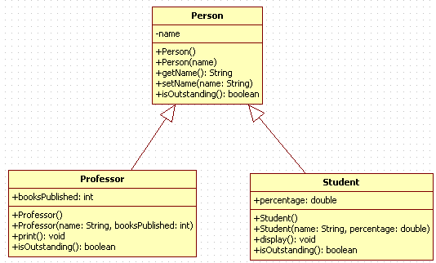

Professor is outstanding if he has published more than 4 books

Student is outstanding if his percentage is greater than 85.

The print() method of Professor displays the name and books published by professor.

The display() method of Student displays the name and percentage of student.

In the application main method create 5 objects of Person type, this can be few Student Objects and remaining can be Professor Objects.

Every object has to be referred using Person reference (upcasting). To refer the objects use an array of Person.

Traverse through the Person array and display the person details only if the person is outstanding. The name and percentage should be displayed if the person referred is a Student. If the Person referred is a Professor, display name and books published

## Polymorphism through Interfaces (Calculating Area of Shape application)

This simple application will be used to calculate area of different shapes such as Circle, Rectangle and Triangle etc.

### Objective:

This application will help to understand how polymorphism can be achieved through Interfaces and where to use interfaces.

### Problem Statement:

You need to calculate area of different shapes, such as Circle, Rectangle and Triangle. All the shapes are represented by different entities, whereas all the entities have one method in common to calculate the area of the shapes. But, the fields of those entities are not same.

So, create three different classes to represent the three shapes and provide fields to those classes. Provide a common method to calculate the area of the shapes. The signature of the method is as follows

public void CalculateArea() 🡪 do not use WriteLine() method of Console class in the method code to display the Calculated Area