By default, home component should be loaded when base url is requested or “Home” link on the navbar is clicked:
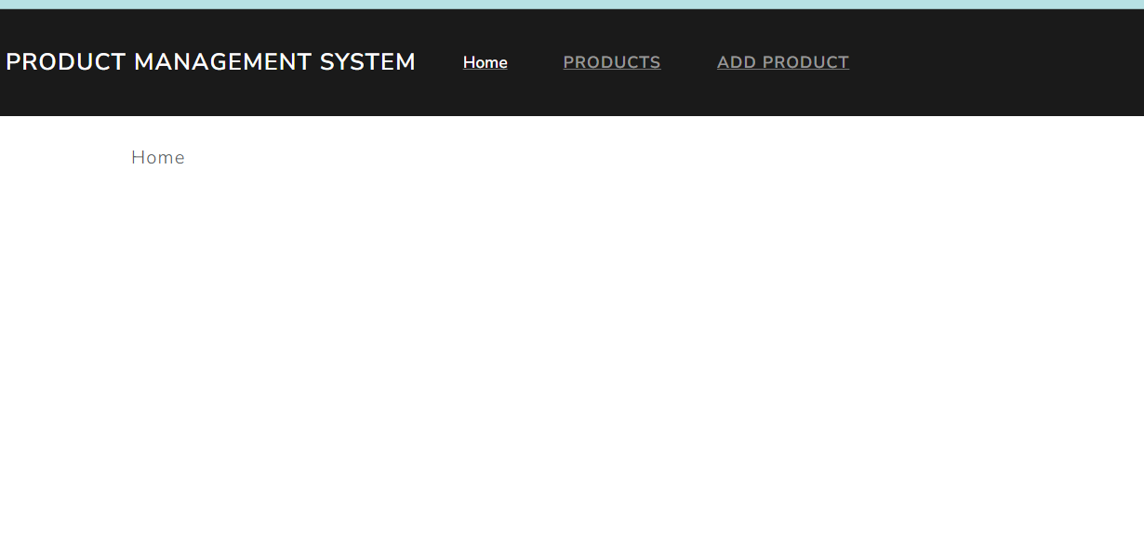
Products component design should be loaded when base the request is http://localhost:4000/products or end user clicks on the “Products” link in the navbar.
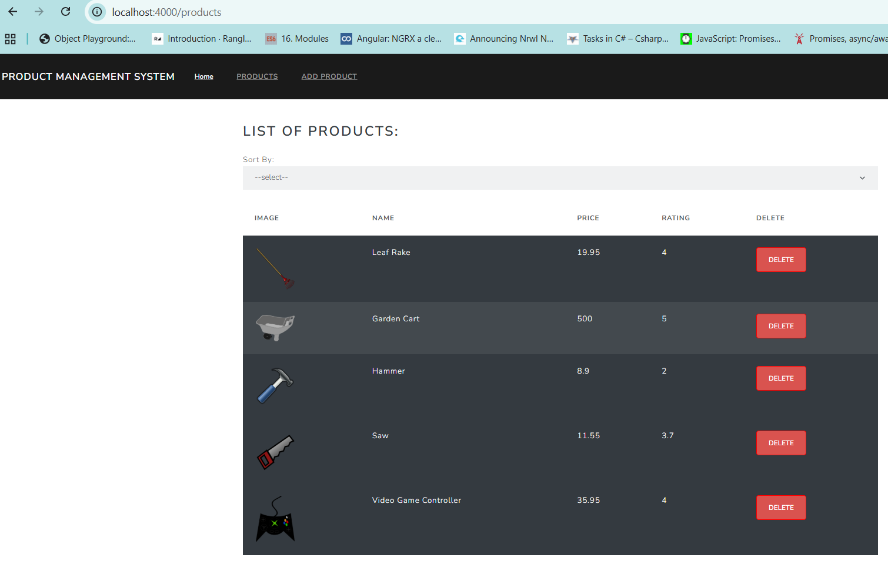
When a product image is clicked end user will be redirected to a component design that will be loaded with details of the product displayed and the request url will look like http://localhost:4000/products/view/{productid}:
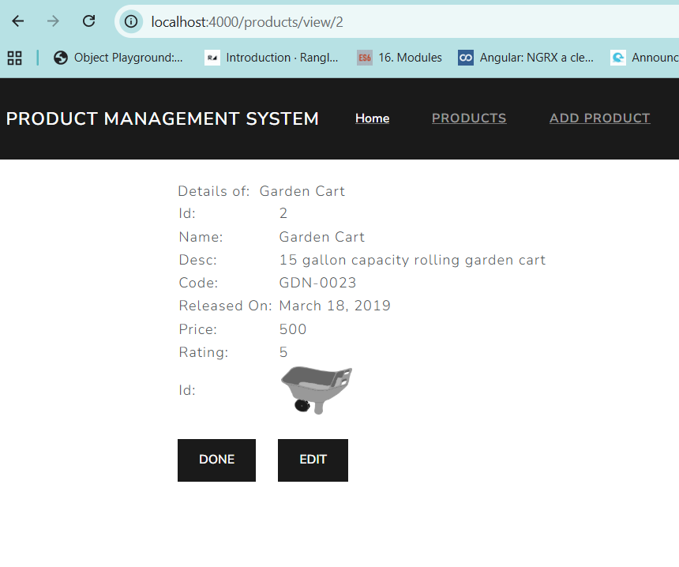
When the “Edit” button is clicked end user will be redirected to a component design which will display the product details that can be edited and then the request url looks like: http://localhost:4000/products/edit/{productid}
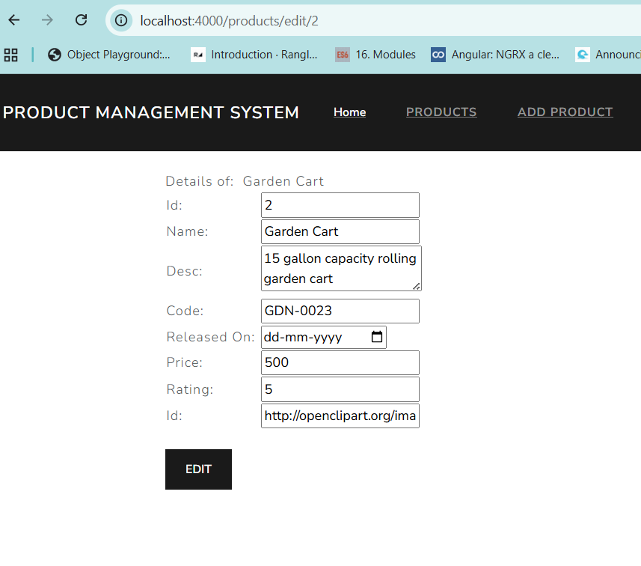
Change values of the product and click the “Edit” button to update the product details in the backend. After that end user will be redirected to the products component which will show the product with update data.
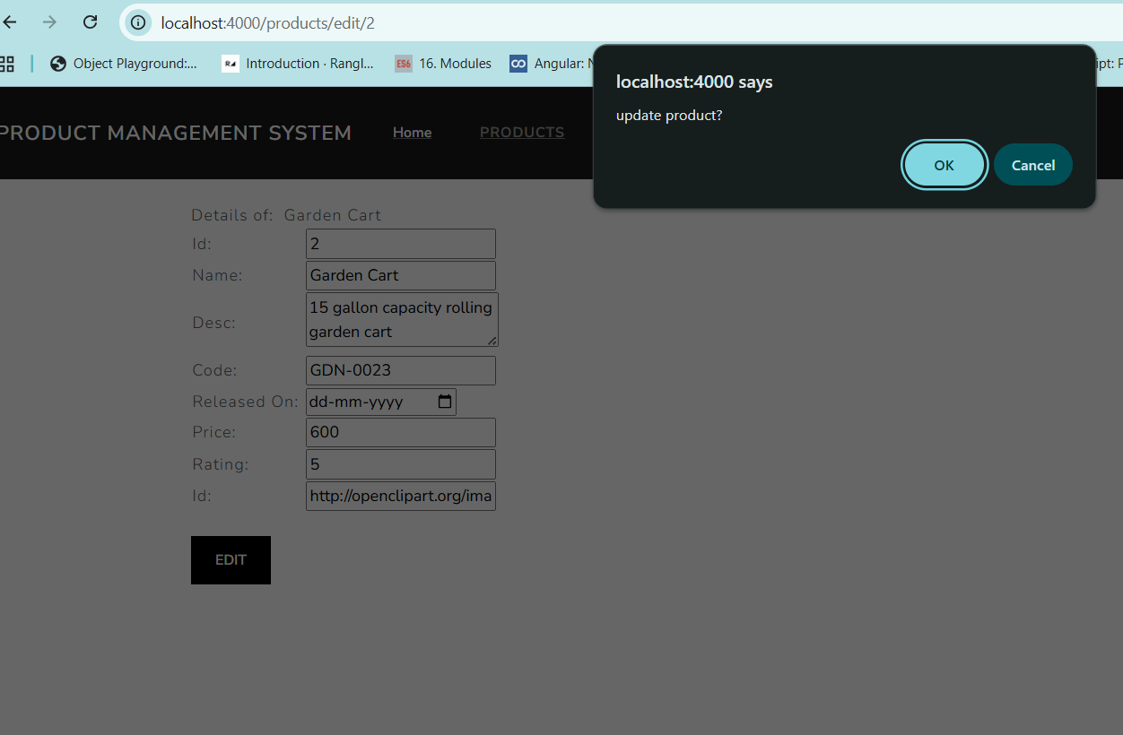
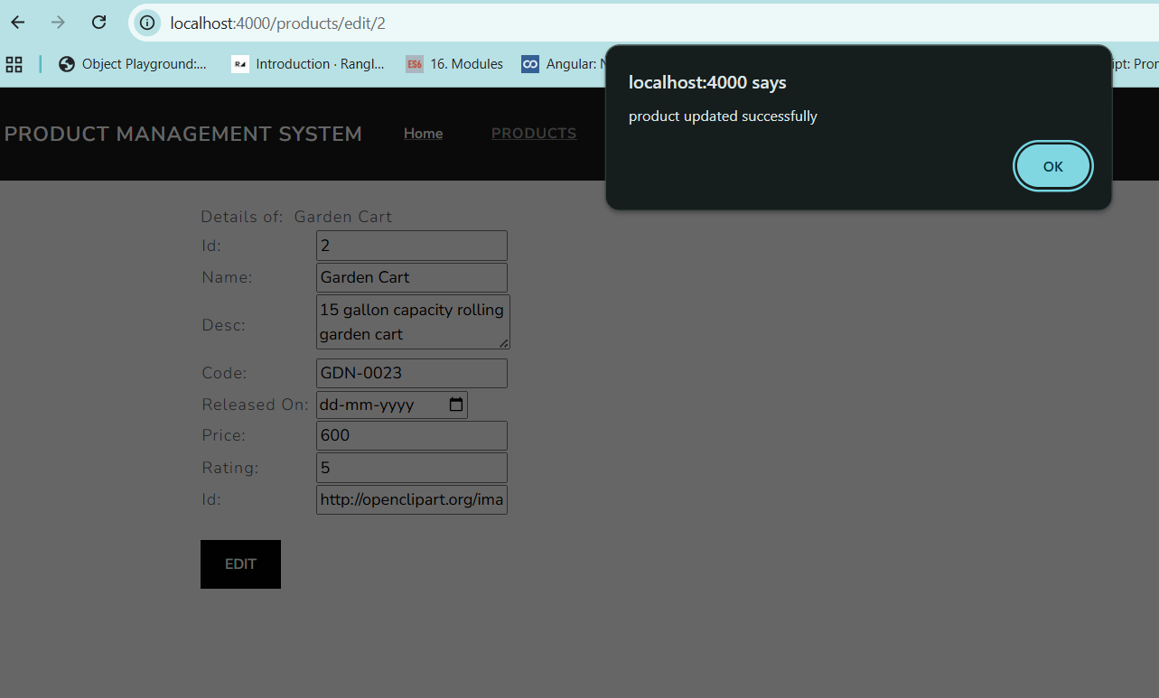
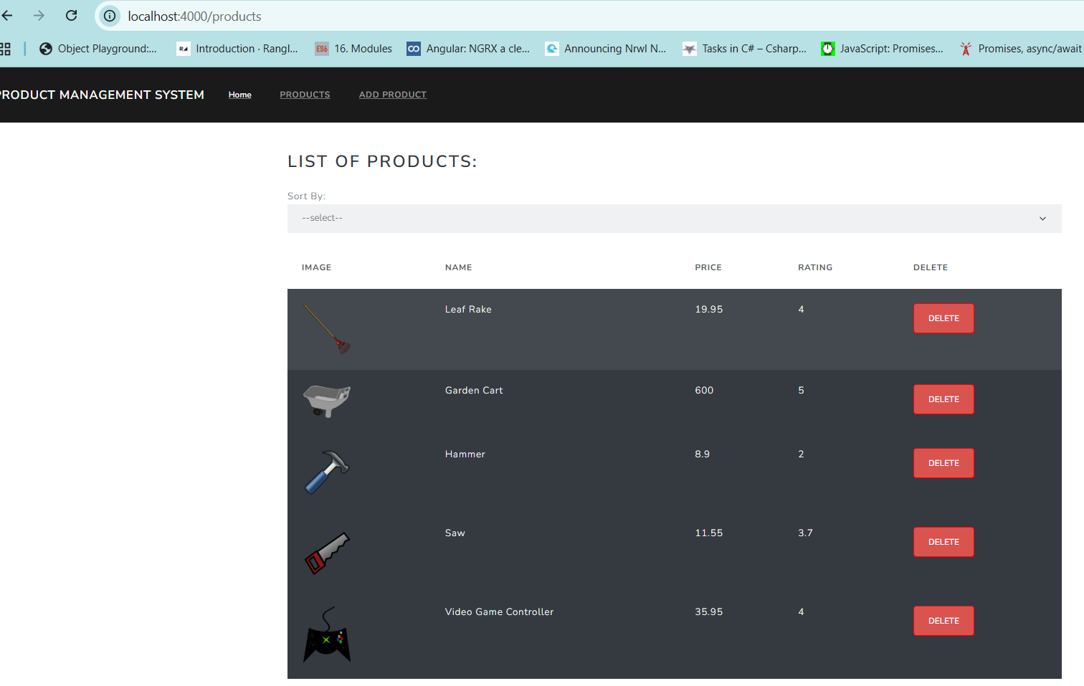
If you click on the “Add Product” link in the navbar and the request is http://localhost:4000/add. Add some new product detail and click on “Add” button to add the product in the backend. End user will be redirected after successful addition, to the products component to view the added product.
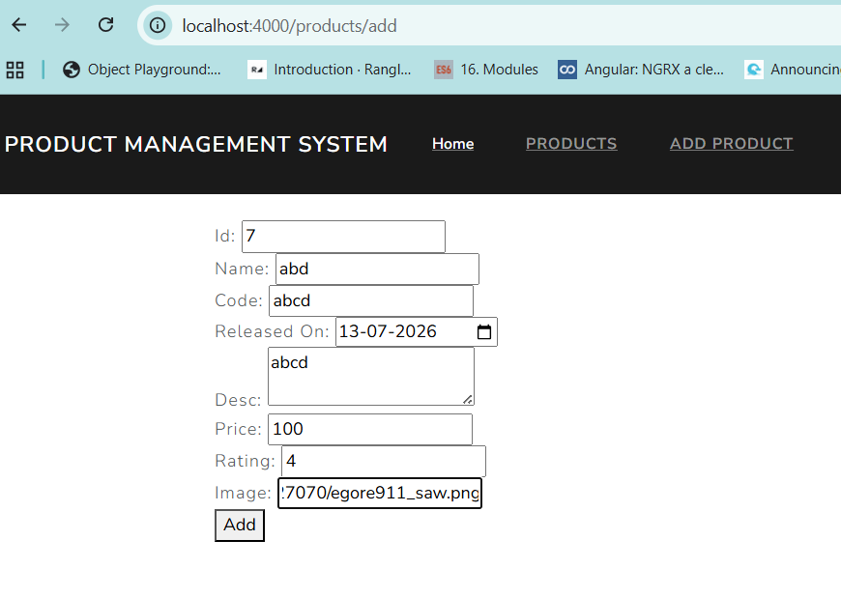
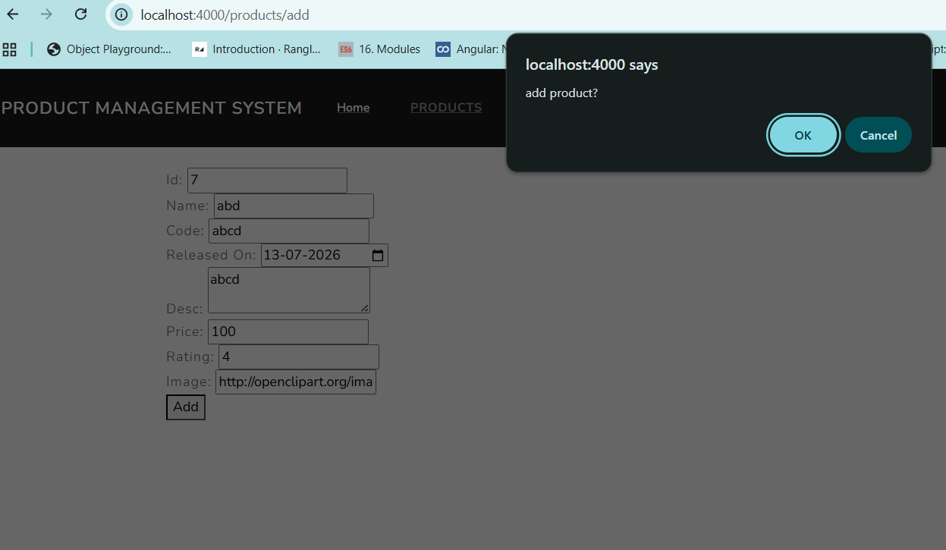
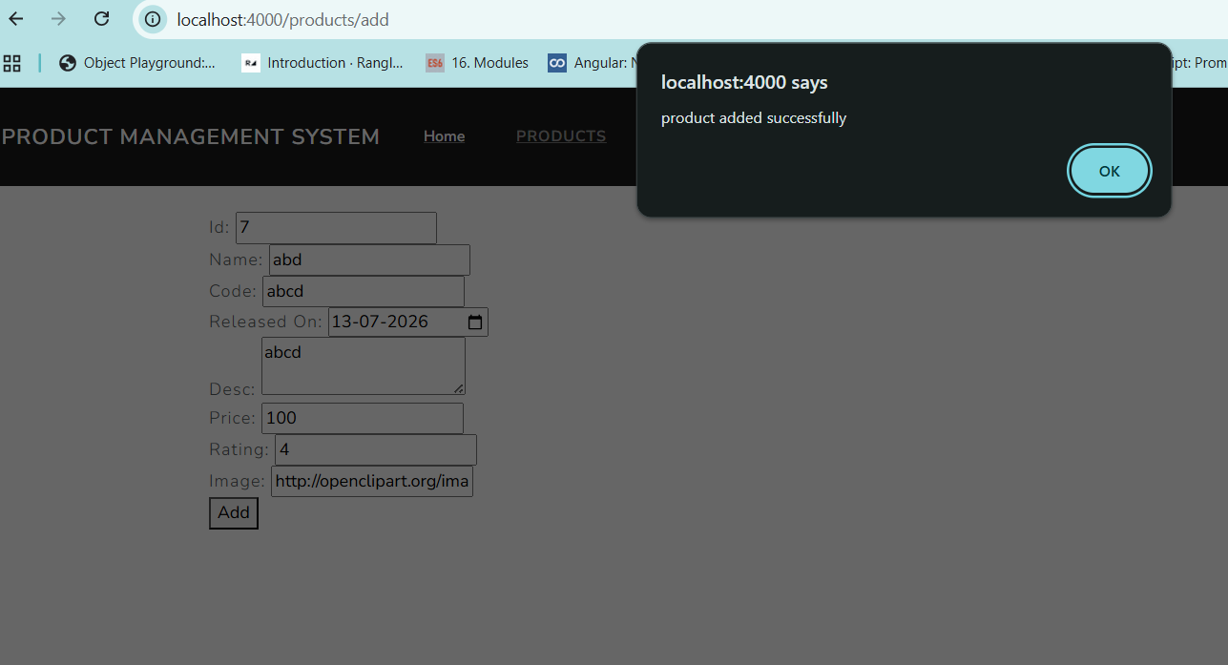
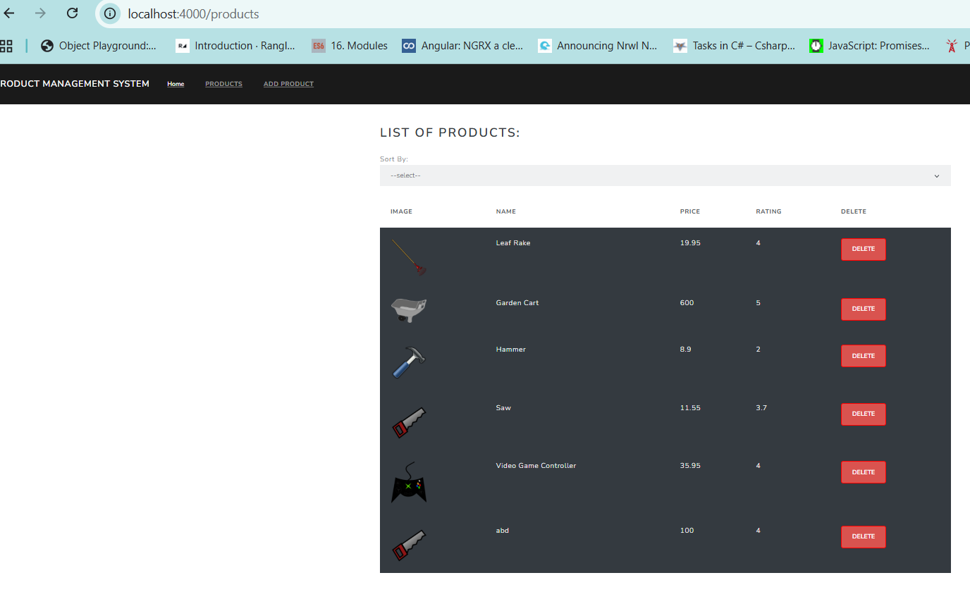
Products component design should be loaded after deletion when the delete button is clicked:
