**Lesson 1 HandsOn**

**Part I**

1. Create three more users of your choosing, using the insertOne() query, and add them to the appusers collection.
   * Include at least the firstName, lastName, and age fields. Feel free to also include any other fields you think would be useful data for an app user.

**Caution!**

Please take a screenshot of each query you run (since you are inserting each user one-by-one using insertOne(), you will run at least three queries) and save it to your NoSQL-HandsOn1 text document.

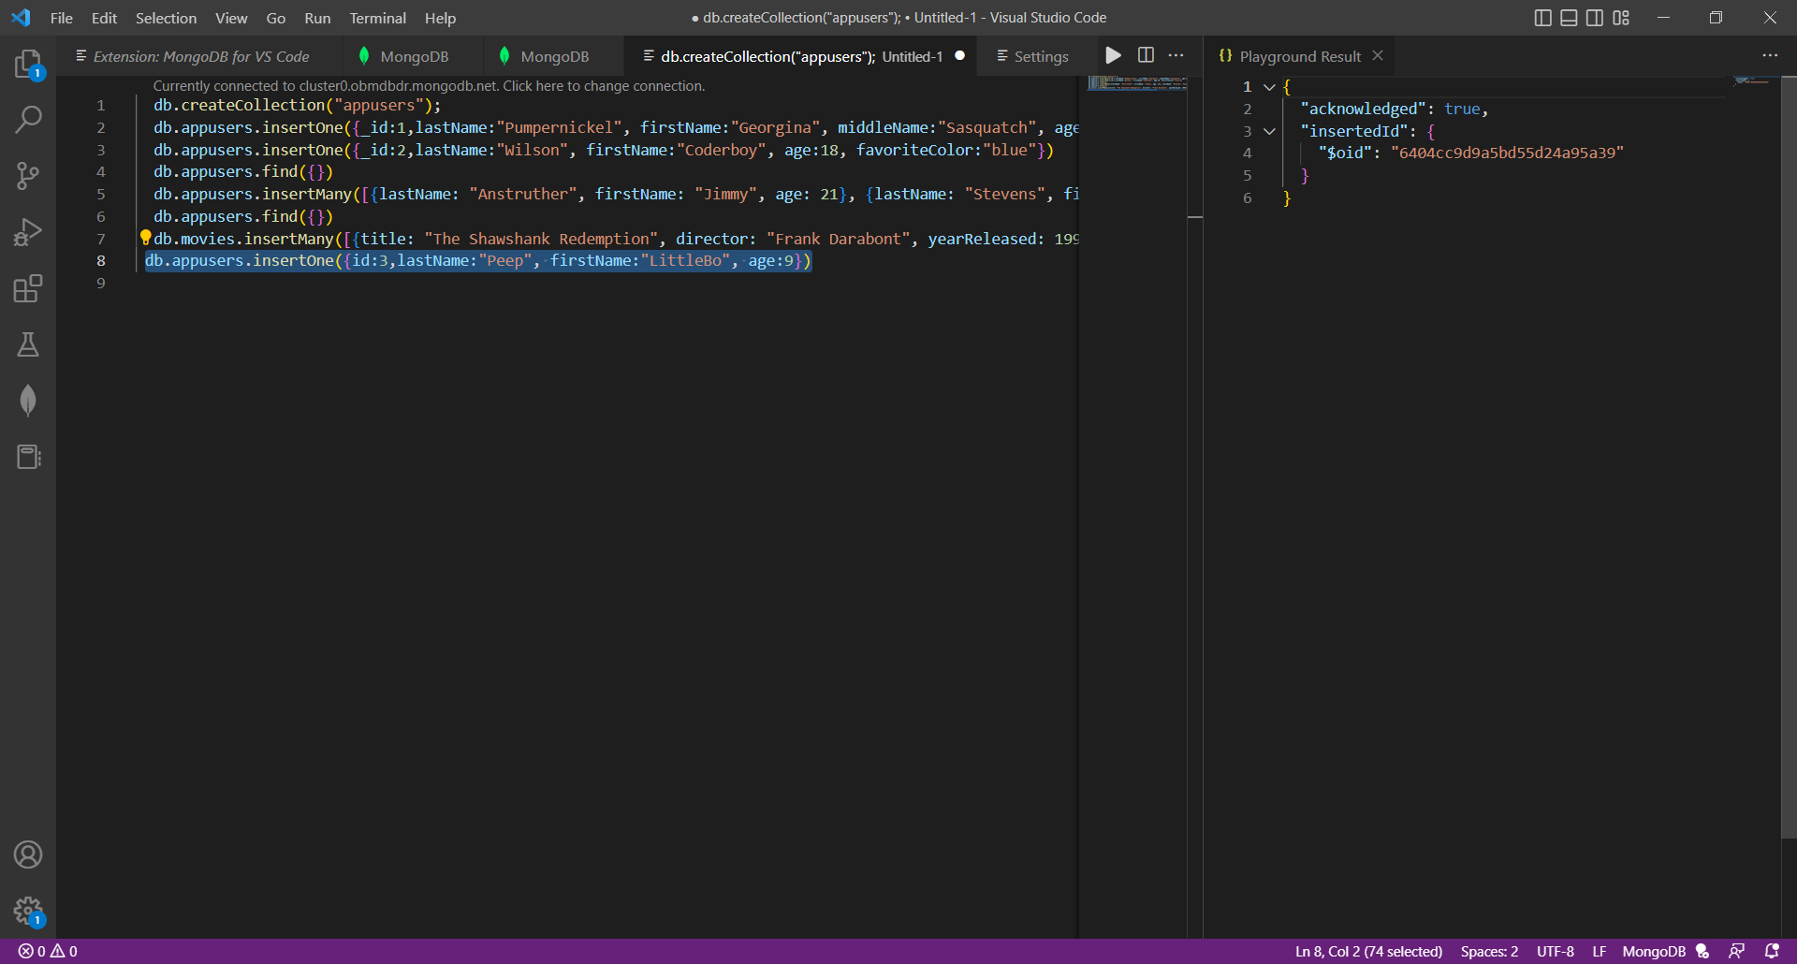

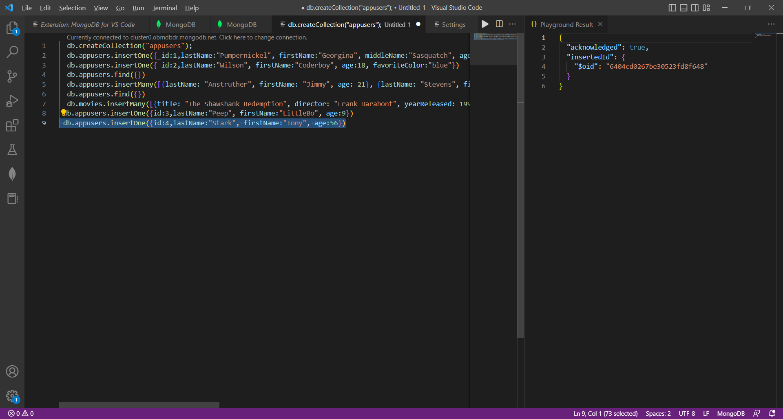

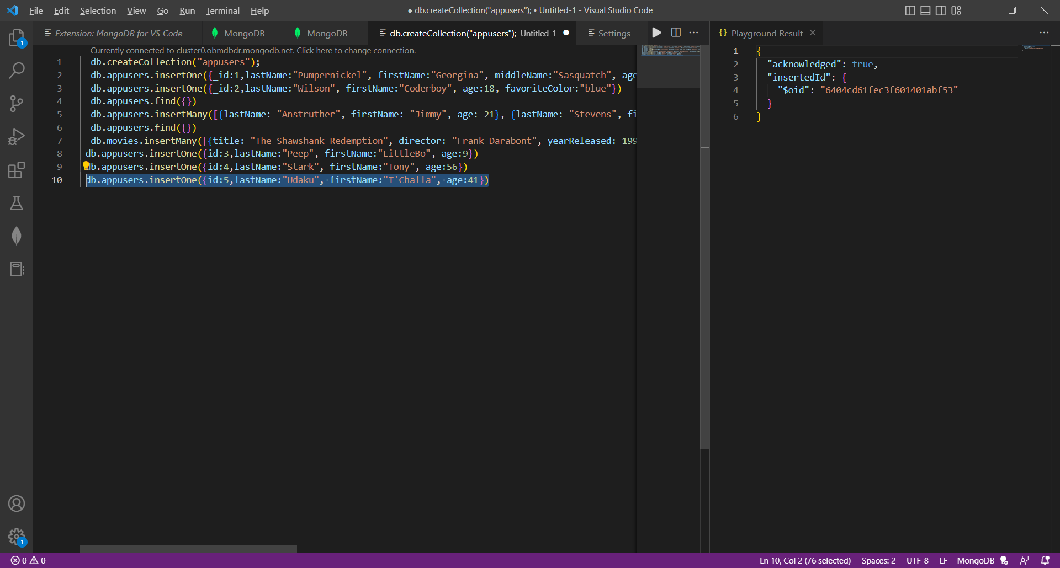

1. Next, run a basic find() query to see all of your documents within your database through the Mongo Shell.

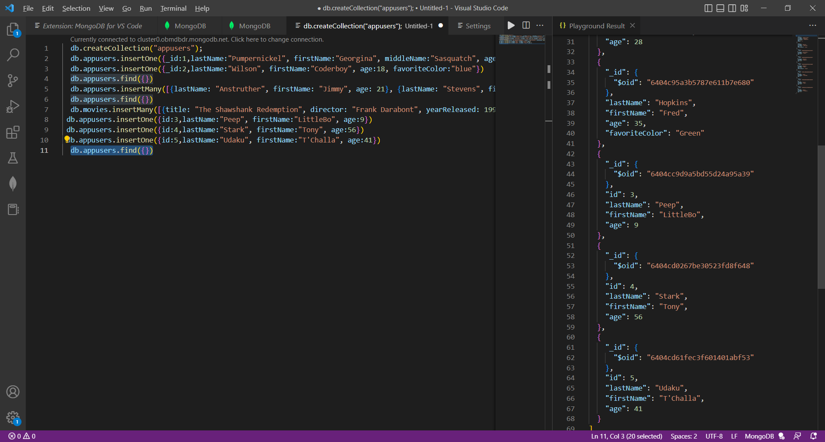

**Part II**

1. Create a new collection within your database through Atlas.
   * This new collection should be named cars.

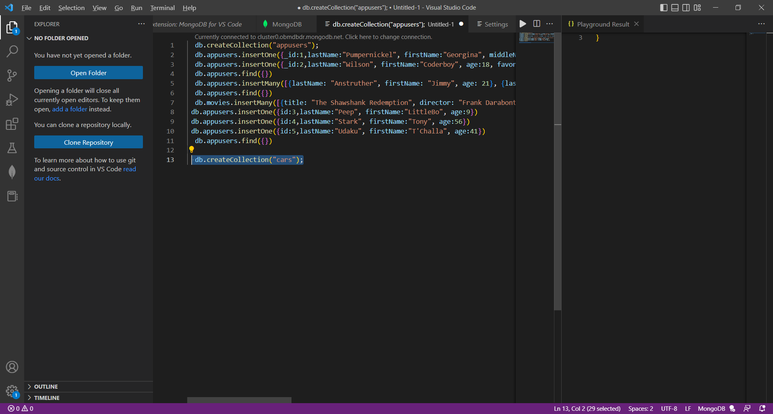

1. Insert five cars into this collection using the insertMany() query.
   * Include the following fields: make, model, color, year, fourDoor, and fourWheelDrive.
     + The last two fields, fourDoor and fourWheelDrive, should be of type Boolean (i.e. true or false).

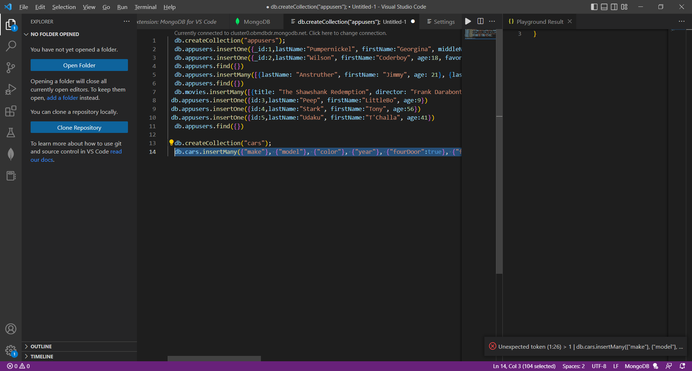

1. Once that is done, run a find() query to see your newly created documents.
2. Lastly, return to Atlas and view your collection and documents there.