Lesson 2 Hands On

**Lesson 2 Hands-On9 points**

**Directions**

For your Lesson 2 Hands-On, you will be working with your new knowledge on NoSQL. This Hands-On will be graded, so be sure you complete all requirements.

**Caution!**

Do not submit your project until you have completed all requirements, as you will not be able to resubmit.

**Setup**

Before you begin, please run the following query to insert this new collection into your database.

db.movies.insertMany([

{_id: 1, title: "Wonder Woman", director: "Patty Jenkins", yearReleased: 2017, leadActors: ["Gal Gadot", "Chris Pine", "Robin Wright"], lengthInMin: 141, genre: ["Action", "Adventure", "Fantasy"], MPAA: "PG-13" },

{_id: 2, title: "Cloud Atlas", director: "Tom Tykwer", yearReleased: 2012, leadActors: ["Tom Hanks", "Halle Berry", "Hugh Grant", "Jim Broadbent", "Jim Sturgess", "Hugo Weaving"], lengthInMin: 172, genre: ["Action", "Drama", "Mystery"], MPAA: "R" },

{_id: 3, title: "Pan's Labyrinth", director: "Guillermo del Torro", yearReleased: 2006, leadActors: ["Ivana Baquero", "Ariadna Gil", "Sergi Lopez"], lengthInMin: 118, genre: ["Drama", "Fantasy", "War", "Foreign"], MPAA: "R" },

{_id: 4, title: "Gone With the Wind", director: "Victor Fleming", yearReleased: 1939, leadActors: ["Clark Gable", "Vivien Leigh", "Thomas Mitchell", "Olivia de Havilland", "Leslie Howard"], lengthInMin: 238, genre: ["Drama", "History", "Romance"], MPAA: "G" },

{_id: 5, title: "Spaceballs", director: "Mel Brooks", yearReleased: 1987, leadActors: ["Mel Brooks", "John Candy", "Rick Moranis", "Bill Pullman", "Daphne Zuniga"], lengthInMin: 96, genre: ["Adventure", "Comedy", "Sci-fi"], MPAA: "PG" },

{_id: 6, title: "Silence of the Lambs", director: "Jonathan Demme", yearReleased: 1991, leadActors: ["Jodie Foster", "Anthony Hopkins", "Anthony Heald"], lengthInMin: 118, genre: ["Crime", "Drama", "Thriller"], MPAA: "R" },

{_id: 7, title: "American History X", director: "Tony Kaye", yearReleased: 1998, leadActors: ["Edward Norton", "Edward Furlong", "Beverly D'Angelo", "Ethan Suplee"], lengthInMin: 119, genre: ["Crime", "Drama"], MPAA: "R" },

{_id: 8, title: "Psycho", director: "Alfred Hitchcock", yearReleased: 1960, leadActors: ["Anthony Perkins", "Vera Miles", "John Gavin", "Janet Leigh"], lengthInMin: 109, genre: ["Horror", "Mystery", "Thriller"], MPAA: "R" },

{_id: 9, title: "The Pianist", director: "Roman Polanski", yearReleased: 2002, leadActors: ["Adrien Brody", "Emilia Fox", "Michal Zebrowski", "Ed Stoppard"], lengthInMin: 150, genre: ["Biography", "Drama", "Music"], MPAA: "R" },

{_id: 10, title: "Gladiator", director: "Ridley Scott", yearReleased: 2000, leadActors: ["Russell Crowe", "Joaquin Phoenix", "Connie Nielsen", "Oliver Reed"], lengthInMin: 155, genre: ["Action", "Adventure", "Drama"], MPAA: "R" },

])

**Requirements**

This Hands-On is structured into *two* parts, and each part may ask you to run multiple queries. After each query, please take a screenshot and add it to a text document (or an equivalent) and name this file NoSQL-HandsOn2. This way, you will be able to submit your answers to each part all at once. Good luck!

**Part 1**

Run the following queries:

* Find all movies that are longer than 2 hours 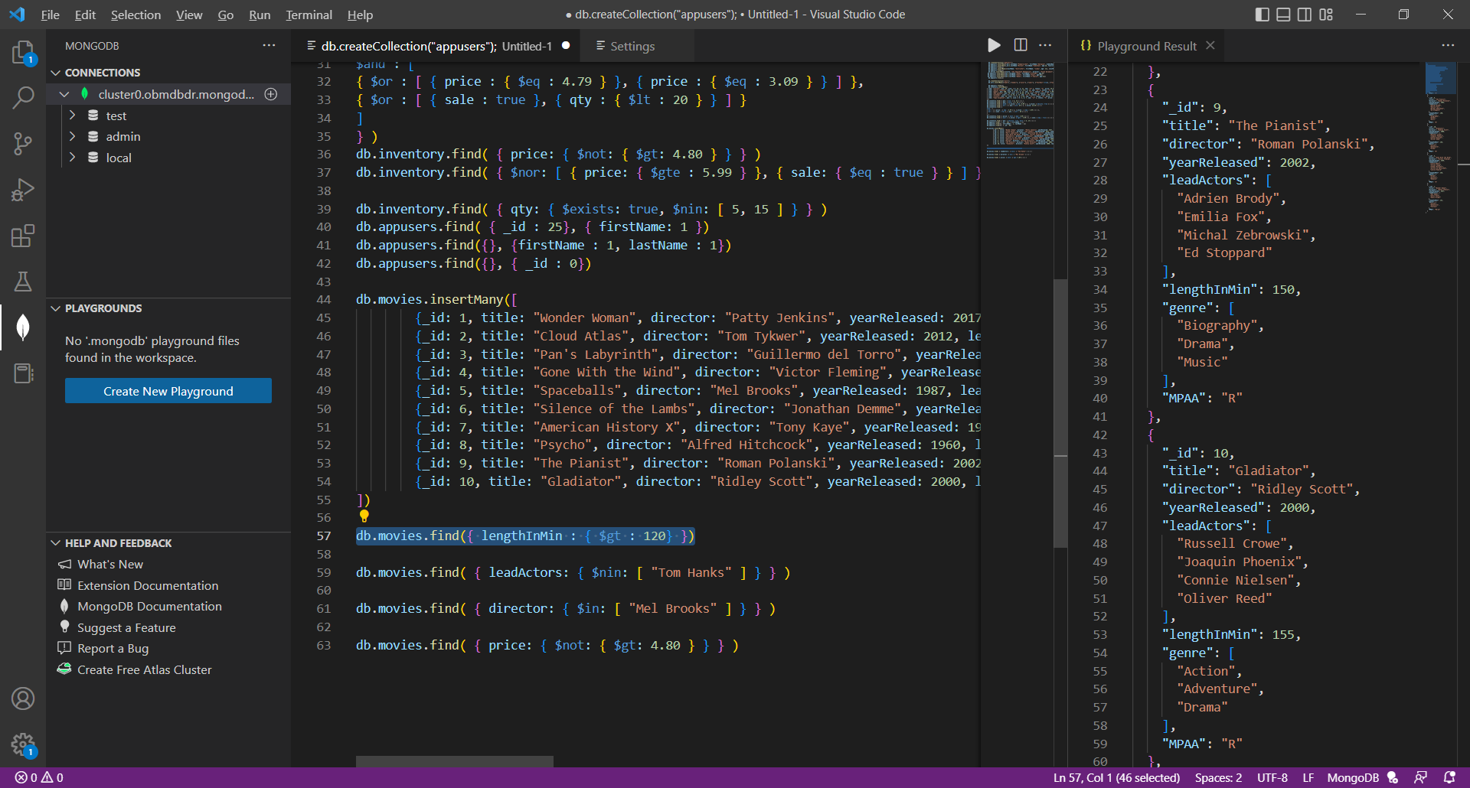
* Find all movies that do not have Tom Hanks as a lead actor 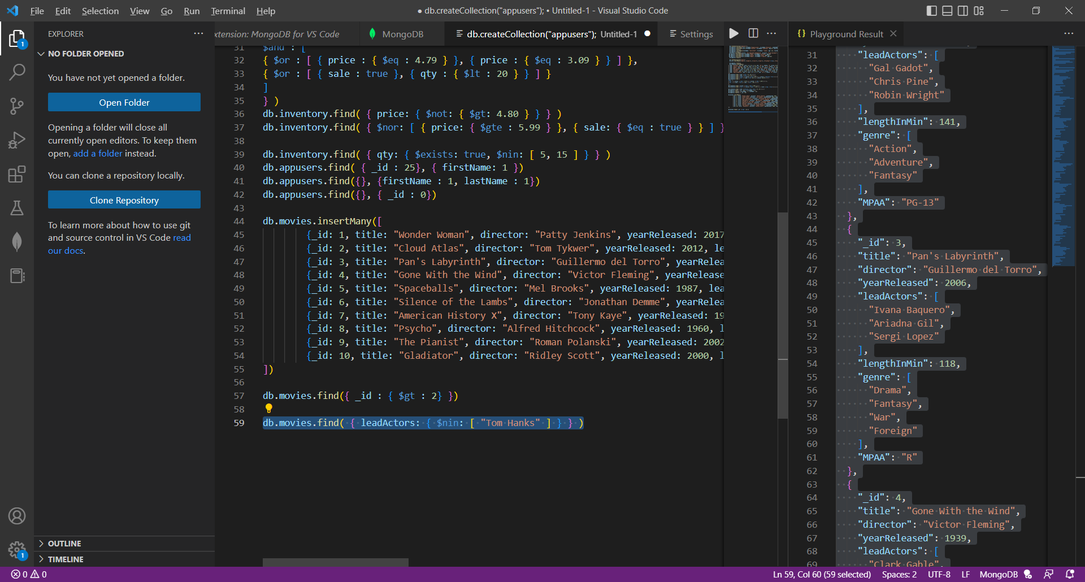
* Find all movies that were directed by Mel Brooks 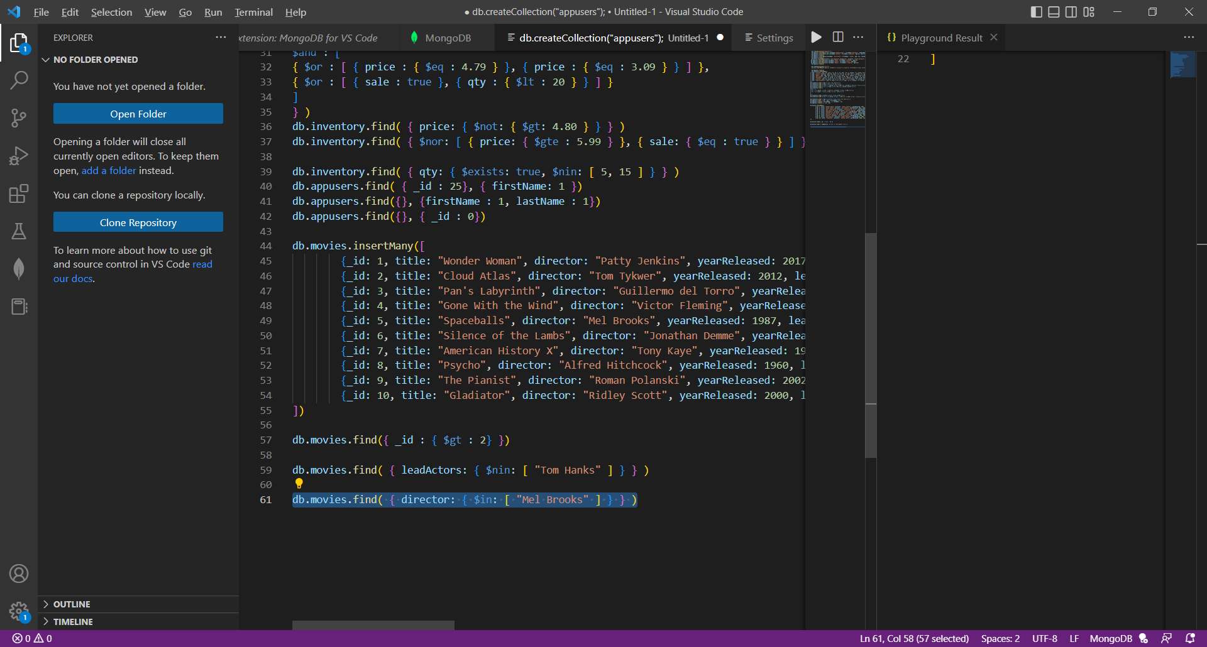
* Find all movies that are not considered Drama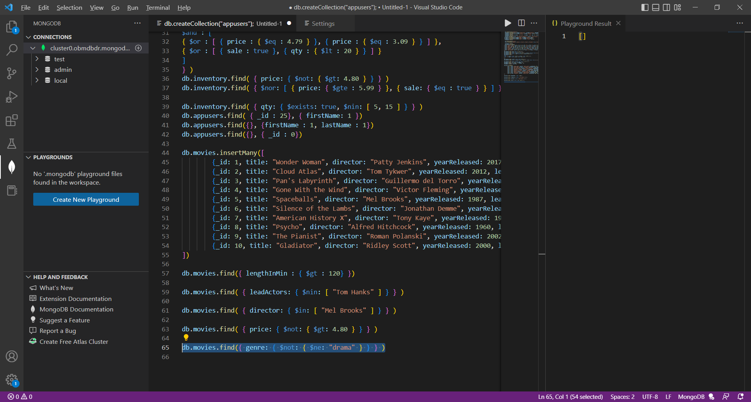
* Find all movies that are longer than 90 minutes but less than 2 hours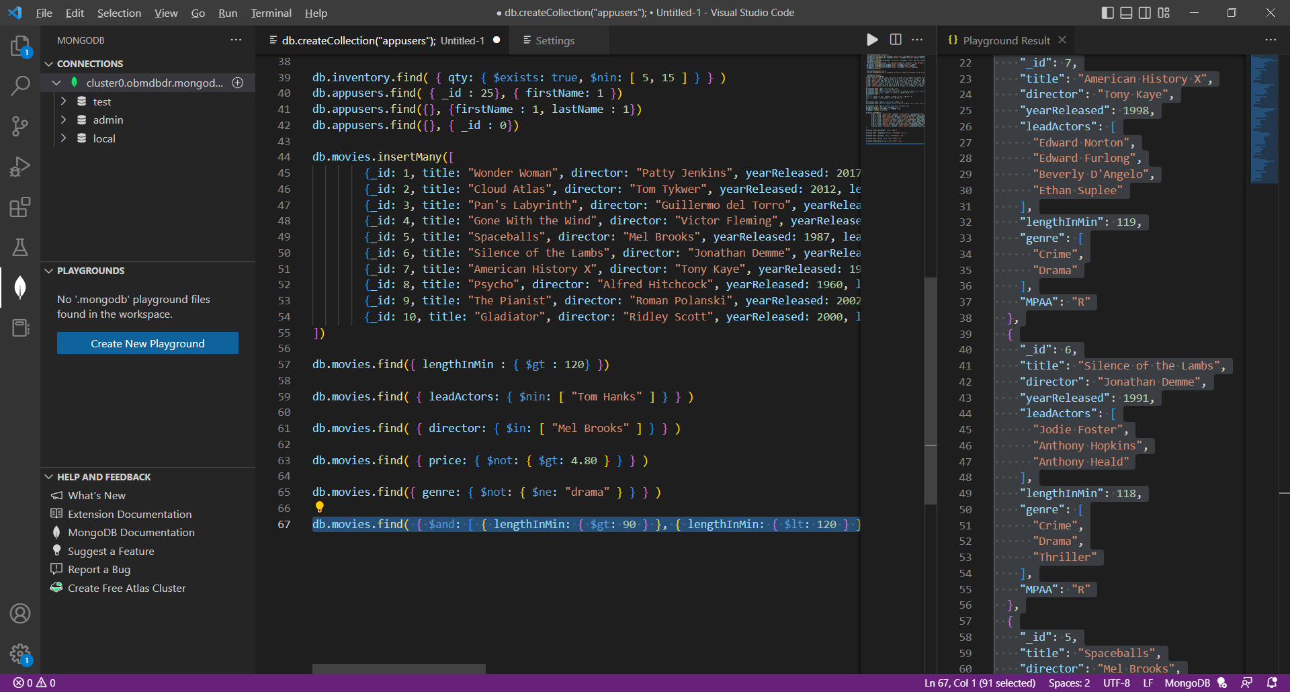
* Find all movies that are considered Action or Adventure and return only the title of the movie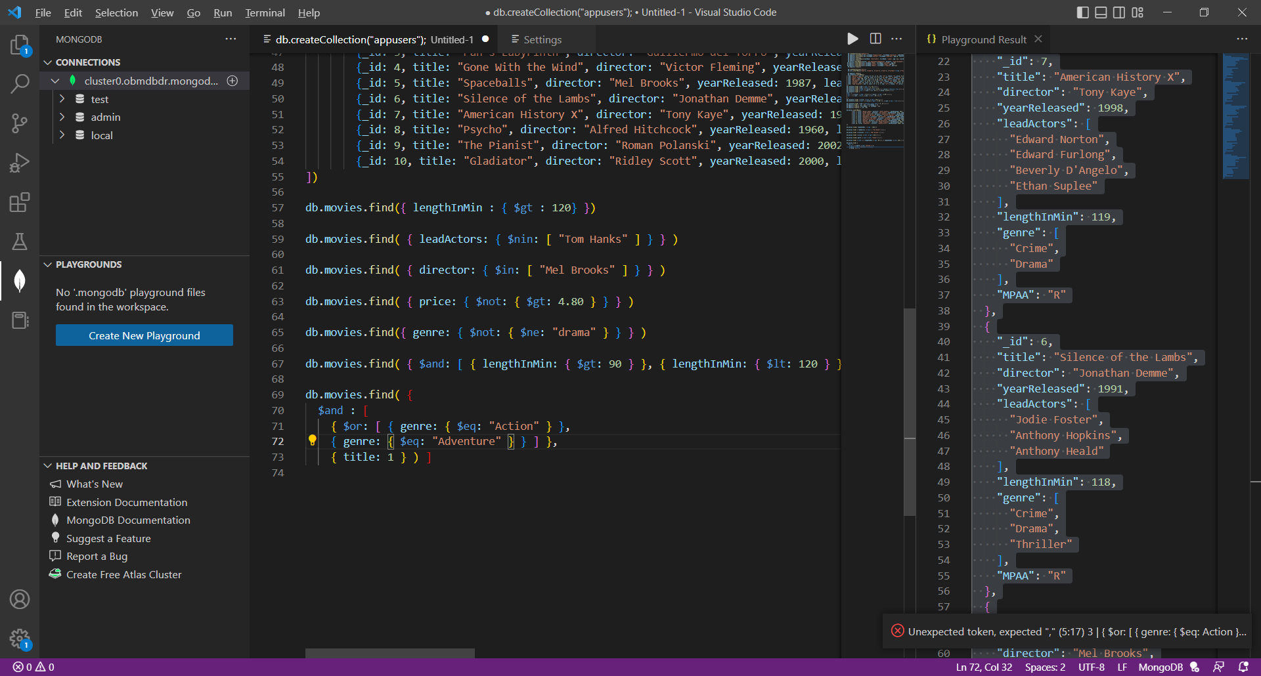

**Part 2**

Below is a real-life scenario. Please read this scenario and run the appropriate queries needed.

The company you work for is having a movie night for all employees, and they are trying to find the perfect movie for movie night. The problem is, so many people have different opinions, and they want to make everyone happy. Sally has very poor eyesight so cannot watch any foreign films but likes comedies and dramas. Robert hates Jodie Foster and refuses to watch any movies with her in it, but likes comedies and horror films. Stewart has somewhere to be after movie night, so he can't watch a movie longer than 2 hours; he prefers thrillers and comedies.

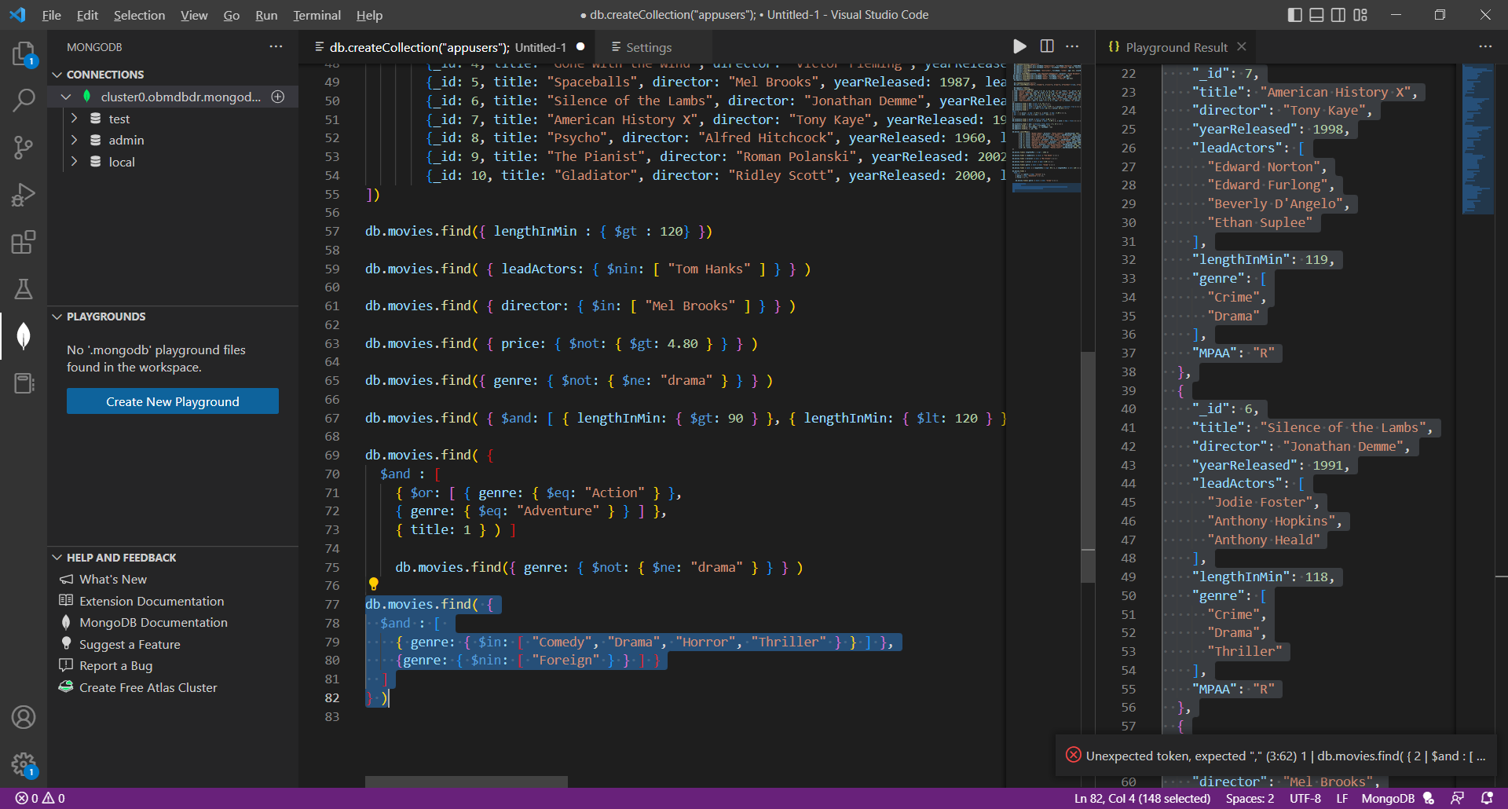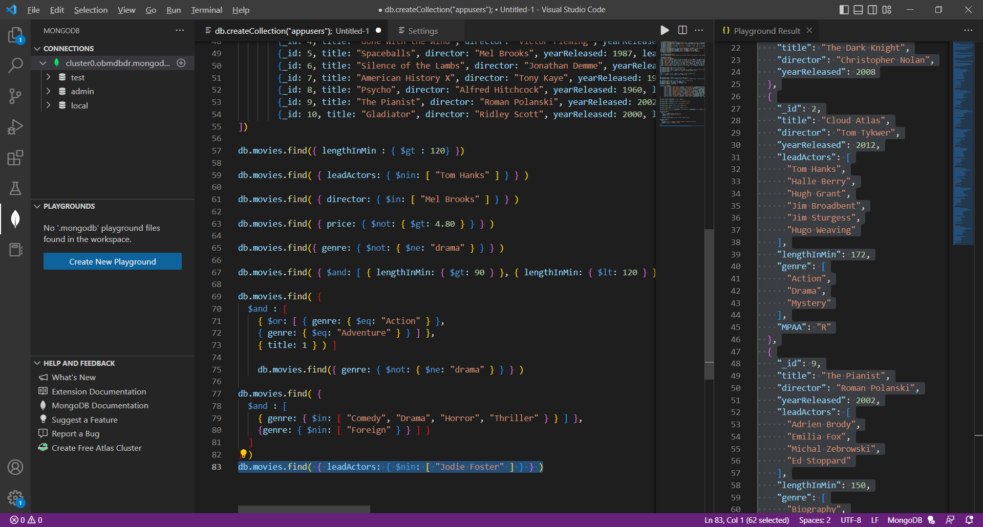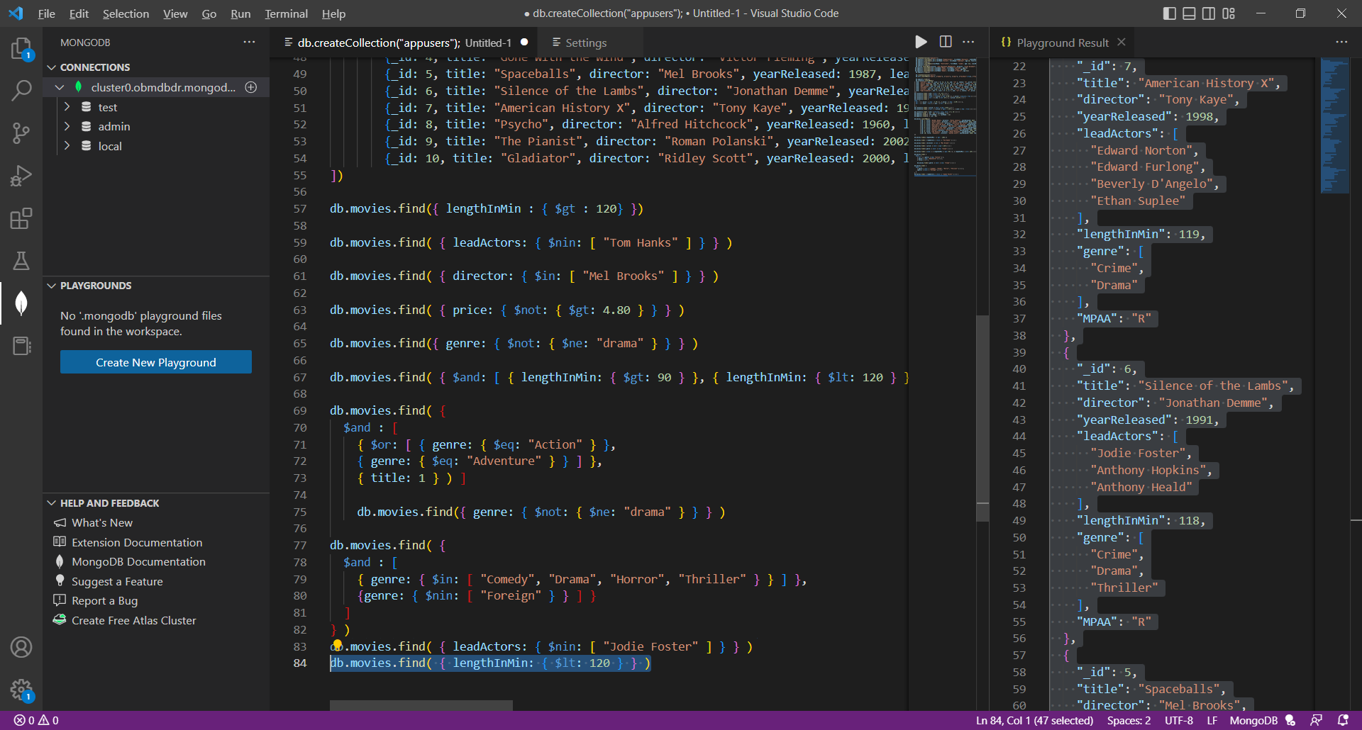

After running your query(ies), what movie is going to be played at movie night?

**Spaceballs**

**Caution!**

Be sure to zip and submit your NoSQL-HandsOn2 text document when finished! You will not be able to re-submit, so be sure the screenshots to each part are located within this document.

Drop files to upload, or click to browse.