**Part 1**

Run the following queries:

1. Create a view named "initialCustomers" that shows the first name, last name, and email address of customers that have an id of less than 100. Once that is complete, select and view your newly created view. 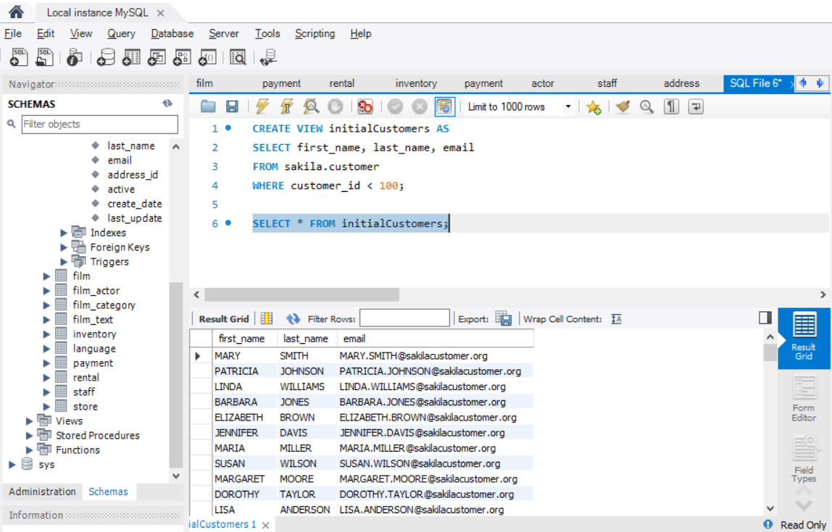

**Part 2**

Complete the following:

Create a table named "ProductList". Include the following columns:

* ProductId
* ProductName
* Price
* DateAdded
* EmployeeSupportId

Include the following requirements:

1. Every product should have an automatically generated id number that should be unique for each product.
2. Give each column a data type that would apply
3. Give the DateAdded column a default value for the current local time.
4. All columns CANNOT be null.

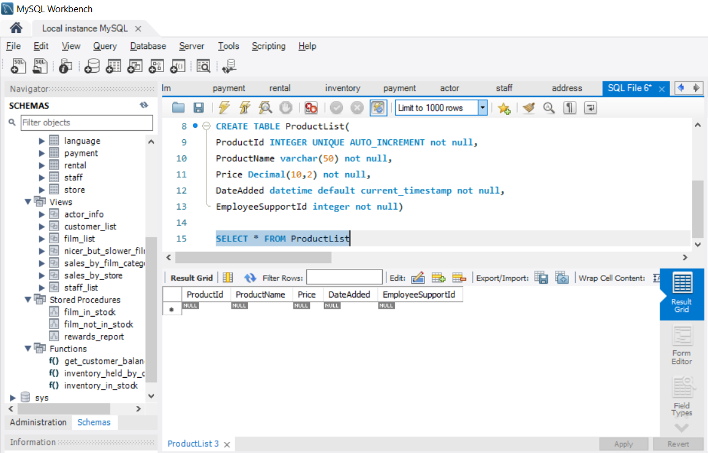

Next, insert one product into the table following the given guidelines when the table was created. When inserting the data, don't include the ProductId or the DateAdded. Finally, run a query to see the single product in your table.

