**Operators Hands-On9 points**

**Part 1**

Create a program that will concatenate string variables together to form your birthday.

1. Create three variables named day, month and year
2. Concatenate each of these variables to create your full birthday.

Hint! You cannot concatenate strings and integers, so all variables will need to be strings

1. Assign the concatenation to a fourth variable named my_birthday.
2. Finally, print the variable my_birthday to see if you have the format identical to the one in the example below:
   * For example, if your birthday is on November 11th of 1991, then the format/output should be November 11, 1991

**Tip!**

To add spaces between each word as you concatenate them, use double quotes with a space in between them like so: " ".

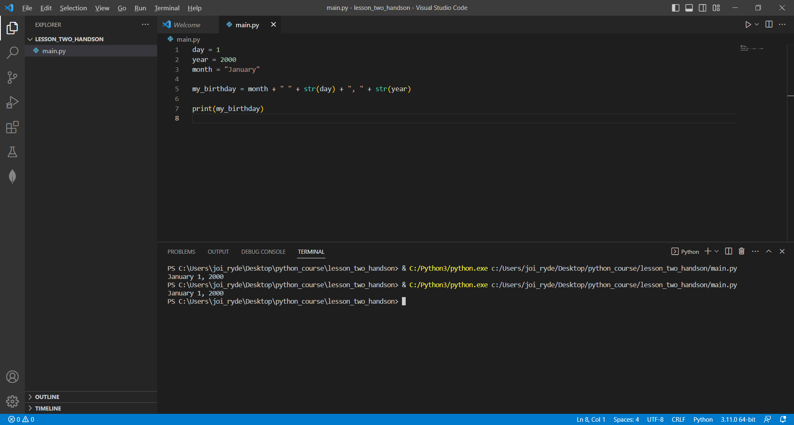

**Part 2**

1. Concatenate the variables first, second, third, and fourth and set this concatenation to the variable final:

first = "happy"

second = "birthday"

third = "to"

fourth = "you"

final =

1. Print the final variable, but all words should be uppercase.
2. Run this code in the VSCode terminal.
   * The output should be HAPPY BIRTHDAY TO YOU.

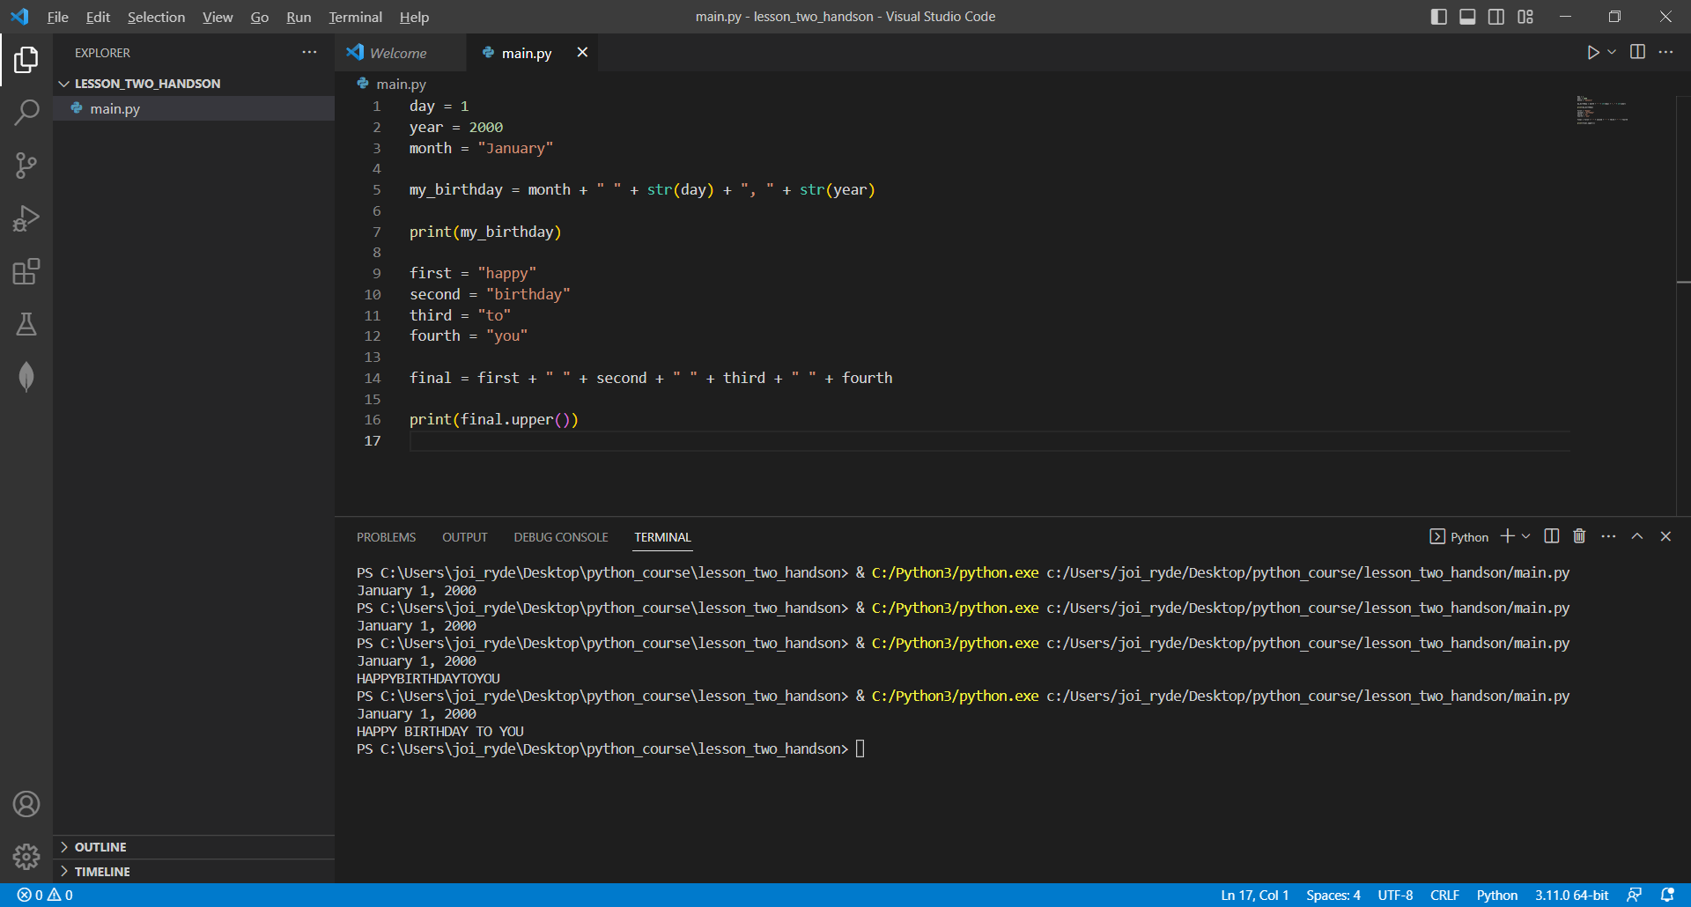

**Part 3**

Finally, add code to your program that determines if the given age allows the attendee to see the movie, printing out a specific message based on the age. There should be four possible outputs:

* If under the age of 10, print Not permitted
* If under the age of 15, print Permitted with a parent
* If under the age of 18, print Permitted with anyone over 18
* If 18 or over, print Permitted to attend alone

Below is some code to get you started:

age = 15

if

**Tip!**

You may need more than one elif statement to capture each condition, and the sequence matters.

