COVID-19 Global Data Analysis Using Python
Project Report
Tools: Python | Pandas | NumPy | Matplotlib | Seaborn | Jupyter Notebook

1. Executive Summary
This project analyzes WHO COVID-19 reported case and death data using Python. The analysis focuses on data cleaning, exploratory data analysis, time-series trends, country comparisons, WHO regional comparisons, India-specific analysis, and descriptive statistics. The objective is to demonstrate a complete beginner-to-intermediate data analytics workflow.

2. Dataset Description
The CSV contains 583,440 rows and 8 columns covering 2020-01-04 to 2026-08-30. It contains 240 countries/areas and 7 WHO regions. The main fields are Date_reported, Country_code, Country, WHO_region, New_cases, Cumulative_cases, New_deaths, and Cumulative_deaths.
Official source: WHO COVID-19 Dashboard — https://data.who.int/dashboards/covid19/data

3. Problem Statement
The purpose of the project is to transform raw COVID-19 surveillance records into useful analytical insights. The project investigates how reported cases and deaths changed over time, how reporting differs across countries and regions, and what patterns can be observed for India.

4. Objectives
- Inspect and understand the raw dataset.
- Identify missing values and duplicate records.
- Convert and derive date-related variables.
- Analyze global daily and monthly reported cases and deaths.
- Compare countries by reported cases and deaths.
- Compare WHO regions.
- Analyze India's reported COVID-19 trend.
- Use a 7-day moving average to smooth daily variation.
- Calculate a descriptive reported case fatality ratio.
- Examine the relationship between reported cases and deaths.

5. Tools and Technologies
- Python
- Jupyter Notebook
- Pandas
- NumPy
- Matplotlib
- Seaborn

6. Data Cleaning and Preparation
The Date_reported column was converted to a datetime data type. Missing values in New_cases and New_deaths were filled with zero for the aggregation used in this project. Year, month, month name, and year-month fields were created for time-series analysis. Duplicate rows were checked.

7. Key Dataset Results
Metric | Value
Rows | 583,440
Columns | 8
Date range | 2020-01-04 to 2026-08-30
Countries/areas | 240
WHO regions | 7
Sum of reported New_cases | 779,366,737
Sum of reported New_deaths | 7,116,554
India reported cases | 45,056,221
India reported deaths | 533,849

8. Global Time-Series Analysis
The largest single country-day value in the New_cases field is 8,401,963 reported cases on 2022-01-30 for China. The largest single country-day value in New_deaths is 57,167 reported deaths on 2023-02-01 for China.
A 7-day moving average was used to reduce day-to-day reporting noise and make broad trends easier to interpret.
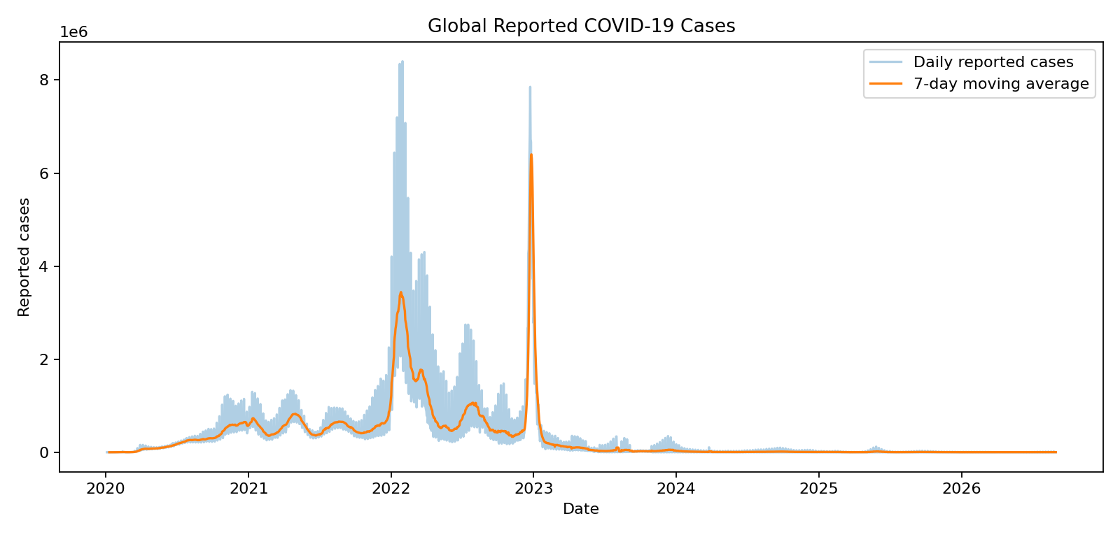

9. Country-Level Analysis
The following countries have the highest totals when New_cases is summed across the available records:
- United States of America: 103,436,829 reported cases and 1,239,049 reported deaths.
- China: 99,381,761 reported cases and 122,398 reported deaths.
- India: 45,056,221 reported cases and 533,849 reported deaths.
- France: 39,061,500 reported cases and 168,207 reported deaths.
- Germany: 38,437,953 reported cases and 174,979 reported deaths.
- Brazil: 38,050,567 reported cases and 704,066 reported deaths.
- Republic of Korea: 34,571,873 reported cases and 35,934 reported deaths.
- Japan: 33,803,572 reported cases and 74,694 reported deaths.
- Italy: 26,969,918 reported cases and 198,523 reported deaths.
- United Kingdom of Great Britain and Northern Ireland: 25,122,084 reported cases and 232,112 reported deaths.
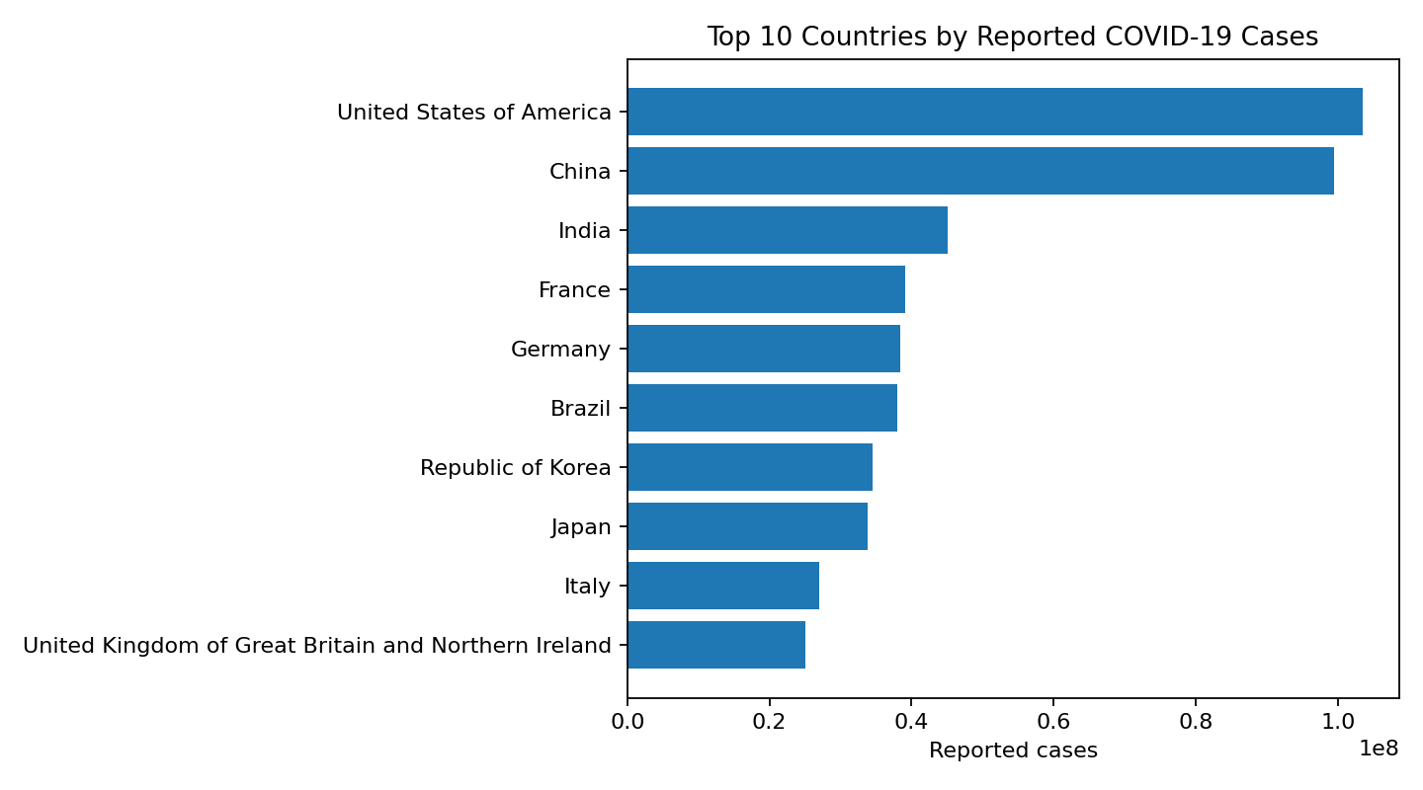

10. WHO Regional Analysis
WHO regional totals were calculated by aggregating New_cases and New_deaths by WHO_region. This provides a high-level comparison of reported surveillance data across regions.
- EUR: 281,769,988 reported cases; 2,283,461 reported deaths.
- WPR: 215,441,060 reported cases; 583,745 reported deaths.
- AMR: 193,917,141 reported cases; 3,074,523 reported deaths.
- SEAR: 55,229,678 reported cases; 647,305 reported deaths.
- EMR: 23,417,911 reported cases; 351,975 reported deaths.
- AFR: 9,590,195 reported cases; 175,532 reported deaths.
- OTHER: 764 reported cases; 13 reported deaths.

11. India Analysis
For India, the dataset contains 45,056,221 reported cases and 533,849 reported deaths when the daily reported fields are summed. Monthly trends were also analyzed to identify periods of increased reporting.
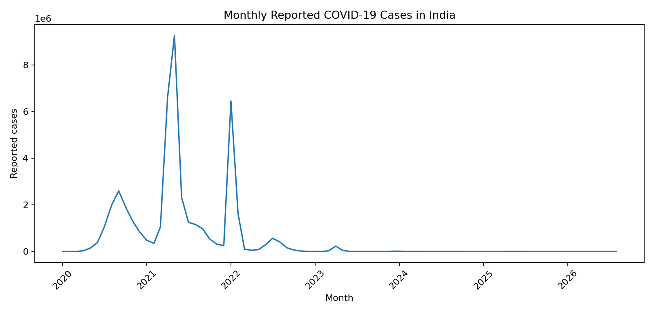

12. Reported Case Fatality Ratio
The descriptive reported case fatality ratio calculated from the summed fields is 0.91%. This is not an infection fatality rate and should not be interpreted as the probability that an infected person dies. It is affected by testing, reporting, case definitions, reporting delays, and retrospective corrections.

13. Cases vs Deaths
The country-level Pearson correlation between summed reported cases and summed reported deaths is 0.768. The analysis also uses a logarithmic scatter plot because country totals vary substantially in scale.

14. Key Findings
- COVID-19 reported counts vary substantially over time and across countries.
- Country and regional comparisons show large differences in reported surveillance totals.
- India has a substantial number of reported cases and deaths in the dataset and shows clear time-series variation.
- A 7-day moving average provides a smoother view of the global reported case trend.
- Reported case totals and reported death totals are positively associated across countries, but the strength and ratio differ between countries.
- The reported case fatality ratio is a descriptive metric and should not be interpreted as a direct measure of true infection fatality.

15. Limitations
- WHO reports that COVID-19 data are subject to continuous verification and retrospective changes.
- Countries differ in testing, case definitions, reporting practices, and reporting frequency.
- Some countries changed from daily to weekly reporting, so zeros or missing values do not necessarily indicate no disease activity.
- Bulk corrections can create unusually large positive or negative daily values.
- Summing daily reported values is a descriptive operation and may not equal the latest cumulative value because the source can include corrections.

16. Conclusion
This project demonstrates a complete data analytics workflow: importing raw data, checking data quality, cleaning and transforming fields, performing exploratory analysis, creating time-series metrics, comparing groups, and communicating findings through visualizations. The notebook is designed to be reproducible by keeping the analysis code separate from hard-coded results.

17. How to Run the Project
- Install Python 3.x and Jupyter Notebook.
- Run: pip install -r requirements.txt
- Place WHO-COVID-19-global-daily-data.csv in the same folder as the notebook.
- Open YourName_COVID19_Data_Analysis.ipynb in Jupyter Notebook.
- Run the notebook cells from top to bottom.

18. References
World Health Organization (WHO), COVID-19 Dashboard: https://data.who.int/dashboards/covid19/data
WHO COVID-19 data documentation notes that reported counts are affected by case detection, definitions, testing, reporting strategies, reporting frequency, and retrospective verification/corrections.

