

13.Sports Tournament Scheduling
a micro project e-report Submitted by

ABEL PAUL ABRAHAM(URK25CS1038)
NAVNEETH P JAYAN(URK25CS1060)
JOYEL JOSE(URK25CS1065)
RIYAN SHONEY(URK25CS1212)

in partial fulfillment of the Continuous Internal Examination
of
25CS306 – Data Structures And Algorithms

In

B. Tech. COMPUTER SCIENCE AND ENGINEERING
under the supervision of

Dr. S. Shirly



KARUNYA INSTITUTE OF TECHNOLOGY AND SCIENCES
(Deemed-to-be-University)
Karunya Nagar, Coimbatore - 641 114.
2026


ABSTRACT
Torneo is a full-stack tournament management platform designed to combine practical sports administration with the study of core data structures and algorithms. It supports single-elimination and round-robin formats, applying distinct rules to knockout results and league draws. The reported client is a React 19 and TypeScript single-page application; the service layer uses FastAPI, Python, and Pydantic, with SQLite and SQLAlchemy for relational persistence and PostgreSQL identified as an alternative. The algorithmic core includes a binary tournament tree for knockout progression, graph representations and traversals for match dependencies, an instrumented multi-criteria Bubble Sort for standings, Binary Search for ordered-record lookup, and the Berger cyclic method for round-robin fixtures.
The supplied project report describes a DSA Visualization Lab intended to make algorithm execution inspectable. Its screens cover tournament operations, standings, a Bubble Sort trace, a binary tournament tree, and a directed match progression graph. This e-report organizes those details into the prescribed academic sections, explains the system workflow and data model, and interprets the interface descriptions. The source material does not provide named project members, a supervisor, a course code, measured evaluation data, or an external bibliography. Accordingly, no quantitative performance result or external citation is represented as verified evidence; these missing submission details are identified for the project team to complete. The report also explains how the platform separates interface responsibilities, domain rules, algorithm services, persistence, and access control. This organization supports future maintenance while keeping each algorithm connected to a visible tournament task. The final sections distinguish described features from evidence that would require source-code review, formal testing, or academic references.

TABLE OF CONTENTS

S.No. | Title |  | Page No.
 | BONAFIDE CERTIFICATE |  | ii
 | ABSTRACT |  | iii
 | TABLE OF CONTENTS |  | iv
1 | INTRODUCTION |  | 1
 | 1.1 | Background of the selected problem | 1
 | 1.2 | Industry relevance | 2
 | 1.3 | Aim and objectives | 2
 | 1.4 | Project scope and curriculum outcomes | 2
2 | LITERATURE REVIEW |  | 4
3 | METHODOLOGY |  | 7
4 | FABRICATION/SIMULATION/PROGRAM OR CODE/DESIGN |  | 10
5 | RESULTS AND INTERPRETATION |  | 14
6 | CONCLUSION AND FUTURE SCOPE |  | 18
 | DECLARATION |  | v
7 | REFERENCES |  | 19

1 INTRODUCTION
1.1 Background and problem
Tournament administration requires teams, schedules, scores, standings, and status updates to remain consistent as a competition progresses. A knockout event has dependencies: a match cannot be finalized until its entrants are known, and its winner must be placed into a later match. A round-robin league follows different rules because every team is expected to meet every other team and a draw can remain a valid result. Managing both formats through manual tables creates repeated work and can make the logic behind a bracket or ranking difficult to inspect.
The Torneo project report identifies a gap between tournament websites that mainly display stored records and algorithm lessons that demonstrate trees and graphs only through isolated examples. Torneo is designed to combine these settings. Tournament functions provide a practical application, while the data structures and algorithms that drive them are exposed through a DSA visualization interface. This makes schedule generation, winner advancement, ranking, and search available for both operational use and educational examination.
1.2 Industry relevance
Sports organizations need reliable ways to register teams, build fixtures, record scores, manage venues, and communicate standings. A shared platform can reduce repeated manual updates when scheduling and ranking rules are applied consistently. Torneo describes administrator, organizer, and viewer roles so that users who operate tournaments can be distinguished from those who only inspect results. It also combines front-end interaction, API validation, relational storage, authentication, and visualization, making it relevant to web engineering as well as applied algorithms. The project report presents these benefits as design goals; it contains no independent user study, adoption data, or measured operational impact.

1.3 Aim and objectives
The project aims to design a tournament platform in which core data structures and algorithms perform visible work. Its objectives are to support single-elimination and round-robin play; represent knockout advancement with a binary tree; model match prerequisites using a directed acyclic graph; rank teams with a custom multi-criteria Bubble Sort; provide Binary Search for ordered collections; generate league rounds with the Berger cyclic method; and connect these operations to interactive views. The workflow also aims to apply format-specific rules consistently: knockout ties require penalty resolution, while league draws remain valid results.
1.4 Project scope and curriculum outcomes
The stated scope includes tournament setup, team registration, fixture generation, score entry, standings, venues, role-based access, and DSA visualization. The supplied report maps sorting and searching to CO3, tree structures to CO4, and graph structures to CO5. It does not provide implementation code or a formal test log. This report therefore describes documented features and separates them from verification that would require the source repository or test results.
The stated scope includes tournament setup, team registration, fixture generation, score entry, standings, venues, role-based access, and algorithm visualization. The report maps sorting and searching to CO3, tree structures to CO4, and graph structures to CO5. The available material does not specify implementation details for every edge case and does not include a completed test log. This report therefore describes the documented design and distinguishes it from verification that would require the source code or test results.
2 LITERATURE REVIEW
2.1 Tournament software and algorithmic context
A tournament information system coordinates users, competitions, teams, venues, matches, and results. A score update may affect a match winner, a later bracket fixture, and the standings table. A schedule generator must respect the format, while the interface must distinguish matches that are ready from those awaiting earlier results. Torneo treats these functions as connected services rather than unrelated forms.
The project stated educational motivation is to show how trees, graphs, sorting, and searching can operate on meaningful records. A database is still needed for durable information, but persistence alone does not explain how a bracket was formed or why a team appears above another. Explicit algorithms make those operations explainable. The supplied report does not cite external studies or compare named commercial systems, so this discussion records the project problem framing and does not claim an independent literature survey.
2.2 Trees and knockout brackets
A single-elimination bracket is hierarchical: early matches feed later matches, with the championship match at the root of the progression. Torneo represents a match as a node containing an identifier, round number, scores, winner, feeder links, and a parent pointer. Once a score is entered and a winner is resolved, the system follows the parent link and inserts that winner into the next fixture. The report gives O(log N) as the advancement time for a balanced tree.
If the entrant count is not a power of two, the design calculates the next power-of-two bracket capacity and assigns the difference as byes. The source states that top seeds receive those byes but does not specify the exact seeding or draw policy. The tree model makes progression explicit and gives the DSA Lab a structure to display: feeder matches sit below later rounds and the final sits at the top.
2.3 Graphs, sorting, searching, and scheduling
The project also models fixtures as vertices in a directed acyclic graph. An edge means that one match outcome is needed before another can begin. An adjacency list stores sparse relationships efficiently, while an adjacency matrix supports direct relationship lookup. BFS inspects matches by stage, and DFS traces a teams path through dependencies. Traversal over an adjacency list is described as O(V + E). Figure 2.1 illustrates this dependency, with quarterfinal winners feeding semifinals and semifinal winners feeding the final.
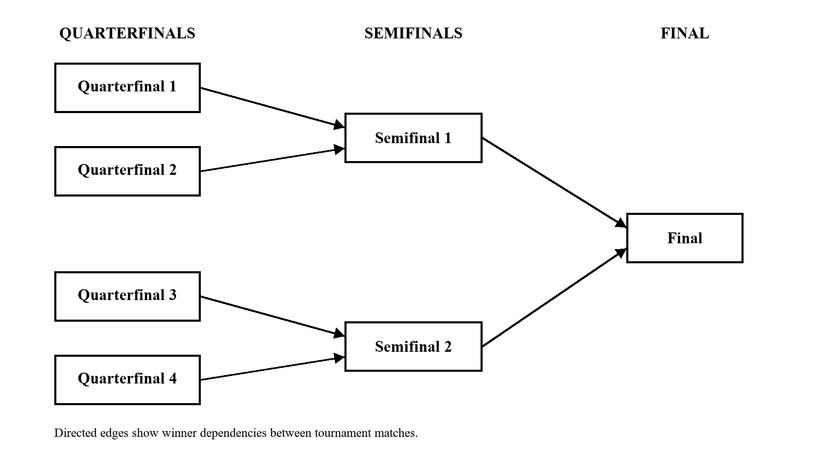
Figure 2.1: Illustrative match-dependency DAG; arrows show winner progression.
Standings use descending points, goal difference, and goals scored, followed by team name in lexicographical order. A custom Bubble Sort exposes comparisons and swaps for learning; its worst case is O(N²), while an early-exit pass gives O(N) behavior on ordered data. Binary Search is used for pre-sorted records and records low, middle, and high positions. For leagues, the Berger cyclic method rotates team positions to produce N-1 rounds for an even number of entrants, with each pair meeting once.
3 METHODOLOGY
3.1 Architecture and development approach
The reported architecture separates a React 19 and TypeScript client from a FastAPI service. Vite supports the front-end build; Tailwind CSS, Lucide icons, and React Flow are listed for interface and visualization work. The back end uses Python 3.13, Uvicorn, and Pydantic v2. SQLAlchemy 2.0 connects domain entities to SQLite, with PostgreSQL named as another database option. Algorithm modules are described as pure Python implementations.
This decomposition assigns presentation, request validation, business rules, persistence, and algorithmic work to separate areas. A browser action sends a request to an API endpoint; the service validates it, applies domain logic, and persists the resulting state. The user interface then presents the updated tournament. The report lists OAuth2, JWT, bcrypt, and role-based access control for security. These are reported design choices; deployment configuration and a threat model were not supplied.
3.2 Tournament lifecycle and domain model
The lifecycle begins when an organizer creates a tournament, selects its format and sport rules, and sets the maximum number of teams. Teams register until capacity is reached. The organizer then generates a schedule: a binary tree creates knockout fixtures and byes, while the Berger method creates round-robin matchdays. Scores are entered by an organizer and validated against format-specific rules. Knockout draws require penalty resolution; league draws remain draws and award one point to each team. Confirmed results trigger standings recalculation.
The named data entities are User, Tournament, Team, TournamentTeam, Match, Venue, and AuditLog. Users carry identity and role data; tournaments store format and status; teams store names and captain details; the join table carries tournament-specific statistics. Matches store scores, round, winner, and parent relationships. Venues store location and capacity information. AuditLog tracks an actor, action, entity type, and timestamp. The source lists foreign keys, cascading deletion, and ACID transactions but does not provide the schema or exact constraints.
3.3 Validation approach
The design maps each operation to a clear responsibility. Bracket creation builds match nodes and dependencies; score confirmation resolves a winner; graph traversal evaluates readiness and paths; a comparator orders standings; Binary Search locates entries in ordered data; and the Berger method creates league rounds. A trace instrumentor records Bubble Sort passes, compared positions, swaps, and array snapshots.
A verification plan should check bracket progression with both power-of-two and non-power-of-two team counts, including bye allocation. League checks should confirm that every pair meets once and that a draw awards one point to each side. Standings tests should exercise each tie-break criterion. Search cases should include present, absent, boundary, and empty inputs. Graph checks should verify reachability, stage order, and path reconstruction. These are recommended tests derived from the described design; the provided report does not say that they have been run.
4 FABRICATION/SIMULATION/PROGRAM OR CODE/DESIGN
4.1 Interface and API responsibilities
The client is described as a single-page application with dashboards, tournament control views, brackets or schedules, standings, and a DSA Lab. The control center groups status, format, fixtures, teams, venues, and table navigation. Administrator, organizer, and viewer roles separate management, competition operations, and read-only access. The API layer validates requests and routes them to services; Pydantic handles validation and serialization, and audit logging records actions and score changes.
The modular structure is intended to keep interface code separate from algorithm logic. The supplied report names source modules for the tournament tree, graph algorithms, Bubble Sort, Binary Search, and bracket service, but the corresponding code files were not provided. For that reason this report does not invent endpoint paths, request shapes, or error messages.
4.2 Tree and graph implementation
A match node contains the round and score state, winner, left and right feeder references, and a parent link. In a completed knockout match, the winner moves upward to a parent fixture. Byes allow a bracket with fewer than a power-of-two number of entrants to be represented in a balanced progression. The source describes the operation as O(log N) for a balanced tree.
The graph view represents each match as a vertex and each prerequisite as a directed edge. BFS uses a queue to inspect stages and identify matches that may be ready together. DFS traces a path through a teams progression. The design maintains both an adjacency list and an adjacency matrix, giving a sparse traversal representation and a direct lookup representation. The project report does not describe how consistency between these two structures is maintained, so implementation details should be confirmed from code.
4.3 Ranking, lookup, and fixture generation
The standings comparator examines points, goal difference, goals scored, and team name in that order. Bubble Sort swaps adjacent rows when their relative order violates the comparator. Its trace records pass number, step, compared indices, swap state, and a snapshot. Worst-case work is N(N-1)/2 comparisons; an early-exit flag avoids further passes when the current order is stable. This is useful for instruction, though less efficient on very large lists than more advanced sorting methods.
Binary Search divides a sorted range around a midpoint and records low, middle, and high at each step. Its precondition is an ordered collection. Berger scheduling keeps one position fixed and rotates the others to create league rounds. For an even team count, the source states that N-1 rounds are produced and each pair plays once. Home/away equity is an objective of the method, though the exact assignment policy is not included.
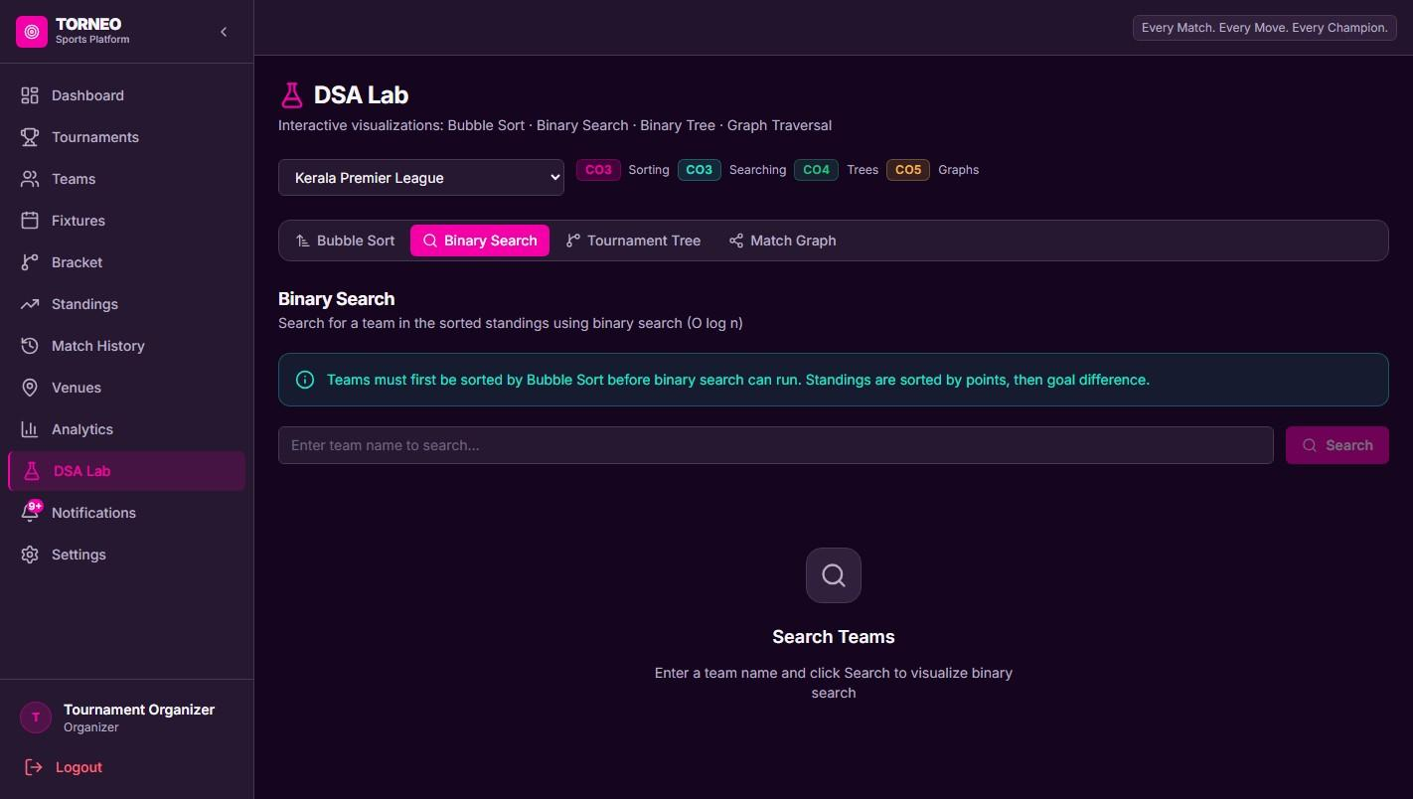
Figure 4.1: Binary Search view in the DSA Lab.
4.4 Persistence and security
The database layer is described as SQLite with SQLAlchemy 2.0, with PostgreSQL as an alternative. Foreign-key constraints and cascading deletions support related records, while ACID transactions are identified for match-state updates. A confirmed score can affect the match, winner, bracket participant, and standings, so a transaction can help prevent partially applied changes. The attached report does not provide the schema, migrations, or transaction code.
The security features named are OAuth2, JWT, bcrypt password hashing, and role-based access control. The role set is administrator, organizer, and viewer. The audit log records changes to administrative entities and scores. The source does not specify token duration, password policy, or the exact authorization matrix; those items should be documented before deployment.
5 RESULTS AND INTERPRETATION
5.1 Described screens and intended outcomes
The supplied report describes an analytics dashboard with tournament metrics, active matches, quick actions, team distribution, and recent score updates. A control center for a Kerala Premier League example shows tournament status, format, fixtures, bracket or schedule, standings, teams, and venues. A standings view displays played, won, drawn, lost, goals for, goals against, goal difference, and points. The DSA Lab includes a Bubble Sort visualizer, a binary tree view, and a match progression graph.
These features are intended to connect operations and learning: the same tournament data that supports an organizer can be used to inspect algorithm steps. The source calls the interface images actual screenshots, but does not include an evaluation procedure or metrics. Accordingly, this section summarizes the features described in the project report rather than claiming independently measured outcomes.
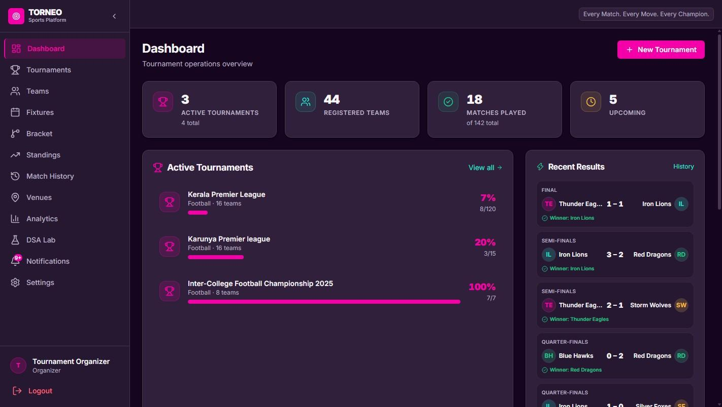
Figure 5.1: Analytics and Tournament Operations Dashboard.
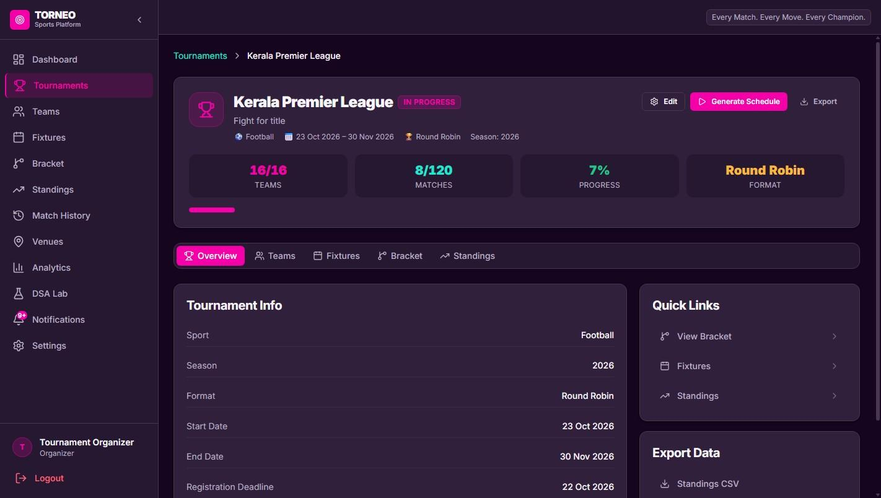
Figure 5.2: Tournament Control Center for the Kerala Premier League.
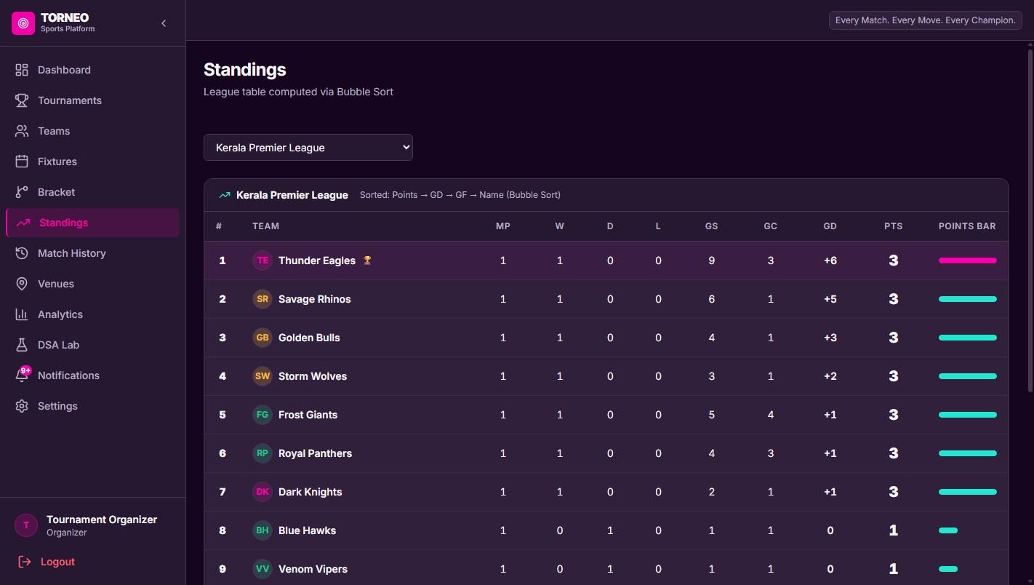
Figure 5.3: Real-Time Standings and League Table.
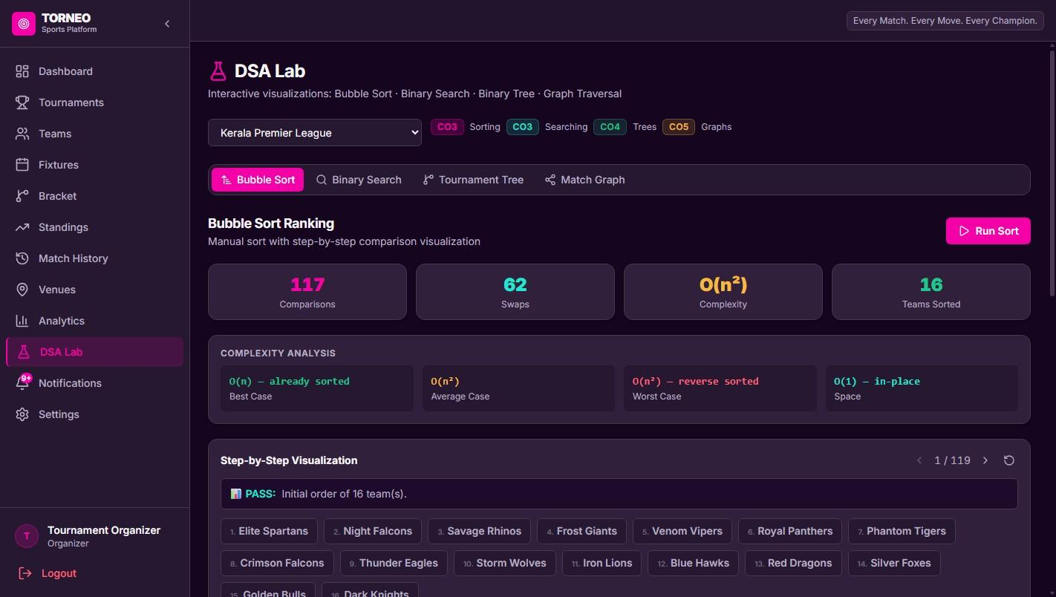
Figure 5.4: Interactive DSA Lab Bubble Sort Visualizer.
5.2 Algorithmic interpretation and evidence limits
The tree, graph, scheduling method, sorting routine, and search routine answer different questions. The tree explains bracket hierarchy; the graph explains prerequisites and traversals; the cyclic method produces league fixtures; the ranking comparator explains standings order; and Binary Search demonstrates efficient lookup when records are sorted. The DSA Lab is designed to expose these operations. The reported complexities are theoretical descriptions, not measured execution times.
No benchmark table, test log, coverage report, deployment record, or learner study is included in the supplied PDF. It therefore cannot support claims about throughput, response time, supported user counts, or learning gains. The source repository was also not attached, so exact schemas, API contracts, error handling, odd-team league behavior, and venue-conflict logic remain to be checked against the implementation. These limits define the strength of the conclusions in this report.
6 CONCLUSION AND FUTURE SCOPE
6.1 Conclusion and future work
Torneo combines tournament administration with an educational view of data structures and algorithms. Its reported design supports knockout and round-robin formats through distinct rules. Binary trees advance knockout winners, a DAG models match prerequisites, Bubble Sort orders standings, Binary Search locates ordered records, and the Berger method generates league rounds. A React and TypeScript client communicates with a FastAPI service and relational database.
The project’s stated contribution is to make algorithmic execution inspectable in an application that also supports tournament operations. The supplied details establish the design and intended features but do not establish measured performance or educational outcomes. Future work should add automated tests for bracket progression, bye assignment, league pair completeness, tie-break ordering, search boundaries, graph traversal, and venue conflicts. It should also document the schema, API, deployment, and security configuration; conduct performance and usability evaluations; review accessibility; and expand sport rules only after current behavior is verified. These are recommendations, not features confirmed in the source.
7 REFERENCES
Source material and citation note
[1] Torneo: Algorithmic Tournament Management Platform & DSA Engine, supplied project report, undated. Used as the source for the architecture, algorithms, workflows, data model, and interface descriptions in this e-report.
No external scholarly or technical references were included in the supplied project details. Before submission, add the textbooks and official technical documentation actually consulted by the team. Do not add sources that were not used.

DECLARATION

I understand that Karunya Institute of Technology and Sciences retains the rights to any product developed (software or hardware) through the Micro Project submitted by me to the Institution.

Furthermore, if I intend to document or publish any findings from the Micro Project work for commercial purposes, I shall obtain a No Objection Certificate (NOC) from the Office of the Registrar before engaging in such activities.

I also understand that any patentable outcomes arising from the Micro Project shall be reported to the Institution, and that patent filing, ownership, and revenue-sharing will be governed by the Intellectual Property Rights (IPR) policies of Karunya Institute of Technology and Sciences.
I acknowledge that any commercial utilization or republication of the Micro Project work, in full or in part, shall require prior permission from Karunya Institute of Technology and Sciences. I further agree that any royalty accruing from such utilization will be shared between the inventor(s) and the Institution in the ratio of 60:40, respectively, in accordance with the Institute’s Intellectual Property Rights policy.


Signature of the Student:
Name of the Student: Abel Paul Abraham
Register Number: URK25CS1038
Date:28/10/2026

DECLARATION

I understand that Karunya Institute of Technology and Sciences retains the rights to any product developed (software or hardware) through the Micro Project submitted by me to the Institution.

Furthermore, if I intend to document or publish any findings from the Micro Project work for commercial purposes, I shall obtain a No Objection Certificate (NOC) from the Office of the Registrar before engaging in such activities.

I also understand that any patentable outcomes arising from the Micro Project shall be reported to the Institution, and that patent filing, ownership, and revenue-sharing will be governed by the Intellectual Property Rights (IPR) policies of Karunya Institute of Technology and Sciences.
I acknowledge that any commercial utilization or republication of the Micro Project work, in full or in part, shall require prior permission from Karunya Institute of Technology and Sciences. I further agree that any royalty accruing from such utilization will be shared between the inventor(s) and the Institution in the ratio of 60:40, respectively, in accordance with the Institute’s Intellectual Property Rights policy.

Signature of the Student:
Name of the Student: Navneeth P Jayan
Register Number:URK25CS1060
Date:28/10/2026

DECLARATION

I understand that Karunya Institute of Technology and Sciences retains the rights to any product developed (software or hardware) through the Micro Project submitted by me to the Institution.

Furthermore, if I intend to document or publish any findings from the Micro Project work for commercial purposes, I shall obtain a No Objection Certificate (NOC) from the Office of the Registrar before engaging in such activities.

I also understand that any patentable outcomes arising from the Micro Project shall be reported to the Institution, and that patent filing, ownership, and revenue-sharing will be governed by the Intellectual Property Rights (IPR) policies of Karunya Institute of Technology and Sciences.
I acknowledge that any commercial utilization or republication of the Micro Project work, in full or in part, shall require prior permission from Karunya Institute of Technology and Sciences. I further agree that any royalty accruing from such utilization will be shared between the inventor(s) and the Institution in the ratio of 60:40, respectively, in accordance with the Institute’s Intellectual Property Rights policy.


Signature of the Student:
Name of the Student: Joyel Jose
Register Number: URK25CS1065
Date: 28/10/2026

DECLARATION

I understand that Karunya Institute of Technology and Sciences retains the rights to any product developed (software or hardware) through the Micro Project submitted by me to the Institution.

Furthermore, if I intend to document or publish any findings from the Micro Project work for commercial purposes, I shall obtain a No Objection Certificate (NOC) from the Office of the Registrar before engaging in such activities.

I also understand that any patentable outcomes arising from the Micro Project shall be reported to the Institution, and that patent filing, ownership, and revenue-sharing will be governed by the Intellectual Property Rights (IPR) policies of Karunya Institute of Technology and Sciences.
I acknowledge that any commercial utilization or republication of the Micro Project work, in full or in part, shall require prior permission from Karunya Institute of Technology and Sciences. I further agree that any royalty accruing from such utilization will be shared between the inventor(s) and the Institution in the ratio of 60:40, respectively, in accordance with the Institute’s Intellectual Property Rights policy.

Signature of the Student: | 
Name of the Student: Riyan Shoney
Register Number: URK25CS1212
Date:28/10/2026

