Rights and Responsibilities of Citizens
Responsibilities - all citizens must:  - Pay income taxes every year by April 15  - Serve on a jury if called  - Sign up for Selective Service (men over 18) | Rights - all citizens may:  - Vote in elections (over 18 only)  - Run for office  - Travel with a US passport

Ways to Participate in the Democratic Process

- vote  - run for office  - join a political party | - help with a political campaign  - call or write to Senators and Representatives

Oath of Allegiance: What you Promise
- Give up loyalty to other countries or leaders  - Support and defend the Constitution  - Be loyal to the US | - Fight or work for the military  - Do any important work for the country the law says you have to (e.g., jury duty)  - Accept the oath without doubts or lying
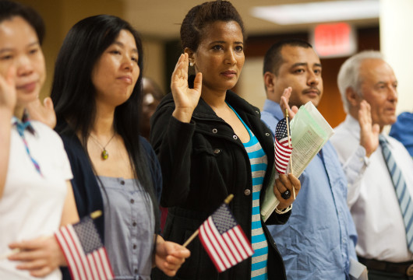

Test Questions
What do we show loyalty to when we say the Pledge of Allegiance?
- the United States
- the flag

Why does the flag have 13 stripes?
- because there were 13 original colonies
- because the stripes represent the original colonies

Why does the flag have 50 stars?
- because there is one star for each state
- because each star represents a state
- because there are 50 states

What is the name of the national anthem?
- The Star-Spangled Banner

What is one responsibility that is only for United States citizens?
- serve on a jury
- vote in a federal election

Name one right only for United States citizens.
- vote in a federal election
- run for federal office

What do we show loyalty to when we say the Pledge of Allegiance?
- the United States
- the flag

What is one promise you make when you become a United States citizen?
- give up loyalty to other countries
- defend the Constitution and laws of the United States
- obey the laws of the United States
- serve in the U.S. military (if needed)
- serve (do important work for) the nation (if needed)
- be loyal to the United States

Oath of Allegiance
"I hereby declare, on oath, that I absolutely and entirely renounce and abjure all allegiance and fidelity to any foreign prince, potentate, state or sovereignty, of whom or which I have heretofore been a subject or citizen; | Oath – promise  Renounce and abjure – give up  Allegiance and fidelity – loyalty  Potentate – powerful leader  Sovereignty – national power  Heretofore – before now
that I will support and defend the Constitution and laws of the United States of America against all enemies, foreign and domestic; that I will bear true faith and allegiance to the same; | Foreign – outside the US  Domestic – inside the US
that I will bear arms on behalf of the United States when required by the law; that I will perform noncombatant service in the armed forces of the United States when required by the law; that I will perform work of national importance under civilian direction when required by the law; | Bear arms – fight  On behalf of – for  Required – have to  Noncombatant service – work that isn’t fighting  Armed forces - military  Civilian – not military
and that I take this obligation freely without any mental reservation or purpose of evasion; so help me God." | Obligation – responsibility, thing you have to do  Mental reservation – doubt  Purpose of evasion – lying

N-400 Questions: Oath Requirements
Do you support the Constitution and form of government of the United States?
Do you understand the full Oath of Allegiance to the United States?
Are you willing to take the full Oath of Allegiance to the United States?
If the law requires it, are you willing to bear arms on behalf of the United States?
If the law requires it, are you willing to perform noncombatant services in the U. S. Armed Forces
If the law requires it, are you willing to perform work of national importance under civilian direction?

