Women’s Rights | Vocabulary:  Suffrage - right to vote and hold office  Suffragist – person who argued that women should be allowed to vote and hold office
Susan B. Anthony (MA)
Susan B. Anthony was arrested for trying to vote in the 1872 presidential election.  She said the 14th Amendment should apply to women, who were like slaves to their husbands.  “The fact is, women are in chains.”  “It was we, the people; not we, the white male citizens… who formed the Union.” |  | 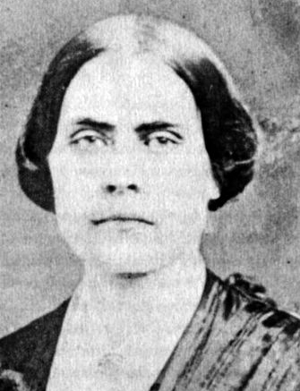
Elizabeth Cady Stanton (NY)
With Anthony, Elizabeth Cady Stanton co-founded the National Women’s Suffrage Association. She wrote many of Anthony’s speeches.  She refused to say “I promise to obey” in her wedding vows.  “We hold these truths to be self-evident: that all men and women are created equal.” |  | 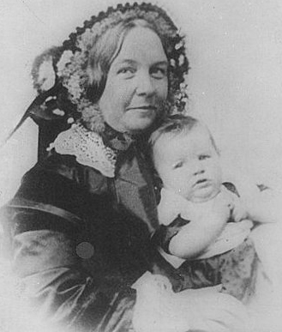
Sojourner Truth (NY)
Sojourner Truth was born a slave, and only escaped after being sold 3 times.  She could not read or write, but gave speeches at anti-slavery and women’s rights events. She also recruited blacks to serve in the Union Army during the Civil War.  “Man is so selfish that he has got women’s rights and his own too!” |  | 