Describe each person’s clothes. Use the words in the vocabulary box. You may use some words more than once. Use “a” or “an” when appropriate.

 | 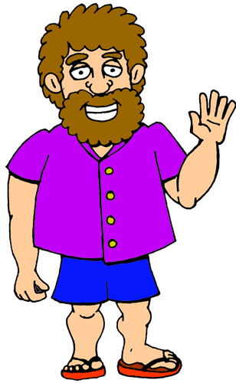 |  |  |  | 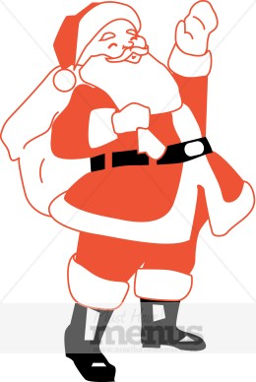
 | a purple shirt
 | blue shorts
 | red flip-flops
 | 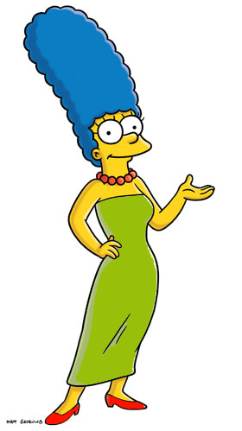 |  | 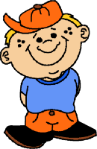 |  | 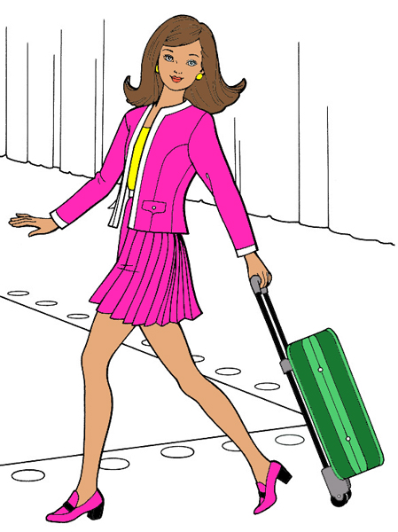

Vocabulary Box
Dress  Skirt  Shoes  Shorts  Pants  Tie | T-shirt  Hat  Boots  Jacket  Shirt  Suit | Red  Orange  Yellow  Green  Blue  Purple | Black  Brown  Gray  Pink

