Video Worksheet - Contradictions
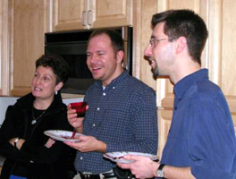  People at party:  Is that your sister?  Oh, no, she's not related to me at all! We're just friends. | 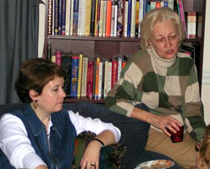  Two women talking:  Oh, I don't feel so great.  Do you think you might be sick?  No, I'm not, I'm just tired.
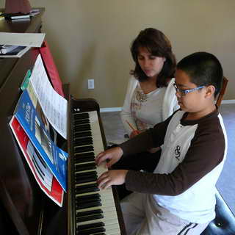  Piano student and teacher:  Oh! I'll never learn this! I'm a total failure!  No, you're not! You just need to practice more. |   Two men talking:  Your father works at the hospital, right?  Yes, but he isn't a doctor, he's a nurse.
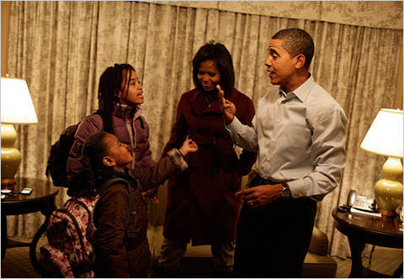  Child and parent:  I can't find my shoes!  What, you aren't ready yet? The bus comes in 10 minutes! |   Two children playing:  Look! I'm Superman!  No, you're not, I'm Superman!

No, I’m Not!

Decide who will be person A and who will be person B. Person A asks a question according to the picture. Person B answers negatively. Try to elaborate on your answers.

Examples:

  A: Are you strong?  B: No, I’m not very strong. | 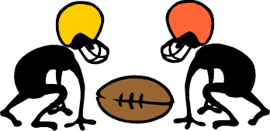  A: Are you a football player?  B: No, I’m not, I’m a baseball player.

- 
- 
- 
- 
- 
- 

