Dates and Ordinal Numbers in English

1-3 are irregular:

  1st | First
2nd | Second
3rd | Third
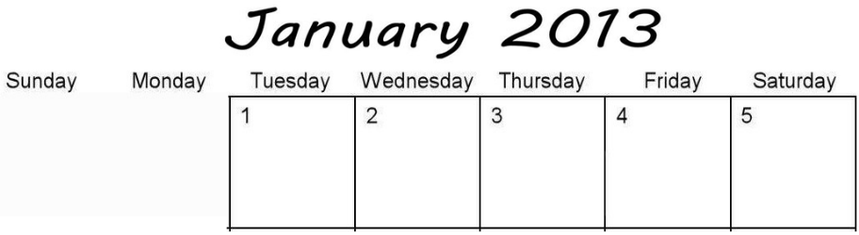

- Tuesday is January __________________.
- Wednesday is January __________________.
- Thursday is January __________________.

After that, just add –th to any number:
4th | fourth
5th | Fifth ← Watch out!
6th | sixth
7th | seventh
8th | eighth
9th | ninth
10th | tenth


- Monday is February __________________.
- Tuesday is February __________________.
- Wednesday is February __________________.

